Naomi Makemie Presbyterian Church
April 2, 2023 Large Print
Onancock, VA
Our Mission Statement
​“Do what is fair and just to your neighbor, be compassionate and loyal in your love, and don’t take yourself too seriously—take God seriously.” Micah 6:8
Compassionate, Fair and Loyal​
nmpreschurch.org

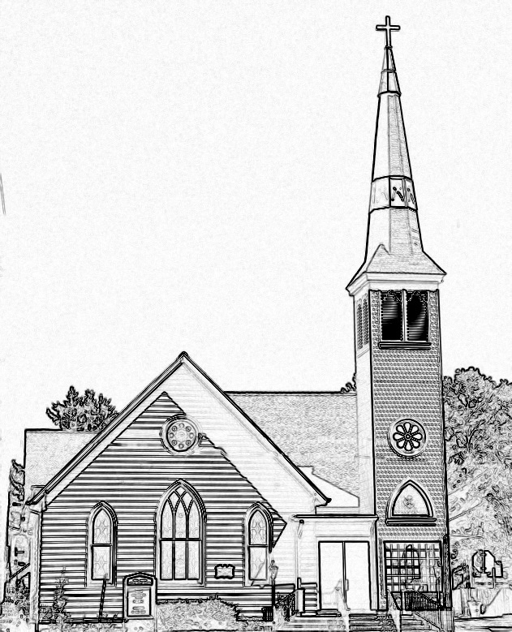

Welcome to worship! We are glad you joined us today. If you are seeking a church home, we invite you to join in the fellowship and ministry of this congregation. We look forward to seeing you again. Please fill out one of the visitor cards and drop it in the offering plate.
Prayer Concerns Carolyn Lin, Eli Chen, Meg Adams, Anne Gilchrist, Mickey Palmer, Anne Barnes

A Lenten Journey of Amazing Grace - Devotional Reading Recap From this past week's devotionals we are reminded that God's Grace is not only for ourselves but even for those we view as undeserving. It is through this gift of Grace, brought to us as a result of Christ's death and resurrection, that we are welcomed into God's eternal mansion, where death is no more, where our tears are wiped away and where all things will be made new. The earth shall soon dissolve like snow, The sun forbear to shine; But God who called me here below, Will be forever mine.
Thank you to the Ames Family for hosting coffee hour.
Reverend Monica Gould c-757-709-2846 mongould@gmail.com
Naomi Makemie 89 Market St Onancock/ Mailing Address- P.O. Box 397 Onancock, VA 23417 757-787-1331 Office Hours Wednesday 9:30-12
Staff, Elders & volunteers
Organist/Pianist-Mark Nuckols, Choir Director-Debbie Ryon, Videographer-Mike Gould, Nursery Worker-Mickey Palmer, Lead Usher-Suzanne Rogers, Clerk-Jennifer Stapleton Treasurer-George Heinrichs Elders:2025 Bill Baird, Patty Davis, Jennifer Stapleton, 2024 Ron May, Linda Arvidson, Meg Adams Class 2023 Megan Ames, Rick Turner, Marsh Ryon; NMPresChurch.org church naomimpchurch@gmail.com

This Week:
Sunday school April 2nd and 23rd
Tuesdays 5:30 pm Made with Love knitting/craft group Thursdays Choir meets at 5:00 pm
Senior Exercises with Rhudy is taking pause until May. Looking Ahead: Maundy Thursday April 6th 7:00pm, Easter Sunday April 9th with flowering of the cross. VBS meeting April 20th 4:00. Guitar service April 23rd. May 13th yard sale.

Naomi Makemie Presbyterian Church Onancock, VA
Mark Nuckols Reverend Monica Gould Debbie Ryon Organist/Pianist pastor Choir Director
April 2, 2023 Palm Sunday
*Asterisk is to stand in body or spirit. Bold print is congregational response.
Prelude
Welcome
Announcements

Choral Opening Taste and see, taste and see the goodness of the Lord. Oh, taste and see, taste and see the goodness of the Lord, of the Lord. Glorify the Lord with me. Together let us all praise God's name. I called the Lord, who answered me; from all my troubles I was set free.

Prelude

Welcome/Announcements

Choral Opening Taste and see, taste and see the goodness of the Lord. Oh, taste and see, taste and see the goodness of the Lord, of the Lord. Glorify the Lord with me. Together let us all praise God's name. I called the Lord, who answered me; from all my troubles I was set free.

Procession proclamation: Blessed is he who comes in the name of the Lord.
Hosanna in the Highest!

Call to Worship
Rejoice greatly, O daughter of Zion!
Shout, O daughter of Jerusalem!
Lo, your king comes to you;
Triumphant and victorious is he,
Humble and riding on a donkey,
On a colt, the foal of a donkey.

Opening Prayer
Everlasting God, in your tender love for the human race you sent you Son to take our nature, and to suffer death upon the cross. In your mercy enable us to share in his obedience to your will and in the glorious victory of his resurrection; through Jesus Christ our Lord, who lives and reigns with you and the Holy Spirit, one God forever, and ever. Amen.

*Opening Hymn All Glory Laud and Honor #88

Prayer of Confession

Jesus, you are our king, yet we do not act like it. You came in humility, to serve and give your life for the world. We do not follow your example. We live our own way and reject yours. We only claim allegiance to you when it’s convenient, when it serves our interests. On this Palm Sunday we are reminded of how quickly our loyalty to you diminishes. Please forgive us for our hypocrisies and apathy. Please give us passion for you as we remember your passion for us this week. Amen. Austin Hill

Words of Assurance
*Gloria Patri #579 Glory be to the Father and to the Son and to the Holy Ghost. As it was in the beginning, is now and ever shall be; world without end, amen. Amen.

*Affirmation of Faith: Apostle’s Creed
I believe in God the Father Almighty, Maker of heaven and earth. And in Jesus Christ his only son our Lord; who was conceived by the Holy Ghost, born of the virgin Mary, suffered under Pontius Pilate, was crucified, dead and buried; he descended into hell; the third day he rose again from the dead; he ascended into heaven, and sitteth on the right hand of God the Father Almighty; from thence he shall come to judge the quick and the dead. I believe in the Holy Ghost, the holy catholic church; the communion of saints; the forgiveness of sins; the resurrection of the body; and the life everlasting. Amen.

Reading Psalm 118:1-2, 9-16; Matthew 21: 1-11 Megan Ames

Anthem Wave the Palms

Sermon Your King is Coming Rev. Monica Gould

*Hymn Ride On Ride On in Majesty #91

Offering/Offertory

*Doxology Praise God, from whom all blessings flow; praise Him, all creatures here below; praise Him above, ye heavenly host; Praise Father, Son, and Holy Ghost. Amen.

*Hymn We Come as Guests Invited #517

Lord’s Supper
Invitation/Prayers of Thanksgiving & The Lord’s Prayer

The Lord be with you. And also with you.
Lift up your hearts. We lift them to the Lord.
Let us give thanks to the Lord our God. It is right to give our thanks and praise…

Our Father who art in heaven, hallowed be thy name. thy kingdom come, thy will be done, on earth as it is in heaven. Give us this day our daily bread; and forgive us our debts as we forgive our debtors; and lead us not into temptation, but deliver us from evil. For Thine is the kingdom and the power and the glory, forever. Amen

Words of Institution/Communion/Prayer after communion

*Hymn Hosanna, Loud Hosanna # 89

*Benediction

*Choral Benediction Make me a servant, humble and meek, Lord let me lift up those who are weak. And let the prayer of my heart always be, make me a servant, make me a servant, make me a servant today.

Postlude

