Naomi Makemie Presbyterian Church
December 18, 2022 Large Print
Onancock, VA
Our Mission Statement
​“Do what is fair and just to your neighbor, be compassionate and loyal in your love, and don’t take yourself too seriously—take God seriously.” Micah 6:8
Compassionate, Fair and Loyal​
nmpreschurch.org

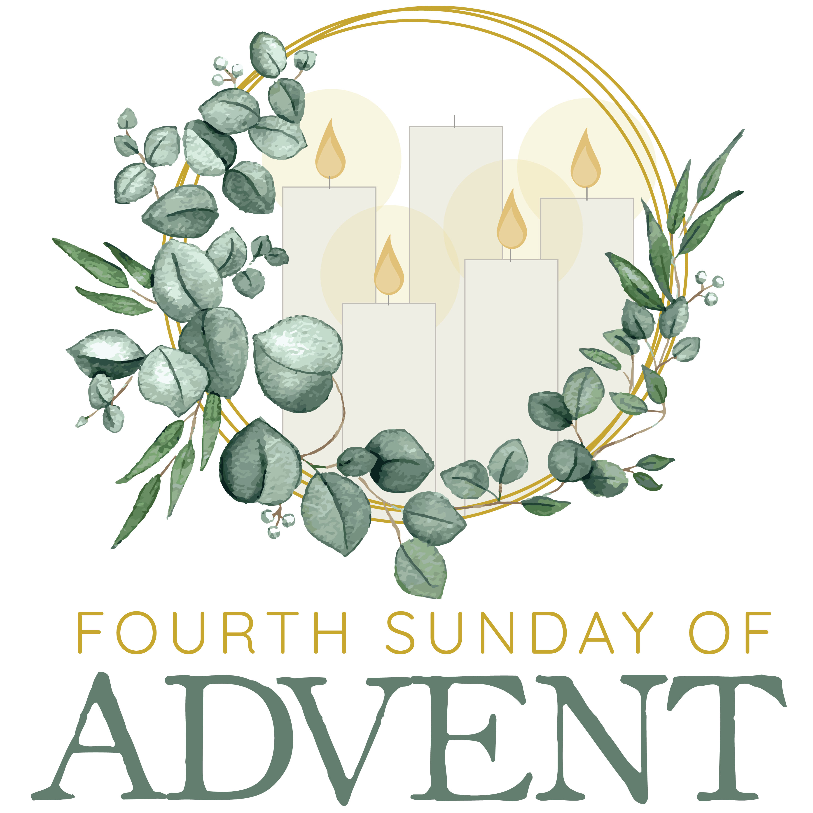

Welcome to worship! We are glad you joined us today. If you are seeking a church home, we invite you to join in the fellowship and ministry of this congregation. We look forward to seeing you again. Please fill out one of the visitor cards and drop it in the offering plate.
Prayer Concerns Carolyn Lin, Jo Penland, Eli Chen, Ginger Pruitt, James Hill, Wilma Motley, Margaret S. Joe K, Coralei Provenzano, Retta Isdell, Meg Adams, Wanda Nuckels

Ways to serve: host fellowship hour, read Scripture, lead liturgy, greet & usher, acolyte
A sign up sheet is available to add your name to read Scripture and/or host coffee hour.
Readers for Christmas Eve-There is space for five readers for Christmas Eve

Acolyte Carter Ames Fellowship host Megan Ames

Holy Communion will be served January 8, 2022 followed by potluck fellowship lunch
Ordination and installation of officers January 8.

Christmas Cookie Exchange Today
Christmas Caroling Today: leaving from NMPC at 3:45 to sing at 4pm at Commonwealth Senior Living, neighbors, and reunite at Rick Turner’s house for a party.
Christmas Eve 7pm Communion, candlelight
Christmas Day 11:00 am

This Week:
Reverend Monica Gould c-757-709-2846 mongould@gmail.com
Naomi Makemie 89 Market St Onancock/ Mailing Address- P.O. Box 397 Onancock, VA 23417
Staff, Elders & volunteers
Organist/Pianist-Mark Nuckols, Choir Director-Debbie Ryon, Videographer-Mike Gould, Nursery Worker-Mickey Palmer, Lead Usher-Suzanne Rogers, Clerk-Jennifer Stapleton Treasurer-George Heinrichs Elders:2024 Ron May, Linda Arvidson, Meg Adams Class 2023 Megan Ames, Rick Turner, Marsh Ryon; 2022 Jennifer Stapleton, George Heinrichs. NMPresChurch.org church naomimpchurch@gmail.com
Tuesdays 5:30 Made with Love knitting/craft group
Thursdays no choir
Fridays Senior Exercise with Rhudy will resume in January

Naomi Makemie Presbyterian Church Onancock, VA
Mark Nuckols Reverend Monica Gould Debbie Ryon Organist/Pianist pastor Choir Director
December 18, 2022 Fourth Sunday of Advent
*Asterisk is to stand in body or spirit. Bold print is congregational response.

Prelude
Welcome/Announcements/celebrations/concerns

Choral Opening (All are invited to sing):
While we are waiting, come; while we are waiting, come. Jesus, our Lord, Emmanuel, while we are waiting, Come.
With power and glory, come; with power and glory, come. Jesus, our Lord, Emmanuel, while we are waiting, Come.

Call to Worship Stapleton Family
The mystery of the ages is now revealed. A ruler will come from Bethlehem, and he will be the shepherd of peace. He will proclaim God’s grace and the world shall be filled with justice and love. To God be the glory forever! Amen.

Lighting of the Advent Wreath Stapleton Family
Opening Prayer & The Lord’s Prayer
Shepherd of Israel, may Jesus, Emmanuel, Sn of Mary be more than just a dream in our hearts. With the apostles, prophets, and saints, save us, restore us and lead us in the way of grace and peace, that we may bear your promise into the world. Amen.

Our Father who art in heaven, hallowed be thy name. thy kingdom come, thy will be done, on earth as it is in heaven. Give us this day our daily bread; and forgive us our debts as we forgive our debtors; and lead us not into temptation, but deliver us from evil. For Thine is the kingdom and the power and the glory, forever. Amen

*Opening Hymn Hark the Herald Angels Sing #31

Prayer of Confession
God of Grace, your eternal Word took flesh among us when Mary placed her life at the service of your will. We neglect your call to respond to your will in our lives. Forgive our arrogance. Forgive our ignorance. Forgive our apathy. By the power of your Spirit prepare our hearts that we may receive your kingdom for the sake of Jesus Christ and choose you serve you forever. Amen.
Words of Assurance

*Gloria Patri #579 Glory be to the Father and to the Son and to the Holy Ghost. As it was in the beginning, is now and ever shall be; world without end, amen. Amen.
*Affirmation of Faith Philippians 2:5-11
Christ Jesus, though he was in the form of God, did not regard equality with God as something to be exploited, but emptied himself, taking on the form of a servant, being born in human likeness. And being found in human form he humbled himself and became obedient to the point of death-even death on a cross. Therefore God also highly exalted him and gave him the name that is above every name, so that at the name of Jesus every knee should bend, in heaven and on earth and under the earth, and every tongue confess to the glory of God: Jesus Christ is Lord! Amen.

Offering/Offertory

*Doxology Praise God, from whom all blessings flow; praise Him, all creatures here below; praise Him above, ye heavenly host; Praise Father, Son, and Holy Ghost. Amen.

Christmas Program

I Hear the Prophet Calling

The Christmas story from Prophecy to Fulfillment.

A Cantata written by Pepper Choplin 2009.

A Program adapted for the congregation.

Please follow insert in your bulletin for the program

*Hymn Silent Night #60

*Benediction

*Choral Benediction

Postlude

Christmas Program

I Hear the Prophet Calling

The Christmas story from Prophecy to Fulfillment.

A Cantata written by Pepper Choplin 2009.
A Program adapted for the congregation.

Participants in today’s Program

Narration
Christopher Ames, Quinn Ames
Addison Stapleton, Logan Stapleton
Skylar Stapleton

The Prophet
A.J. Nielsen

Mary
Amelia Stapleton

Joseph
Carter Ames

Angel
Everly Stapleton

Piano/Director
Debbie Ryon

Percussion
Dave Sommerville

Flute
Diane Taylor

The Choir
Sopranos
Anne Barnes, Patty Davis
Jo Penland, Diane Taylor

Altos
Becky Everhart, Monica Gould
Joan May

Tenor
Rhudy Naylor

Bass
Mark Nuckols, Rick Turner

Part 1
Introduction
The Prophet
I Hear the Prophet Calling
Solo-Rhudy Naylor

Part 2
Darkness

The People Who Walk in Darkness

Part 3
Prophecy

Part 4
Mary & Joseph & Angel

Rockin’ Slow and Even
Solo-Diane Taylor

Part 5
Shepherds

Go Tell It;
Solo-Patty Davis

Finale
Prophecy Fulfilled

Silent Night;
Solo-Jo Penland

