My Experience at the American Wilderness Leadership School (AWLS) 2016
By Lisa Bircher, East Palestine High School (EPHS) Science Teacher

As I carefully packed my bags for AWLS, I had no idea how incredible my experience would be! I found it strange to pack gloves, hat and assorted “winter” items to make my stay comfortable. As a former Girl Scout, I did not want to be unprepared or uncomfortable. Even though it was July, I had to be prepared for ANY and ALL weather conditions.
My flight into Jackson, WY was easy enough and I was ready for a challenge. I attended AWLS with my colleague and friend, Bonnie Sansenbaugher; we were mostly hoping to get supplemental materials for teaching conservation to our Science Club and Camp students at EP Schools. Bonnie and I have previously participated in several summer professional development opportunities together (i.e. EPA Lake Guardian Shipboard Science) and they have all been great. As a result, we had very high expectations for AWLS. Bonnie and I definitely found our AWLS experience to be most excellent…even surpassing our expectations! We are excited to integrate many activities, ideas and concepts into our science teaching for the 2016-17 academic year.
When we arrived at AWLS, we were excited to find the facilities most satisfactory. Our dorm room was comfortable, the dining room was cozy (and the food was great!), the little library was fabulous, the classroom was spacious, and we were super-excited to get onto the 3-D archery course we immediately noticed. The scenery at AWLS is spectacular with all the mountains in the background and Granite Creek meandering in front of all of the lodgepole pines, aspen and sagebrush. Wildlife abounds at AWLS too. Throughout the week, we saw snowshoe hare, ground squirrels they call “chiselers,” mule deer, and even a moose with a calf at the mineral lick. The only animal missing was the grizzly bear and I was content NOT to see a grizzly bear while at AWLS!
As I am not a hunter, I was a little nervous to engage in the shooting activities at AWLS. I knew it was part of the program and it was the part I was most apprehensive about. However, the way they teach shooting and archery at AWLS is most effective. I never felt awkward or foolish when shooting any of the firearms or participating in archery (NASP training). As a matter of fact, I feel now like I could be a markswoman if I practice. Really, I am thinking about taking up archery as a hobby in the coming year. I now feel that confident!
We also engaged in outdoor survival scenarios while at AWLS. It was so much fun to hike out a little ways and create a shelter, obtain water from Granite Creek, build a fire and boil the water, all while being on-alert for the ever curious “bear”. They even gave us bear spray to use on the interested “bear.” On a personal note, I have done my fair share of camping in Ohio and I have never been able to start a fire as fast as I did at AWLS! It was almost effortless using the techniques they taught for quick and efficient fire starting.
We had “Wildlife Ecology” college classes while at AWLS. Our professor was a tall, young man from Texas A&M University-Kingsville by the name of Dr. Fidel Hernandez. He insisted on being called just “Fidel” and he was most engaging and very personable. His lectures were interesting and he sure could tell some funny stories when he saw we were losing concentration. I really enjoyed his classes as I took copious notes.
The field trips at AWLS were just the best too. We went to the Granite Hot Springs Pool, Jackson, Pinedale, The Grand Teton’s National Park and even whitewater rafting on the Snake River! All the trips were so interesting and replete with special guest experts on a variety of topics from the oil and gas fields to the importance of hunting and fishing in the North American Model of Wildlife Conservation. We even engaged in some really fun Project Wild Activities I really liked. To me, the funniest was this game “Oh Deer” that simulates the changes in deer population based on a variety of variables. I really enjoyed getting “killed” by a car with another one of my classmates during that game that we played at the park in Pinedale. It was fun to have the people in the park that day watch us “adults” playing the game and laugh at us. Good times!
To me, the most significant part of my AWLS experience is the confidence I have gained in my ability to do activities outside of my comfort zone. Because AWLS is located at an elevation of 7,000 feet, you have this “heady” and “giddy” feeling the entire time you are there. No alcohol needed to achieve this sensation! I so enjoyed walking the Forest Loop Road in the morning (even though it took my breath away.) I loved interacting with a stellar group of educators and the staff were super professional while portraying a caring and fun-loving demeanor. I do not think I have ever been at a professional development for teachers that was so finely orchestrated and scheduled seemingly without a glitch.
I want to go back to AWLS right now and I hope this feeling will not fade. So, I thank you East Ohio Northwest Penn Chapter of SCI for supporting me in my professional development in the summer of 2016. It is one I will never forget!
I wrote this poem about my experience at AWLS and I want to share it with you. If you go to AWLS, I know you will understand. Also, below are some photos from my experience.

AWLS July 15, 2016 (A Poem)

Eyes sparkle like “Granite Creek”
My heart in a piece of home.
Fully engaged with passion abound.
Love with hope; experience with depth.
An ethic of care with much to give.

“Open Door” to the sky, what can I do?
To see is to understand nature…
Swimming in your eyes,
Glistening like the snow!

Beyond “Trapper’s Point”
Meet me at the pass?
Imagine a bright future beyond those hills.

To make a difference in all we do—
To pass this work to the children
And tell our stories, share these gifts.

All while fully alive and acutely aware!

Photos:
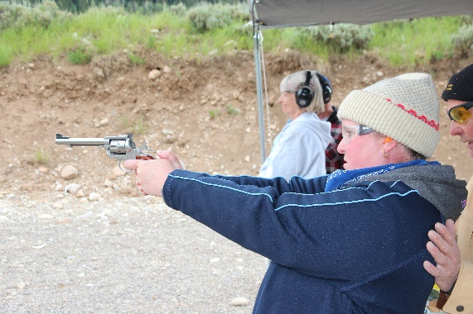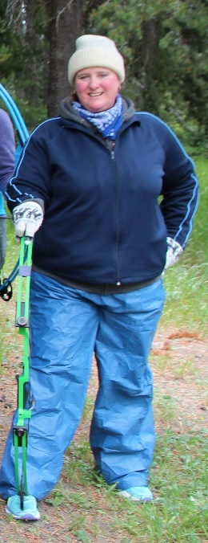
Lisa shooting the pistol Lisa at the 3-D archery range

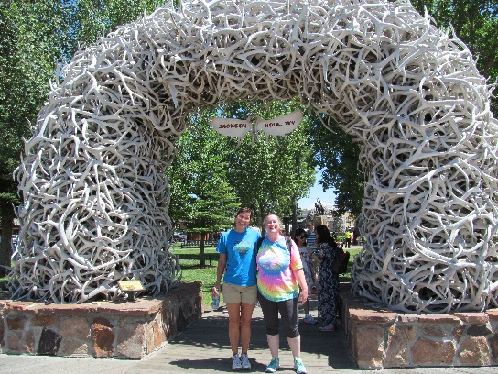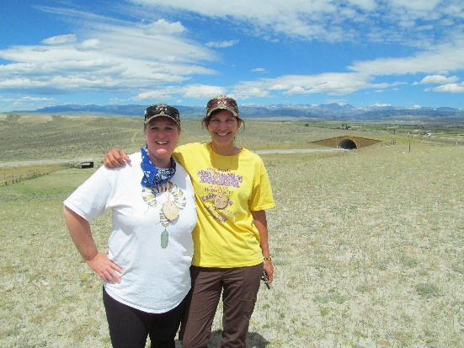

Bonnie and Lisa in Jackson, WY Lisa and Bonnie at Trapper’s Point near Pinedale, WY

