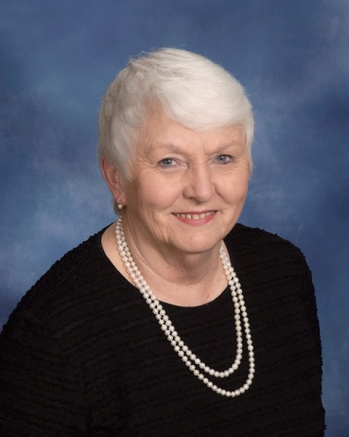 | Adams, Faye  172 Highland Drive  Greenwood, SC 29648  (864) 229-3199
Adams, Sherri
Sarah-Kathe, Graham
102 Rock Knoll Drive #6
Greenwood, SC 29649

Adams, Tony
307 Manning Road
Greenwood, SC 29649

Addis, Kevin & Leigh
Caroline, Cameron
207 Cheekwood Road
Greenwood, SC 29649

Addy, Frank, Jr. & Kelly
Robert, Grayson
106 Arthur’s Point
Greenwood, SC 29649

(864) 223-3714

Addy, Mary Kay
105 Stratford Road
Greenwood, SC 29649

(864) 223-4512

Alexander, Jennifer
Grant, Katelyn Miller
242 Dry Branch Court
Greenwood, SC 29649

(864) 93-7762

Alexander, Jonsie
Grant, Katelyn Miller
574 Hwy. 185 S.
Donalds, SC 29638

(864) 379-8583

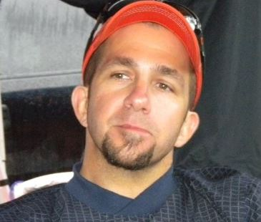 | Alexander, Keith  1103 Northlake Drive  Greenwood, SC 29649  (864) 9292-3083  keithalexander88@yahoo.com
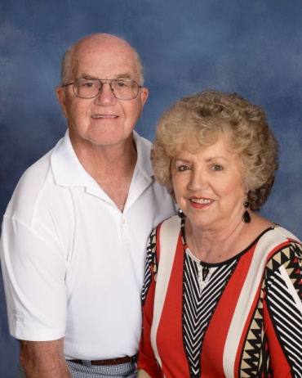 | Alexander, Kirk, Sr. & Judy  128 Rutledge Road  Greenwood, SC 29649  (864) 223-6268  judykirk01@nctv.com
Alexander, Terri
Trey III,Tori
131 Lauren Circle
Greenwood, SC 29649

Alverson, Jr., Sarah
Greenwood, SC 29649

Anderson, Don and Jamie
Lauren
942 Sunset Drive
Greenwood, SC 29649

(864) 993-1677

Anderson, Mary Ellen
1830 Alexander Road W.
Greenwood, SC 29646

(864) 223-5275
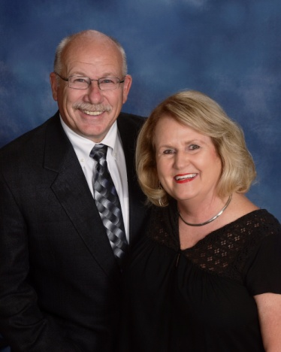 | Anderson, Neil & Maree  102 St. Augustine Drive  Greenwood, SC 29649-3210  (864) 223-8818  nmanderson@embarqmail.com
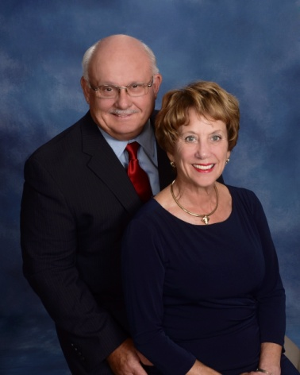 | Arnett, Cliff & Carol  707 Swing About  Greenwood, SC 29649  (864) 223-1018  cliffarnett@earthlink.net
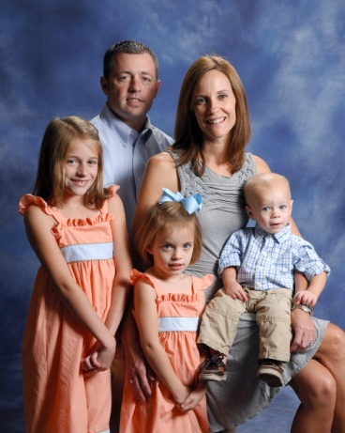 | Arnold, Jason & Elizabeth  Emma Grace, Eva, Davis  115 PC Jean Road  Ninety-Six, SC 29666  (864) 980-5496  elizabethjo@embarqmail.com
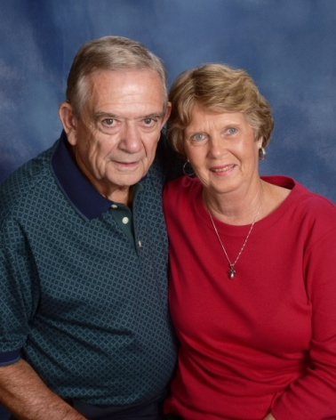 | Arnold, T.R. & Bobbie  2497 Hwy. 72 E.  Abbeville, SC 29620  (864) 229-2974  Barnold001@centurylink.net

Arnoti, Justine
]802 W. Deadfall Road
Greenwood, SC 29649

(864) 229-9075

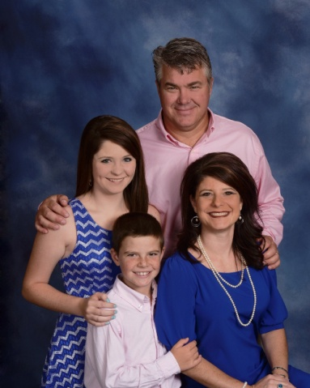 | Ashley, Keith & Amy  Kellynn , Hampton  118 Puckets Pointe Road  Greenwood, SC 29649  (864) 554-4926  Amy.safehousevalve@gmail.com
Ashley, Sonan
105 Ashley Lane
Greenwood, SC 29649

(864) 223-1683

Attaway, Talmadge & Denise
Crystal, Tammy
221 Park Street
Ninety-Six, SC 29666

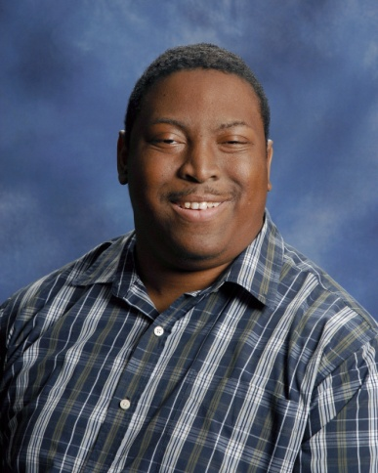 | Austin, Tim  119A S. Hospital Street  Greenwood, SC 29646  (864) 358-1191
Babb, Bootsie
106 Coosaw Run
Greenwood, SC 29649

(864) 223-8775

Babb, John & Sue
116 Charles Street
Greenwood, SC 29649

(864) 993-8768

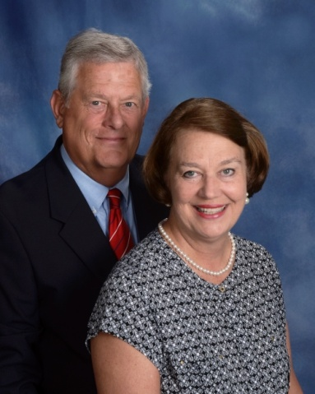 | Babb, Waddy & JoAnne  364 Tranquil Road  Greenwood, SC 29646  (864) 229-6932  wandjbabb@centurylink.net
Bailey, Jim & Johnnie
112 St. Andrews Lane
Greenwood, SC 29646

(864) 229-4794

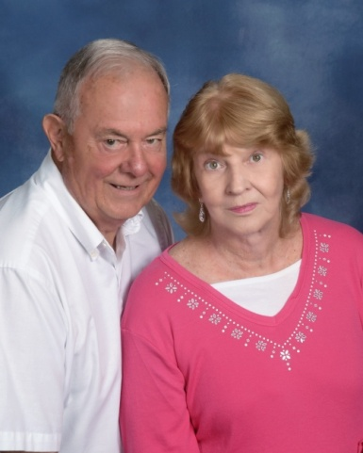 | Bailey, Robert & Carolyn Bolan  312 Nautical Way  Greenwood, SC 29649  (864) 223-3839  cpbolan@aol.com
Baker, Wendy
Coleton Lollis, Lawson
100 Westwood Road
Abbeville, SC 29620

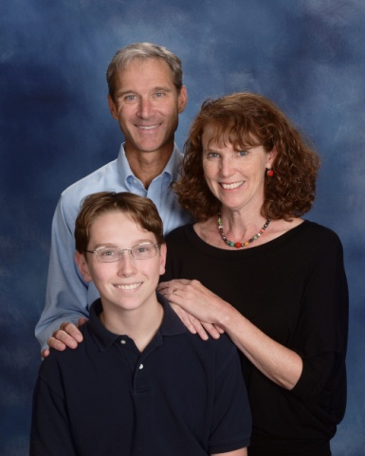 | Ball, Richard & Martha  Danny  205 Harvest Lane  Greenwood, SC 29649  (864) 388-0939  martha@rmbhome.net
Bartley, Mike & Pam
120 Queens Court
Greenwood, SC 29649

(864) 223-3303

Bass, Beth
120 Laurel Avenue W.
Greenwood, SC 29649

(864) 223-3233

Bass. Jonathan & Stacey
120 Laurel Avenue W.
Greenwood, SC 29649-1543

(864) 223-3233
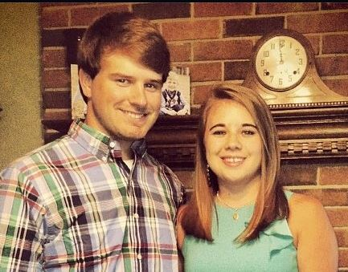 | Beale, Jr., John & Kayla  Unknown  kaylaechrisley@gmail.com
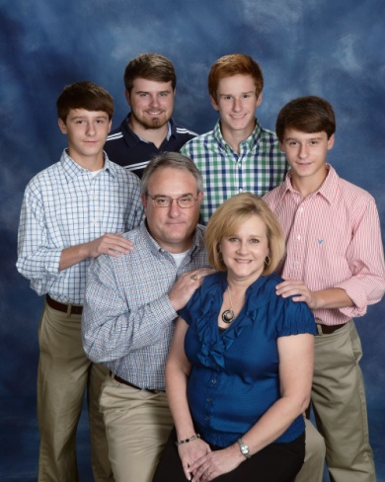 | Beale Sr., John & Beth  John Edward, Zachary, Chase, Chandler  108 Woodridge Road  Greenwood, SC 29646  (864) 229-0692  beales@nctv.com
Bean, Steve & Beth
11 Daly Place
McCormick, SC 29835

(864) 391-8381

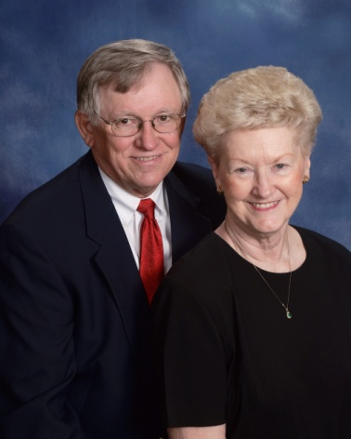 | Bearden, Dannie & Gloria  320 Compass Point  Ninety-Six, SC 29666  (864) 941-0690  gloria_bearden@embarqmail.com
Beardsley, Tom & Donna
226 Chatham Drive
Greenwood, SC 29649

(864) 992-5795

Beauford Jr., John & Susan
John Robert, Blake
225 Edgewood Drive
Abbeville, SC 29620

(864) 446-2278

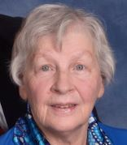 | Bedenbaugh, Jean  512 Marietta Drive  Greenwood, SC 29646  (864) 223-6705  jeanjerry@embarqmail.com
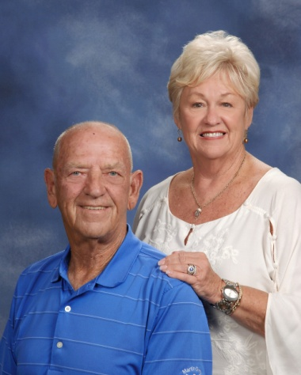 | Bell, Jimmy & Cheryl  27 Curltail Road  Abbeville, SC 29620  (864) 993-5003  cbell@lander.edu
Bell, Tammy
109 Curltail Road
Abbeville, SC 29620

(864) 229-6703

Bettis, Chad & Jami
Will
106 N. Hill Court
Hodges, SC 29653

(864) 223-8895

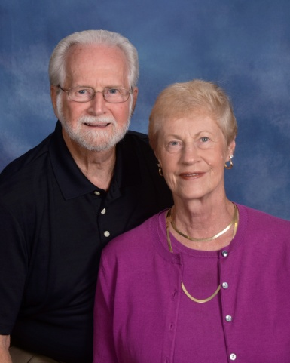 | Bickerton, Tom & Miriam  109 Runnymeade Court  Greenwood, SC 29649  (864) 227-9761  tandmbickerton@embarqmail.com
Bishop, Cary & Beth
Matthew
111 Creekside Court
Greenwood, SC 29649

(864) 229-2017

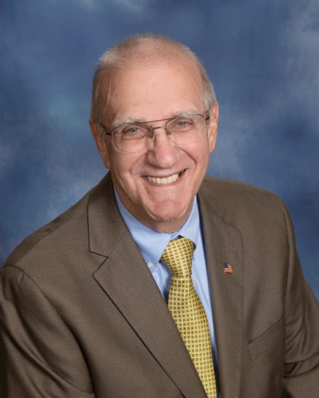 | Blackburn, Wayne  101 Pin Oak Drive  Greenwood, SC 29649  (864) 992-7736  wblackburn@centurylink.net
Blake, Marilyn
101 Rivers Way
Abbeville, SC 29620

(864) 943-0661

Blakely, Hope
223 Woodlawn Street
Greenwood, SC 29649

Bledsoe, Scott & Lisa
Evan, Meredith
118 Sand Trap Lane
Greenwood, SC 29649

(864) 554-5606
Lbledsoe0404@gmail.com

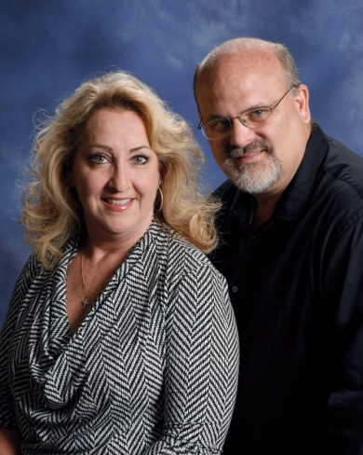 | Boazman, Joe & Sandi  202 Evergreen Drive  Greenwood, SC 29649  (864) 554-9463  boazman@nctv.com
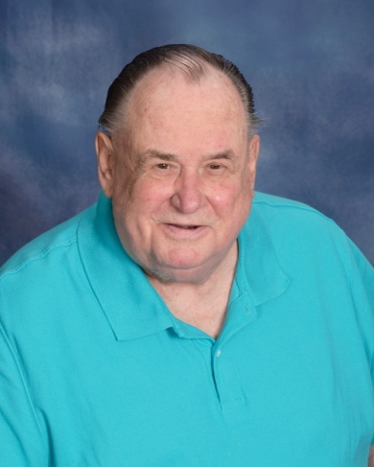 | Boehling, Hank  109 Patriot Pointe Court  Ninety-Six, SC 29666  (864) 980-8361  hank1238@embarqmail.com
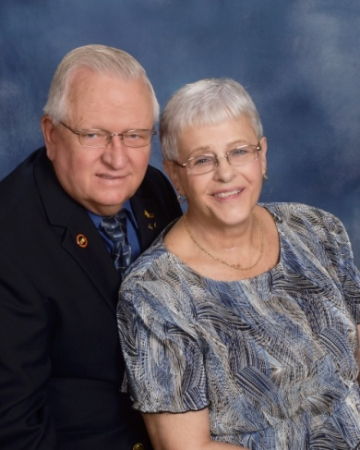 | Boerger, John & Donna  106 Culbertson Court  Greenwood, SC 29649  (864) 980-8361  boergerh@nctv.com
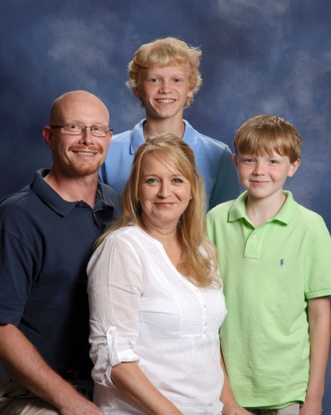 | Boggs, Benji & Kristi  Parker, Evan  144 Kensington Drive  Greenwood, SC 29649  (864) 993-5741  boggk@gwd50.org
Boggs, Lauren
5222 Hwy. 185
Hodges, SC 29653

(864) 223-1168

Boggs, Scott
103 Gentry Run
Greenwood, SC 29649

Bond, Susan
P. O. Box 1092
Abbeville, SC 29620

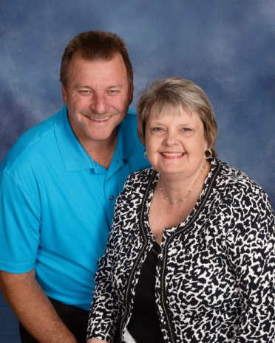 | Boone, Jerry & Kim  214 Curl Creek Road  Greenwood, SC 29649  (864) 223-9486  kwbridges@hotmail.com
Bosler, Kevin & Sandra
78 Rivers Way
Abbeville, SC 29620

(864) 941-6180

Bouknight, Mike & Sherry
Brittany, Daniel
208 Salak Road
Greenwood, SC 29646

(864) 229-1622

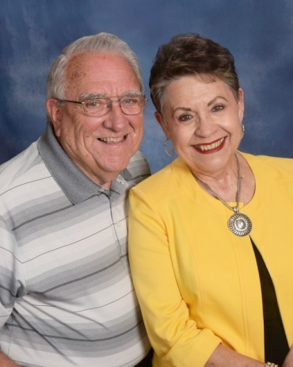 | Bowers, Elbert & Bobbie  120 Orchard Park Drive  Greenwood, SC 29649  (864) 227-0868  bobbiebowers@hotmail.com
Boyd, Laura
Jack, Sam
202 Hutson St.
Greenwood, SC 29649

(864) 980-1880
lboyd@greenwoodeyeclinic.com

Boyer, Dale & Ginger
299 Circle Drive
Greenwood, SC 29646

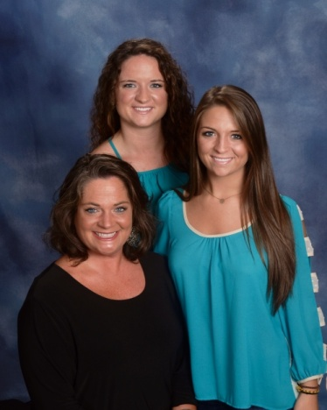 | Bradley, Kayce  Jordan, Grae  310 Belle Meade Road  Greenwood, SC 29649  (864) 550-0118
Braid, Ted & Jacqueline
728 Eagles Harbor Drive
Hodges, SC 29653

(864) 374-7651
tejac@aol.com

Brandt, Dave & Janet
107 Luton Place S.
Greenwood, SC 29649

(864) 229-3427

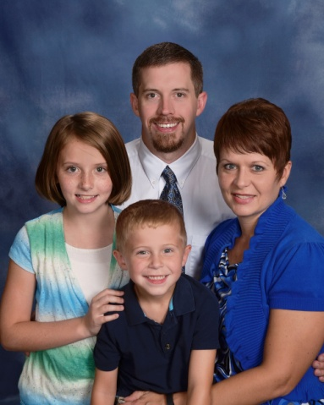 | Branyon, Cal & Nicole  Amaris, Cooper  1106 Jefferson Street  Greenwood, SC 29646  (864) 344-4033  a11504maris@gmail.com
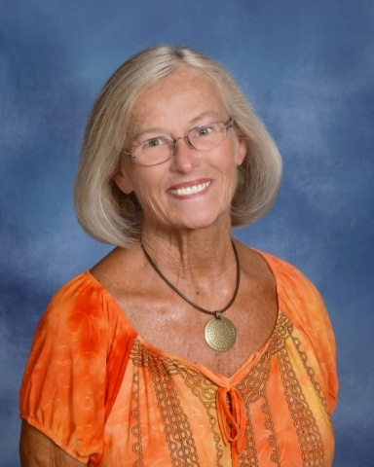 | Braxton, Judie  109 Sheffield Road  Greenwood, SC 29646  (864) 992-4661
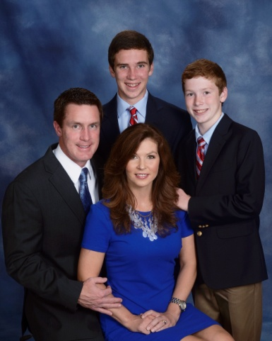 | Brewington, Tyler & Sheri  Mathis, Trevor  207 Windtree Road  Greenwood, SC 29649  (864) 388-7802  twinkletoesspb@yahoo.com
Brock, Randy & Edie
520 Clem Road
Greenwood, SC 29649

Brogan, Steve & Barb
Emily, Joseph
]403 Jennings Avenue
Greenwood, SC 29649

(864) 388-2109

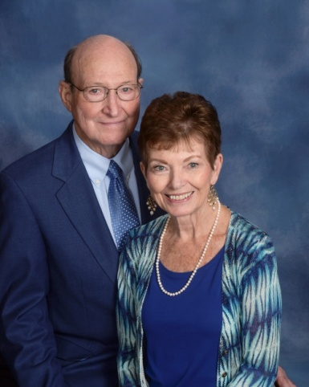 | Broome, Budgie & Ann  1139 Frazier Road  Ninety-Six, SC 29666  (864) 543-1550  abroome41@embarqmail.com

Brothers, Harriett
Mary Fran McCammon
220 Creek Boulevard N.
Greenwood, SC 29649

(864) 223-5809

Brown, Chris & Shelia
Sydney, Brantlee
116 St. Andrews Lane
Greenwood, SC 29646

(864) 943-0307

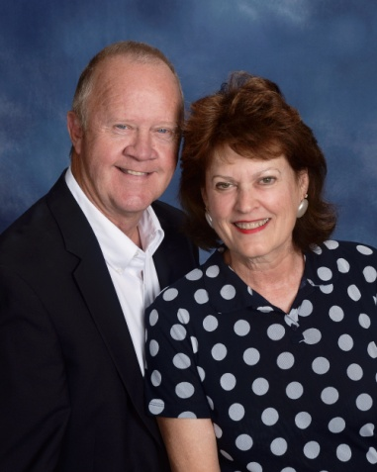 | Brown, Dubie & Fran  Wes Westbrook, III  112 River Birch Court  Greenwood, SC 29649  (864) 942-0797  franbrown112@gmail.com
Brown, Ed
419 Stonewood Drive
Greenwood, SC 29649

(864) 223-5627

Brown, Jerry
125 Heathwood Drive
Greenwood, SC 29649
(864) 227-3711

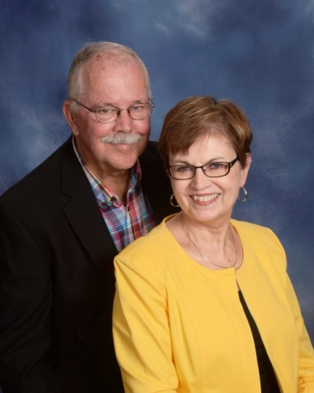 | Brown, Jim & Jean  105 Reid Court  Hodges, SC 29653  (864) 992-9959  jeabro@centurylink.net
Brown, Tommy & Maxine
Alana
226 Greenway Drive
Greenwood, SC 29649

(864) 229-2003

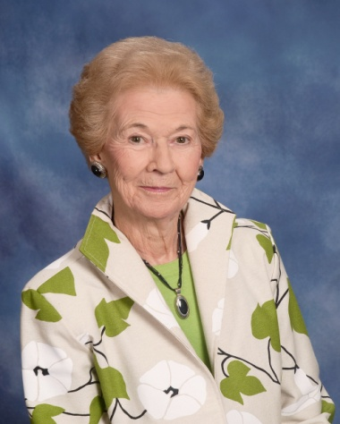 | Brown, Wini  Wesley Commons  1110 Marshall Road  Greenwood, SC 29646  (864) 330-1310
Brownlee, Beth
1110 Northlake Drive
Greenwood, SC 29649

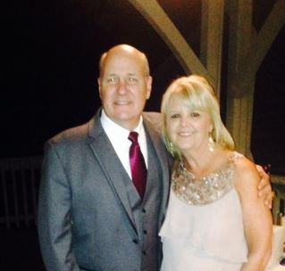 | Bruce Sr., Wilson & Cyndi  Will, Motsy, Winston, Derek  115 Culbertson Court  Greenwood, SC 29649  (864) 223-2883
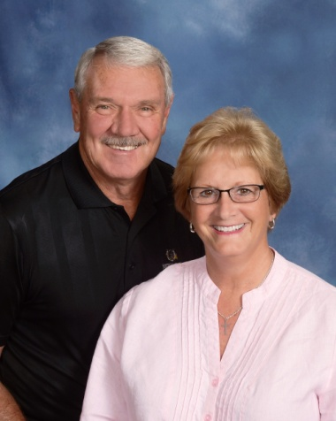 | Bryant, George & Jane  122 Folly Bend Drive  Greenwood, SC 29649  (864) 538-4556  janej23@nctv.com

Buckshorn, David & Kelly
Abby, Will, Benjamin
108 Northwoods Road
Greenwood, SC 29649

(864) 223-4890

Bundrick, Chad & Laura
Reese, Kate, Ben, Luke
104 Milford Springs Road
Greenwood, SC 29649

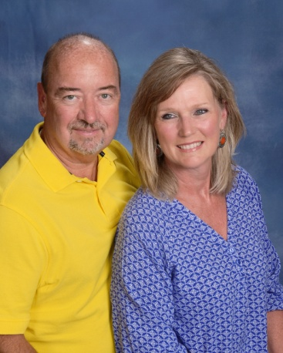 | Burch Jr., Carroll & Deb  716 Fairway Lakes Road  Greenwood, SC 29649  (864) 942-9686  dqburch@yahoo.com
Burch, Jacob & Amie
Leah, Sawyer
129 Limerick Road
Greenwood, SC 29649

(864) 992-2151
amielee01@yahoo.com

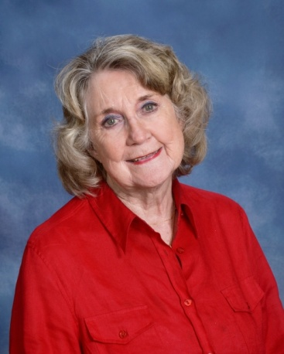 | Burch, Jean  103 Dorsey Court  Greenwood, SC 2949  (864) 223-9667  Jeanburch32#gmail.com

Burch, Jr., Susan
103 Lands End
Greenwood, SC 29649

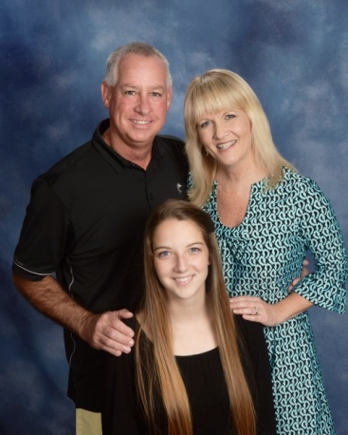 | Burke, Jimmy & Tracey  Raine Templeton  833 Callison Road  Bradley, SC 29819  (864) 910-2882  titb70@yahoo.com
Burton, Beverly
Burton Runyan, Wesley Runyan
211 Melrose Terrace
Greenwood, SC 29649

(864) 223-1676

Burton, Jimmy & Linda
412 Tranquil Road
Greenwood, SC 29646

(864) 229-1969
lindakennedyburton@gmail.com

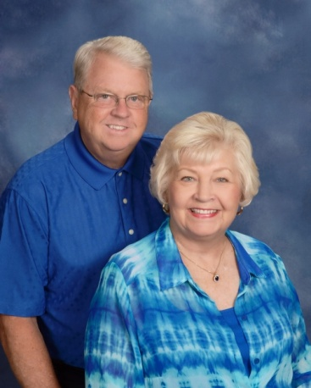 | Burton, Tommy & Patty  208 Sheffield Road  Greenwood, SC 29646  (864) 223-5556  alagrane@nctv.com
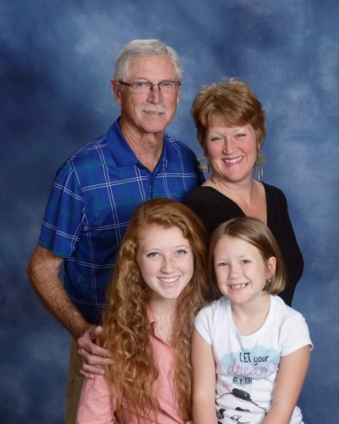 | Burton, Wayne & Paula Prince-Burton  Aylah Burton, Lily Prince  105 White Oak Lane  Greenwood, SC 29646  (864) 227-8032  bigdogsandgraydays@yahoo.com
Butler, Jack & Gail
Jarrett
103 Tally Ho Drive
Greenwood, SC 29649

(864) 223-6461

Cade, Katherine
111 Lilly Lane
Greenwood, SC 29649

Calvert, Derrell
117 Wingard Street
Ninety-Six, SC 29666

Camp, Bill & Denise
Drew Stockman, Jeremiah, Isaiah
205 Chatham Drive
Greenwood, SC 29649

(864) 942-0282

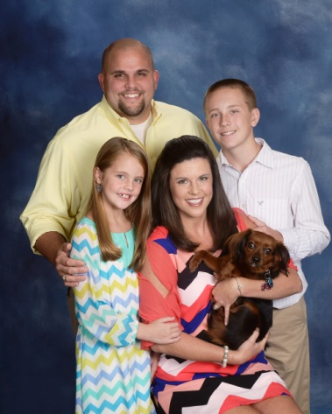 | Camp, Hugh & Twyla  Garrett Luquire, Kylie, Pippa  109 Old Oak Drive  Greenwood, SC 29649  (864) 229-3626  twylamh@yahoo.com
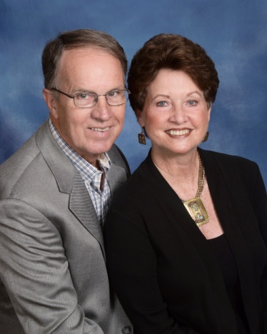 | Campbell, Joe & Dale  103 Hampton Road  Greenwood, SC 29649  (864) 223-5827  joeanddale@gmail.com
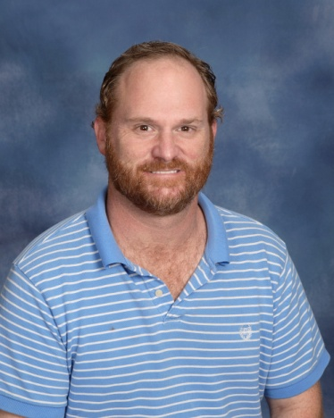 | Campbell, Josh  151 Kate Way  Greenwood, SC 29646  (864) 321-3538
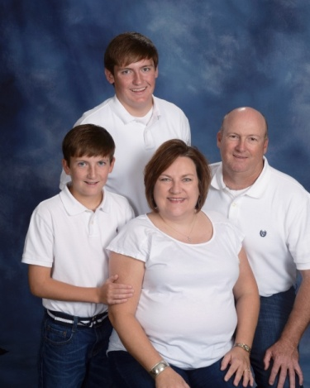 | Campbell, Ken & Dena  Jake, Tyler  310 Dukes Avenue  Greenwood, SC 29646  (864) 229-0912  denacampbell@embarqmail.com
Campbell, Kevin & Christa
Kylie, Kaylynn
110 Bee Pond Road
Ninety-Six, SC 29666

Campbell, Rev. Taylor & Joyce
101 Shannon Street
Greenwood, SC 29646

(864) 942-0414

Case, Steve & Rachel
Sydney, Taylor
110 Wagon Tree Lane
Greenwood, SC 29646

(864) 992-9154

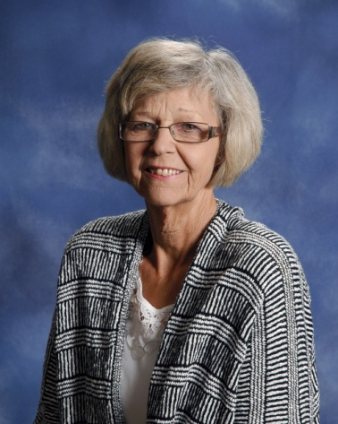 | Cawood, Sandra  222 Autumn Trace  Greenwood, SC 29649  (864) 388-0960
Chandler, Jan
318 Heritage W. Court
Greenwood, SC 29649

(864) 223-0571

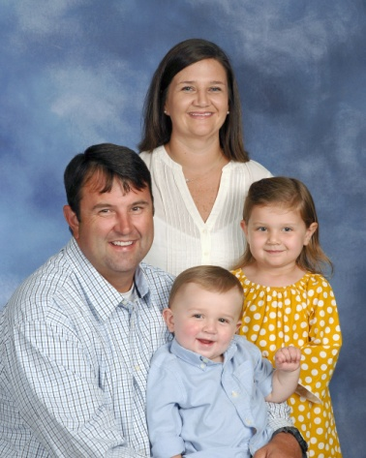 | Chapman, Corey & Jessica  Addi Grace, Tucker  206 Wentworth Drive  Greenwood, SC 29649  (864) 91-05522
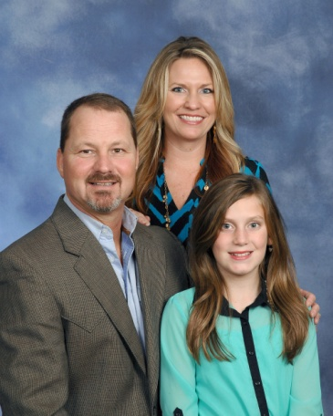 | Chappell, Tommy & Windy  Savannah Mallon  103 Ridge Pointe  Greenwood, SC 29649-8765  (864) 992-2487  windychappell@yahoo.com

Christenson, Marvin & Lorraine
625 Fairway Lakes Road
Greenwood, SC 29649

(864) 227-3740

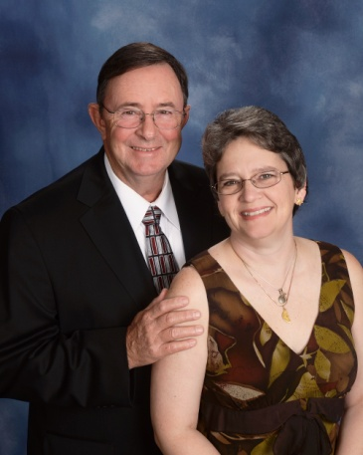 | Christian, Grover & Teresa  614 Salak Road  Greenwood, SC 29646  (864) 2278227  chrisfam@embarqmail.com
Clamp Jr., Vernon & Glynnis
Lauren
1124 Northlake Drive
Greenwood, SC 29649

(864) 538-0345

Clark, Ben
314 Marietta Drive
Greenwood, SC 29646

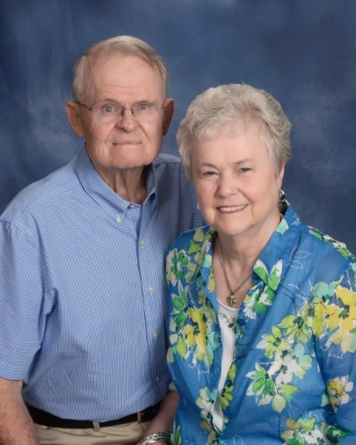 | Clark Jr., Colonel Niles & Ruth  119 Tryon Court  Greenwood, SC 29649  (864) 223-0860  clarkr384@yahoo.com
Clark, Elizabeth
811 Old Calhoun Falls Road
Abbeville, SC 29620

(864) 3911676

Clark, Eric
124 Anderson Drive
Greenwood, SC 29646

(864) 871-3109

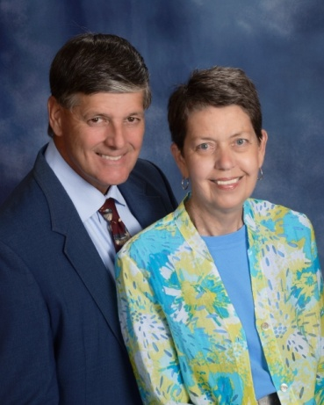 | Clegg, Tom & Anne  1340 Calhoun Road  Greenwood, SC 29649  (864) 229-2395  tomclegg@embarqmail.com
Clem, Chris & Sudie
Sudie, Macy
101 Thornblade Drive
Greenwood, SC 29649

(864) 227-2699

Cobb, Ken & Leslie
Kensley
5225 Hwy 185
Hodges, SC 29653

(864) 374-3314

Coker, David
106 Durst Avenue W.
Greenwood, SC 29649

Coleman, Bill & Gay
Tara
P. O. Box 17
Hodges, SC 29653

(864) 980-1430

Collin, Robert
111 Siloam Acres Drive
Greenwood, SC 29646

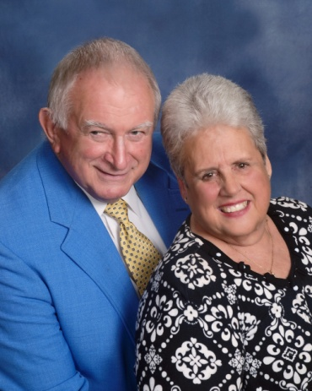 | Conley, Jim & Dodie  402 Heritage W. Court  Greenwood, SC 29649  (864) 389-1230  Drcc27@gmail.com
Cook, Ron & Karen
120 Luton Place N.
Greenwood, SC 29649

(864) 943-0561
kkcook@nctv.com

Cooley Jr., Fred & Linda
Chris
109 Wimbledon Court
Greenwood, SC 29646

(864) 229-9458

Coon, Michael & Nancy
515 Pascal Drive
Greenwood, SC 29649

(864) 554-7927
coon.m@ptc.edu

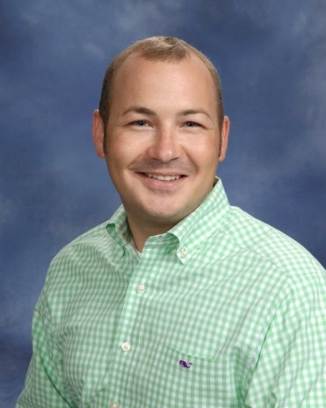 | Corley, Joseph  325 W. Cambridge Avenue  Greenwood, SC 29646  (864) 993-9073  josephcorley@live.org
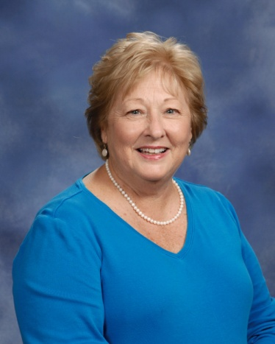 | Corley, Nancy  314 Curl Creek Road  Greenwood, SC 29649  (864) 941-6891
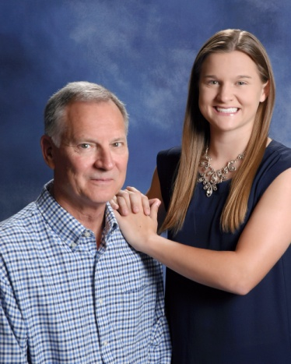 | Corriher, Doug  Emily  101 Mayapple Street  Greenwood, SC 29649  (864) 992-0074
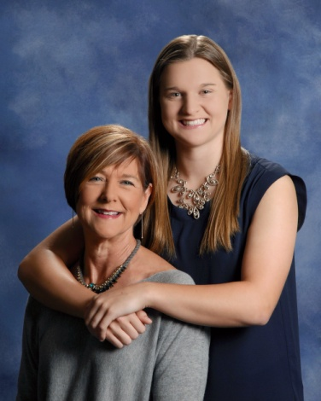 | Corriher, Judy  Emily  321 Gatewood Drive, A-4  Greenwood, SC 29646  (864) 993-1526
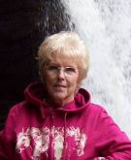 | Coursey, Nancy  206 Haltiwanger Road  Greenwood, SC 9649  (864) 229-0069
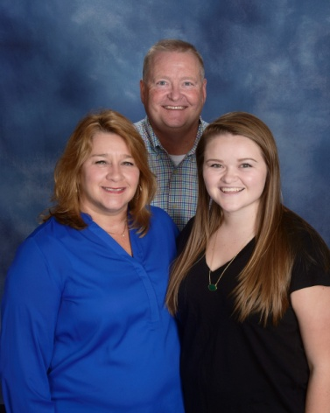 | Coyle, Frank & Holley  Maddie  130 Hatchers Pass  Greenwood, SC 29646  (864) 223-5572  holleycoyle@yahoo.com
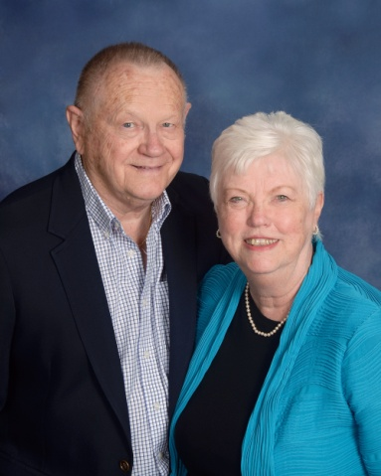 | Crane, George & Betty  1110 Marshall Road  Greenwood, SC 29646  (864) 227-7314  crane2569@mywesleycommons.org
Crawford, Dan & Lisa
Hannah, Rachel
107 Appaloosa Lane
Greenwood, SC 29646

(864) 942-2573

Crenshaw, Roger & Dana
Jason, Robin, Matthew
102 Timberlane Drive
Greenwood, SC 29646

(864) 229-6048

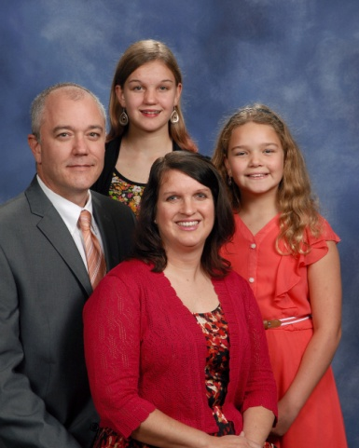 | Creswell, Jonathan & Jennifer  Jasmine, Julia  1107 Saddle Hill Road  Greenwood, SC 29646  (864) 229-3802  jsc41297@gmail.com
Cronic, Ray
216 Stewart Landing
Boiling Springs, SC 29316

Crosby, Tripp & Taylor
5221 Hwy. 185
Hodges, SC 29653

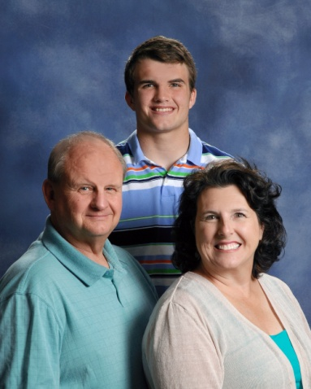 | Crowder, Doug Jeanine  Steven  107 Nabors Road  Hodges, SC 29653  (864) 456-3308
Cullens, Doug & Katie
Rylie, Reece
108 Timber Lane
Greenwood, SC 29646

(864) 992-7082

Cullens, Kevin & Shannon
Patrick, Catalin
248 Oak Ridge Drive
Greenwood, SC 29649

(864) 344-8828

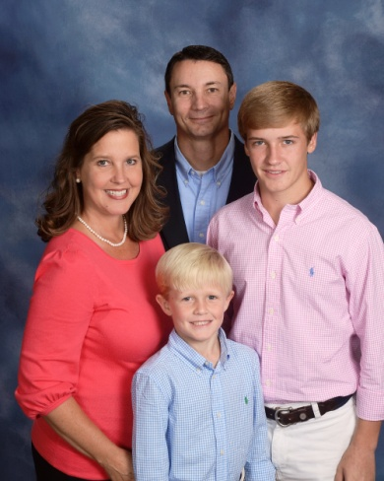 | Dalton, Todd & Connie  Thomas, Matthew  101 Bridle Court  Greenwood, SC 29646  (864) 223-7070  tdalton@fujifilm.com
Daniels, Bob & Judith
1220 Devonshire Road
Coatesville, PA 19320

Davenport, Carole
133 Meadow View Lane
Greenwood, SC 29649

(864) 227-8691

Davis, Adrian
120 Hammond Road
Greenwood, SC 29646

(864) 229-4819

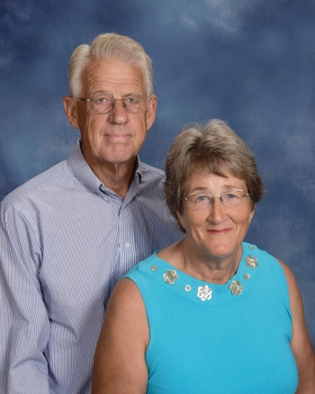 | Davis, Harlan & Kay  110 Greenside Drive  Greenwood, SC 29649  (864) 992-0033  kdavismallardct@gmail.com

Davis, Katherine
120 Hammond Road
Greenwood, SC 29646

(864) 229-4819

Davis, Stephen & Reva
Laniey, Jacob
308 Fawnbrook Drive
Greenwood, SC 29646

(864) 223-5919

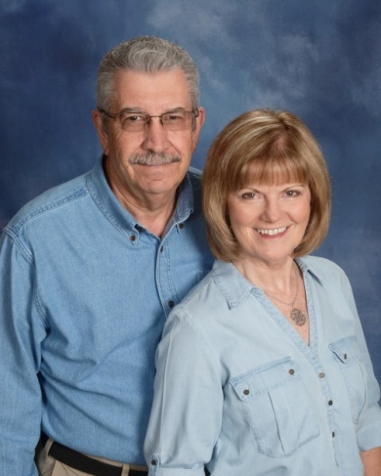 | Dean, Jay & Jeanie  110 Kings Grant Lane  Greenwood, SC 29649  (864) 388-9023  jaydean@embarqmail.com
Dean, Sarah
204 Gracemount Drive
Greenwood, SC 29649

Decker, Jim
434 S. Mill Road
Greenwood, SC 29646

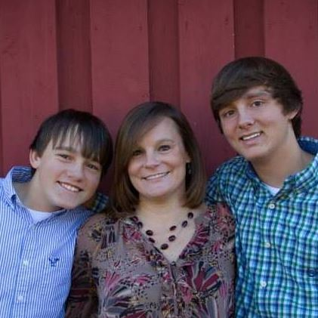 | Deloach, Beth  Hunter, Dylan  213 Saco Avenue  Greenwood, SC 29646

Deloach, Lamont
119 Anderson Drive
Greenwood, SC 29646

(864) 229-0454

Descoteaux, Roger & Cheryl
1225 Mathis Road, Unit 14
Greenwood, SC 29649

Dickey, Cameron & Amy
Chandler, Peyton
204 Charles Road
Greenwood, SC 29649

(864) 227-1791

Dixon, Jack & Dottie
512 Heritage W. Court
Greenwood, SC 29649

(864) 223-0447

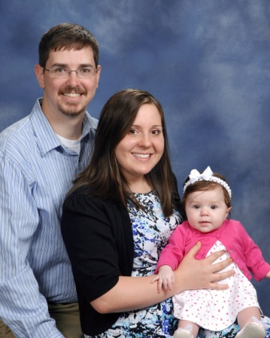 | Dominick, Henry & Kim  Olivia  102 Phoenix Road  Greenwood, SC 29646  (803) 271-2638  kimhdominick@gmail.com
Dorn Sr., Mike
132 Crescent Road
Greenwood, SC 29649

(864) 229-1946

Dorn, Rickey & Ana
Braydyn
435 Grove Street
Greenwood, SC 29649

(864) 227-3523

Dorroh III, Griff
105 Summit Street
Greenwood, SC 29649

Dorroh II, Noah
105 Pine Needle Lane
Greenwood, SC 29649

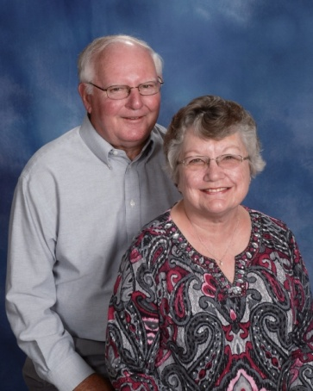 | Dorroh Jr., Olin & Kathy  202 Locksley Drive  Greenwood, SC 29649  (864) 223-4479  godorroh111@embarqmail.com
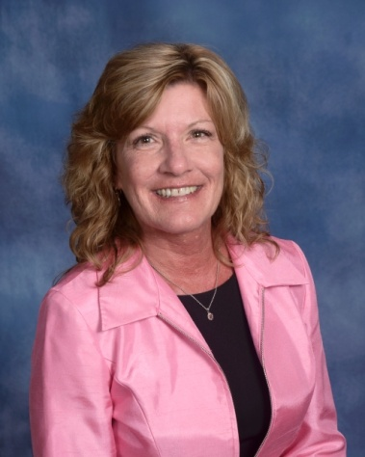 | Dorroh-Byrd, Dena  215 Eastman Drive  Greenwood, SC 29649  (864) 943-9122  dena.byrd@dcrotts.com
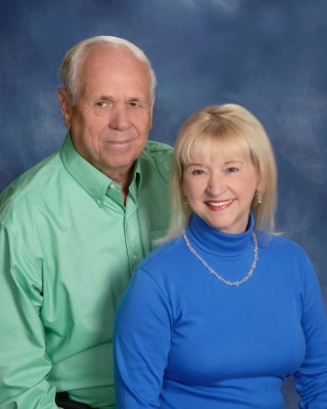 | Durden III, George & Mary  111 Westgate Drive  Greenwood, SC 29646  (864) 223-7685  gdurdeniii@aol.com

Eaddy, Jay & Sherrill
Sara Grace, Anna Kate
107 Wenmount Court
Greenwood, SC 29646

(864) 942-0879

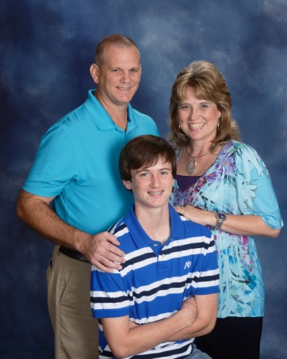 | Ebert, Frank & Angela  Ryan  132 Limerick Road  Greenwood, SC 29649  (864) 980-4952  ebertfw0319@yahoo.com
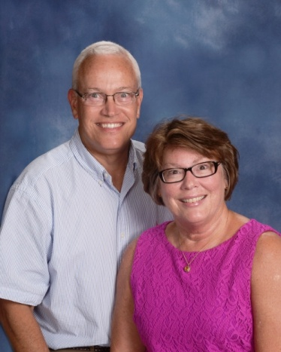 | Elliott, David & Karen  108 Greenside Drive  Greenwood, SC 29649  (864) 993-8089  dbelliott75@gmail.com
Ellis, Angie
P. O. Box 49803
Greenwood, SC 29649

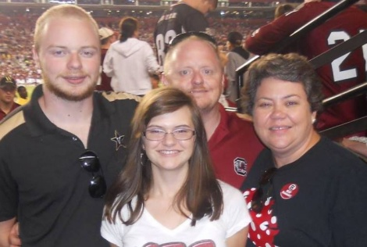 | Elmore Jr., John and Kay  JC, Hannah  308 Clairmont Drive  Greenwood, SC 29649  john@stmarkgreenwood.com
Engeler, Marc & Jami
4701 Hwy 25 S
Greenwood, SC 29646

Engeler, Sharon
Davis
5 Crystal Springs Road
Apt 250
Greenville, SC 29615

Eppelsheimer, John
Unknown

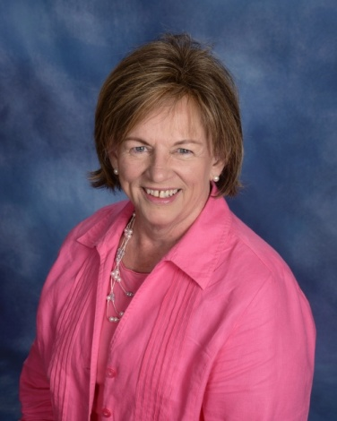 | Eppley, Pinka  122 Pin Oak Drive  Greenwood, SC 29649  (864) 380-6109  pinkaeppley@yahoo.com
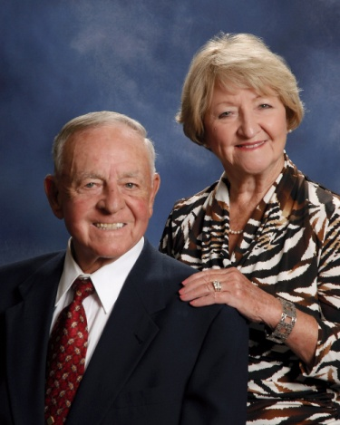 | Ethridge, Tim & Jo Marie  123 Chinquapin Road  Greenwood, SC 29646  (864) 223-7943  Joree60@nctv.com
Eubanks, Sam & Joanna
Jacob
210 Clem Road
Greenwood, SC 29649

(864) 227-3244

Evans, James & Mary Anna
508 Chinquapin Road
Greenwood, SC 29646

(864) 229-2980
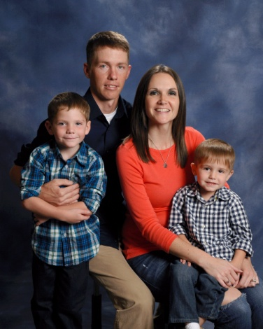 | Evans, Ray & Angela  Jacob, Carter  110 Draper Street  Ninety-Six, SC 29666  (864) 543-4450  Evans_angela@gmail.com
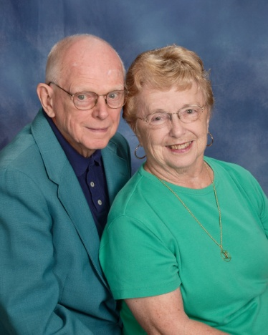 | Eyman, Dick & Doris  Wesley Commons  1110 Marshall Road  Greenwood, SC 29646  (864) 330-1353  rdeyman@mywesleycommons.org
Fain, Brandon
125 Kathy Hill Road
Greenwood, SC 29646

Fain, Maddie & Gray
213 Oak Ridge Drive
Greenwood, SC 29646

(864) 388-9239
Fair, Bobbie
103 Cheekwood Court
Greenwood, SC 29649

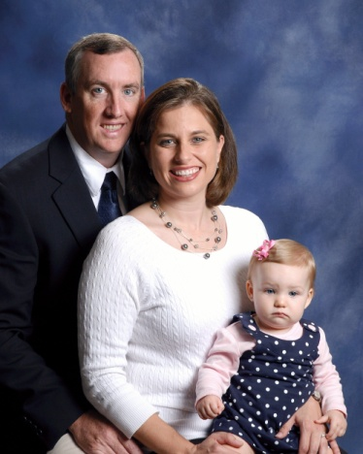 | Farren, Kevin & Leslie  Caroline  118 Beech Run Drive  Greenwood, SC 29649  (864) 980-2317  les_pt@yahoo.com
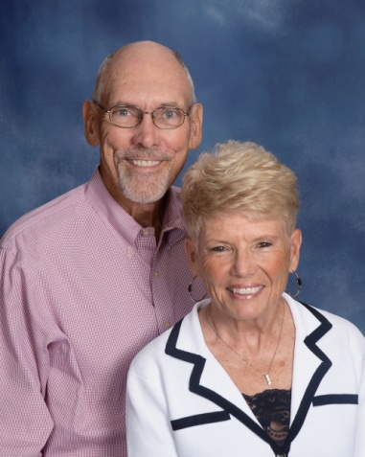 | Farris, Ken & Sylvia  15 Tryon Court  Greenwood, SC 29649  (864) 344-3552  kennethfaris33@yahoo.com
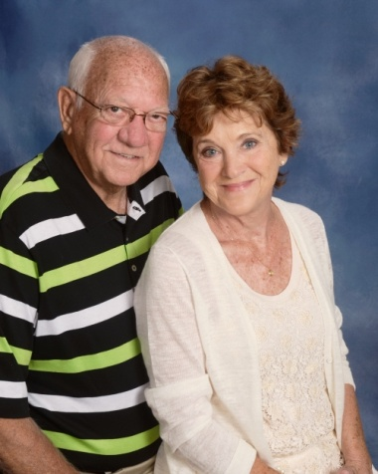 | Fellows, Sam & Margie  107 Westgate Drive  Greenwood, SC 29646  (864) 223-7149  smfellows@embarqmail.com
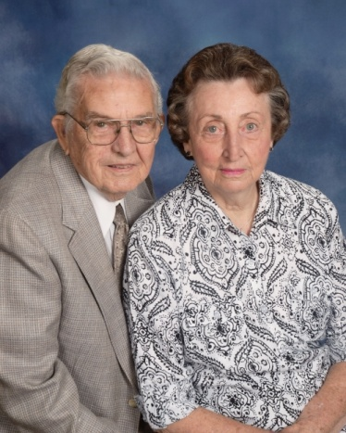 | Fennell, Dick & Evelyn  308 Marietta Drive  Greenwood, SC 29646  (864) 223-7449
Ferguson, Greg & Julie
Nick
103 Longleaf Court
Greenwood, SC 29649

Ferguson, Sara
115 Windsor Oaks
Greenwood, SC 29649

(864) 229-1954

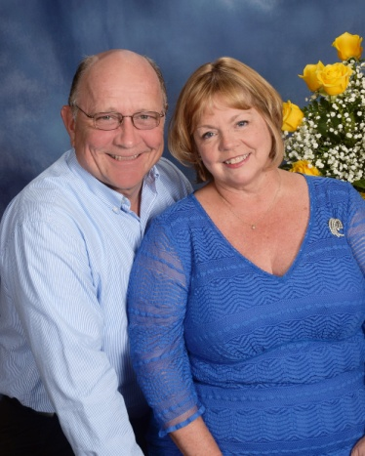 | Fezler, David & Martine  610 Fairway Lakes Road  Greenwood, SC 29649-8435  (864) 223-8160  mfezler@lander.edu
Fields, Cliff
896 Old Abbeville Hwy.
Abbeville, SC 29620

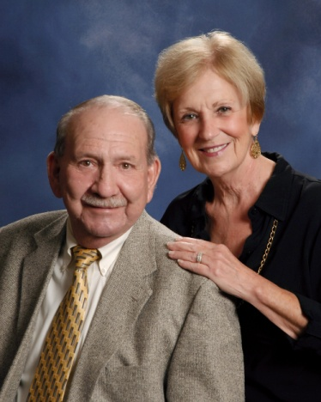 | Finney, Larry & Karen  285 Tranquil Road  Greenwood, SC 29646  (864) 223-6058  karen1945@embarqmqail.com
Fitzgerald, Doris
102 Wood Creek Drive
Greenwood, SC 29649

(864) 223-1859

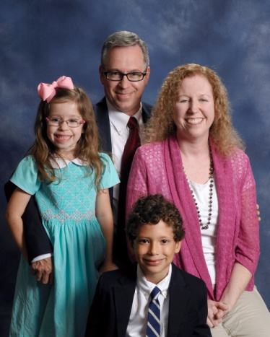 | Fitzgerald, Russ & Ana  Eli, Claire  230 Grace Terrace  Greenwood, SC 29649  (864) 227-0871  fitzgerald.ana@gmail.com
Florence, Lorene
662 Lake View Farm Road
Cross Hill, SC 29332

Florence, Lori
109 Hunter Drive
Belton, SC 29626

Frady, David & Brenda
107 Broken Ridge Drive
Greenwood, SC 29649

Franke, Tom
5 Griffin Drive
Ware Shoals, SC 29692

Franks, Joe & Kelly
Williams, Brent, Driggers, Spencer
41 N. Acres Road
Greenwood, SC 29649

(864) 229-1090

Free, Bubber
105 E. Durst Avenue
Greenwood, SC 29649

(864) 223-6246

Free, Wiley
205 Rock Knoll Drive
Greenwood, SC 29649

(864) 223-0189

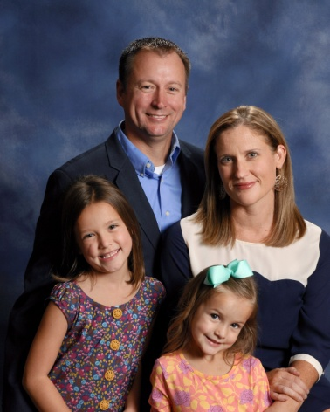 | Frick, Andy & Stephanie  Addison, Maddie  1302 Nursery Road  Little Mountain, SC 29075  (864) 223-0402  frickstephanie@yahoo.com
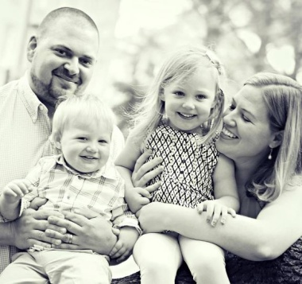 | Frick, Paul & Katie  Kaleigh, Cooper  1215 Epworth Camp Road E.  Ninety-Six, SC 29666
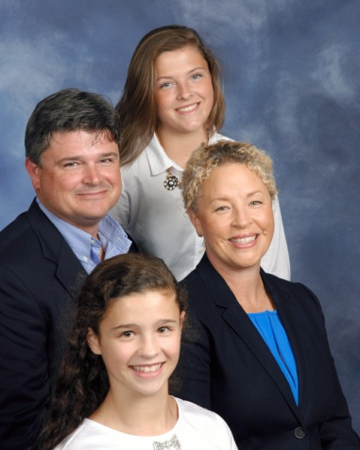 | Furman, Courtney & Caroline  Christian, Mae, Ella  204 E. Creek Road  Greenwood, SC 29646  (864) 992-2038  caroline.s.furman@gmail.com
Gantt, Jerry & Bernice
206 Beech Wood Circle
Greenwood, SC 29646

(864) 229-4163

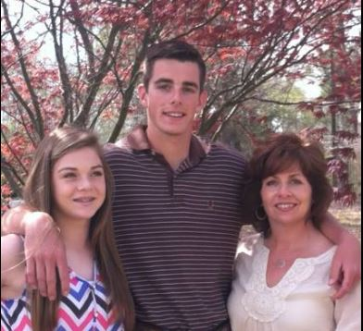 | Gantt, Sally  Kolby, Kylie  119 Rhett Court  Greenwood, SC 29649  (864) 992-0227  momof2onthemove@yahoo.com
Garren, Steve & Pam
Kathryn, Blayne
102 Woodlawn Court
Greenwood, SC 29649

(864) 993-3672

Garrett, Brian & Emily
Parks, Josie
219 Janeway
Greenwood, SC 29649

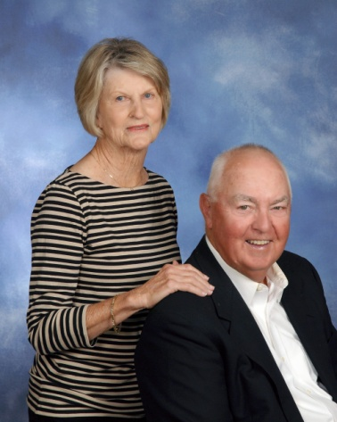 | Garrett, Harry & Pat  110 St. Andrews Lane  Greenwood, SC 29646  (864) 223-5637  hgarrett@embarqmail.com
Garvin, Josh and Mai
Annie, Laila, Stella, Jordan Lovett, Max
212 Oakmonte Circle
Greenwood, SC

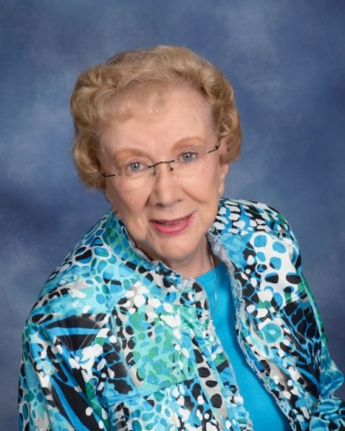 | Gault, Helen  134 Westgate Drive  Greenwood, SC 29646  (864) 229-0904
Geiwitz, Allen & Nancy
224 Swing About
Greenwood, SC 29649

(864) 229-1197

Genevie, Michael & Kathy
Meg
103 Brookview Drive
Abbeville, SC 29620

(864) 366-9588

Gentry, Robbie & Janice
128 Effie Drive
Greenwood, SC 29649

(864) 229-2580

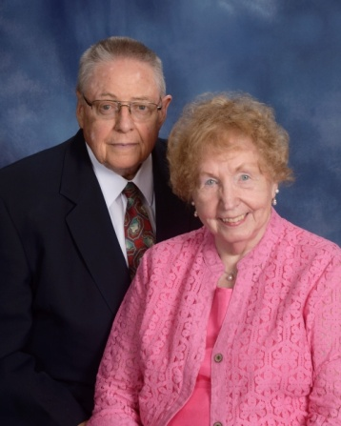 | Gillespie, Ray & Mary  Wesley Commons  1110 Marshall Road  Greenwood, SC 29646  rgillespie@mywesleycommons.org
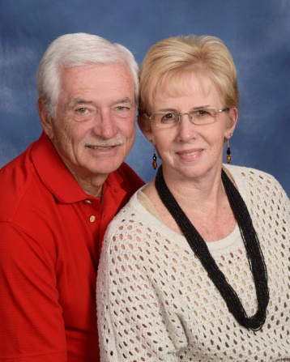 | Gilliam Jr., Harold & Jan  110 N. Acres Road  Greenwood, SC 29649  (864) 223-2917  haroldgilliam@embarqmail.com
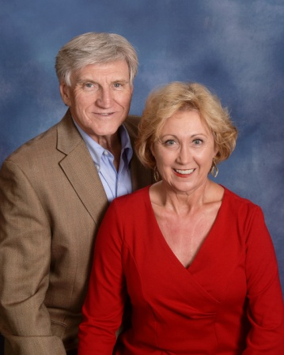 | Gillian Jr., Ernie & Candy  216 Briarwood Road  Greenwood, SC 29646-8700  (864) 223-5463  cgillian@embarqmail.com
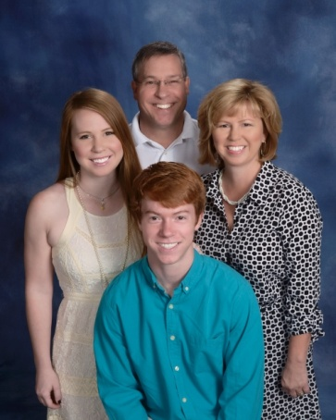 | Glanton, Craig & Kelly  Kaitlyn, Grayson  425 Saddle Hill Road  Greenwood, SC 29646-9480  (864) 223-7552  glanton_k@yahoo.com

Godwin, Tim & Allye
Will, Josh, Luke
128 Folly Bend Drive
Greenwood, SC 29649

(864) 538-0925

Goff, Greg & Lisa
Katherine, Julia, Thomas
701 Fairway Lakes Road
Greenwood, SC 29649

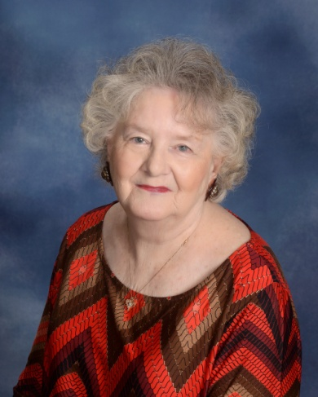 | Goff, Sylvia  508 Marietta Drive  Greenwood, SC 29646  (864) 229-3860  sylviagoff45@gmail.com
Goforth, Edith
Ali
157 Cherokee Drive
Greenwood, SC 29646

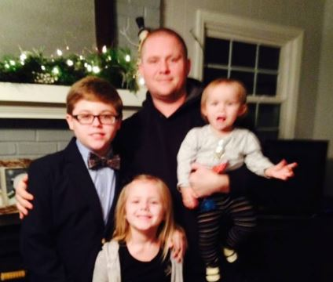 | Goforth, Jacob  Culler, Abigail  157 Cherokee Drive  Greenwood, SC 29646  (864) 223-4644
Golden, Tommy & Denise
Greenwood, SC 29649

Goodman, Danny & Kim
Blake
306 Mathews Heights Road
Greenwood, SC 29646

(864) 229-3288

Gordy, Chris
509 Saddle Hill Road
Greenwood, SC 29649

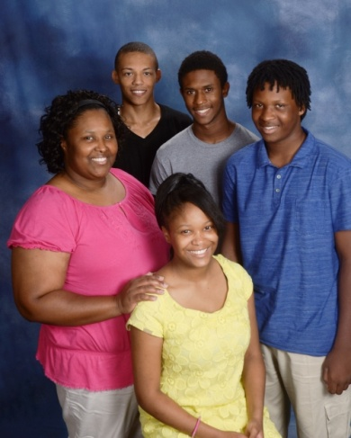 | Grant, Jhana  Quae Howard, Kya Brownlee, Aaron Brownlee, Tyrel Wideman  235 Florida Avenue, Apt. 41  Greenwood, SC 29646  (864) 910-0461  jhanag@yahoo.com
Gravelee Jr., George & Diane
210 Summit Street
Greenwood, SC 29649

(864) 554-2328

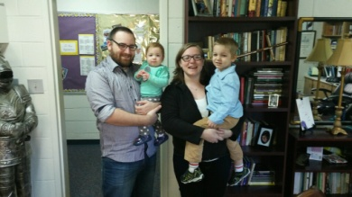 | Graves, Shawn and Samantha  Brody, Sara  114 Winter Way, Unit H  Greenwood, SC 29649
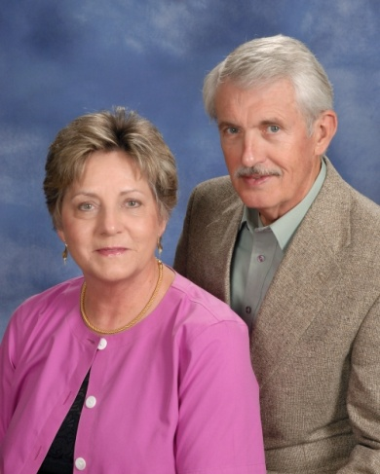 | Gregory, Derrell & Kay  139 Roman Circle  Greenwood, SC 29649  (864) 554-4740  kgreg@nctv.com
Gretta, Dan and Pam
108 Morningside Drive
Greenwood, SC 29649

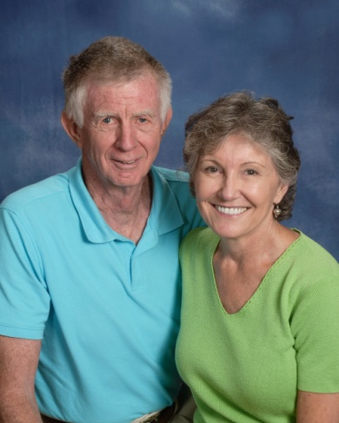 | Griffin, Buck & Jean  12223 Hwy. 2446 N.  Greenwood, SC 29649  (864) 923-1245  jeansg57@gmail.com
Grogan, Bobby & Susan
103 Baldwin Road
Ninety-Six, SC 29666

(864) 388-9240

Grooms, Jo
115 Arthurs Point
Greenwood, SC 29649

(864) 229-9666
rjgroomes@nctv.com

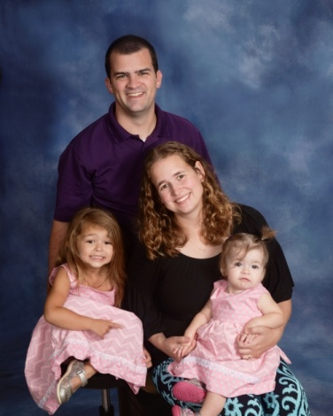 | Hackett, Tom & Stephanie  Caitlyn, Carsyn  253 Oak Ridge Drive  Greenwood, SC 29649  (864) 245-5959  slarnold@gmail.com
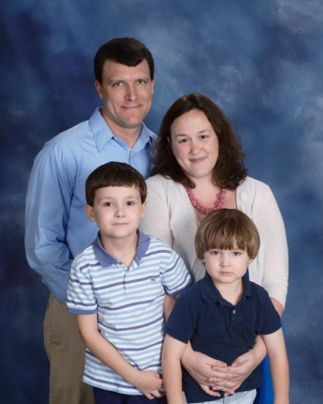 | Hadd, Josh & Cathi  Avery, Grady  307 E. Henrietta Avenue  Greenwood, SC 29649  (864) 992-7865
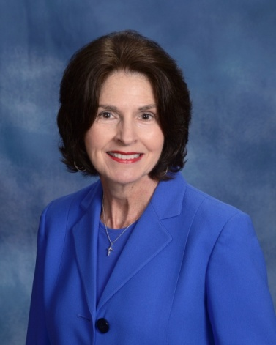 | Hagen, Linda  108 Kensington Drive  Greenwood, SC 29649  (864) 223-3683  ljgh.0727@gmail.com
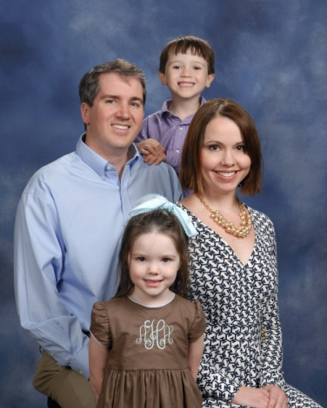 | Haigler Jason & Mary  Austin, Aly  320 Johns Creek Road  Hodges, SC 29653  (864) 993-4470  mchaigler@hotmail.com
Hamilton, Doug
Paul, Blake
223 Ware Street
Greenwood, SC 29646

Hammett, Joe
Ross
138 Crescent Road
Greenwood, SC 29649

(864) 223-3337

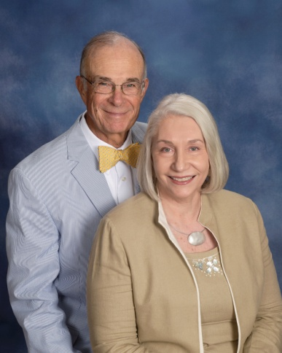 | Hannah, David & Patsy  104 Kensington Drive  Greenwood, SC 29649  (864) 229-6997  phannah@nctv.com
Harley Jr., Jim
103 Carnoustie Court
Greenwood, SC 29646

(864) 229-6057

Harman, Arlie & Barb
Wesley Commons
1110 Marshall Road
Greenwood, SC 29646

(864) 330-1316

Harris, Alan & Allison
109 Curl Drive
Greenwood, SC 29649

Harrison, Michelle
Hannah
205 Parkwood Road
Greenwood, SC 29646

(864) 861-2222

Harter, Rick & Mary Jane
223 St. Augustine Drive
Greenwood, SC 29649

Harwood, Brian & Melissa
Hayden, Holland, Halle
103 Erica Place
Greenwood, SC 29649

Hays, Kristi
Wesley Crooks, Will
104 Windtree Court
Greenwood, SC 29649

Hazel Jr., Joey & Marissa
Jace
216 Holly Avenue
Greenwood, SC 29649

(864) 992-8310

Hazel Sr., Joseph & Donna
209 Sanders Drive
Greenwood, SC 29649

(864) 223-0752

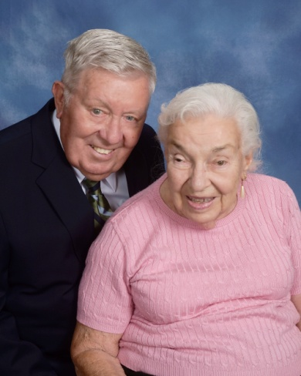 | Heintzelman, Skip & Ruth  Wesley Commons  1110 Marshall Road  Greenwood, SC 29646  (864) 227-7421  skiph@mywesleycommons.org
Helker, Don & Sondra
130 Swing About
Greenwood, SC 29649

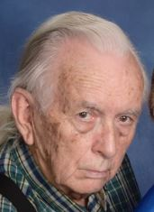 | Helms, Charlie  109 Brookhaven Drive  Greenwood, SC 29646  (864) 227-6017
Hembree, Ray
Hodges, SC 29653

(864) 229-5891

Henderson, Caron & Sandy
109 Hitt Street
Greenwood, SC 29648

(864) 554-2800

Henderson Jr., Charles
P. O. Box 1784
Greenwood, SC 29648

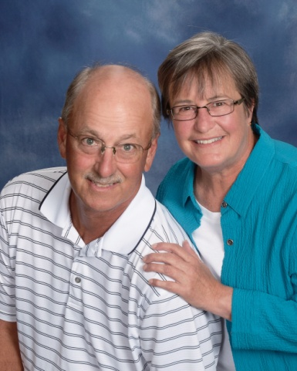 | Henderson, Rick & Nancy  137 Kensington Drive  Greenwood, SC 29649  (864) 223-4819  nlhenderson@embarqmail.com
Herlong III, Mike & Gloria
Jody
P. O. Box 50151
Greenwood, SC 29649

Hill, Mary
125 York Drive
Greenwood, SC 29649

Hitt, Cindy
506 Marietta Drive
Greenwood, SC 29646

(864) 223-8083

Hodges, Lynn
703 Johns Creek Road
Hodges, SC 29653

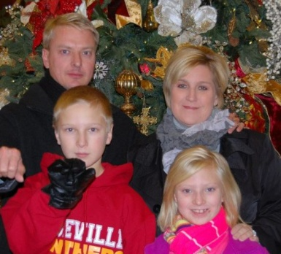 | Hodges, Tim & Paige  Carson, Mary Elliott  47 Oakwood Farms Court  Greenwood, SC 29649  (864) 223-3562
Holland, Andrew and Holly
Eli Fender
107 We Smith Road
Greenwood, SC 29649

Holland, Becky
Lily Kate

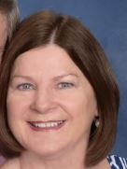 | Holland, Penny  320 Plantation Drive  Greenwood, SC 29649  (864) 223-2914  rholland@nctv.com
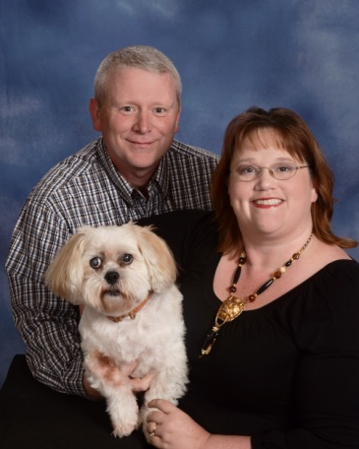 | Holley, Russell & Paige  507 Marietta Drive  Greenwood, SC 29646  (864) 554-7922
Holliday, Vicki
Brianne
224 Autumn Trace
Greenwood, SC 29649

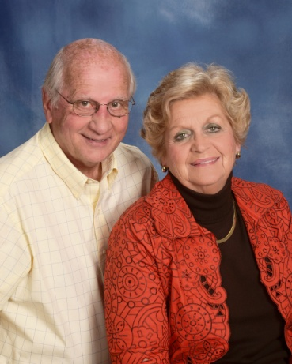 | Hood, Eddie & Susan  107 Devon Park  Greenwood, SC 29649  (864) 229-0844  ehood@hoodmail.com
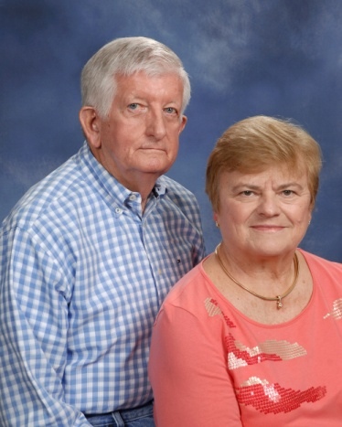 | Hook Jr., Louis & Linda  402 Gatewood Drive  Greenwood, SC 29646  (864) 229-5852  alhirh@earthlink.net
Hoole, Billy & Martha
2939 Ninety Six Hwy.
Ninety-Six, SC 29666

(864) 543-9943

Hornyak, Lisa
115 Shortleaf Court
Greenwood, SC 29649

House, Bill & Betty
Greenwood, SC

(864) 223-2612

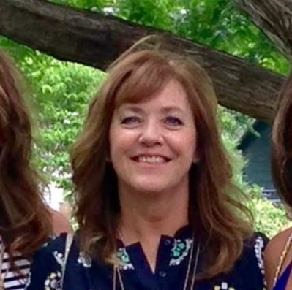 | Howell, Sydney  408 Farmdale Road  Hodges, SC 29653
Hudgens Jr., Nolan
134 Creek Road E.
Greenwood, SC 29646

(864) 229-2078
nolan_hudgens@yahoo.com

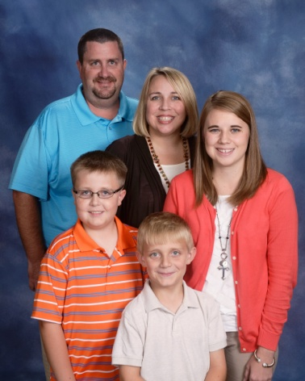 | Hudson, JJ & Lara  Kayla Chrisley, Dawson, Thomas  103 Shortleaf Court  Greenwood, SC 29649  (864) 941-6712  lhudson@greenwoodymca.org
Hughes, Claude
305 Fairway Lakes Road
Greenwood, SC 29649

(864) 942-7152

Hughes Jr., Rusty
109 Gannt Road
Greenwood, SC 29646

(864) 993-2528

Human Jr., Bill & Fran
115 Deerwood Lane
Greenwood, SC 29646

(864) 229-1209

Hunley, Sam
305 Milford Springs Road
Greenwood, SC 29649

(864) 223-9340

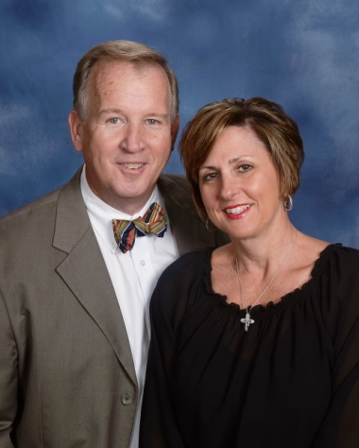 | Hunsucker, Carl & Fran  207 Belle Meade Road  Greenwood, SC 29649  (843) 457-2721  fhunsucker@gmail.com
Huntsberger, Lee
323 W. Commodore Drive
Cross Hill, SC 29332

(864) 998-9036

Huskey, Sidney
509 Norwood Avenue
Greenwood, SC 29646

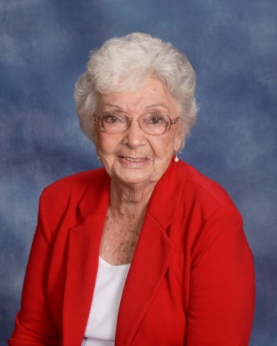 | Jackson, Rekah ‘Sig’  111 Rosemont Drive  Greenwood, SC 29646  (864) 223-1190
Jacobs, Lynn
Caroline Alexander, Ashley Alexander
138 Ossie Hayes Road
Pickens, SC 29671

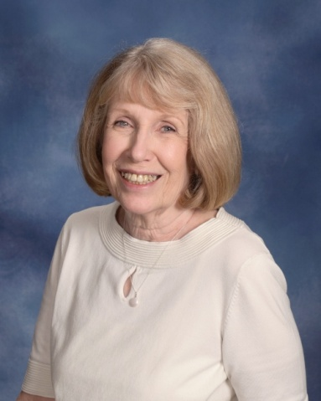 | Jaffe, Sue  110 P. C. Jean Road  Ninety-Six, SC 29666  (864) 543-3290  jaffefamily@nctv.com
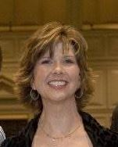 | James, Rebekah Buchanan  104 Brookfield Drive  Greenwood, SC 29646  (864) 227-6894
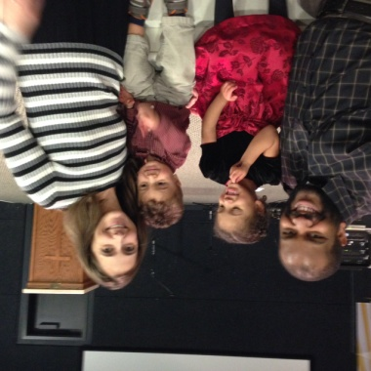 | Johnson, CJ and Megan  Andrew, Lilly  111 Tifton Drive East  Greenwood, SC
Johnson, Harold & Melanie
Taylor, Sarah Ellen, Jase
724 Windsor Road
Hodges, SC 29653

(864) 374-7838

Johnson, Terri
Greenwood, SC 29649

Jolly, Brenda
P. O. Box 201
Greenwood, SC 29648

Jolly, Kevin & Gina
Rachel
506 Watford Avenue
Greenwood, SC 29649

Jones, Brad & Mary
Jessica Chandler, Bryce
120 Kensington Drive
Greenwood, SC 29649

(864) 554-7473

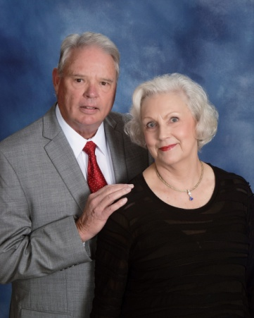 | Jones, Charlie & Carol  117 Watersedge Road  Greenwood, SC 29649  (864) 942-0996  ccjones@embarqmail.com
Jordan III, George
523 Clem Road
Greenwood, SC 29649

Kapfer, Brad & Samantha
505 Rivers Run
Greenwood, SC 29649-8474

Keppler, Tim & Dottie
111 E. Commodore Drive
Cross Hill, SC 29332

(513) 617-2315

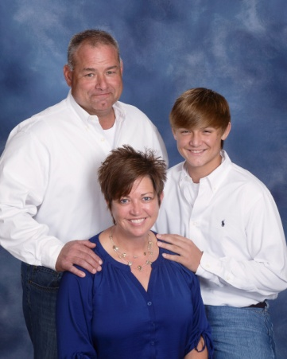 | Keller, Tony & Shana  Evan  114 Emili Lane  Greenwood, SC 29646  (864) 344-6099  shana.keller@selfregional.org
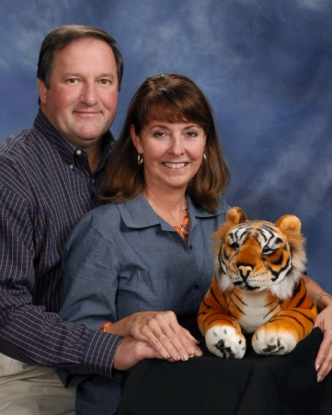 | Kelley, Chuck & Janey  Will, Reed, Tiger  502 Fairway Lakes Road  Greenwood, SC 29649  (864) 223-0273  janeytkelley@yahoo.com
Kelley, Ladd & Lynn
Lake
125 Tally Ho Drive
Greenwood, SC 29649

(864) 229-7710

Kelley, Ron & Carolyn
103 Foxmeadow Court
Greenwood, SC 29649

(864) 223-1739

Kelly, Keenan & Beth
Joshua, Brett
1877 Cedar Springs S.
Abbeville, SC 29620

(864) 446-2661

 | Kennedy, Verna
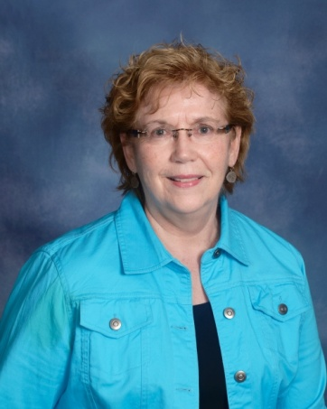 | Kennerly, Margaret  106 Chelsea Square  Greenwood, SC 29649  (864) 223-0909  mkennerly@embarqmail.com
Kidd, Brantlee
105 Pine Needle Lane
Greenwood, SC 29649

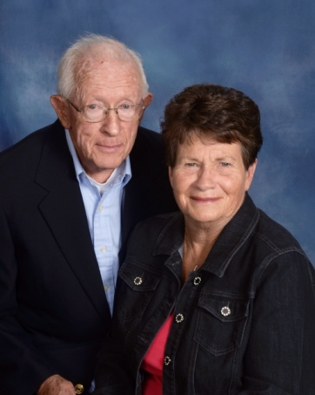 | Kilgore, Tom & Joyce  148 Highland Drive  Greenwood, SC 29649  (864) 229-6055
Kirby, Thomas & Brooke
125-08 Edinborough Circle
Greenwood, SC 29649

Kneece, Emily
Maddie Brown
104 Pumpkin Road
Hodges, SC 29653

(864) 729-8217

Knight, David & Velma
208 Kathy Hill Road
Greenwod, SC 29646

(864) 227-2646

Knight, Jimmy
108 Hampton Toad
Greenwood, SC 29649

(864) 943-2446

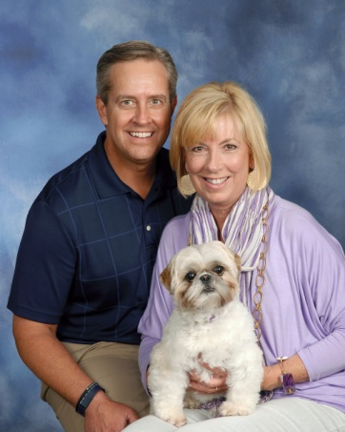 | Knott, Brad & Vicki  Charlee  108 Fairway Court  Greenwood, SC 29649  (864) 229-3355
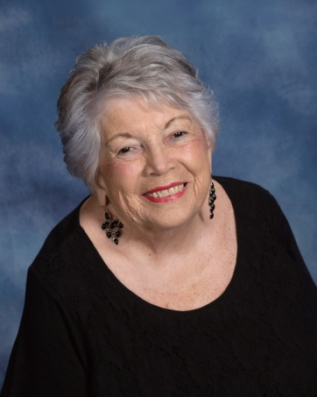 | Koone, Charlotte  104 Heritage W. Court  Greenwood, SC 29649  (864) 227-6942
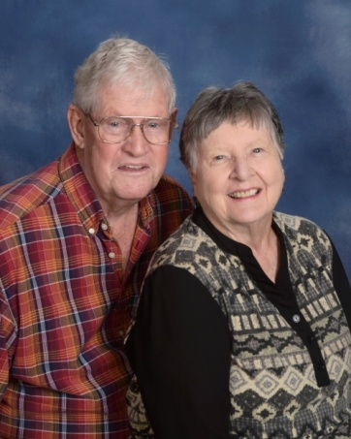 | Kruzan, Jim & Lee  Wesley Commons  1110 Marshall Road  Greenwood, SC 29646  (864) 227-7339  lekruz35@yahoo.com
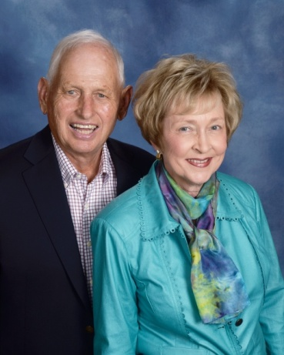 | Lacoste, Bill & Pat  314 Lodge Drive  Greenwood, SC 29646  (864) 229-3339  bplacoste@icloud.com
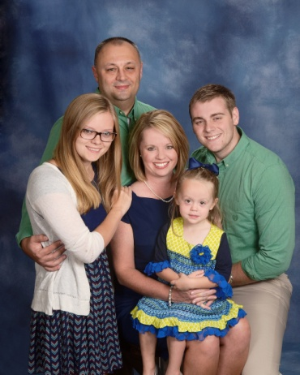 | Lake, Calvin & Teresa  Brett Clark, Jessica Clark, Mallory  406 Twisted Oak Drive  Greenwood, SC 29646  (864) 981-3238  lakecalvin75@gmail.com
Landrith, Amy
Lauryn
112 Fawn Brook Drive
Greenwood, SC 29646

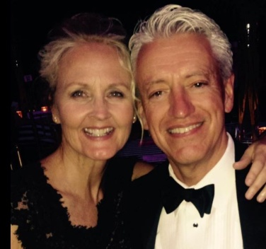 | Lanford, Jeff & Robin  Hayes, Savannah  106 Brighton Court  Greenwood, SC 29646  (864) 227-9497
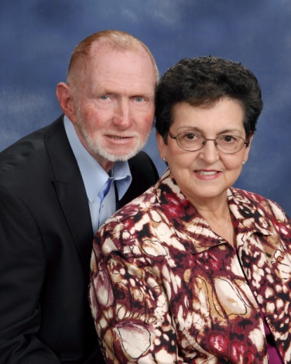 | Langley, Ed & Doris  303 Lynn Street  Greenwood, SC 29649  (864) 229-2334  doublerock@embarqmail.com
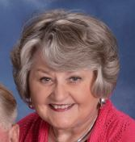 | Langley, Jean  106 Colonial Drive  Greenwood, SC 29649  (864) 992-7559  jlangley5584d@nctv.com
Lankford, David & Vonne
136 Hunters Village Drive
Greenwood, SC 29649

(864) 538-0622
vmlankford@hotmail.com

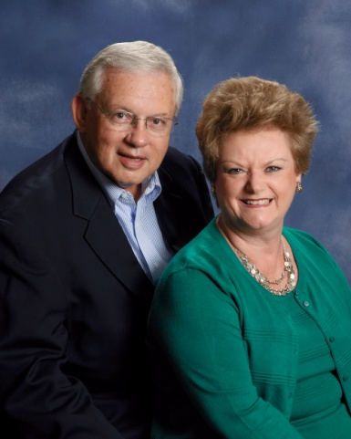 | Latham, Fred & Betty  601 Gatewood Drive  Greenwood, SC 29646  (864) 223-4097  flatham@earthlink.net
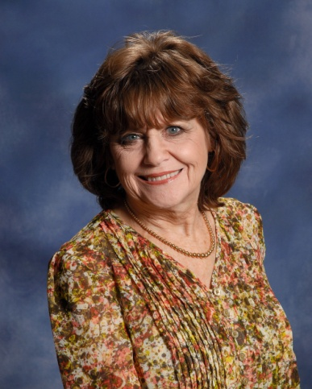 | Latham, Jo  118 Shortleaf Court  Greenwood, SC 29649  (864) 223-3659  joslatham@yahoo.com
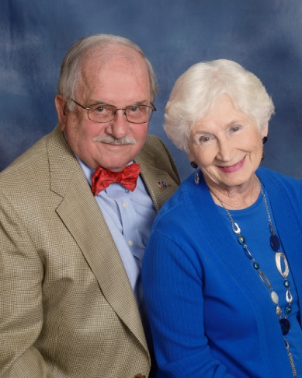 | Lax Sr., Colonel Robert & Jean  1135 Frazier Road  Ninety-Six, SC 296666  (864) 543-3271  relax06@embarqmail.com
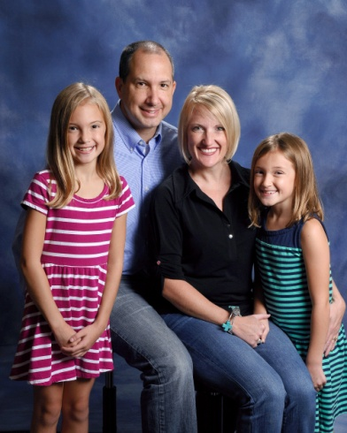 | Layland, Ralph & Erin  Lexi, Charlee  132 Kingston Road  Greenwood, SC 29649  (864) 388-7919  erin.layland@parksterlingbank.com
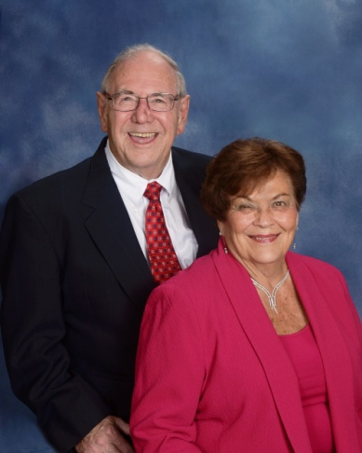 | Leaman, Sam & Dot  208 Heritage W. Court  Greenwood, SC 29649  (864) 229-1251  samleamanjr@embarqmail.com
Lee, Gilliean & Marae
116 Folly Bend Drive
Greenwood, SC 29649

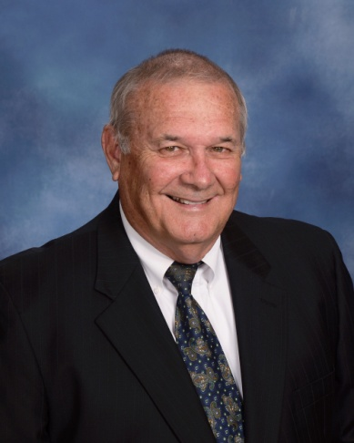 | Lee, Sonny  109 Country Village Lane  Greenwood, SC 29649  (864) 229-0347  leek1942@embarqmail.com
Lee, Starla
210 Curl Creek Road
Greenwood, SC 29649

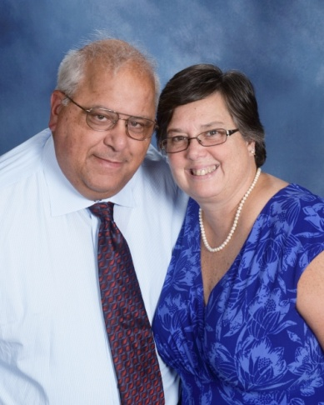 | Leo Jr., Conrad & Jaye  909 Saddle Hill Road  Greenwood, SC 29646  (864) 942-1869  jaye_leo1234@yahoo.com
Leopard, Johnny
Peyton, Austin, Jewel Malone
112 Nottingham Lane
Greenwood, SC 29649

(864) 377-1542

Lepp, Heather
435 Haltiwanger Road, Apt. 27
Greenwood, SC 29649

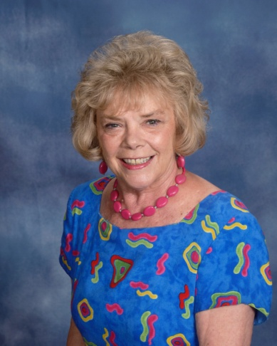 | Leslie, Faye  104 Windsor Oaks Court  Greenwood, SC 29649  (864) 980-3036  lesliesassy2002@yahoo.com
Lightsey, David & Betty
119 Orchard Park Drive
Greenwood, S C 29649

(864) 223-6725

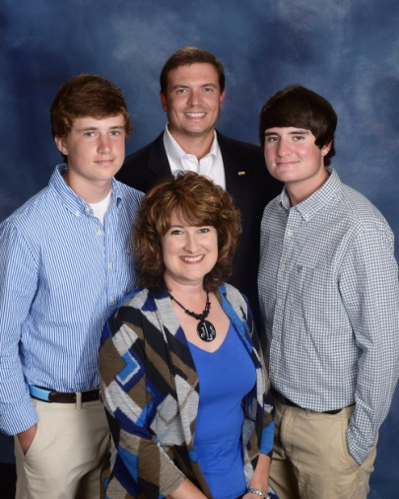 | Lindler, Phil & Jennifer  Blake, Rhett  228 Chatham Drive  Greenwood, SC 29649-9512  (864) 941-0336  lindlerj@gwd50.org
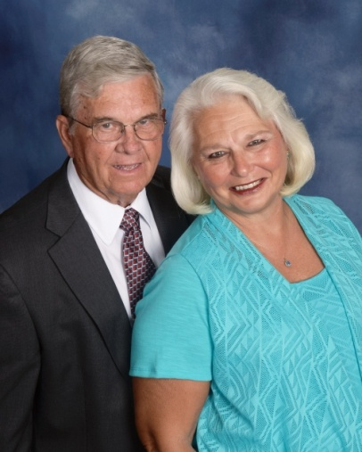 | Lindley, Billy Joe & Sherlyn  1218 Saddle Hill Road  Greenwood, SC 29646  (864) 941-7469  sherlyn7726@gmail.com
Liner, Chris & Meredith
Cade, Emma
5392 Hwy. 76 W.
Laurens, SC 29360

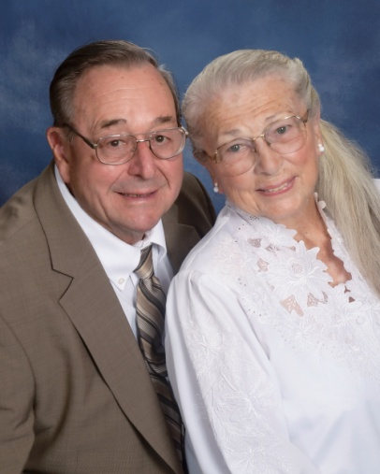 | Logan, Verne & Margie  228 Pumphouse Road  Greenwood, SC 29649  (864) 554-8632  marvalsandshore@embarqmail.com
Lollis Jr., James
108 Culbertson Court
Greenwood, SC 29649

(864) 943-1366

Long, Jason
204 Winter Ridge Court, Apt. C
Greenwood, SC 29649

Long, Jeff & Glenda
Kierstin Cook
4 Royal Oak Drive
Greenwood, SC 29649

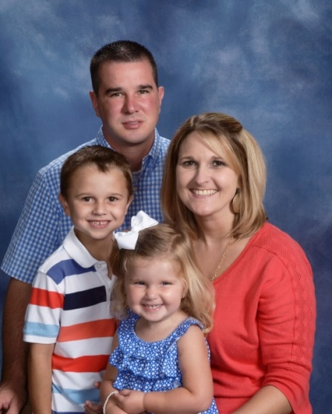 | Long, John & Amanda  Gentry, Aubrey  311 Johnston Road  Ninety-Six, SC 29666  (864) 993-7113  along@phgrp.com
Long, Ronnie & Betty
102 Evergreen Drive
Greenwood, SC 29649

(864) 29-4351

Long, Ted & Ann
222 Swing About
Greenwood, SC 29649

(864) 223-2016

Long, Wheeler & Nancy
125 Donegal Drive
Greenwood, SC 29646

(864) 223-3384

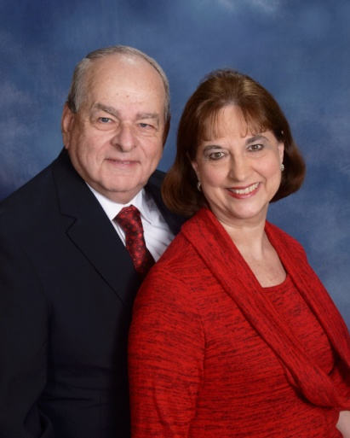 | Lucas, Linda & Phil  120 N. Acres Road  Greenwood, SC 29649  (864) 229-7252  lindalucas@nctv.com
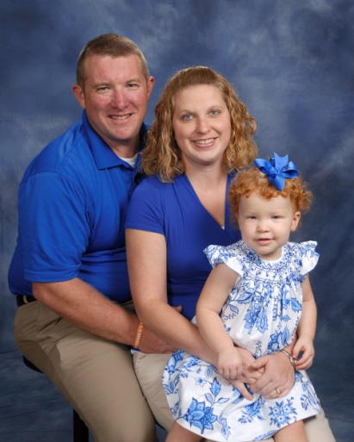 | Lybrand, Billy & Susan  Addison  302 Loblolly Circle  Greenwood, SC 29649  (864) 993-7104  srlybrand@gmail.com
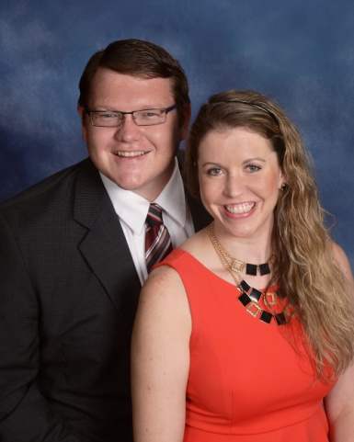 | Lybrand, Robert & Jennifer  434 Sagewood Road  Greenwood, SC 29646  (864) 980-3927  rtlybrand@liberty.edu
Lyles, Jamie & Lauren
Steven
210 Winding Oak Way
Blythewood, SC 29016

Lynch, Kevin & Sandra
1007 S. Main Street
Greenwood, SC 29646

(864) 229-0519

Malacky, Mike & Jackie
John Michael
114 Cypress Hollow
Greenwood, SC 29649

Mallon, Keith
108 Ansley Court
Greenwood, SC 29649

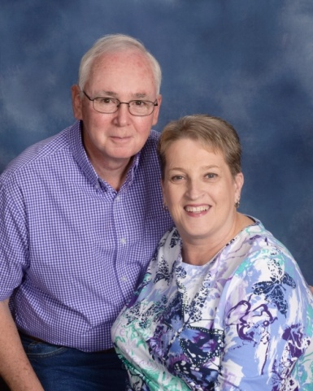 | Manley, Doug & Kathy  405 Pascal Drive  Greenwood, SC 29649  (810) 624-5358  ck_manley@hotmail.com
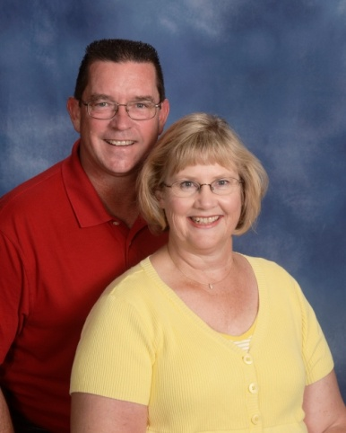 | Manning, Peter & Sharon  Sammie Jo  107 Brookfield Drive  Greenwood, SC 29646  (864) 229-2126  manninbglawfirm@simplepc.net
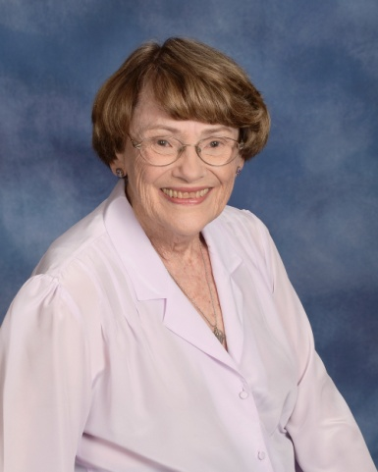 | Mannion, Louse  Wesley Commons  1110 Marshall Road  Greenwood, SC 29646  (864) 330-1303  jmannion@mywesleycommons.org
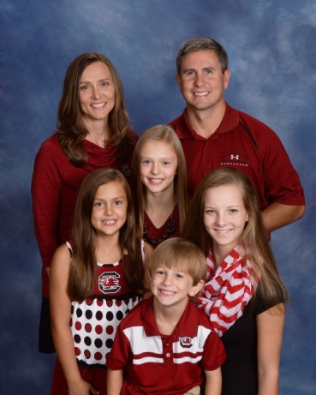 | Mapes, Mark & Jennifer  Jessica Steepy, Tyler, Jordan, Jillian  420 Johns Creek Road  Hodges, SC 29653  (864) 953-2150  jennifer.mapes@sageai.com
Marcengill II, Jimmy & Whitney
Harrison
108 Carriage Court
Greenwood, SC 29646

(864) 223-3477
marcengillj@yahoo.com

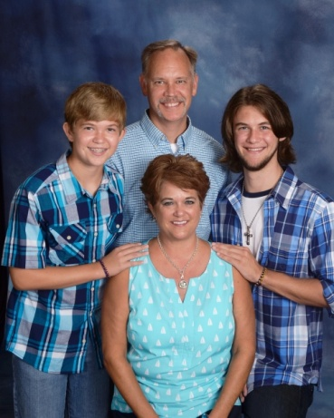 | Markward, Todd & Cindy  Austin, Quintin  107 Tryon Court  Greenwood, SC 29649  (864) 993-1356  tcaq@embarqmail.com
Marshall, Joe & Shannon
315 Loblolly Circle
Greenwood, SC 29649

(864) 223-3126

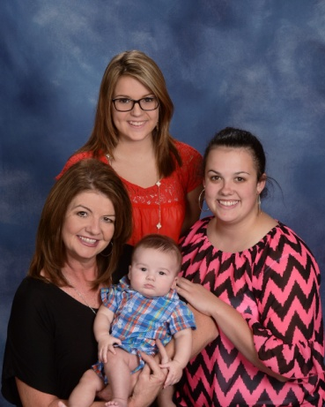 | Marshall, Tammy  Kendall O’Quinn, Ally Grace, Daniel O’Quinn  119 Crescent Road  Greenwood, SC 29649  (864) 910-1256  tmarshall29649@gmail.com
Marshall, Walter & Gay
113 Heathwood Drive
Greenwood, SC 29649

(864) 223-4201

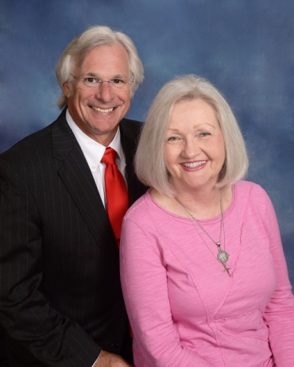 | Martin, George & Margaret  203 Hatchers Pass  Greenwood, SC 2966  (864) 388-4247  gmartin@greenwoodmetro.com

Matthews, Buddy & Annette
1111 Old Abbeville Hwy
Greenwood, SC 29649

(864) 229-7619

Matthews, Tim & Rhonda
Graham
821 Mt. Moriah Road
Greenwood, SC 29646

McAlister III, Rob & Susan
Clark, Will
1105 Reedy Creek Road
Bradley, SC 29819

(803) 227-9367

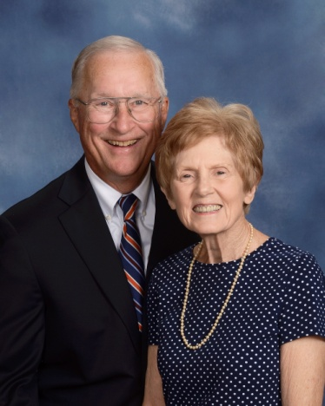 | McCaffrey, Glenn & Julie  101 Wendover Road  Greenwood, SC 29649  (864) 223-0879  gjmcca@emeraldis.com
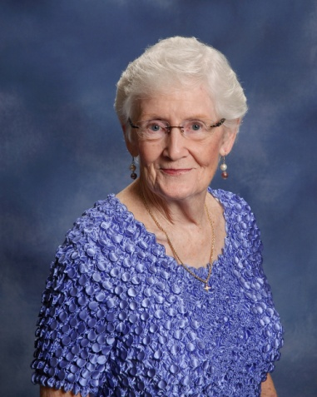 | McCall, Wilma  Hannah Cronic  142 Pinehaven Drive  Ninety-Six, SC 29666  (864) 543-2223  wilmamccall@embarqmail.com
McCallum III, Edward & Jeannie
104 Blue Heron Court
Greenwood, SC 29646

(864) 229-2903

McCarty, Scott
204 Loblolly Circle
Greenwood, SC 29649

McClain, Rick
715 New Market Street
Greenwood, SC 29646

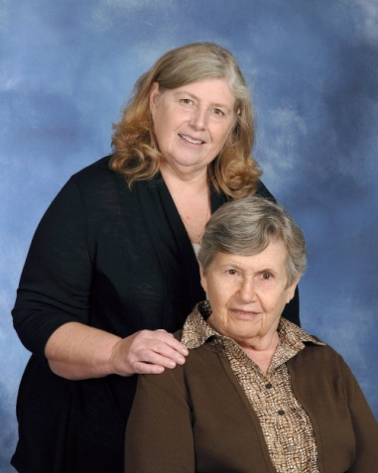 | McClain, Debbie & Martha Talbert  204 Heathwood Drive  Greenwood, SC 29649  (864) 223-9477
McClinton, Jessica
125 Rivers Way
Abbeville, SC 29620

(864) 223-4888

McClinton, Kathy
101 Faye Drive
Ninety-Six, SC 29666

McClinton, Sam & Becky
Haven, Erica
111 Appaloosa Lane
Greenwood, SC 29646

(864) 227-1407

McColl, Jim & Ruth
117 Creek Road E.
Greenwood, SC 29646

(864) 229-2106

McCrea, Tommy & Tricia
Sadie, Gray
108 Tryon Court
Greenwood, SC 29649

(864) 344-1340

McCullough, Adam
2605 Bel Ivy Road
Newberry, SC 29108

McCurry, Austin
115 Court Square
Abbeville, SC 29620

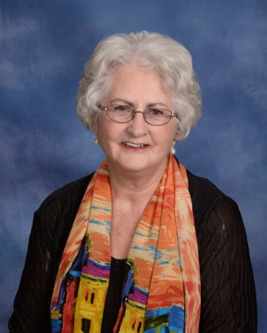 | McDaniel, Audrey  724 Rockhouse Road  Greenwood, SC 29646  (864) 227-1502  mcdaniela@centurylink.net
McDonald, Charles & Harriett
P. O. Box 49942
Greenwood, SC 29649

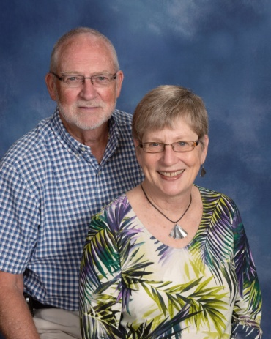 | McFarland, Bill & Susan  216 Starboard Tack  Greenwood, SC 29649  (864) 227-8175  bmcfarland@embarqmail.com
McGehee, Pat & Patti
Emily
116 Emili Lane
Greenwood, SC 29646

McGill, Preston
201 Athens Court
Greenwood, SC

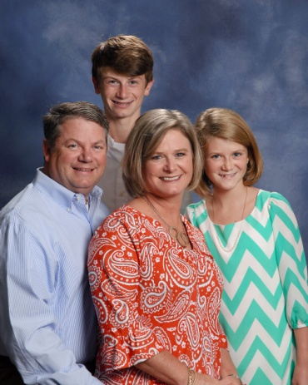 | McGovern, Jimmy & Tracie  Patrick, Meg  108 Palmer Place  Greenwood, SC 29649  (864) 4079969  jtmcgovern@centurylink.net
McIntosh, Dave & Becky
Ted Sullivan, Ben
918 Ole Pucketts Ferry Road
Greenwood, SC 29649

(864) 223-2291

McIntosh, Lisa
Lauren Powell, Ryan Coffey, Eric
812 Hunters Creek Boulevard
Greenwood, SC 29649

(864) 229-6730

McKellar, Elizabeth
1804 McCormick Hwy
Greenwood, SC 29646

(864) 223-5460

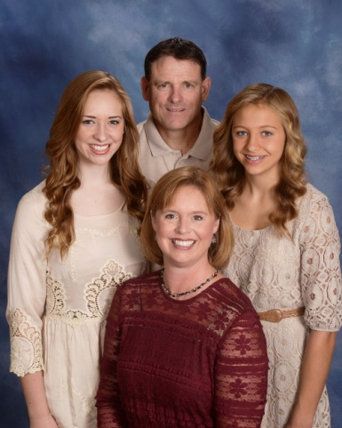 | McLaughlin, Kevin & Julie  Anna Grace, Haley  1213 Saddle Hill Road  Greenwood, SC 29646  (864) 910-1567  julie@stmarkgreenwood.com
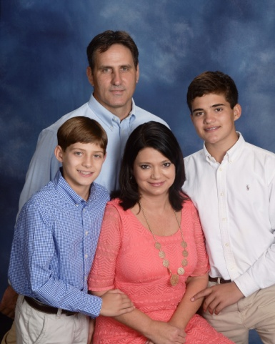 | McLaughlin, Tom & Kim  Jacob, Caleb  103 Appaloosa Lane  Greenwood, SC 29646  (864) 388-0474  kimberlym@embarqmail.com
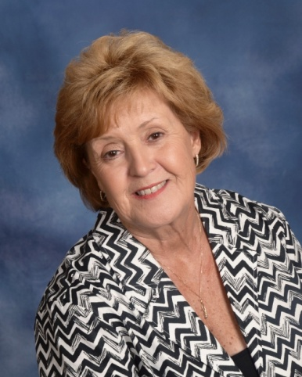 | McMahan, Janice  105 Pin Oak Drive  Greenwood, SC 29649  (864) 391-7360  jpmcmahan@embarqmail.com
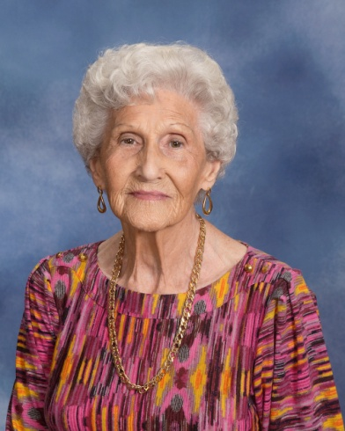 | McManus, Annell  110 Northgate  Greenwood, SC 29649  (864) 229-1596
McManus, Chaz
112 Loblolly Circle
Greenwood, SC 29649

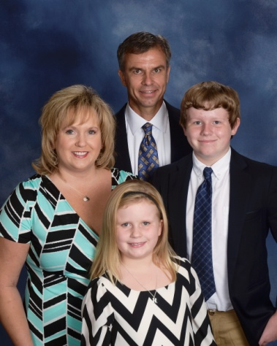 | McManus, Zvi & Gina  Tyler, Rylee  106 St. Augustine Drive  Greenwood, SC 29649  (864) 554-4938  zviandgina@embarqmail.com
McWhorter, Rick & Joy
101 Amherst Drive
Greenwood, SC 29649

(864) 223-5382

Medlock, Bobby & Diane
Kevin, Brian
113 Culbertson Court
Greenwood, SC 29649

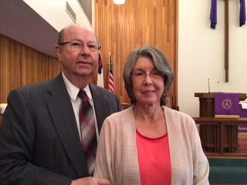 | Meints, Jerry & Sandra  311 Hunters Creek Boulevard  Greenwood, SC 29649  (864) 223-9656
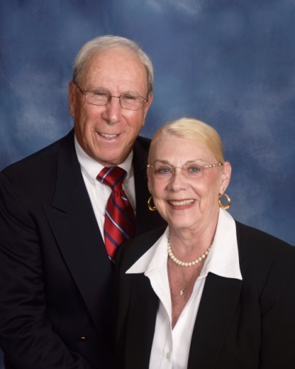 | Menaker, Stuart & Jackie  105 Hunters Village Drive  Greenwood, SC 29649  (864) 229-2387  stujac@emarqmail.com
Miles, Sondra
208 Forest Lane
Greenwood, SC 29649

(864) 223-2719

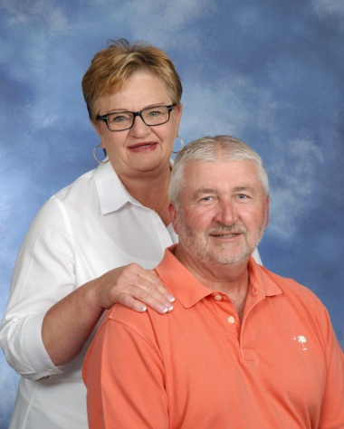 | Millender, Ronnie & Brenda  319 Hammond Road  Greenwood, SC 29646  (864) 223-4091  millender@emeraldis.com
Miller, Amsey & Catherine
104 Rivers Run
Greenwood, SC 29649

(864) 538-6254

Miller, Chris
108 E Forest Drive
Greenwood, SC 29646

Miller, David & Linda
Drew, Erin
121 Woods Drive
West Union, SC 29696

(864) 888-2416

Miller, Lee & Cathy
Benjamin
206 Gentry Run
Greenwood, SC 29649

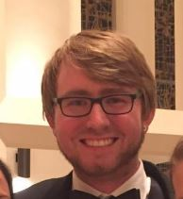 | Miller, Matthew  204 Gracemount Drive  Greenwood, SC 29649  (864) 554-6013  matthew@stmarkgreenwood.com

Miller, Reid
RR 2, Box 549-A
Saluda, SC 29138

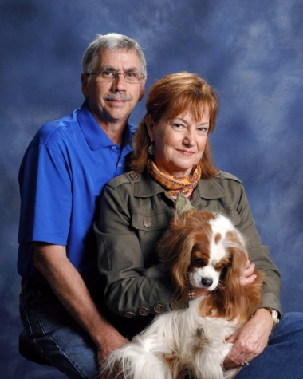 | Miller, Sam & Patti  Charlie  126 Windsor Oaks Court  Greenwood, SC 29649  (864) 378-1772  pattim285@gmail.com
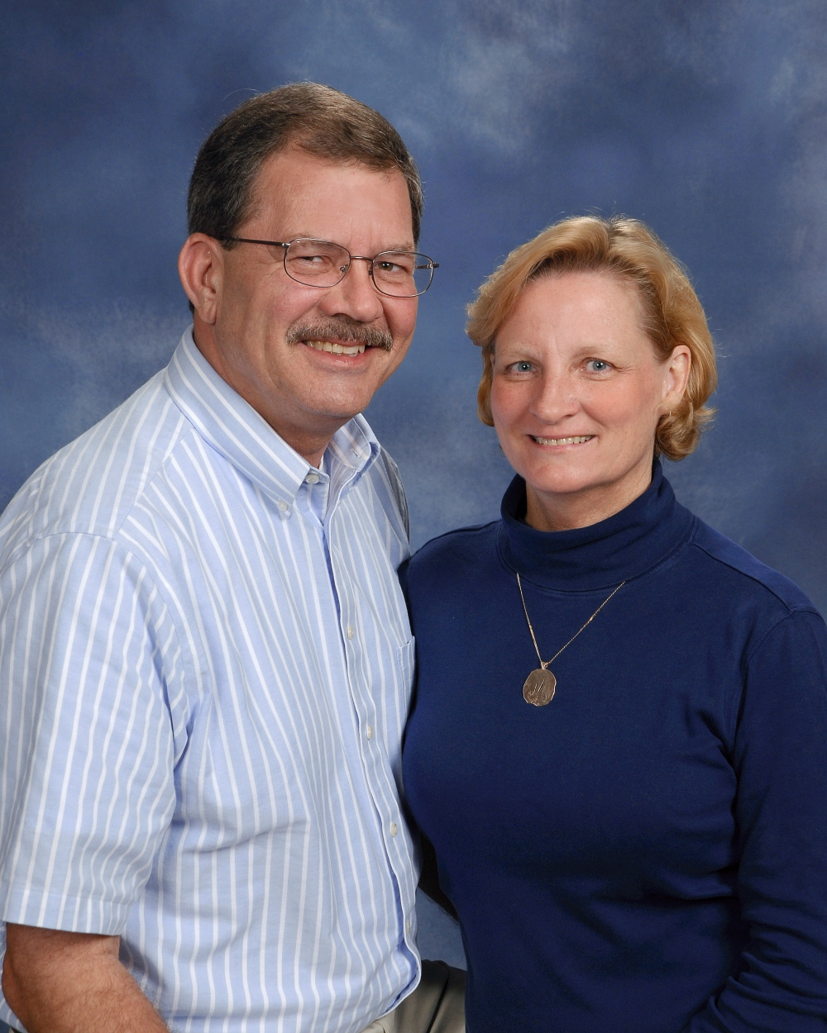 | Miller, Tom & Debbie  108 E. Forest Drive  Greenwood, SC 29646  (864) 942-0254  tommiller@centurylink.net
Milner, Ben
409 Woodlawn Road
Greenwood, SC 29649

(864) 223-4537

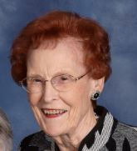 | Miskelly, Mary  109 Locksley Drive  Greenwood, SC 29649  (864) 229-3672

Mitchell, Jerry & Linda
130 Hunters Village Drive
Greenwood, SC 29649

(864) 229-6790

Mock, Holly
249 Oakridge Drive
Greenwood, SC 29649

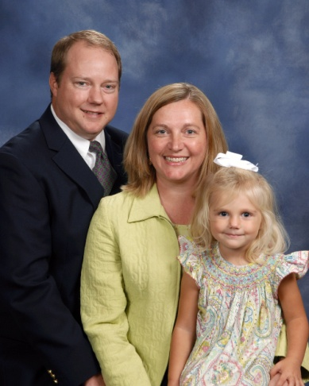 | Moeller, Marcus & Elizabeth  Lillie, Ella Cate, Emma  128 Crescent Road  Greenwood, SC 29649  (864) 980-9825  ecrs80@yahoo.com
Moeller, Steve
57 Edgewood Harbor Drive
Waterloo, SC 29384

(864) 677-2020

Moffitt, Harold & Chris
218 Heathwood Drive
Greenwood, SC 29649

Molenda, Chuck & Gwen
317 Arsenal Drive
Ninety-Six, SC 29666

(864) 543-2071

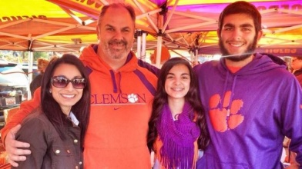 | Monda, Cam & Uzma  Amaan, Laila  116 Tally Ho Drive  Greenwood, SC 29649  (864) 953-0017  mondauc@embarqmail.com
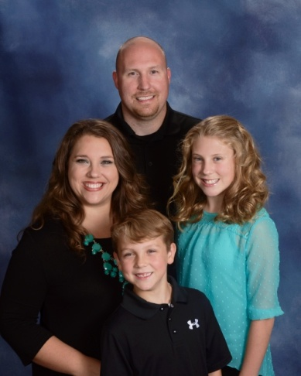 | Moore, Harley & Melissa  Zoe, Gavin  203 Forest Park Drive  Greenwood, SC 29649  (864) 2290778  hmzgmoore@emarqmail.com
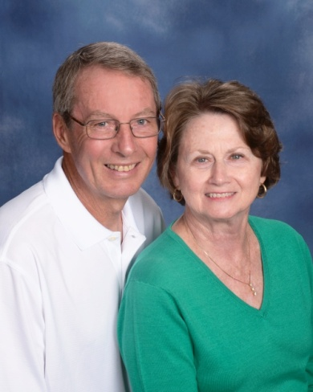 | Moore, Toby & Elaine  106 Brandon Drive  Hodges, SC 29653  (864) 374-7637  elainejonesmoore@yahoo.com
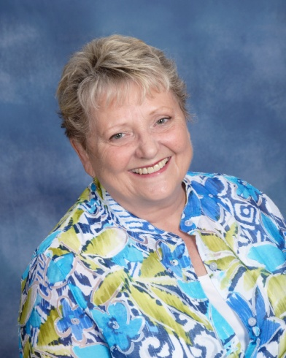 | Morgan, Pam  1221 Violet Court  Greenwood, SC 29649  (864) 227-8885  pam128@gmail.com
Morris, Ian
111 Court Square
Abbeville, SC 29620

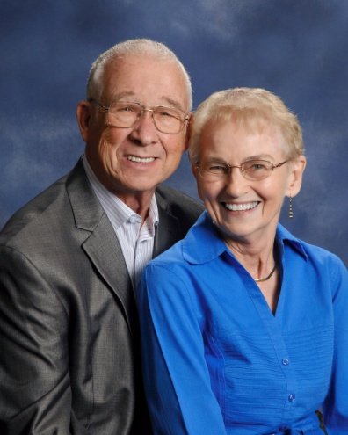 | Morse, Richard & Nancy  508 Nautical Way  Greenwood, SC 29649  (864) 227-8446  dicknansc04@gmail.com
Mosley, Heather
1707 E. Durst Avenue
Greenwood, SC 29649

(864) 229-3460

Moss Jr., J. B.
93 Beltline Road
Abbeville, SC 29620

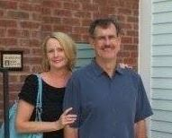 | Moss, Dr. Lewis & Holly  105 Deer Wood Lane  Greenwood, SC 29646  (864) 229-1506
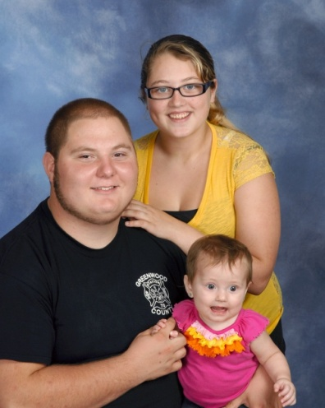 | Mullikin, Timothy & Brenanna  Aubree  727 Callison Road  Bradley, SC 29819  (864) 992-1742  efdff721@gmail.com
Murff, Frances
301 Hunting Road
Greenwood, SC 29646

(864) 223-5348

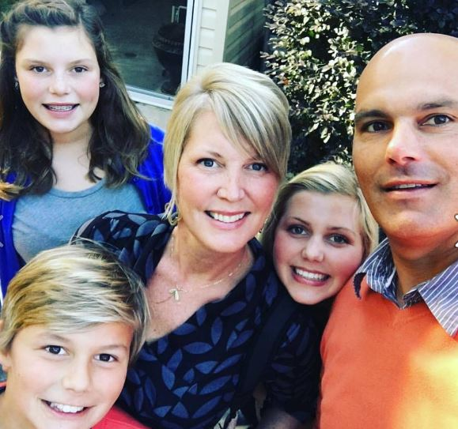 | Murray, Michael & Becca  Gloria Grace, Olivia, Beatty  317 Starboard Tack  Greenwood, SC 29649  (864) 270-3227
Nasrollahi, Sammy & Jan
Josh
133 Kingston Road
Greenwood, SC 29649

(864) 223-2279

Neeley, Dennis & Cornelia
110 Parkwood Road
Greenwood, SC 29646

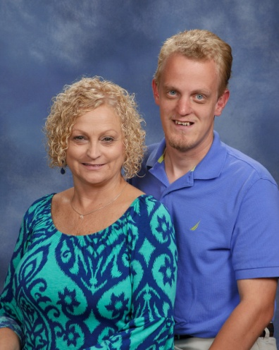 | Neighbors, Kim  Sam  218 Winding Creek Drive  Greenwood, SC 29649  (864) 993-2989
Nelson, Ray & Jamey
Andy, Philip
207 Rock Knoll Drive
Greenwood, SC 29649

New Jr., Ellis
Erin
638 Fairway Lakes Road
Greenwood, SC 29649

(864) 229-3498

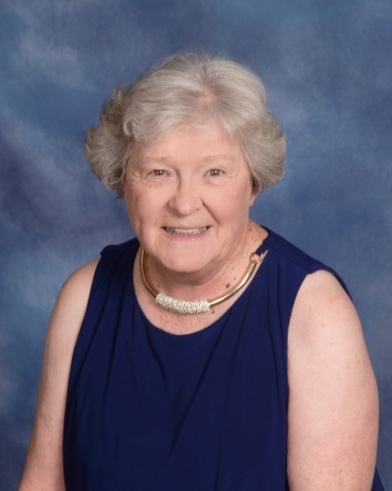 | Newman, June  123-4 Edinborough Circle  Greenwood, SC 29649  (864) 223-5171
Newton, Kevin & Hope
Bryan
P. O. Box 182
Waterloo, SC 29384

(864) 677-2828

Nicoletti, Mabel
113 Chatham Drive
Greenwood, SC 29649

(864) 229-4887

Nicoletti, Terri
105 Lanette Street
Greenwood, SC 29649

(864) 227-8171

Odell, Gayle
112 Devon Park
Greenwood, SC 29649

(864) 943-0905

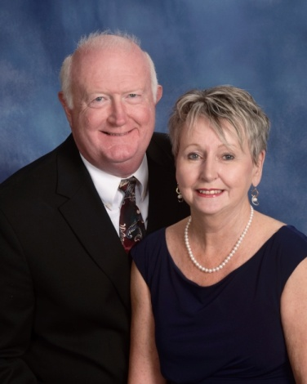 | O’Dell, Harold & Debbie  327 Green Oaks Road  Greenwood, SC 29649  (864) 941-3393  harold1217@embarqmail.com
Olson, Scott & Joy
Ella
209 Wentworth Drive
Greenwood, SC 29649

(864) 980-6203

Ott, Tim & Renee
Courtney, William, Chad
821 E. Deadfall Road
Greenwood, SC 29649

(864) 229-1932

Owen, Bob & Elizabeth
Jenna
106 Starboard Tack
Greenwood, SC 29649

(864) 223-2858

Owens, Ronni
101 Mistletoe Way
Greenwood, SC 29649

Owings, Steve & Margaret
Steven
167 Highland Drive
Greenwood, SC 29649

(864) 227-2711

Papke, Ray & Jannie
624 Grand Harbor Boulevard
Ninety-Six, SC 29666

(864) 543-1566

Park, Beverly
Wesley Commons
1110 Marshall Road
Greenwood, SC 29646

(864) 227-7406

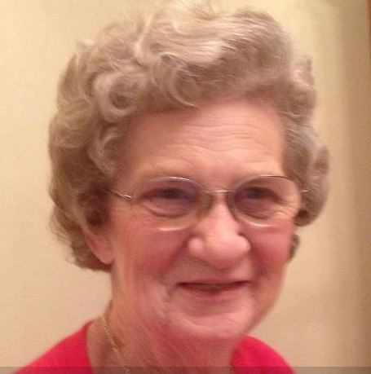 | Parkman, Hilda  115 Hill & Dale Drive  Greenwood, SC 29646  (864) 227-2542  hildaparkman@nctv.com
Parkman, Russell
4124 Pickens Creek Road
Hodges, SC 29653

(864) 374-9985

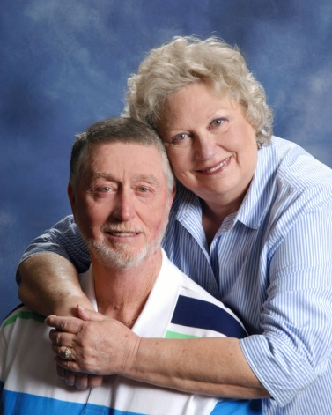 | Parnell, Olin & Millie  101 Carriage Court  Greenwood, SC 29646  (864) 388-9239  milliepster@gmail.com
Pate, Jim & Marie
Brad
128 Devon Park
Greenwood, SC 29649

(864) 229-5033

Patterson, Beth
P. O. Box 1252
Greenwood, SC 29649

Patterson, Brandon
107 Wenmount Court
Greenwood, SC 29646

(864) 942-0879

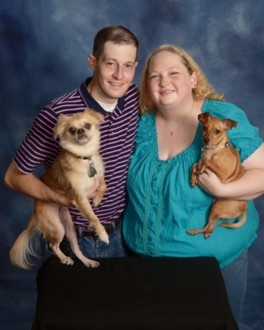 | Patterson, Carey & Monica  Gizmo, Daisy  1319 Hwy. 185 S.  Donald, SC 29638  (864) 379-8191  mnickles@hotmail.com
Patterson, Laura & Tracy
Evan
406 Chinquapin Road
Greenwood, SC 29646

(864) 229-1373

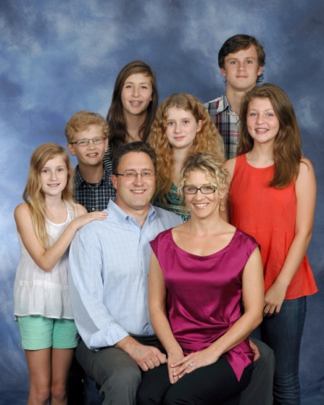 | Patterson Sr., Lee & Angie  Andrew, Caroline Cormeny, Margaret Cormeny, Annika, Amelia, Finn Cormeny  104 Hawthorne Court  Greenwood, SC 29646  (864) 228-8660
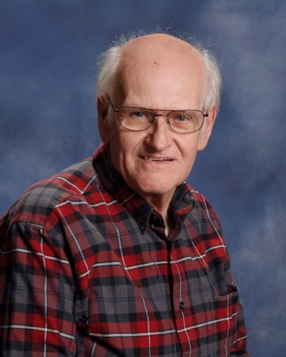 | Patterson, Randy  5352 Hwy. 72 W.  Calhoun Falls, SC 29628  (864) 3780294  rpatterson@wctel.net
Patton, Rick & Rosa
Rachel
114 Culbertson Court
Greenwood, SC 29649

Payne, Fred & Pam
411 Joe Wells Road
Greenwood, SC 29646

(864) 223-2292
paynpl@centurylink.net

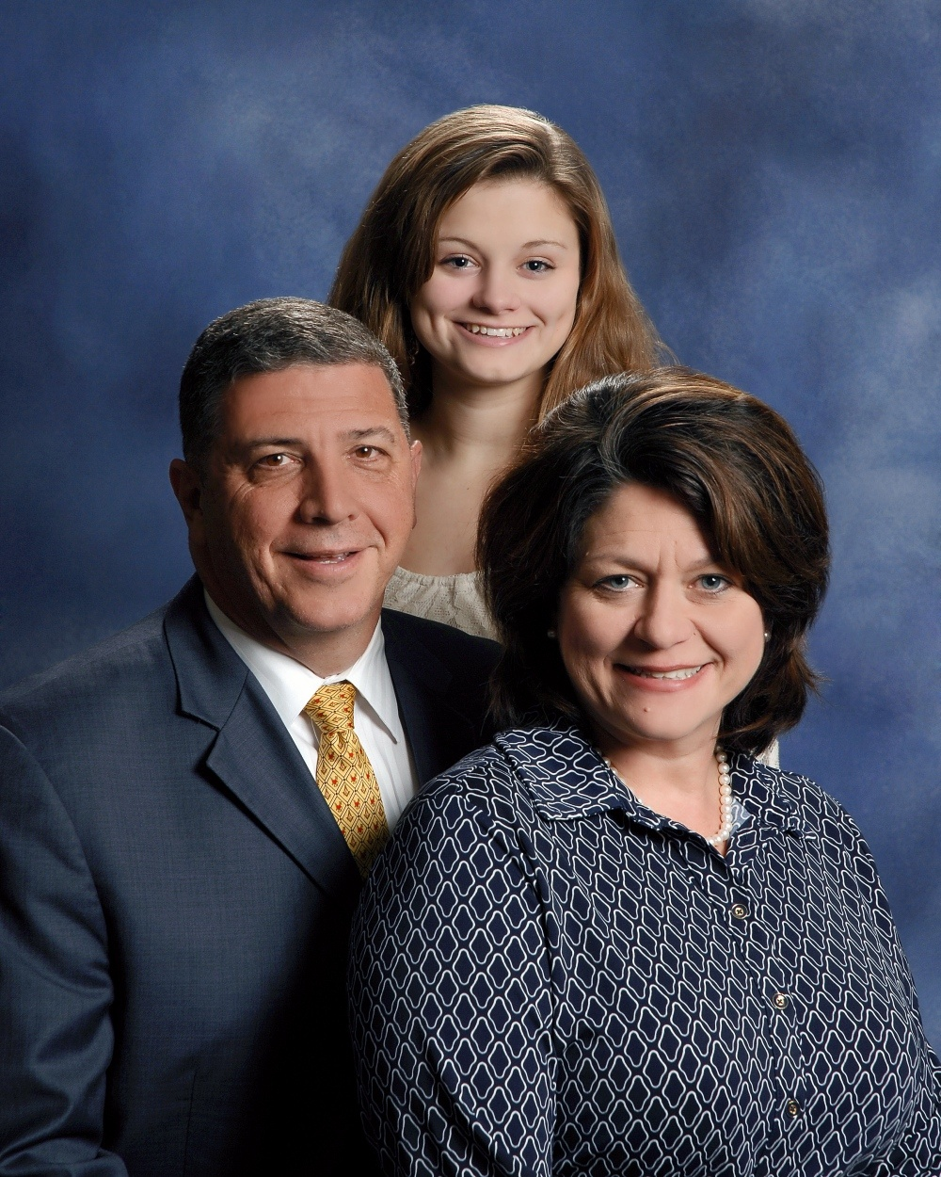 | Pearson, Jay Adam & Diana  Caroline  128 Abbey Court  Greenwood, SC 29649  (864) 227-1738
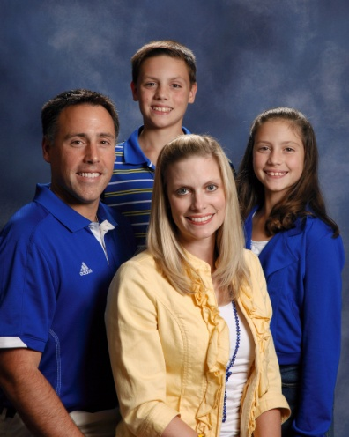 | Pederson, Kevin & Adair  Conner, Clary  112 Tifton Drive E.  Greenwood, SC 29649  (864) 992-2556  adairclaryped@yahoo.com
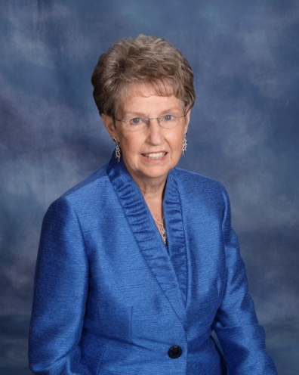 | Peebles, Sallie  110 Colonial Drive  Greenwood, SC 29649  (864) 229-2783  felnsal7@simplepc.net
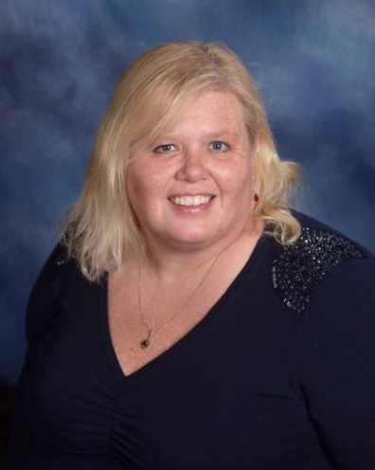 | Peksa, Annette  Banner  414 W. Kirksey Drive  Greenwood, SC 29649  (864) 279-8305  peksa.annette@gmail.com
Perkey, Robert & Jenny
Ashlynne
101 Mimi’s Manor
Greenwood, SC 29649

Perrin, Glenn and Alyson
Noah, Wiley, Sawyer
715 Fairway Lakes Road
Greenwood, SC 29649

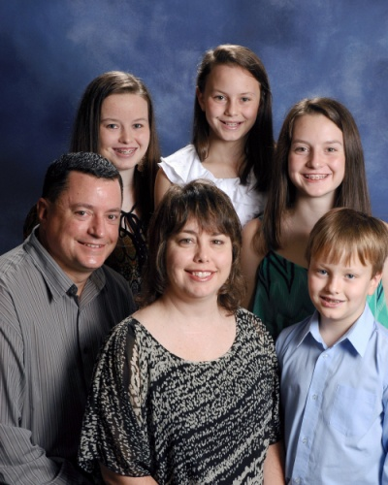 | Philcox, Todd & Christine  Meghan, Kynslea, Rhianna, Eric  119 Limerick Road  Greenwood, SC 29649  (864) 344-3393
Pierce, Betty
249 Oak Ridge Drive
Greenwood, SC 29649

Pippin, Chadd & Rhonda
Casey, Cody, Allison
110 Loblolly Circle
Greenwood, SC 29649

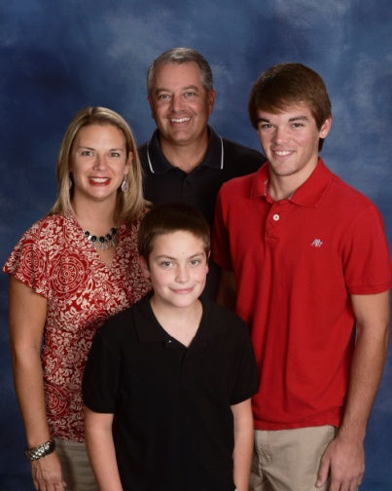 | Pitts, Billy & Meredith  Rylan, Landon  103 Barrett Drive  Greenwood, SC 29649  (864) 227-6757  thepitts@embarqmail.com
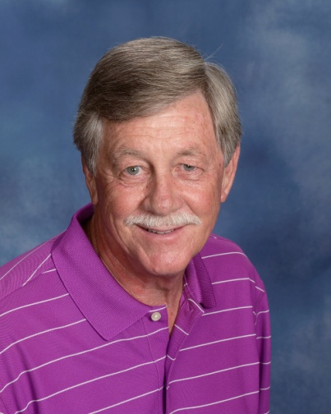 | Polatty, Ronnie  346 Tranquil Road  Greenwood, SC 29646  (864) 941-0238  ronniejoepolatty@hotmail.com
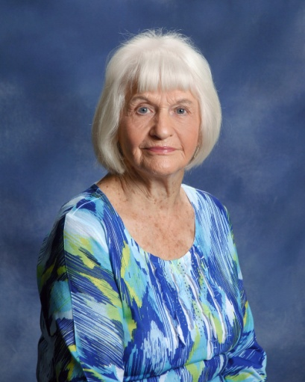 | Pollard, Dorothy  1632 Mathis Road  Greenwood, SC 29649  (864) 229-4044
Pollard, Tiffany
Kalyn James, Casey Abercrombie, Chase Abercrombie
1109 Durst Avenue E.
Greenwood, SC 29649

(864) 943-0465

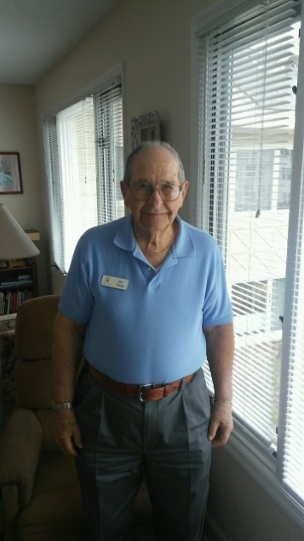 | Poole, Pat  Wesley Commons  1110 Marshall Road  Greenwood, SC 29646
Poore, Bryan & Christi
Kirsten, Kinsley
1103 Marshall Road
Greenwood, SC 29646

(864) 388-9572

Poore, Greg & Laura Beth
Caden
204 Andrews Avenue
Greenwood, SC 29646

(864) 227-9411

Poore, Nell
Chris
1102 Marshall Road
Greenwood, SC 29646

(864) 377-4004

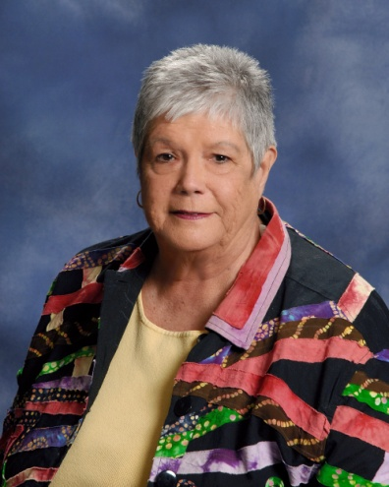 | Powell, Betsy  107 Mayapple  Greenwood, SC 29649  (864) 229-0555  bybetsy@centurylink.net
Powers, Mike & Jodi
6818 Hwy. 25 S.
Ninety-Six, SC 29666

Price, Carol
1103 Sweetwater Road
Greenwood, SC 29646

(864) 227-6608

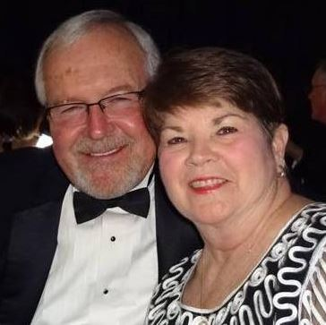 | Price Jr., Harold & Patsy  308 Fairway Lakes Road  Greenwood, SC 29649  (864) 227-2650
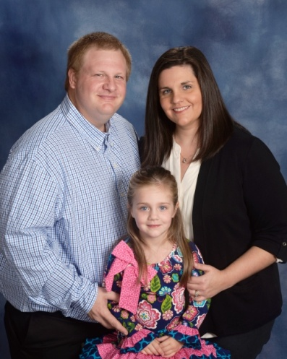 | Price, Jamie & Megan  Natalee  420 E. Grumling Road  Hodges, SC 29653  (864) 980-9465
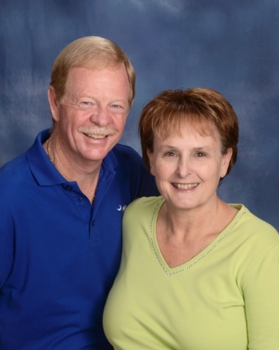 | Price, Ray & Jeannie  506 E. Grumling Road  Hodges, SC 29653  (864) 374-3669  jeanprice09@yahoo.com
Pridmore Jr., Bob & Paula
130 Kensington Drive
Greenwood, SC 29649

(864) 223-4486

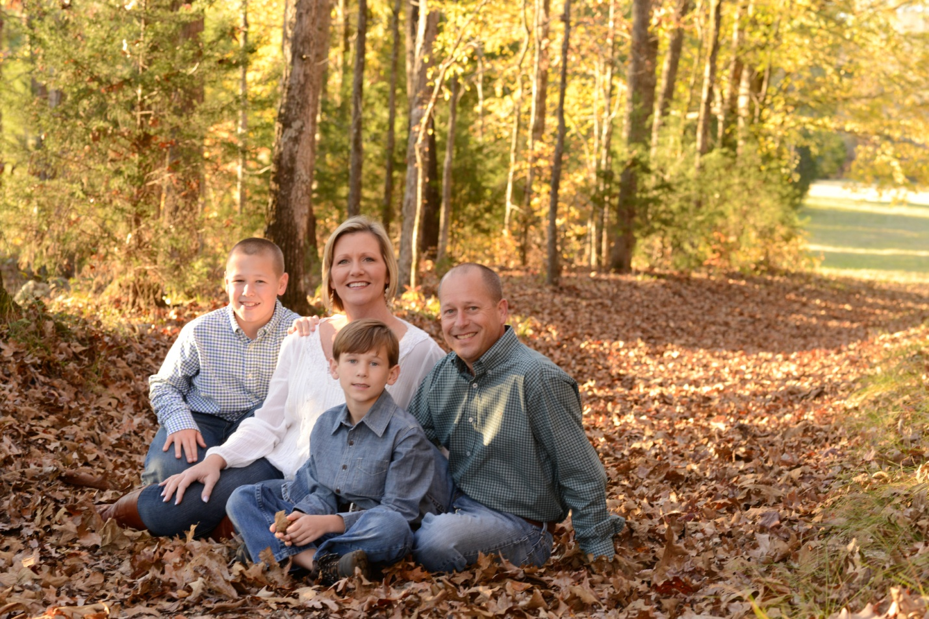 | Prince, Patrick & April  Wyatt, Adam  309 W. Creek Road  Greenwood, SC 29646-8518  (864) 942-7015  april.prince@parksterlingbank.com
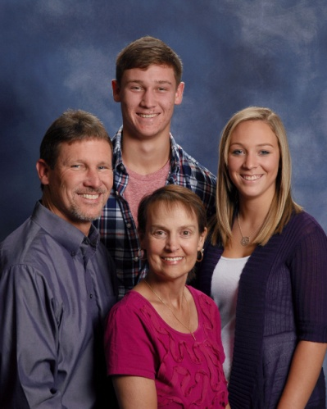 | Pruitt, Dayne & Traci  Megan, Brandon  18 Roxanna Drive  Ninety-Six, SC 29666  (864) 543-4000  dayne.pruitt@gmail.com
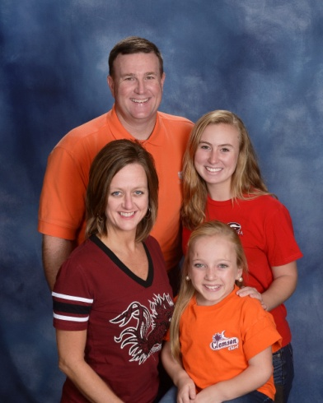 | Pundt, Carl & Carrie  Leann, Carlie  106 Fenwick Court  Greenwood, SC 29649  (864) 980-6373  cgpundt@embarqmail.com
Quattlebaum, Chad
204 Crestmont Drive
Greenwood, SC 29649

(864) 223-2944

Rambo, Barry & Sara
3892 Curltail Road
Bradley, SC 29819

Ready, Janet
3892 Curltail Road
Bradley, SC 29819

(864) 223-3035

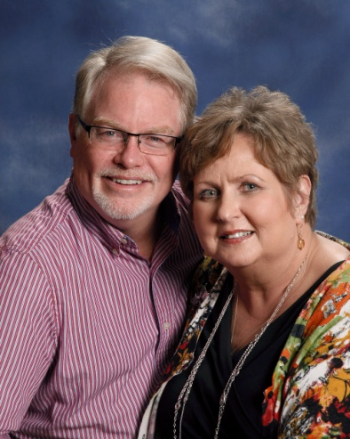 | Redfern, John & Taina  108 Burnham Court  Greenwood, SC 29649  (864) 992-2592  tainaredfern@embarqmail.com
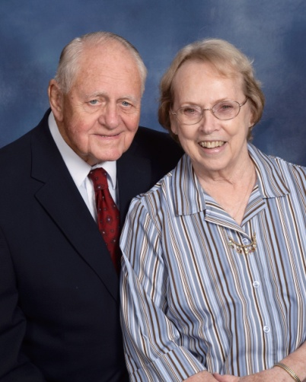 | Reece, Walter & Jenny  P. O. Box 307  Due West, SC 29639  wcrvcr@yahoo.com
Reese, Chad & Karen
133 Creek Road E.
Greenwood, SC 29646

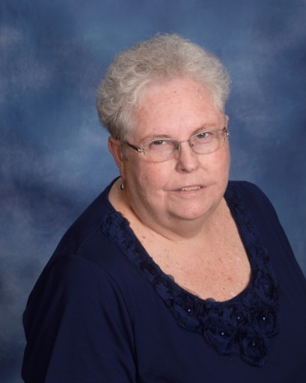 | Reighley, Faye  510 Marietta Drive  Greenwood, SC 29646  (864) 229-4646  freighley@emeraldis.com
Rhoads, Kent & Vickie
205 Swing About
Greenwood, SC 29649

(864) 227-8948

Rice, Frank and Skippy
Sam
302 Hatchers Pass
Greenwood, SC

Richey, Denise
1615 Mathis Road
Greenwood, SC 29649

Riley, Mel & Mary Ann
612 Cobb Road
Greenwood, SC 29649

(864) 229-1385

Roark, Hunter
Greenwood, SC 29649

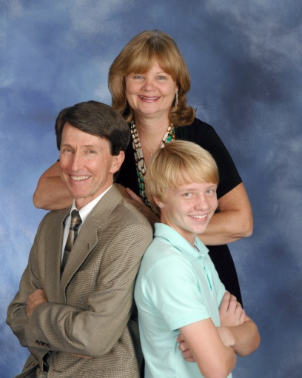 | Robinson, Coleman & Debra  Abigail, Zach  120 Partridge Road  Greenwood, SC 29649  (864-942-7132  debra@stmarkgreenwood.com
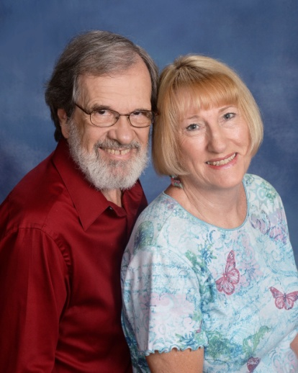 | Roby, John & Susan  209 Lakeview Drive  Greenwood, SC 29646  (864) 388-9987  jsroby@embarqmail.com
Rochelle, Carolyn
214 Laurel Ridge Way
Greenwood, SC 29649

Rochester, Wes and Elizabeth
Maggie, Susie
206 Evergreen Drive
Greenwood, SC 29649

Rodriguez, Micky
Schanen Palmerin
105 Biltmore Street
Greenwood, SC 29649

(864) 554-3337

Rogers, Vergil & Peggy
5314 Kinards Road
Ninety-Six, SC 29666

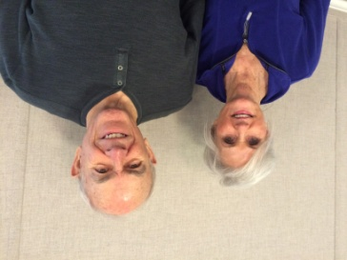 | Rollings, Jim and Deanna  101 Sand Trap Lane  Greenwood, SC 29649
Roper, Gary & Jane
301 Fairway Lakes Road
Greenwood, SC 29649

(864) 223-0957

Rork, Diane
115 Reedy Cove Lane
Greenwood, SC 29649

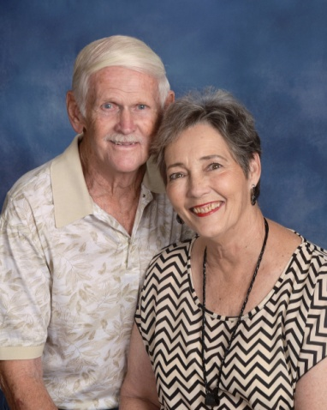 | Ross, David & Toni  110 Pin Oak Drive  Greenwood, SC 29649  (864) 229-4674  tpross@centurylink.net
Ross, Denise
Stan Getzelman, Clint Getzelman
306 Kelli Drive
Greenwood, SC 29649

(864) 229-0989
samandboo@embarqmail.com

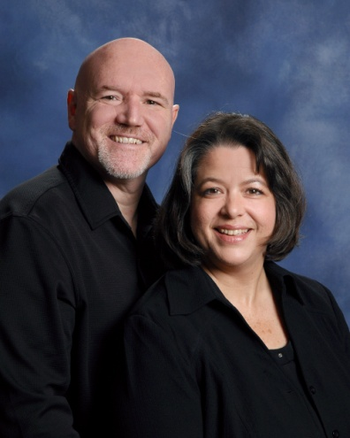 | Roy, Bob & Teresa  109 Hailey Court  Greenwood, SC 29649-2273  (864) 993-3192  troy@cornerstonecares.org
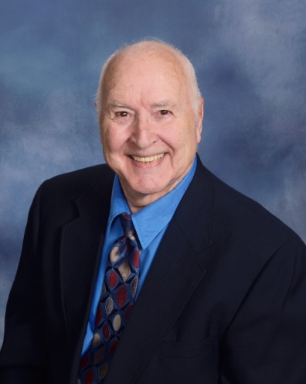 | Roy, Elmer  407 Lake Forest Road  Greenwood, SC 29649  (864) 223-8131
Rucker, Suzanne
308 Rivers Run Road
Greenwood, SC 29649

(864) 388-7864

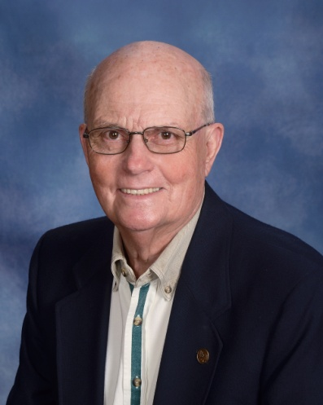 | Rush, Archie  122 Kings Grant  Greenwood, SC 29649  (864) 388-7969
Russell, Kim
412 Rivers Run
Greenwood, SC 29649

(864) 388-0494
kim9561@gmail.com

Rylander, Andrew & Mary
Griffin Medford
229 Chatham Drive
Greenwood, SC 29649

(864) 828-0349

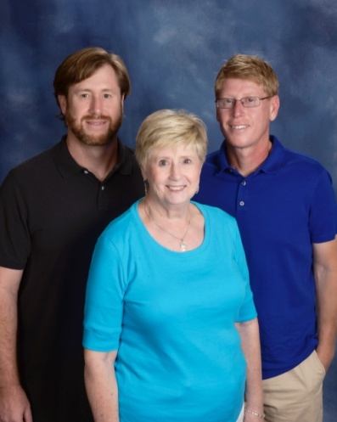 | Sample, Fay  Chris, Mike  207 Abbey Lane  Greenwood, SC 29649  (864) 992-3609  ffsamp2@yahoo.com
Sanders, Connie
122 Woodhaven Court
Greenwood, SC 29649

(864) 223-3774

Sanders, Stephen
122 Woodhaven Court
Greenwood, SC 29649

Sanders, Tim
P. O. Box 49037
Greenwood, SC 29649

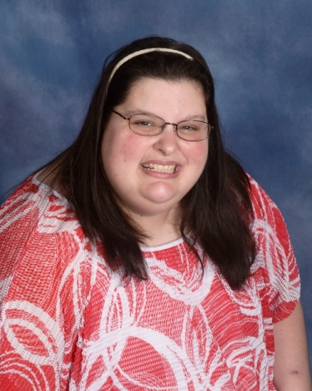 | Sartin, Danielle  136 Cambridge Avenue W.  Greenwood, SC 29646  (864) 941-7469  sherlyn7726@gmail.com
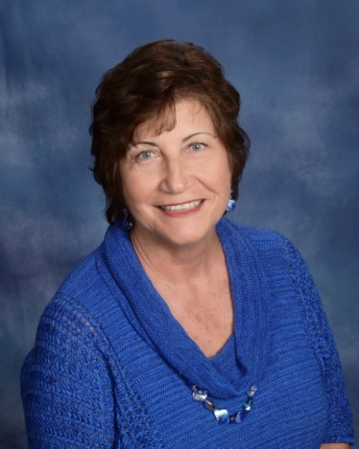 | Sauerwein, Linda  938 Central Shilon Road  Abbeville, SC 29620  (864) 446-2196  yochem@wctel.net
Scarborough, Ostell & Patti
225 Swing About
Greenwood, SC 29649

(864) 223-2360
Schmidt, Kathy
1005 E. Laurel Avenue
Greenwood, SC 29649

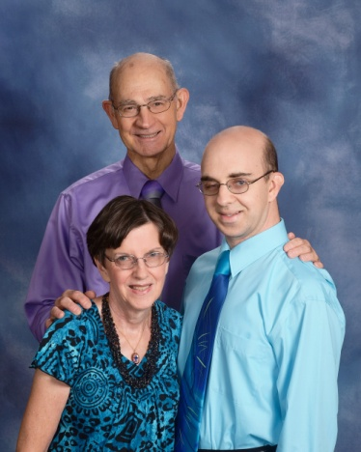 | Schwarzmann, Henry & Kaye  Karl  146 Kingston Road  Greenwood, SC 29649  (864) 229-2065  jkpschwarzmann@hotmail.com
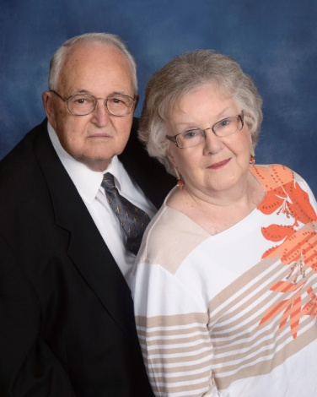 | Scott, W. O. & Sondra  950 Sunset Drive  Greenwood, SC 29646  (864) 223-7987  oimay@embarqmail.com
Scurry, Ro
204 Janeway
Greenwood, SC 29649

Scurry, Tricia
204 Janeway
Greenwood, SC 29649

Seagle, Vickie
P. O. Box 835
Greenwood, SC 29648

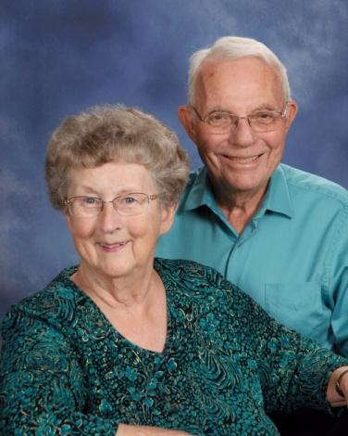 | Search, Bud & Mary  Wesley Commons  1110 Marshall Road  Greenwood, SC 29646  (864) 227-7416  searchparty@mywesleycommons.org
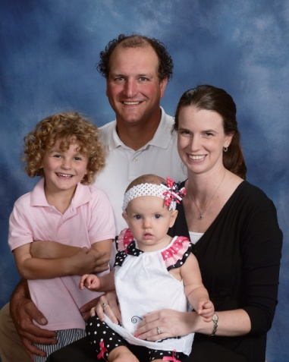 | Sears, Greg & Abbey  Jennings, Sophia  108 Kinkade Drive  Greenwood, SC 29649  (864) 388-7933  abbeycsears@yahoo.com
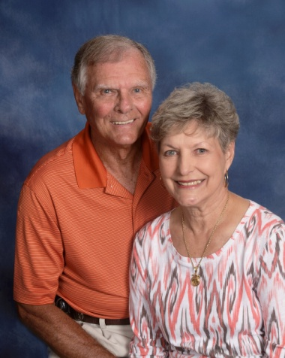 | Sears, Homer & Kaye  402 Marietta Drive  Greenwood, SC 29646  (864) 229-5066  kayefsears@yahoo.com
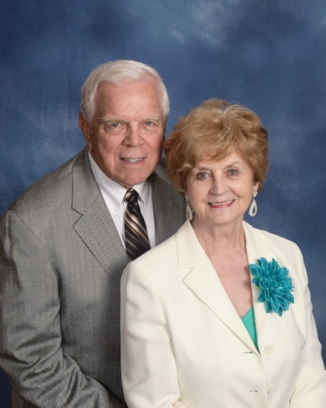 | Sease, Bill & Dawn  111 Rutledge Road  Greenwood, SC 29649  (864) 223-0194  billdawn@embarqmail.com
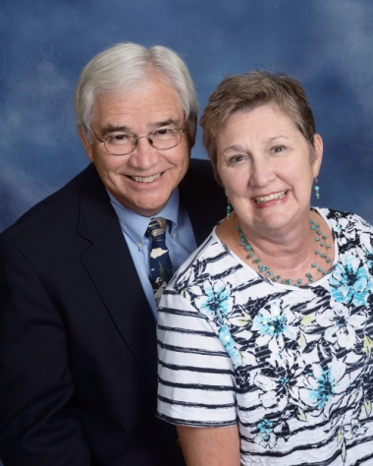 | Sexton Jr., Chuck & Jennifer  206 Moore Street  Greenwood, SC 29649  (864) 223-9713  chucksexton@embarqmail.com
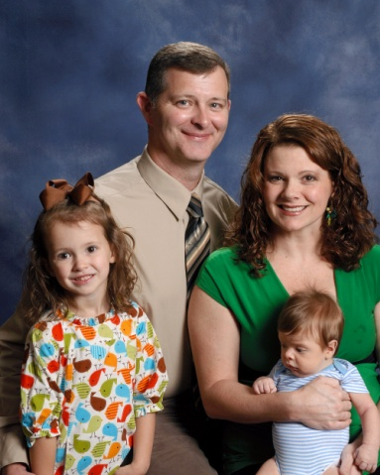 | Shaw, Eddie & Suzy  Annie, Jake  606 Woodland Street  Greenwood, SC 29649  (864) 554-4226  suzycshaw@yahoo.com
Shaw, Daniel and Haley
Mattie,Bailey, Tyler
137 Patrick Road
Greenwood, SC 29646

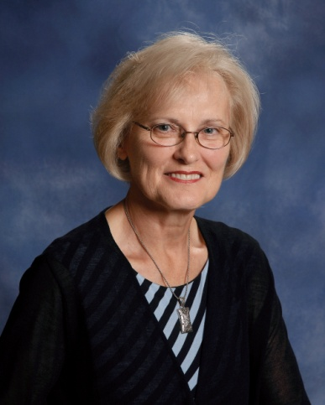 | Shelton, Shirley  116 Queens Court  Greenwood, SC 29649  (864) 984-9730  skip.shelton@gmail.com
Shepherd, Larry & Levelle
202 Flatwood Road
Hodges, SC 29653

(864) 337-5272

Shinall, Darrell & Sue
Ashley, Timmy
2832 Hwy. 25 N
Hodges, SC 29653

Shirley, Richard & Pegge
16 Lawton Street
Greenwood, SC 29649

Simmons, Judy
214 Abbey Lane
Greenwood, SC 29649

Skeen, Roger & Sandy
114 Creekside Court
Greenwood, SC 29649

(864) 223-0424

Skipper Jr., Lee & Holly
104 Bamboo Court
Greenwood, SC 29649

(864) 229-7220

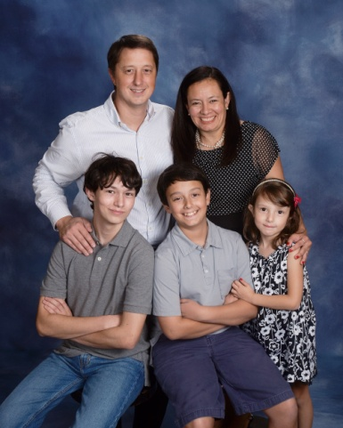 | Smathers, Ian & Tony  Michael, Patrick, Isabel  221 St. Augustine Drive  Greenwood, SC 29649  (864) 227-6016  smathem@centurylink.net
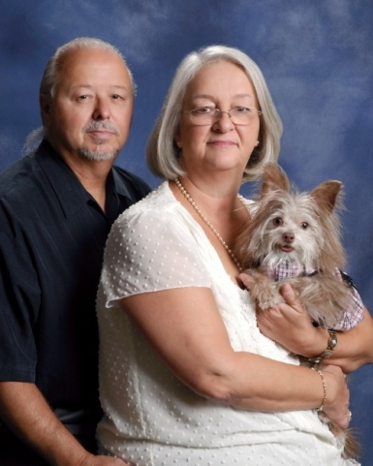 | Smathers, Jerry & Debbie  Rosie  114 Valley Road  Greenwood, SC 29646  (864) 223-9353  djsmathers@yahoo.com
Smeal, Jordan & Luann
1109 Northlake Drive
Greenwood, SC 29649

(864) 942-0253

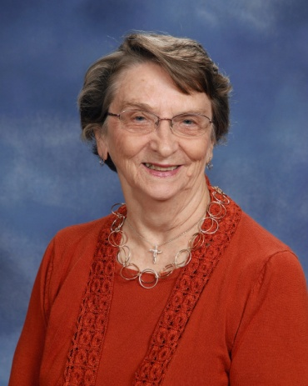 | Smith, Barbara Jean  224 Elm Court  Greenwood, SC 29646-2281  (864) 223-9474
Smith, Randy & Connie
201 E. Grumling Road
Hodges, SC 29653

(864) 374-3227

Smith, Ronney & Joan
Greenwood, SC

(864) 943-3376

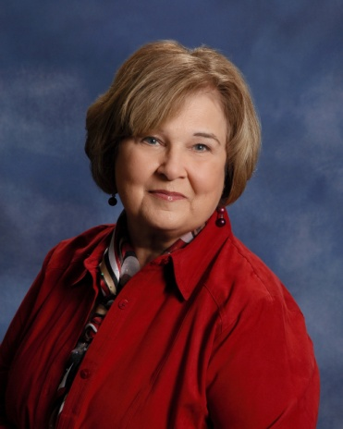 | Smith, Sandy  105 Mayapple  Greenwood, SC 29649  (864) 993-6989  sgs29649@gmail.com
Smith, Dr. Scott & Catherine
Zachary, Joshua, Elijah
502 Lodge Drive
Greenwood, SC 29646

(864) 223-8121

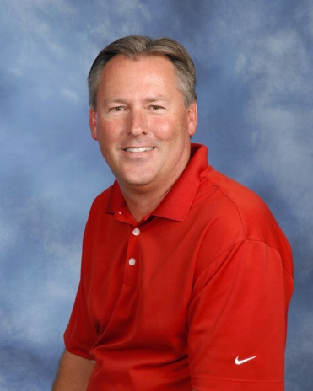 | Smith, Stan  125 Heathwood Drive  Greenwood, SC 29649  (864) 993-7850
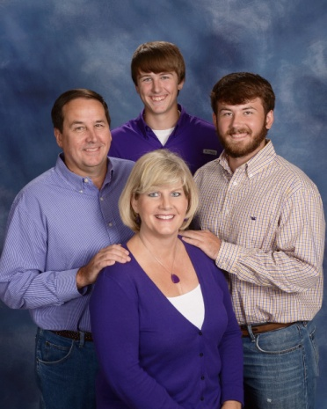 | Sparks, John & Kim  Brig, Brenden  110 Hillside Road  Greenwood, SC 29646  (864) 227-9569  skrapsk@embarqmail.com

Stafford, Jerri
124 Hatchers Pass
Greenwood, SC 29646

(864) 227-8194

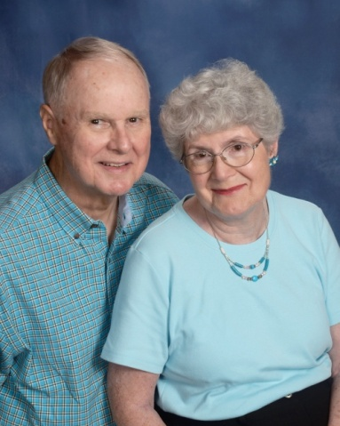 | Staley, Dale & Ann  111 Woodcrest Street  Greenwood, SC 29649-1664  (864) 223-4413  annsta@embarqmail.com
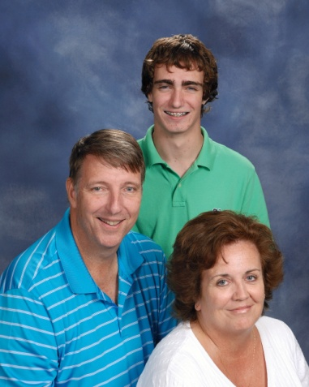 | Stallworth, Gray & Michelle  Ashleigh, Asa  103 Coosaw Run  Greenwood, SC 29649  (864) 223-1949  mstallworth2001@yahoo.com
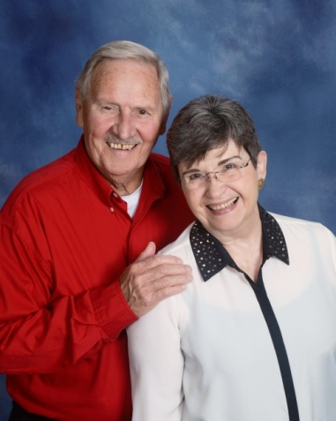 | Stanton, Tom & Paula  569 Ridgewood Drive  Waterloo, SC 29384  (864) 677-3947  pdstanton1@prtcnet.com
Steifle, Gregg & Ross Ann
Ashley, Brock
511 Colonial Drive
Greenwood, SC 29649

(864) 388-9015

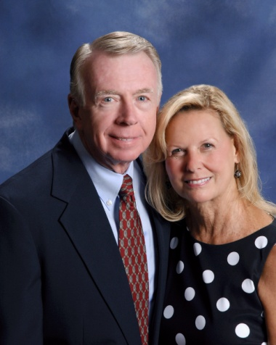 | Steifle, Neil & Jenelle  142 Roman Circle  Greenwood, SC 29649  (864) 223-2157
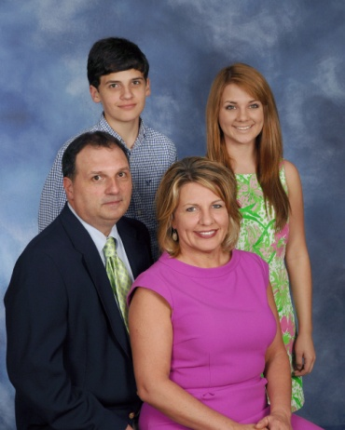 | Stevens, Greg & Christy  Julie, Reid  110 Twisted Oak Drive  Greenwood, SC 29646  (864) 229-2267  thestevens12@embarqmail.com
Stevenson, Mary
Wesley Commons
1110 Marshall Road
Greenwood, SC 29646

(864) 330-1301

Stewart, Kim
Jennie, Brad
106 Summerhill Drive
Greenwood, SC 29649

Stillwell, Ada
Wesley Commons, Apt. 5005
1110 Marshall Road, Box 175
Greenwood, SC 29646

(864) 227-7416

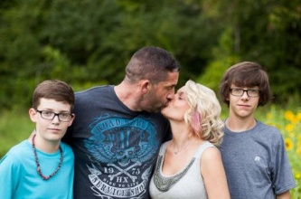 | Stockman, Trae & April  Thomas, Max  104 Winter Ridge Court, Unit G  Greenwood, SC 29649  (864) 992-5419
Stone, Clyde & Kimberly
Austin
130 Kensington Drive
Greenwood, SC 29649

(864) 223-4486

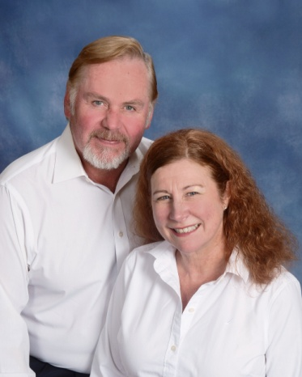 | Strawn, Chuck & T. J.  Wes, Jessica, Tess  103 Blue Heron Court  Greenwood, SC 29646  (864) 229-8069  tjstrawn@embarqmail.com
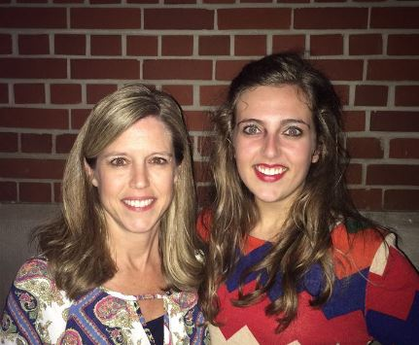 | Strickland, Amy  Lauren  117 Carriage Court  Greenwood, SC 29646  (864) 229-3598
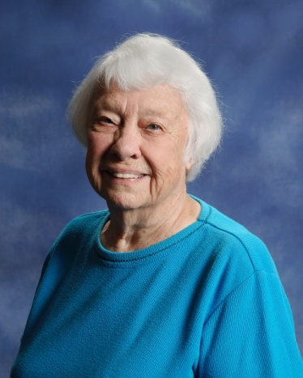 | Strom, Carolyn  115 Devon Park  Greenwood, SC 29649  (864) 223-6106

Strom, Steve
303 Lawton Street
Greenwood, SC 29646

(864) 229-3188

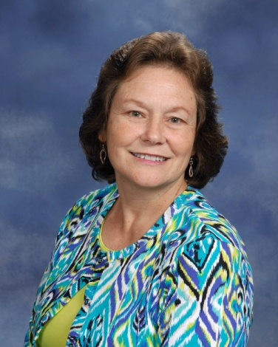 | Strom, Yvonne  315 Green Oaks Road  Greenwood, SC 29649  (864) 229-3188  yostrom@gmail.com
Strong, Jim & Carla
2106 Briarwood Road
Greenwood, SC 29646

Sutherland, George
108 Kennedy Court
Greenwood, SC 29649

(864) 223-0966

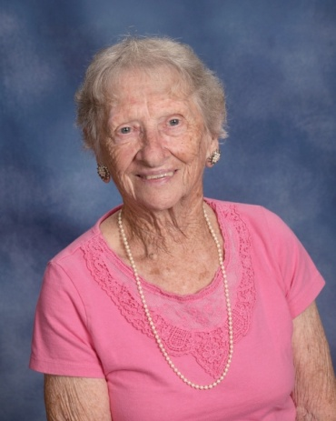 | Sutton, Sara  450 Dogwood Drive  Greenwood, SC 29646  (864) 223-7444
Svenningsen Sr., Tommy & Dana
Tommy
Waterloo, SC 29384

Swartzentruber, Adam & Jill
Mollie
140 St. Kitts Court
Greenwood, SC 29649

(864) 229-2525

Sweet, Ashley
203 Harvest Lane
Greenwood, SC 29649

(864) 223-5051

Swygert, Karen
Greenwood, SC

(864) 227-3179

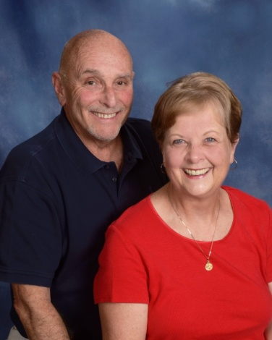 | Tabor, Mike & Betty  318 Driftwood Drive  Greenwood, SC 29649  (864) 992-7459  2tabors@gmail.com
Tafta, Tony & Shirley
111 Broken Ridge Court
Greenwood, SC 29646

Talbert, Martha (see McClain, Debbie)
444 Dogwood Drive
Greenwood, SC 29646

(864) 223-7016

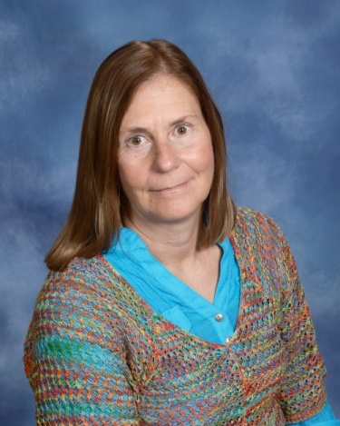 | Talcott, Betsy  Andy, Philip  201 Plantation Drive  Greenwood, SC 29649  (864) 229-6788  betsyft@yahoo.com
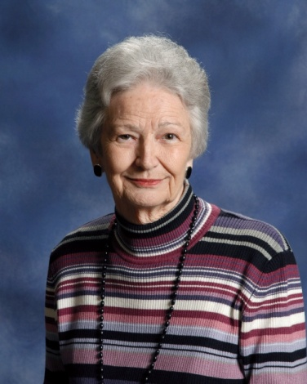 | Taylor, Carlyne  204 Cheekwood Road  Greenwood, SC 29649  (864) 388-0282
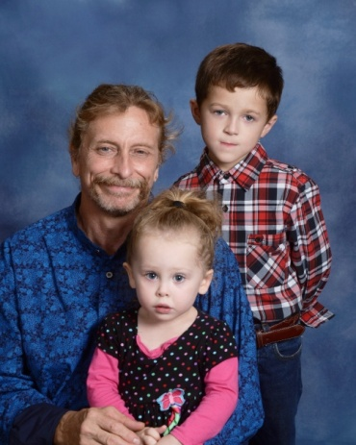 | Taylor, Chuck  Mark Watts, Arielle  3003 County Farm Road  Greenwood, SC 29646  (864) 341-4775  thechuckyt@hotmail.com
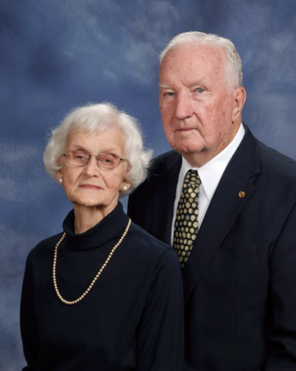 | Teeter, Fred & Barbara  108 Belcourt Drive  Greenwood, SC 29649  (864) 223-5000
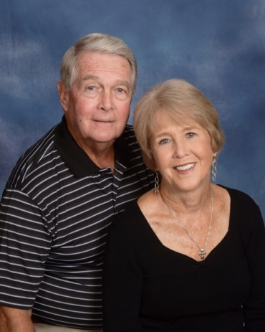 | Templeton, Bob & Mabel  105 Evergreen Drive  Greenwood, SC 29649  (864) 223-4677  mbtempleton@embarqmail.com
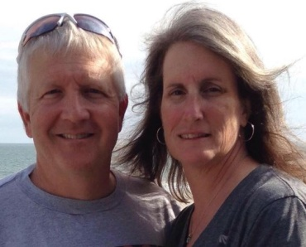 | Templeton Jr., Robbie & Robin  Reed, Ryan  210 Yosemite Drive  Greenwood, SC 29649  (864) 223-3585
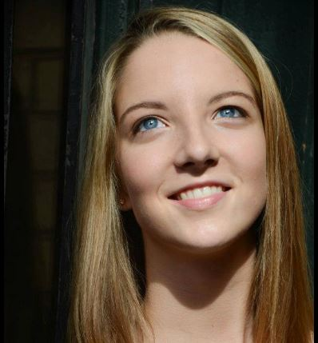 | Templeton-Bradley, Raine  833 Callison Road  Bradley, SC 29819
Thomas, Ken & Gloria
115 Egret Lane
Greenwood, SC 29649

(864) 229-0331

Timmerman III, Lynn
190 Old Douglas Mill Road
Abbeville, SC 29620

(864) 366-8983

Timmerman, Robert & Cach
Katelyn
123 Heathwood Drive
Greenwood, SC 29649

(864) 227-3955

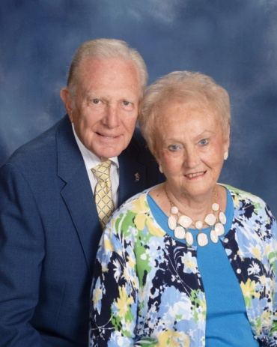 | Todd, Gene & Faye  114 Amherst Drive  Greenwood, SC 29649  (864) 229-4260  fayetodd59@gmail.com
Todd, Luke
212 Camelia Circle
Greenwood, SC 29646

(864) 942-0356

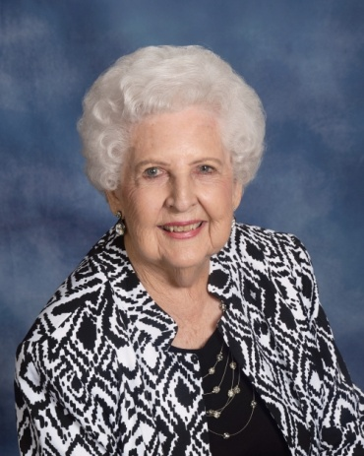 | Tolbert, Irene  308 Milford Springs Road  Greenwood, SC 29649  (864) 229-6492
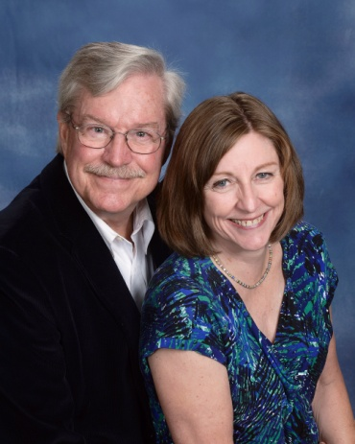 | Tolbert, Sam & Margo  115 Parkwood Road  Greenwood, SC 29646  (864) 992-0944  tolbert.margo@gmail.com
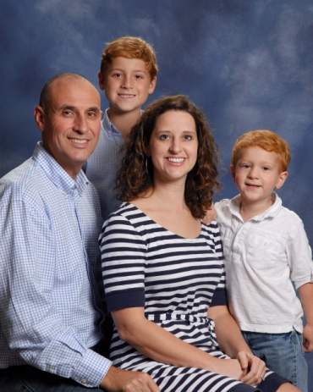 | Tompkins, David & Casey  Liam, Max  114 Sand Trap Lane  Greenwood, SC 29649  (864) 554-1083  dclmtompkins@gmail.com
Trammell, Rick & Cindy
Anna
2105 Woodlawn Road
Greenwood, SC 29649

(864) 229-7840

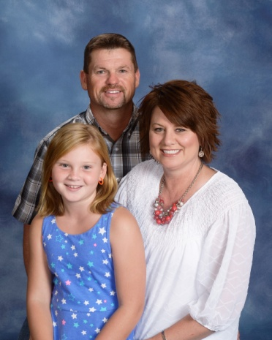 | Trasak, David & Robbie  Kinsley  1516 Old Abbeville Hwy.  Greenwood, SC 29649  (864) 223-9284  rtrasak@yahoo.com
Traynham, Jacob & Beth
Jennifer, James
Greenwood, SC 29649

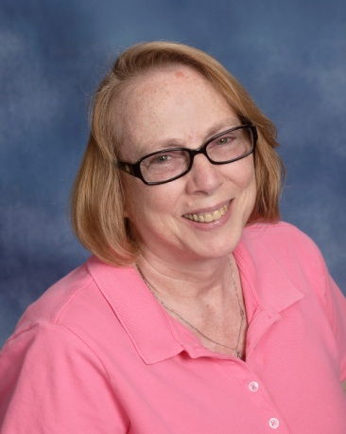 | Trevino, Cathy  111 Siloam Acres Drive  Greenwood, SC 29646  (864) 992-2228  cathyt24@yahoo.com
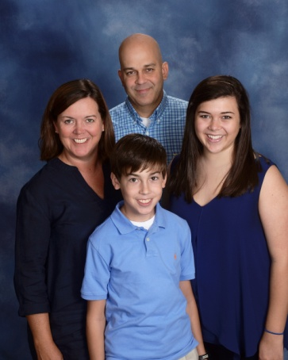 | Tripp, Chris & Missy  Madison, Andrew  115 Greenside Drive  Greenwood, SC 29649  (864) 388-0100  tripp@embarqmail.com
Turner, Allen & Emily
Sara Myles
811 Sunset Drive
Greenwood, SC 29646

Underhill, Thomas & Trieste
Emily, Stephen
183 Old Woodlawn Road
Greenwood, SC 2946

Vail, Scott
Jeff
Greenwood, SC

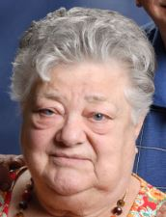 | Valkenburg, Jenny  119 Creek Road E  Greenwood, SC 29646  (864) 223-0987
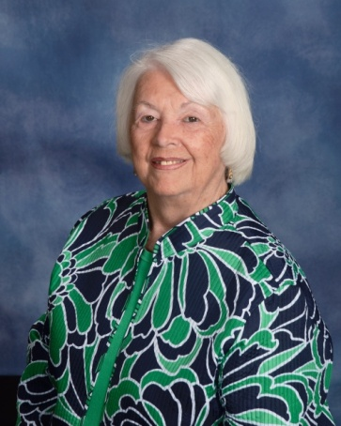 | Vaughn, Jeanette  422 Sagewood Road  Greenwood, SC 29646  (864) 223-7352
Vaughn, Neal
128 Cherokee Drive
Greenwood, SC 29649

(864) 229-7038

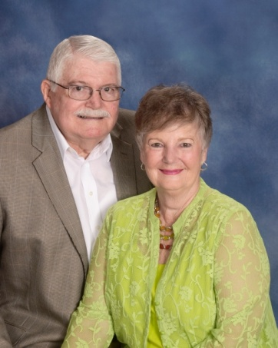 | Wade, Bobby & Gaynell  107 Windsor Oaks  Greenwood, SC 29649  (864) 223-8275  boblw@simplepcdsl.com
Walden, Kenneth & Paige;
Way, Alex, MacKenzie, Avery
207 N. Hill Road
Greenwood, SC 29646

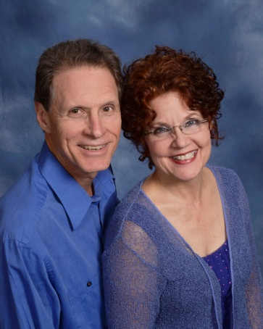 | Waldrep, Brian & Denise  318 Creek Road W.  Greenwood, SC 29646  (864) 223-9440  dwaldrep@simplepc.net
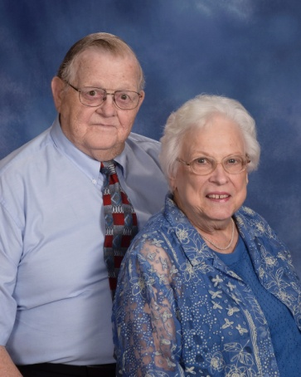 | Waldrep, Frank & Lorene  106 Evergreen Drive  Greenwood, SC 29649  (864) 229-5049  lfwaldrep@simplepc.net
Waldrep, Todd & Sara
Savannah, Niles
114 Summitt St.
Greenwood, SC 29649

(864) 227-3195

Waldrop, Ragen & JC
103 Thames Court
Greenwood, SC 29649

Walker, Iris
Wesley Commons
1110 Marshall Road
Greenwood, SC 29646

Walker, Mary Beth
2909 County Farm Road
Greenwood, SC 29646

Ward Jr., Grant & Frances
106 Crescent Drive
Greenwood, SC 29649

Ward III, Trey & Ann
Jack, Harriet
304 Stonewood Drive
Greenwood, SC 29649

(864) 993-4227

Warner, Mark & Teresa
15 Central Avenue
Honea Path, SC 29654

(864) 369-2320

Watkins, Anne
18911 Hwy. 76 W.
Honea Path, SC 29654

(864) 377-0329

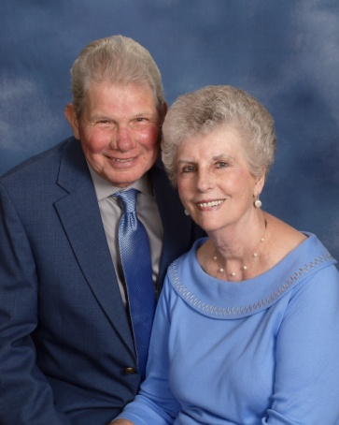 | Watkins, Charles & Helen  116 Greenbriar Drive  Greenwood, SC 29649  (864) 223-5395  hcwatkins@embarqmail.com
Watkins, Chrystal
Jon Preston Medlin
18911 Hwy. 76 W
Honea Path, SC 29654

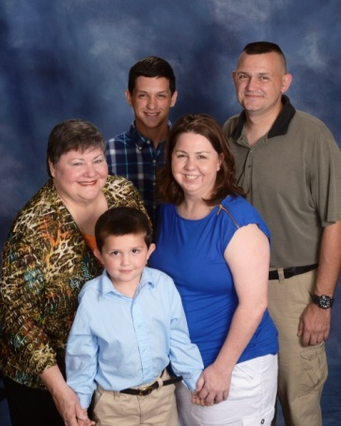 | Watkins, James & Paula  Bret, Jackson, Zoe Kolar  109 N. Hill Road  Greenwood, SC 29646  (864) 554-2216  ervetchick@yahoo.com
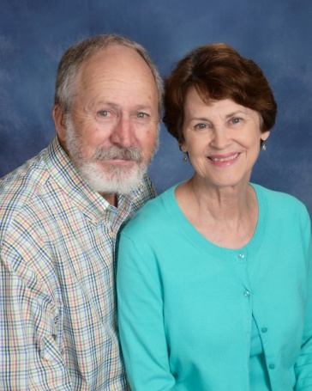 | Watkins, Tom & Betsy  126 Laguna Lane  Greenwood, SC 29646  (864) 223-4734  etwwatkins@gmail.com
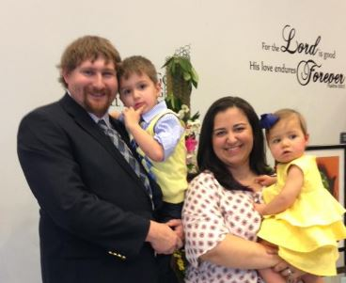 | Watts, Christopher & Sally  Isaiah, Zoe  chris@stmarkgreenwood.com
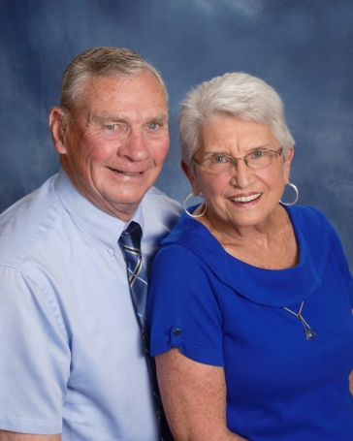 | Wedeking, Bill & Carolyn  101 Thornhill Road  Greenwood, SC 29649  (864) 223-1439
Weeks, Chris & Freeda
1403 Woodlawn Road
Greenwood, SC 29646

(864) 229-2948

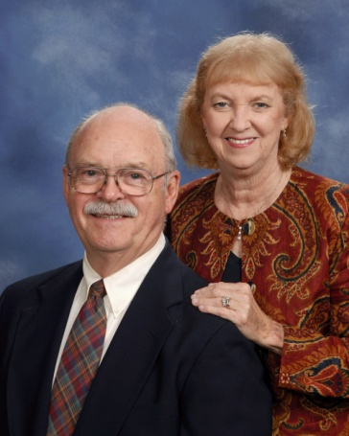 | West, Al & Jane  203 N. Acres Road  Greenwood, SC 29649  (864) 980-7212  aljwest@earthlink.net
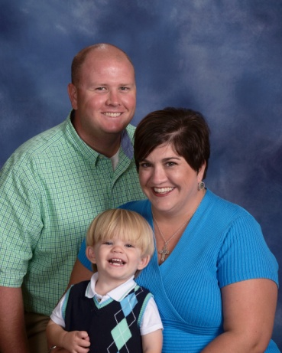 | Westmoreland, Brandon & Stacie  Max  407 Bond Avenue  Greenwood, SC 29646  (864) 941-7546  staciewestmoreland@gmail.com
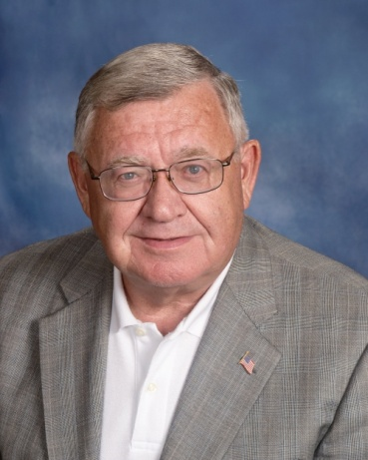 | Wheeler, James  122 Orchard Park Drive  Greenwood, SC 29649  (864) 337-5412  wheelerjm83@yahoo.com
White, Betty
104 Country Village Court
Greenwood, SC 29649

(864) 229-1981

White Elyse
123 Country Village Court
Greenwood, SC 29649

(864) 979-4341

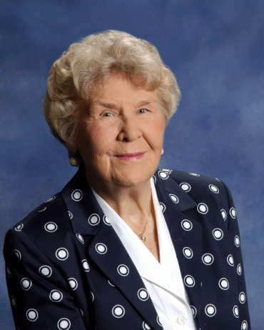 | Whitlock, Helen  125 Pin Oak Drive  Greenwood, SC 29649  (864) 223-8658
Will, Todd & Michelle
Nicholas, Lindsey, Tyler
114 Surrey Court
Greenwood, SC 29649

(864) 227-5242

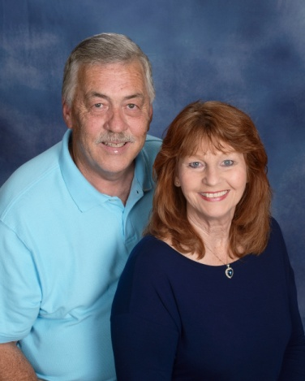 | Williams Jr., Mike & Pat  100 Windsor Oaks Court  Greenwood, SC 29649  (864) 980-4001  mfwilliams@earthlink.net
Williamson, Perryne
123 Lollie Road
Greenwood, SC 29649

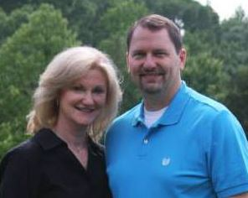 | Willis, Mike & Angie  110 Heritage W. Court  Greenwood, SC 29649
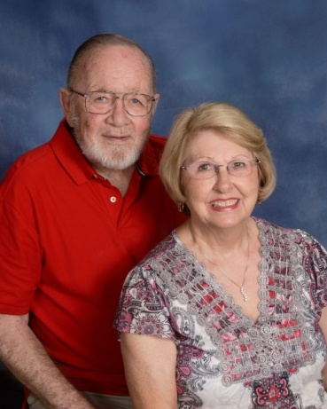 | Wilson, Jerry & Sandy  131 Bridge Point Road  Greenwood, SC 29649  (864) 223-4739  jwilson@greenwood.net
Wilson, Jim & Aundrea
108 Mayapple
Greenwood, SC 29649

(864) 223-3204

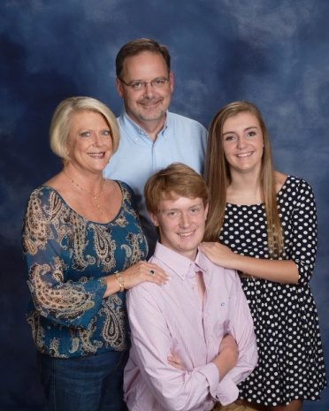 | Wilson, Tod & Cheryl  Brock, Hayden  115 Limerick Road  Greenwood, SC 29649  (864) 227-0924  wilson2@simplepc.net
Winchester, Brandon and Tara
Wells, Kayla
409 Bent Creek Road
Greenwood, SC 29649

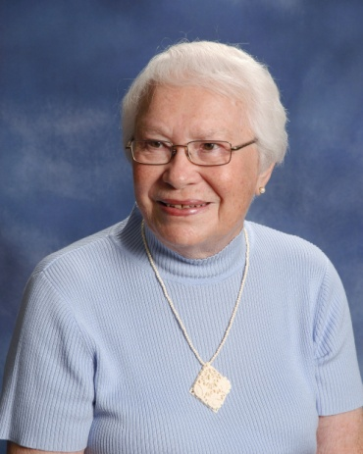 | Witte, Jeanne  Wesley Commons  1110 Marshall Road  Greenwood, SC 29646  (864) 227-7343  jwitte@mywesleycommons.org
Wood, Clint Douglas &Tracy
Erica, Paige
204 Lakewood Drive
Greenwood, SC 29649

(864) 223-4770

Woods, Ken & Bo
Mallory Hull
101 Wentworth Drive
Greenwood, SC 29649

(864) 992-6310

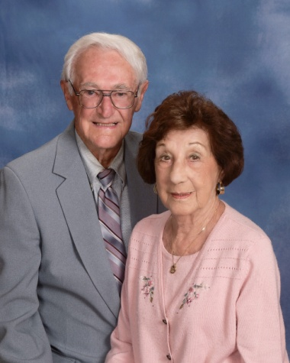 | Worthington, Joe & Millie  604 Old Abbeville Hwy.  Greenwood, SC 29649  (864) 229-7471
Wright, Robin
138 Shearbrook Drive
Greenwood, SC 29646

(864) 227-1617

Yassney III, Joe
126 Country Club Drive
Greenwood, SC 29646

(864) 223-4825

Young, Andrew & Wendi
Sara Beth, Annie, Palmer
5021 Hwy. 221 S.
Bradley, SC 29819

(228) 365-8026
wendi0312@gmail.com

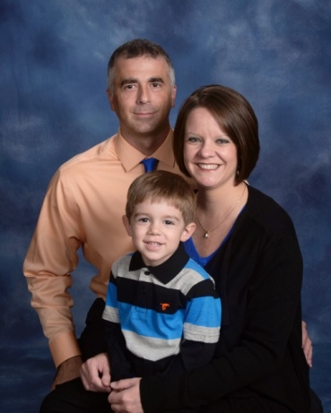 | Young, Jeff & Beth  Bradley, Dylan  107 Country Village Court  Greenwood, SC 29649  (864) 227-1730  beyoung926@gmail.com
Young, Jordan & Jacque
Addie
3192 Gwin Oaks Drive
Lawrenceville, GA 30044

Zehr, Russell & Sandra
120 Devon Court
Greenwood, SC 29649

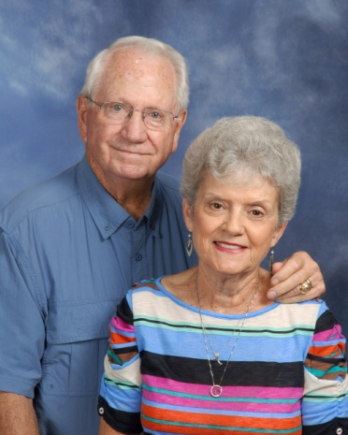 | Zittrouer, Sam & Gene  426 Herndon Drive  Ninety-Six, SC 29666  (864) 543-2591  samzsc@yahoo.com

