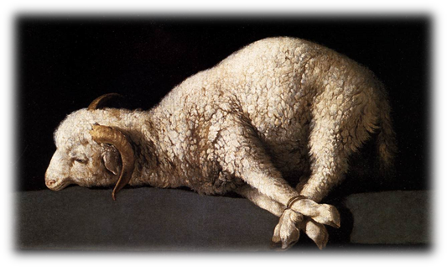
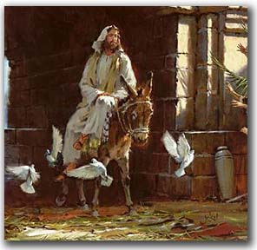
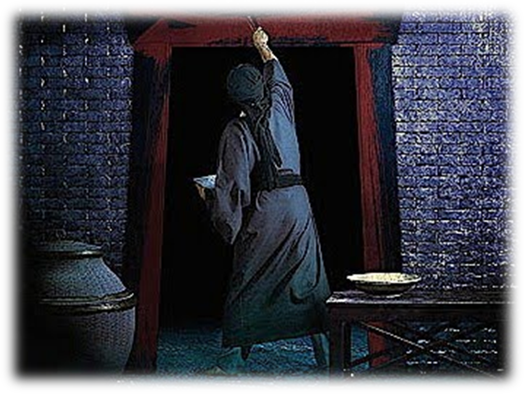
הגדה של פסח
DeuTERONOMY 16:1 Observe the month of Abib, and keep the passover unto Yahweh yOUR Elohim: for in the month of Abib Yahweh yOUR Elohim brought thee forth out of Egypt by night.
Israelite
Passover
Seder
Order of the Passover Seder

Introduction 1-3
Passover Seder 4-23
Lighting Candles, Blowing the Shofar 4
1st Cup: Sanctification 4
Foot Washing 6
'Karpas': The Dipping of the Parsley 7
Unleavened Bread 9
Bitter Herbs 10
The Charoset 11
The Questions 12
Magid - The Story of the Passover 13
2nd Cup: Plagues/ Judgment 15
The Zoroah (Shank Bone of the Lamb) 17
Preparation for the Meal ~Break~ 18
3rd Cup: Redemption 19
Grace After Meal 20
Hallel 20
4th Cup: Praise/ Restoration 22
Song of Praise 22
Conclusion 23
Acceptance Prayer 23
Notes 24
Return of the Remnant
www.returnoftheremnant.com

*We realize that some people may feel uncomfortable saying the Name ‘LORD’, ‘Adonai’, ‘Hashem’, or ‘Yahweh’. We leave it up to your convictions as we go through the Seder in regards to how each one of us pronounces the Name of Elohim (G-d). We are all here as one body under our Messiah and judge no one in regards to the ‘correctness’ of the ‘Name’.
Introduction:
Tonight we are gathering together to celebrate the Passover, which is the First of all the Biblical Feasts. It marks the beginning of the Hebrew calendar (see Exodus 12:1, 2). The Biblical background is found in Exodus 12, 13, and 14. The seven annual Biblical Feasts of יהוה are a practical teaching tool that Elohim (G-d) gave His people, for us to learn who He is. Together they form a picture of Yahshua (Messiah) and the work of the Ruach HaKodesh (Holy Spirit), as they tell the story of His death, resurrection, giving of the Ruach HaKodesh, the judgment to come, the return of Yahshua, and the reign of His Kingdom on earth.

We are instructed by יהוה, through Moses, to keep this as a Feast to יהוה and to remember that which יהוה has done for His people Israel by bringing them out of the house of slavery and into freedom. We are instructed by Yahshua to keep this as a Feast to יהוה and to remember that יהוה has brought us out of the slavery of sin and has given us eternal life.

Each person keeping The Feast is to believe that יהוה is passing over him personally in his heart. As believers of Yahshua, we are also to remember the death, burial, resurrection of Yahshua until He comes. To accomplish all of this we have set our table in a special ceremonial way. Each guest has been given a specific place to observe The Feast. In the same manner, Yahshua is preparing a specific place for us in His Kingdom. Let us, therefore, observe this Feast of Unleavened Bread as special and set apart.

Seder is the Hebrew word for order; it is an ordered service. This basic Seder is celebrated worldwide by many this very evening. The aim of the Passover Seder is to bring the story of the Exodus out of the past and into the present so that each person, young and old, will be made to feel as though he personally has come up out of the land of bondage.

There was only one Passover. There was only one occasion when the blood was applied to the doorposts and lintels of believing homes. And, only once did יהוה go through Egypt to smite the firstborn where the blood was not applied. So, according to Exodus 12:14, every succeeding Passover was to be a memorial or remembrance of the first Passover. We understand this first Passover also looked forward to Yahshua, the Passover Lamb of Elohim. As Colossians 2:17 instructs, it is also a shadow of our complete redemption.

The word Haggadah meaning “telling” is the recounting of the story of the Exodus to an assembled household. Tonight we are that assembled household. Exodus 13:8 gives the Biblical precept for the whole service of Passover . . . “On that day tell your son, ‘I do this because of what יהוה did for me when I came out of Egypt.’” In every generation, every person should feel as though he himself made the journey from Egypt. Our goal is to bring the story of the Exodus out of the past and into this evening so that you will picture yourself leaving Egypt.

This Haggadah retells the story of redemption that Elohim provided for His people Israel, and also tells the redemption of “grafted in Israel” through the death, burial, and resurrection of Messiah, Yahshua. Remember the theme of the Passover – redemption.

Preparation for Passover: The Search for Leaven
The search for leaven is completed the night before the Seder meal. According to Exodus 12:19, 20, all leaven was to be removed from the house. Leaven is symbolic of sin. The search for leaven symbolizes our personal cleansing of mind and body from sin. We must search our hearts, deeds, and words for any sinful act or attitude that must be removed. I Corinthians 5:6-8 states, “Your boasting is not good. Do you not know that a little leaven leavens the whole lump of dough? Clean out the old leaven, that you may be a new lump, just as you are in fact unleavened. For Messiah our Passover also has been sacrificed. Let us therefore celebrate the feast, not with old leaven, nor with the leaven of malice and wickedness, but with the unleavened bread of sincerity and truth.”

It was during the days of the casting out of leaven that Yahshua entered the Temple and cast out the moneychangers. In so doing the Master kept the command of cleansing the home by cleansing His Father’s house of leaven, or sin.

Let us begin our Seder to commemorate this special day, Passover.
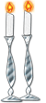

1. Lighting of the Festival Candles

Leader: “The mother or woman of the house lights the candles, thus signifying that the home is ready for the Passover. By this act, we see that the Light of the World has entered the world by the flesh of a woman.”

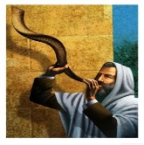
Woman: “Blessed are You, O יהוה our Elohim, King of the Universe. You have sanctified us by Your Living and Written Word, and now we kindle the Festival lights. Blessed are You, O יהוה our Elohim who has kept us in life, and has preserved us, and has enabled us to reach this Passover season.”

2. Blowing of the Shofar:

Reader: Psalm 81:3-4 states, "Sound the ram's horn on the day of the new moon, and on the day of the full moon when our festival begins. For observing the festival is a requirement for Israel; it is an ordinance given by the God of Jacob.
(Blow the Shofar)
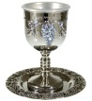
3. The First Cup: The Cup of Sanctification

Leader: “The Passover has begun. During the course of our Seder we will drink from our cups and replenish them four times. Please wait to drink of the cup until you are instructed to do so. We will be using grape juice in place of the wine. Nobody should pour their own juice, but rather each person should pour for one another – in other words, we are freed (redeemed), yet we learn the role of a servant. Please pour for the person on your left now, and wait to drink.”

Reader: The Kiddush, or sanctification prayer (from the word kadosh or holy) is the traditional prayer that sums up the significance of a season. The 1st cup on Passover is known as the cup of sanctification.

Leader: Blessed are You O יהוה our Elohim, King of the Universe, Who chose us from among all people, and sanctified us in Your Word. In love, You gave us appointed seasons for joy and gladness, and this day, the feast of unleavened bread, the time of our freedom, a holy convocation, a memorial to the greatness of Your salvation. For You have chosen us and You have sanctified us from all peoples, and Your Word is true and stands forever. Blessed are You O יהוה, Who sanctifies believers and the time of our freedom. Amen.

Reader: The four cups are based upon the “I wills” found in Exodus 6:6-7: “I will bring you out from under the burdens of the Egyptians, and I will deliver you from their bondage. I will also redeem you with an outstretched arm and with great judgments. Then I will take you for My people and I will be your Elohim; and you shall know that I am the יהוה your Elohim, who brought you out from under the burdens of the Egyptians.”

All: “Let us set this day and dinner apart from all other days and meals of this year. Let us lift our glass and say the blessing over the cup.

All: say the blessing~

“Baruch Atah Adonai Eloheinu melech ha’olam borei p’ri hagafen. Amen.”

“Blessed art Thou, O LORD our God, King of the Universe, who Creates the fruit of the vine. Amen”

All: Holy Father, we bless You for sanctifying us, and making us holy through Your Son, Messiah Yahshua, the perfect Lamb of Elohim. Amen.
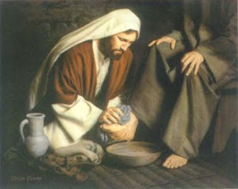
(All may drink the entire Cup of Sanctification.)

4. Foot Washing:

Leader: “Having sanctified this meal with the Cup of Sanctification we now prepare ourselves. This symbolic act of purification ("Urchatz") prepares us to enter into the holiness of this feast. It was at this time during the "Last Supper" that Yahshua removed His outer garments of honor, and took water and a towel to wash the feet of His disciples. He wanted to make sure His disciples understood the concept of being clean, thus washing their feet as well. This object lesson demonstrated that He was about to become the suffering servant of יהוה. We know that this water cannot really make our hearts clean. The only way that we can be made pure and holy is by Yahshua’s act of obedience to His Father – death on the tree (cross).”

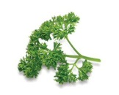
All: (John 13:5, 12—14) Then he poured some water into a basin and began to wash the feet of the talmidim (disciples) and wipe them off with the towel wrapped around him. He said to them, “Do you understand what I have done to you?” You call me ‘Rabbi’ and ‘Master,’ and you are right, because I am. “Now if I, the Master and Rabbi, have washed your feet, you also should wash each other’s feet.” ~Break for foot washing~

5. The Karpas: The dipping of the parsley

Reader: “…the people of Israel still groaned under the yoke of slavery, and they cried out, and their cry for rescue from slavery came up to Elohim…”Exodus 2:23

Leader: We eat bitter herbs at Passover to identify with bondage, and then with the redemption from the bondage. This vegetable, called karpas, represents life, created and sustained by the Almighty Elohim. The parsley is also symbolic of hyssop, which is associated in Scripture with cleansing (Numbers 19:6 & 18, Psalms 51:7). The blood of the Passover lamb was applied to the doorposts with hyssop for our cleansing from sin. (Exodus 12:22).

Reader: “As we eat this plant and dip twice in the salt water, we are reminded of how the nation of Israel was born of tears. It reminds us of how Elohim led us by dry land through the salt waters of the Sea of Reeds and caused the waters to come over Pharaoh’s chariots.”

Reader: “The green parsley represents life and vitality. The salt water represents the tears which the Israelites shed in Egypt in their slavery. So, too, it represents the tears we shed when we remember that each of us was a slave to sin. Even today, sometimes life is full of tears.

Leader: “The green plant reminds us of Israel – the planting of יהוה.”

Reader: “But why do we dip twice?”

All: “It is because we must be born again! Even as Israel was born first of tears and must be born again spiritually, so we must be born again of the Spirit rising in newness of life.”

Reader: While Dipping the parsley into the salt water let us recite the following blessing; remembering that life is sometimes immersed in tears

(All) Baruch atah Adonai Eloheinu Melech Ha Olam, Boray P’ree Ha adamah. Amein

(All) Blessed are you, O LORD our God, King of the Universe, Creator of the fruit of the earth. Amen

(All) In bondage our lives were drenched in grief and tears. For our tears were as a ‘sea of sorrows’, even the Sea of Suf, through which the LORD delivered us.”

Leader: But, just as יהוה parted the salty Sea of Suf for our deliverance, so now He wipes away every tear, as Messiah came to bear our grief's and deliver us from sin.

(All) He was despised and rejected by men, a man of sorrows and acquainted with grief. Surely He has borne our grief’s and carried our sorrows.” (Isaiah 53:4)

Leader: Now, let us together, eat the karpas as we remember and give thanks for deliverance.
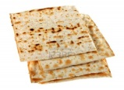
6. Passover Symbols: Unleavened bread and bitter herbs

Leader: Unleavened bread or matzah is made without leavening. It has been pierced and crushed. It is the bread of humility and is not puffed up. This is the bread of affliction which our fathers ate in the land of Egypt when they quickly departed the slavery of Egypt to freedom.

Reader: In like manner it is the bread of Yahshua. He was without sin or leaven. The prophet Isaiah has said, “With His stripes we are healed. He was pierced for our transgressions and He was crushed for our iniquities.”

(Pass the matzah and take a piece, wait to eat)

All: Messiah our Passover was removed, broken for us, hidden in the tomb, and then brought back to life on the third day.

All: say the blessing~

“Baruch Atah Adonai Eloheinu melech ha’olam Hamotzi lechem min ha’aretz. Amen.”

“Blessed art Thou, O LORD our God, King of the Universe, who brings forth bread from the earth. Amen.”
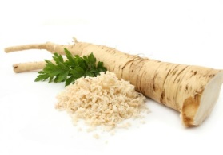
(All may eat the matzah)

7. Bitter Herbs

Leader: The Maror or bitter herbs are a symbol of slavery. We eat bitter herbs to remind us of the bitter bondage we suffered under the hand of the Egyptian taskmasters. It also reminds us of the discomfort of sin and the need for a Redeemer; One who will purchase us out of the slavery of sin. And, HalleluYAH, Yahshua has paid the price for us!

Reader:…the Egyptians came to dread the people of Israel and worked them relentlessly, making their lives bitter with hard labor—digging clay, making bricks, all kinds of field work…(Exodus 1:12-14)

Reader: Indeed it was for my own peace that I had great bitterness; and You have lovingly delivered my soul from the pit of corruption, for You have cast all my sins behind Your back. (Isaiah 38:17)

All: say the blessing~

“Baruch Atah Adonai Eloheinu melech ha’olam asher kid-shanu b’mitzvotav v’tzivanu al achilat maror. Amen.”

“Blessed art Thou, O LORD our God, King of the Universe, who has sanctified us by Your commandments and has commanded us to eat bitter herbs. Amen.”
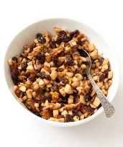
(Dip the matzah in the bitter herb and eat)

8. The Charoset

Leader: On all other nights we do not dip our vegetables even once, but tonight we dip them twice. We have already dipped the parsley into the salt water.
(Lifting the Charoset, the brown apple mixture)

Reader: The children of Israel toiled to make treasure cities for Pharaoh, working in brick and clay. We remember this task in a mixture called Charoset, made from chopped apples, sugar, walnuts, cinnamon and grape juice.

Leader: This is our cruel labor in bondage, the mortar for Pharaoh's storehouse.

All: We know that all things work together for good to those who love God, to those who are called according to His purpose. (Romans 8:28)

(All may eat the Charoset)

9. The Questions:

Reader: “When your children ask you, ‘What do you mean by this ceremony?’ ..." Exodus 12:26

All: You shall say to them: "It is the sacrifice of the LORD'S Passover, who passed over the houses of the children of Israel in Egypt, when he smote the Egyptians, and delivered our houses...". "And you shall observe this thing for an ordinance to you and to your children forever." (Exodus 12:24, 27)

Reader: “Why is this night different from all other nights? On this night, why do we only eat unleavened bread, bitter herbs, and lamb roasted by fire, and why do we dip twice?”

Leader: “This night is different from all other nights because it is יהוה's Passover. On this night our ancestors sat in their houses with the blood of the lamb on the doorposts and lintel. The Angel of יהוה passed over our houses and spared the first born of Israel. But the Egyptians suffered a great judgment. On the next morning, we left Egypt as a free people. We eat unleavened bread because there was not time enough for the bread to rise. It is the bread of haste. We eat bitter herbs to remind us of the bitter bondage we suffered under the hand of the Egyptian taskmaster. We dip twice to remind us of how we were born of tears and our crossing the Sea of Reeds to salvation.”
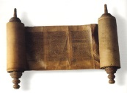
The Story of the Passover – Maggid
I have remembered My covenant. (Exodus 6:5)

Leader: The story of Passover is a story of redemption, a story of the mighty power of Elohim to overcome evil. We were slaves to Pharaoh in Egypt. But יהוה our Elohim took us out of Egypt with a mighty hand and an outstretched arm. And if the Holy One, blessed be He had not taken our fathers out of Egypt, then we, our children and grandchildren might still be enslaved to Pharaoh in Egypt. And even if we were all the wisest of men and all perceptive, it would still be our duty to tell of the deliverance from Egypt, and for those who enlarge on the telling of the Exodus, it is accounted praiseworthy.

Reader: Jacob our father, a wandering sojourner, went down to Egypt with his household of seventy souls. Dwelling in the land of Goshen, the children of Israel increased in possessions and greatly multiplied in number.

Reader: The LORD had promised the land of Israel to Abraham, Isaac and Jacob. Yet here were the children of Israel enslaved in the land of Egypt. For, after Joseph had died, a new king arose who said: “Behold these people are too many and too mighty for us; come let us deal wisely with them, lest they multiply and join themselves to our enemies, fight against us, and leave our land.” Therefore they set over them cruel taskmasters who afflicted them with grievous burdens. And they built for Pharaoh the store cities, Pithom and Raamses. Yet the more the Egyptians afflicted them, the more the LORD blessed His people in strength and in number.

Reader: Pharaoh grew more frightened and ordered every baby boy among the Israelites to be drowned in the Nile River. One Israelite couple hid their little boy for three months. Finally, entrusting his future to God, they set him in a basket and placed him upon the river. His sister, Miriam, watched as he floated downstream. Coming upon the basket, Pharaoh’s daughter took pity on the child and chose to raise him as her own son. She called him Moses, meaning “drawn from the water.”

Reader: And Moses grew and became aware of the travail of his people. One day, in a rage, he lost control of himself and killed an Egyptian who was beating a Hebrew slave. Fleeing the palace and the eye of Pharaoh, Moses became a shepherd in the land of Midian, far from the cries of his suffering brothers.

Reader: Still, the Egyptians made their lives bitter with hard bondage, and made them serve with rigor. And they continued to cry out to the LORD, Who heard their voice, and saw their affliction and oppression. He would raise Moses up to be the deliverer to lead them out of bondage. It was then that He appeared to Moses in the midst of a bush that burned with fire, yet was not consumed. Moses drew close and listened as God commissioned him to go to Pharaoh. Fearful and reluctant, still Moses agreed to bring God’s message to the king of Egypt, “Let My people go!”

Leader: Therefore He commanded us to observe the Passover in its season, year by year, that we should never forget His salvation, and that we would savor His mighty deeds and declare them unto our children in every generation.

All: Now all these things happened to them as examples, and they were written for our instruction, upon us whom the ends of the age have come. (I Corinthians 10:11)
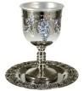
10. The Second Cup (Plagues/Judgment):

Reader: I will free you from the forced labor of the Egyptians…(Exodus 6:6)

Reader: “With thankfulness we will also recall each of the plagues God brought upon the Egyptians. God judged Egypt by plaguing them, and each plague represented a judgment on a specific Egyptian god. We take no joy in seeing the judgments of God upon mankind. It would be our desire to see all men receive His mercy and loving kindness. However, when men harden their hearts against the LORD, He is not mocked, nor does that man prevail. As we are reminded of those great judgments upon the Egyptians, let us diminish the joy of our cup by dipping and removing a drop of wine onto the napkins on our plates for each punishment.

Leader: Let us fill one another's cups a second time. A full cup is a symbol of joy and indeed on this occasion we are filled with great joy at Elohim’s mighty deliverance. But let us also remember the great cost at which redemption was purchased. Lives were sacrificed to bring about the release of Elohim’s people from the slavery of Egypt. But a far greater price purchased our redemption from slavery to sin—the death of Messiah. As we recount each plague, let us dip a little finger into the cup, allowing a drop of liquid to fall, reducing the fullness of our cup of joy this night.

All: “Blood! Frogs! Gnats! Beasts! Cattle Disease! Boils! Hail! Locusts! Darkness! Death of the Firstborn!”
(Do not drink of the 2nd cup yet)

Reader: Why the slaying of the firstborn? Why such a horrific Plague?

Leader: “Then you shall say to Pharaoh, ‘Thus says יהוה: “Israel is My son, My firstborn. So I say to you, let My son go that he may serve Me. But if you refuse to let him go, indeed I will kill your son, your firstborn.”” (Exodus 4:22, 23).

Reader: But to those who heeded the message of the LORD and applied the blood to their doorposts the angel of death passed over them and their entire house was saved. God was looking for a sign; for He was not going to redeem a people merely of the flesh, but a people of faith. The blood had to be applied for judgment to “pass over” their homes. The blood applied as Scripture prescribes makes for a sign of redemption that speaks of a greater redemption from a far greater judgment. So, finally our attention comes to Golgotha, where the Messiah Yahshua, the true Lamb of God was nailed to the executioner’s stake and God fulfilled His sign promise for our eternal redemption.
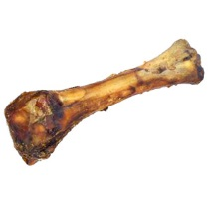
11. The Passover Lamb (Pesach)
The Zoroah (Shank bone of the Lamb)

Reader: “The blood will serve you as a sign marking the houses where you are; when I see the blood I will pass over you” (Exodus 12:13)

Leader: We have eaten the matzah to remind us of the haste with which the children of Israel fled Egypt. We have tasted the bitter herbs to remind us of the bitter slavery they experience there. (Lifting the shank bone of the lamb) The roasted shank bone represents the lamb whose blood marked the houses of the children of Israel, signifying their obedience to the command of יהוה. It is also a remembrance that it was יהוה Himself Who redeemed the children of Israel from slavery.

All: And the LORD brought us out of Egypt with a strong hand and a stretched-out arm, with great terror, and with signs and wonders. (Deuteronomy 26:8)

Reader: We, who have come to faith in Messiah Yahshua, know that He is the Lamb of God, our Passover. Like the ancient Israelites we know that it was God Himself and not an angel, God Himself and not a seraph, God Himself and not a messenger, who achieved the final redemption from sin and death. It is God Himself, through Yahshua, Who takes away the sin of the world.

All: Blessed are You, O God, for You have, in mercy, supplied all our needs. You have given us Messiah, forgiveness for sin, life abundant and life everlasting. Amen.

All: Baruch atah Adonai Eloheinu Melech Ha Olam, Boray p’ree hagafen. Amein

All: Blessed are You O Lord our God, King of the Universe, Who creates the fruit of the vine. Amen
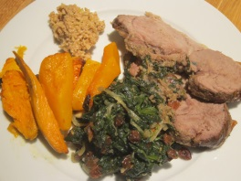
(You may drink of the cup)

12. Preparation for the meal:

Leader: “Give thanks unto יהוה for He is good.”

All: “His mercy endures forever!”

Leader: “Give thanks to יהוה who sent His only Son to be our Redeemer, our Deliverer, and our Salvation.”

All: “His mercy endures forever." “For great is His loving kindness, and His mercy endures forever. Amen.”

Leader: “Blessed are You, O יהוה our Elohim, King of the Universe, Who has freed us and our ancestors from Egypt and brought us here this night to eat matzah and maror. O יהוה, help us to celebrate future Biblical Feasts in peace and joy.”

13. The Passover Meal is served: Let us now partake of a fellowship meal with one another!

~BREAK FOR MEAL~
14. The Third Cup: The Cup of Redemption

Please fill one another's cup and wait to drink

Leader: In the gospel according to Luke it is written: (Luke 22:20) ‘And in the same way, He (Yahshua) took the cup after they had eaten, saying, “This cup which is poured out for you is the new covenant in My Blood.” It is also written: "For this is my blood of the new testament, which is shed for many for the remission of sins." (Matthew 26:28) Every Passover Seder is a memorial of the atoning death of Messiah Who gave Himself for every person.

Let us lift our glass and say the blessing over the cup

All: “Baruch Atah Adonai Eloheinu melech ha’olam borei p’ri hagafen. Amen.”

“Blessed art Thou, O LORD our God, King of the Universe, who creates the fruit of the vine. Amen.”

(All may drink the entire Cup of Redemption)

15. Grace after the meal:
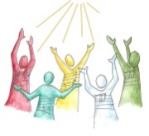
All: “We praise You, O LORD our God, King of the Universe, Who in goodness, mercy, and kindness gives food to the world. Your love for us endures forever. We praise You, LORD, Who provides food for all life. Amen”

16. Hallel: Psalms of Praise: Psalm 113 - 118

Leader: “Matthew 26:30 states, ‘And after singing a hymn (Psalm), they (Yahshua and His Disciples) went out to the Mount of Olives.’”

Reader: “Psalm 113 ‘Praise the LORD! Praise, O servants of the LORD. Praise the name of the LORD. Blessed be the name of the LORD from this time forth and forever. From the rising of the sun to its setting the name of the LORD is to be praised. The LORD is high above all nations; His glory is above the heavens. Who is like the LORD our God, Who is enthroned on high, Who humbles Himself to behold the things that are in heaven and in the earth? He raises the poor from the dust, and lifts the needy from the ash heap, to make them sit with princes, with the princes of His people. He makes the barren woman abide in the house as a joyful mother of children. Praise the LORD!’”

Reader: “Psalm 114 ‘When Israel went forth from Egypt, the house of Jacob from a people of strange language, Judah became His sanctuary, Israel, His dominion. The sea looked and fled; the Jordan turned back. The mountains skipped like rams, the hills like lambs. What ails you, O sea, that you flee? O Jordan, that you turn back? O mountains, that you skip like rams? O hills, like lambs? Tremble, O earth, before the Lord, before the God of Jacob, Who turned the rock into a pool of water, the flint into a fountain of water.’”

Reader: “Psalm 117 ‘Praise the LORD all nations; laud Him, all peoples! For His loving kindness is great toward us, and the truth of the LORD is everlasting. Praise the LORD!’”

Reader: “Psalm 118: 22-24 ‘The stone which the builders rejected has become the chief corner stone. This is the LORD’S doing; it is marvelous in our eyes. This is the day which the LORD has made; let us rejoice and be glad in it.’”

Leader: “Yahshua knew He was going to His death, yet He rejoiced in that day knowing that the acceptable sacrifice, the Lamb of Elohim would provide salvation for us.”

17. The Fourth Cup: The Cup of Praise/Restoration
Reader: "I will take you as My people." (Exodus 6:7)

Leader: “Please pour one another's fourth and final cup, and wait to drink. When Messiah Yahshua held His last supper with His disciples He did not drink of this cup. He said, “I will not drink of this cup until we are in the Kingdom.” This cup is prophetic and is a promise of the Kingdom to come. Let us, therefore, drink this Cup of Praise- blessing in the Name of יהוה as we look for His Kingdom to come.”

Let us lift our glass and say the blessing over the cup

All:

“Baruch Atah Adonai Eloheinu melech ha’olam borei p’ri hagafen. Amen.”

“Blessed art Thou, O LORD our God, King of the Universe, who creates the fruit of the vine. Amen.”
(All may drink the entire Cup of Praise)
18. Song of Praise: [Hodu La’Adonai Ki Tov]
Ho-du l’Adonai kee-tov, kee lay-olam chas-doe
Ho-du l’Adonai kee-tov, kee lay-olam chas-doe
Ho-du, Ho-du, Ho-du, Ho-du, Ho-du l’Adonai kee-tov
Ho-du, Ho-du, Ho-du, Ho-du, Ho-du l’Adonai kee-tov.
Give thanks to the Lord for He is good, His Mercy endures forever. Give thanks to the Lord for He is good, His Mercy endures forever. Give thanks, give thanks, give thanks, give thanks, give thanks to the Lord- He is good. Give thanks, give thanks, give thanks, give thanks, give thanks to the Lord- He is good!

19. Conclusion:

Leader: Our Seder is now complete. Just as Elohim’s Redemption is complete in us, so we have kept the Passover as Elohim had commanded us to do. We remember throughout the year that our redemption is complete by the sacrifice of our Passover Lamb, Yahshua, the Messiah. And let us not forget Jerusalem, the city that He loved and wept over.

20. Acceptance Prayer:

Leader: “Our Heavenly Father, the Passover Seder is now finished according to its prescribed manner. Grant each of us grace to do Your will. Draw us closer to You and take us to the place that You are preparing for us. In the end of the Scriptures we read: ‘And I saw a new heaven and a new earth; for the first heaven and the first earth passed away, and there is no longer any sea. And I saw the holy city, new Jerusalem, coming down out of heaven from Elohim, made ready as a bride adorned for her husband. And I heard a loud voice from the throne, saying, “Behold, the tabernacle of Elohim is among men, and He shall dwell among them, and they shall be His people, and Elohim Himself shall be among them, and He shall wipe away every tear from their eyes; and there shall no longer be any death; there shall no longer be any mourning, or crying, or pain; the first things have passed away”’” (Revelation 21: 1-4).

“Father, we look forward to You establishing Your Kingdom here on earth. We know there are still many who have yet to receive redemption and eternal life in Messiah Yahshua. We continue to pray for the salvation of those who are lost, who have yet to trust Messiah and receive atonement and eternal life. We ask that You would draw members of our family and friends to You, and bring them home to You. Let us not forget to pray for the peace of Jerusalem. Let us remember that true peace will not come until the Prince of Peace comes. “Moshiach Bo”. Come quickly Messiah Yahshua! Amen.”

All: “LORD, we thank You, we give You all our praise, as we exclaim. . .

. . . Next year in New Jerusalem!

COMMENTS, QUESTIONS?

Return of the Remnant
www.returnoftheremnant.com
NOTES

This was a night when יהוה kept vigil to bring them out of the land of Egypt, and this same night continues to be a night when יהוה keeps vigil for all the people of Israel through all their generations. (Exodus 12:42-43)

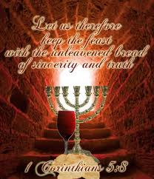

Return of the Remnant
www.returnoftheremnant.com

~2013~
Works cited:
Messianic Passover Haggadah, by Monte Judah(www.lionlamb.net)
Passover Seder by Mike Clayton (www.joinedtohashem.org)
Passover, 2006 Congregation Kehilat Sar Shalom
2012 Seder by Yosi Weintz (www.beitshofarot.com)
2012 Hagaddah The Wilhelms (www.yourlivingwaters.com)
Various Internet sources

