Counting of the Omer 2014

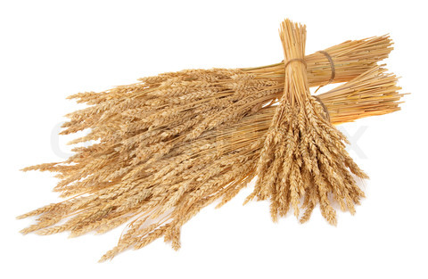

ספירת העומר

Lev 23:15-16 ‘And from the morrow after the Sabbath, from the day that you brought the sheaf of the wave offering, you shall count for yourselves: seven completed Sabbaths. ‘Until the morrow after the seventh Sabbath you count fifty days, then you shall bring a new grain offering to יהוה.
We are instructed by יהוה to count 49 days (7 completed Sabbaths) concluding with the celebration of Shavuot on the 50th day. This period is called "Sefirat HaOmer", the counting of the Omer. According to Rabbinic sources, the Omer count recalls an earlier event when the children of Israel prepared themselves for receiving the Torah at Mt. Sinai at Shavuot. It is also important to note that on Shavuot ("Pentecost" in Greek) the disciples of Yahshua were filled with the "Spirit of Elohim" (Acts 2). May you draw near to HIM and be filled with the spirit of wisdom and truth during these 50 days.

Day 1 [Sunday following the regular Shabbat during unleavened bread]
€Yeshayahu 1 and 2

Day 2 - April 21st
€ Yeshayahu 3

Day 3
€ Yeshayahu 4

Day 4
€ Yeshayahu 5

Day 5
€ Yeshayahu 6

Day 6
€ Yeshayahu 7

Day 7 Shabbat ~ First Completed Week ~ April 26th
€ Yeshayahu 8 and 9

Day 8
€ Yeshayahu 10 and 11

Day 9
€ Yeshayahu 12

Day 10
€ Yeshayahu 13

Day 11
€ Yeshayahu 14

Day 12
€ Yeshayahu 15

Day 13
€ Yeshayahu 16

Day 14 Shabbat ~ Second Completed Week ~ May 3rd
€ Yeshayahu 17 and 18

Day 15
€ Yeshayahu 19 and 20

Day 16
€ Yeshayahu 21

Day 17
€ Yeshayahu 22

Day 18
€ Yeshayahu 23

Day 19
€ Yeshayahu 24

Day 20
€ Yeshayahu 25

Day 21 Shabbat ~ Third Completed Week ~ May 10th
€ Yeshayahu 26 and 27

Day 22
€ Yeshayahu 28 and 29

Day 23
€ Yeshayahu 30

Day 24
€ Yeshayahu 31

Day 25
€ Yeshayahu 32

Day 26
€ Yeshayahu 33

Day 27
€ Yeshayahu 34

Day 28 Shabbat ~ Fourth Completed Week ~ May 17th
€ Yeshayahu 35 and 36

Day 29
€ Yeshayahu 37 and 38

Day 30
€ Yeshayahu 39

Day 31
€ Yeshayahu 40

Day 32
€ Yeshayahu 41

Day 33
€ Yeshayahu 42

Day 34
€ Yeshayahu 43

Day 35 Shabbat ~ Fifth Completed Week ~ May 24th
€ Yeshayahu 44 and 45

Day 36
€ Yeshayahu 46 and 47

Day 37
€ Yeshayahu 48

Day 38
€ Yeshayahu 49

Day 39
€ Yeshayahu 50

Day 40
€ Yeshayahu 51

Day 41
€ Yeshayahu 52

Day 42 Shabbat ~ Sixth Completed Week ~ May 31st
€ Yeshayahu 53 and 54

Day 43
€ Yeshayahu 55 and 56

Day 44
€ Yeshayahu 57

Day 45
€ Yeshayahu 58

Day 46
€ Yeshayahu 59

Day 47
€ Yeshayahu 60

Day 48
€ Yeshayahu 61 and 62

Day 49 Shabbat ~ Seventh Completed Week ~ June 7th
€ Yeshayahu 63 and 64

Day 50 ~ SHAVUOT! ~ (Yom HaBikurim) – June 8th
€ Yeshayahu 65 and 66 Scroll of Ruth (optional)

Additional readings on Shavuot:
Acts 2:1 - 47 Numbers 28:26 - 31
Exodus 19:3 - 20:26 Deuteronomy 14:22 - 16:17
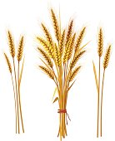
Leviticus 23:15 – 21
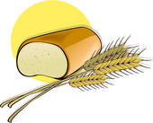

Other dates to remember during the counting of the Omer:
Hebrew Date:
Aviv/Nissan 27 Holocaust Memorial day (Yom Hashoah)
Iyar 4 Memorial Day (Yom Hazikaron)
Iyar 5 Israel Independence Day (Yom Ha'Atzmaut)
Iyar 28 Jerusalem Day (Yom Yerushalayim)
Iyar 29 Hebron (Liberation) Day (Yom Hebron)

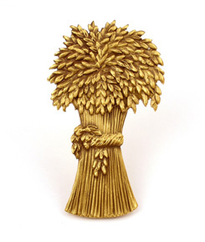
For Further information, go to:
www.returnoftheremnant.com

