Was Israel in Egypt for 430 Years?
Have you ever watched the movie “The Ten Commandments” starring Charlton Heston? Do you remember the scene in the movie after the 10 plagues and Israel is leaving Egypt when Joshua (played by John Derek) says: “Four hundred years in bondage…”
But is this true? Was Israel in Egypt for 430 years? If we look at scripture, Exodus 12:40 says: “the sojourning of the children of Israel, who dwelt in Egypt, was four hundred and thirty years,”. Most people who read this verse are convinced that this is correct and accurate and believe that Israel was in Egypt for 430 years. But if that is true then how do you explain these verses?
Gal 3:16-17 But the promises were spoken to Abraham, and to his Seed. He does not say, “And to seeds,” as of many, but as of one, “And to your Seed,” who is Messiah. Now this I say, the Law (Torah), that came four hundred and thirty years later, does not annul a covenant previously confirmed by Elohim in Messiah, so as to do away with the promise.
I believe Paul is referring to the covenant YHWH made with Abraham in Genesis 15: Gen 15:13 And He (YHWH) said to Abraham, “Know for certain that your seed are to be sojourners in a land that is not theirs, and shall serve them, and they shall afflict (mistreat) them four hundred years.” This covenant was made when Abraham was 80 years old and began the 430 year countdown.
Notice also that within the Genesis 15:13 verse that the affliction would start with Abraham’s seed- that seed being Isaac. Abraham was 100 years old when Isaac was born (Gen 21:5). We read later in Genesis 21:9-11 that Hagar’s son, Ishmael, was ‘mocking’ his half-brother Isaac. This is when the mistreatment began and in my opinion it began when Isaac was 10 years old. If you look at the 430 Year Timeline below, you can see that Abraham was 100 years old when Isaac was born (Gen 21:5) . You can also see that when Isaac was 60 years old (Gen 25:26), Jacob was born… Lastly, we know that Jacob was 130 years old when he entered into Egypt with his family (Gen 47:9). From this data we can see that Abraham, Isaac, and Jacob were in the land of Canaan 210 years from the time YHWH made a covenant with Abraham.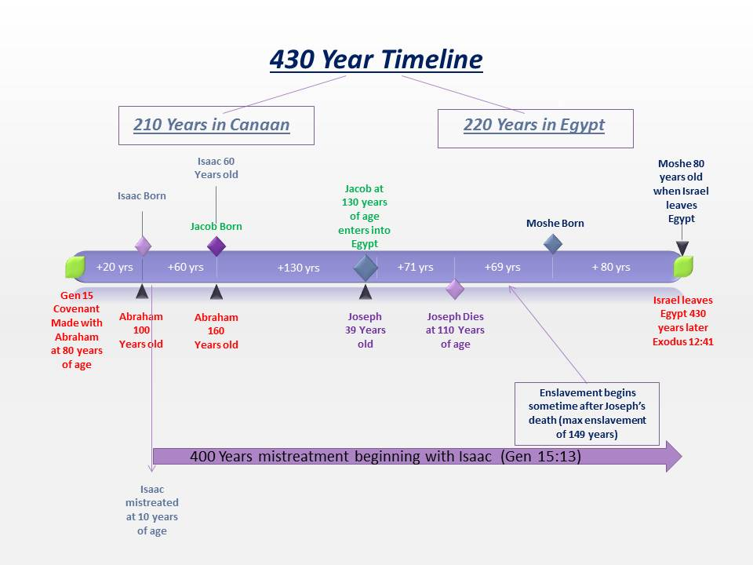This timeline also puts the children in Egypt for 220 years. Now, some scholars have proposed that the covenant was made back in Genesis 12, when Abraham was 75 and the mistreatment with Isaac started when he was 5 years old. This would put the years in Canaan at 215 and the years in Egypt at 215. The main thing is that Israel was NOT in Egypt for 430 years.
Josephus writes that Israel was in Egypt 215 years, NOT 430.
2. They left Egypt in the month Xanthicus, on the fifteenth day of the lunar month; four hundred and thirty years after our forefather Abraham came into Canaan, but two hundred and fifteen years only after Jacob removed into Egypt. It was the eightieth year of the age of Moses, and of that of Aaron three more. They also carried out the bones of Joseph with them, as he had charged his sons to do. [Flavius Josephus Antiquities of the Jews- Book II. (2.15.2)]
So how do we rectify Exodus 12:40? Do we have a problem with this particular text? One thing to keep in mind is that the majority of our Bibles today come from what is called the Masoretic Text. These texts were copied (sometimes even edited) and distributed by a group of Jews known as the Masoretes between the 7th -10th centuries CE. The oldest known complete copy is the Lenningrad Codex, which dates from the late 10th to early 11th century CE. This source is where the majority of our Bibles containing the Tanakh section (Old Testament) come from… such as: KJV, NASB, ESV, NIV, etc.
Now if we look at Exodus 12:40 in the Septuagint (LXX) we read the following:
Exo 12:40 And the sojourning of the children of Israel, while they sojourned in the land of Egypt and the land of Chanaan (Canaan), was four hundred and thirty years.
Notice that “and the land of Canaan” is in this particular translation of text. Keep in mind that the Septuagint was written much earlier than the Masoretic text. Scholars believe that the Torah (Pentateuch) was translated from Hebrew to Greek around the 3rd Century BCE and the rest of the Tanakh was translated around 2nd Century BCE. Now, I am not saying that the LXX is superior to the Masoretic text but I would encourage you to have a copy of one to compare scriptures. A good English translation of the Septuagint is by Sir Lancelot Brenton and I would highly encourage obtaining one for Bible studies.
Here is another translation of Exodus 12:40 found in the Samaritan Pentateuch:
Exo 12:40 Now the sojourning of the children of Israel and their fathers while they had dwelt in the the land of Canaan and in Egypt was four hundred and thirty years
The Samaritan Pentateuch is a text of the Torah written in Samaritan script derived from the Paleo-Hebrew script. It dates back to one of the ancient versions that existed during the 2nd Temple period. Again, this particular version also predates the Masoretic text by over 1000 years. However, there are several differences with this version in other places of the Torah such as the commandment to build an altar on Mt. Gerizim on which sacrifices should be offered. I am only using this particular version to make a point that sometimes we need more than one Bible in our studies and textual criticism.
There is overwhelming evidence showing that Israel did NOT stay in Egypt for 430 years. The LXX, the Samaritan Pentateuch, and the writings of Flavius Josephus show that indeed the affliction (mistreatment) of Abraham’s seed: Isaac/Jacob/Israel was in Canaan and in Egypt. The timeline from several verses within the Torah shows that the mistreatment lasted anywhere from 210 years in Canaan and 220 years in the land of Egypt or quite possibly 215 in Canaan and 215 in Egypt. Either way, the information provided clearly shows that Israel was not in Egypt for 430 years!
This study does not negate the validity of our current bible versions, but as I stated earlier, it would be wise to have earlier versions such as the LXX along with English translations of the Dead Sea Scrolls (DSS) for good biblical exegesis.
Shalom,
Chad
www.returnoftheremnant.com

