Counting of the Omer 2020
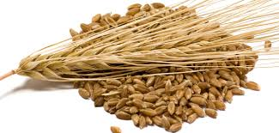
ספירת
העומר

Lev 23:15-16 ‘And from the morrow after the Sabbath, from the day that you brought the sheaf of the wave offering, you shall count for yourselves: seven completed Sabbaths. ‘Until the morrow after the seventh Sabbath you count fifty days, then you shall bring a new grain offering to יהוה.
We are instructed by יהוה to count 49 days (7 completed Sabbaths) concluding with the celebration of Shavuot on the 50th day. This period is called "Sefirat HaOmer", the counting of the Omer. According to Rabbinic sources, the Omer count recalls an earlier event when the children of Israel prepared themselves for receiving the Torah at Mt. Sinai at Shavuot. It is also important to note that on Shavuot ("Pentecost" in Greek) the disciples of Yahshua were filled with the "Spirit of Elohim" (Acts 2). May you draw near to HIM and be filled with the spirit of wisdom and truth during these 50 days.

Day 1 Rashit Katzir – Sunday, April 12th
€ Matthew 24

Day 2 -
€ Daniel 1

Day 3
€ Daniel 2

Day 4
€ Daniel 3

Day 5
€ Daniel 4

Day 6
€ Daniel 5

Day 7 Shabbat ~ First Completed Week ~ April 18th
€ Daniel 6

Day 8
€ Daniel 7

Day 9
€ Daniel 8

Day 10
€ Daniel 9

Day 11
€ Daniel 10

Day 12
€ Daniel 11

Day 13
€ Daniel 12

Day 14 Shabbat ~ Second Completed Week ~ April 25th
€ Revelation 1

Day 15
€ Revelation 2

Day 16
€ Revelation 3

Day 17
€ Revelation 4

Day 18
€ Revelation 5

Day 19
€ Revelation 6

Day 20
€ Revelation 7

Day 21 Shabbat ~ Third Completed Week ~ May 2nd
€ Revelation 8

Day 22
€ Revelation 9

Day 23
€ Revelation 10

Day 24
€ Revelation 11

Day 25
€ Revelation 12

Day 26
€ Revelation 13

Day 27
€ Revelation 14

Day 28 Shabbat ~ Fourth Completed Week ~ May 9th
€ Revelation 15

Day 29
€ Revelation 16

Day 30
€ Revelation 17

Day 31
€ Revelation 18

Day 32
€ Revelation 19

Day 33
€ Revelation 20

Day 34
€ Revelation 21

Day 35 Shabbat ~ Fifth Completed Week ~ May 16th
€ Revelation 22

Day 36
€ Zechariah 1

Day 37
€ Zechariah 2

Day 38
€ Zechariah 3

Day 39
€ Zechariah 4

Day 40
€ Zechariah 5

Day 41
€ Zechariah 6

Day 42 Shabbat ~ Sixth Completed Week ~ May 23rd
€ Zechariah 7

Day 43
€ Zechariah 8

Day 44
€ Zechariah 9

Day 45
€ Zechariah 10

Day 46
€ Zechariah 11

Day 47
€ Zechariah 12

Day 48
€ Zechariah 13

Day 49 Shabbat ~ Seventh Completed Week ~ May 30th
€ Zechariah 14

Day 50 ~ SHAVUOT! ~ (Yom HaBikurim) – May 31st
€ Luke 21

Additional readings on Shavuot:
Acts 2:1 - 47 Numbers 28:26 - 31
Exodus 19:3 - 20:26 Deuteronomy 14:22 - 16:17
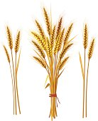
Leviticus 23:15 – 21
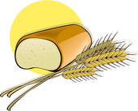

Other dates to remember during the counting of the Omer:

May 2nd Holocaust Memorial day (Yom Hashoah)
May 8th Memorial Day (Yom Hazikaron)
May 9th Israel Independence Day (Yom Ha'Atzmaut)
June 2nd Jerusalem Day (Yom Yerushalayim)
June 3rd Hebron (Liberation) Day (Yom Hebron)

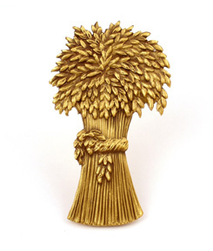
For Further information, go to:
www.returnoftheremnant.com

