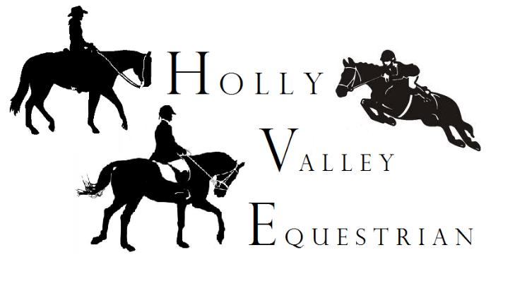
RELEASE AND HOLD HARMLESS AGREEMENT
****************************************************************************************************WARNING: Under Ga. Law an equine activity sponsor or equine professional is not liable for the injury to or death of a participant in equine activities resulting from the inherent risk of equine activities, pursuant to Chapter 12 of Title 4 of the Official Code of Ga. Annotated.
NAME:_________________________________________AGE/B-DAY_____________ (Riders/Students Name) (if student)
ADDRESS:____________________________________ CITY/STATE:__________________________________ZIP:_____________________HOME PHONE:_________________________WK/CELL:_______________________
In consideration for the privilege of riding/and or working with horses and farm animals at Holly Valley Equestrian Stable, LLC, I ,_________________________________, acknowledge that I have read the above “WARNING” and the statements on this Release and Hold Harmless Agreement, and hereby indemnify and hold harmless, Holly Valley Equestrian Stable, LLC, and it’s employees from any liability arising from accident injury, theft, or damages to myself , my representatives, helpers, all equipment and property, and animals under my jurisdiction. I understand the potential danger that I could incur in mounting, riding, walking, boarding, feeding assigned horse; including, but not limited to, any interactions with other horses. Understanding those risks I hereby release Holly Valley Equestrian Stable, LLC, its officers, directors, shareholders, employees, and anyone else directly or indirectly connected with Holly Valley Equestrian Stable, LLC from any liability whatsoever in the event of injury or damage of any nature(or perhaps even death) to me or anyone else caused by or incidental to my electing to mount and ride and horse owned or operated by Holly Valley Equestrian Stable, LLC. I further voluntarily agree and warrant to Release and Hold Harmless this equine professional from any liability whatsoever, including, but not limited to, any incident caused by or related to said equine professional’s negligence, relating to injuries known, unknown, or otherwise not herein disclosed; including but not limited to, injuries, death or property damage from; riding; mounting; dismounting; walking; grooming; feeding; use of barn, paddocks, or arenas, in any capacity; falling off horse whether horse is bucking, flipping, rearing, spooked; or my failure to understand any equine professional’s directions relating to my riding or otherwise use and control, or lack thereof, of my horse or the horse I have been assigned to.
GRANT OF PERMISSION
I/we the undersigned, (student/rider above named for, if minor, parent/guardians) hereby grant permission and authority to Holly Valley Equestrian Stable, LLC, and authorized employees to act for us in executing verbal instructions if unable to contact us, to act for us in dealing with physicians, available ambulance companies and hospitals, to obtain prompt medical attention for the participant named in the event of any perceived medical emergency. I hereby covenant and agree to release Holly Valley Equestrian Stable, LLC, it’s officers, agents, and employees, and owners of any property or horse concerned, and hold harmless from liability for any injury or damage which the rider may sustain while at Holly Valley Equestrian Stable, LLC. Or participating in any activity sponsored by Holly Valley Equestrian Stable, LLC, and from any liability connected with obtaining prompt medical attention for the rider named above.
The terms of this release form shall be constructed as the entire agreement and may not be altered, amended, or modified except in writing and signed by both parties. The terms of this release shall be governed by the laws of the state of Georgia.

IF UNDER 18, THE PARENT OR LEGAL GUARDIAN MUST READ AND SIGN

DATE:________________SIGNED:_________________________________________ Participant/Parent/Legal Guardian(if minor under 18)

NOTICE: Wearing an ASTM/SEI approved hard hat is strongly recommended for all riders. RIDERS UNDER 18 MUST WEAR HELMET.

