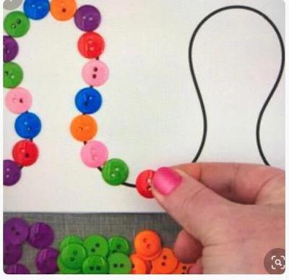
Draw a wavy line on a piece of paper and ask your child to follow it with their finger. Then encourage them to cover it with small objects such as, buttons, coins, Lego, pasta or lentils.

