**MICHIGAN STATE GRANGE**

**2024 Second Quarter Lecturer’s Bulletin**

Jackie Bishop, 479 Tuscany Dr, Portage, MI 49024

(269) 365-0401

[Jacqueline_bishop@hotmail.com](mailto:Jacqueline_bishop@hotmail.com)



**April is Grange Month**

At the end of this newsletter is the Proclamation from National President/Master, Christine Hamp for Grange month. I included information in my March/April Michigan Grange News article also. However, there are some good ideas in the Proclamation – you might want to read this at your event or a program in April. I look forward to hearing about your Grange Month activities.

-----

**Buy Local – Farm Markets, Eateries, Small Businesses**

Many small business growers continue to have a tough time due to pandemic restrictions. This summer continues to be a good time to support these growers, either at their own stands, or at farm markets. The Michigan Farmer’s Market Association is a statewide member-based non-profit supporting farmers markets and the farmers and vendors who sell there. Their website: [www.localfarmmarkets.org/MIfarmmarkets.php](http://www.localfarmmarkets.org/MIfarmmarkets.php). This organization has existed since 2006. At their website are several videos for shoppers as well as ways to find the location of farmer’s markets. I found that typing in a major city like Kalamazoo gave me all those in the general vicinity. While taking that vacation to another part of Michigan, this is an easy way to find sources of fresh fruits and vegetables.

It is also a good time to help out the local, non-chain eateries in your area. The local eateries have also had a tough time in Michigan and many are gone, however I have noticed that there are now new businesses where the old ones used to be. It appears that many small businesses have had a tough time as well. Once again, the recommendation is to help out these small businesses by “buying local”.

**-----**

**A Little Humor**

What do clouds wear during Spring showers? Answer: Thunderwear!

---

What did the dirt say to the rain? Answer: If you keep this up, my name will be mud!

**Spring Activities Checklist – Possible Interactive Program**

This is a subset of a list found in Real Simple magazine. You could use this in a Lecturer’s Program to identify which activities are popular amongst your Grangers. Have a roll call of members asking each to identify their one or two most favorite activities. Or, you might provide the list as suggestions for Spring activities. It is likely that some of these could get some discussion started regarding past experiences.



1. Plant something green
2. Find the first crocuses
3. Take a hike
4. Ride a bike
5. Fly a kite
6. Look for four-leaf clovers
7. Jump in puddles
8. Blow bubbles
9. Find a playground and swing on the swings
10. Wade in a creek
11. Draw pictures on the sidewalk with chalk
12. Skip stones across a pond
13. Roast a bunch of asparagus
14. Bake cupcakes with pink, lavender, yellow, or baby blue frosting
15. Pick strawberries
16. Eat jellybeans
17. Buy a package of Peeps
18. Listen to the rain
19. Notice the trees budding
20. Spot a rainbow
21. Listen to the birds singing
22. Feel the sun on your face
23. Wear open-toed shoes
24. Buy a fun umbrella
25. Get caught in a spring shower

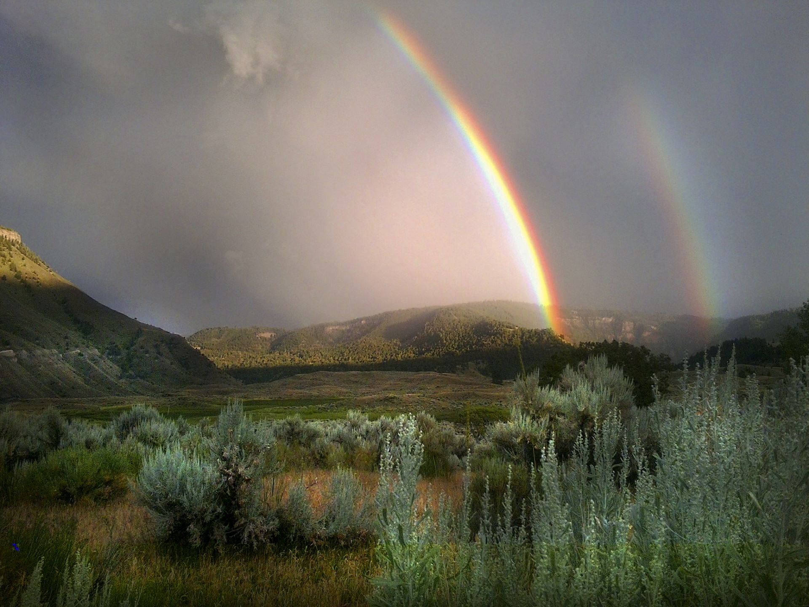

**Arts Contest**

Since last year, the class categorization is based on what a contest article is created from – the media or material – instead of what the resulting article is. This year, the Arts Contest is now merged with the Hand-Crafted Arts Contest, as certainly the items that are hand-crafted are artistic items. Only a minor change was made, as a result of confusion last year over where to enter items. As a result, there are a variety of items possible in each class. For example, Class A – yarn could include knitted articles, crocheted articles, crewel articles from your craft stash, etc.

One question that may arise is what to do if an article is made from multiple media/materials. Class F – mixed media – is the best place. The entrant must choose where to enter their item. If an item is predominantly made from one of the materials, they may enter that class instead of the mixed class. In recent years, classes included additional materials such as leather, wood, and beads. This kind of item would now be entered in Class G - miscellaneous.

**Time to begin working on contest entries, and remind your members to do so!**

1. Traditional or Unusual Family Recipe Contest
2. Photography: Animals; People; Farm Crops Scene; Sky; Monuments
3. Arts: Yarn items; Paper items; Fabric items; Thread items; Paints, water colors, pen, pencil, etc. items; Mixed media items; Miscellaneous items
4. Home-Made Food Contest: Yeast breads; Fruit pies; Canned Items



HYPttps://www.spinnyspinny.com/2009/04/15/a-weekend-baby-quilt/This Photo by Unknown Author is licensed under [CC BY-SA-NC](https://creativecommons.org/licenses/by-nc-sa/3.0/)



**Time to Think About Which Persons You Will Give Your Vote**

With the 2024 elections receiving a lot of news, I am repeating this article I used last year for how one can evaluate the various statements that individuals or news media personnel make. It was originally found at the Colorado State website, but is no longer there. These few paragraphs seemed like a good starting point, but does assume that an individual is open to evaluating information that may be contrary to their opinions and beliefs. This could be printed out and given to Grange members. It’s too late for the primary, but gives good thought as we make our choices in November. (Adapted from: Fowler, H. Ramsey. The Little, Brown Handbook. Boston: Little, Brown.)

**Distinguishing Fact, Opinion, Belief, and Prejudice**

When forming personal convictions, we interpret factual evidence through the filter of our values, feelings, tastes, and past experiences. Hence, most statements we make in speaking and writing are assertions of fact, opinion, belief, or prejudice. The usefulness and acceptability of an assertion can be improved or diminished by the nature of the assertion, depending on which of the following categories it falls into:

A fact is verifiable. We can determine whether it is true by researching the evidence. This may involve numbers, dates, testimony, etc. (Ex.: "World War II ended in 1945.") The truth of the fact is beyond argument if one can assume that measuring devices or records or memories are correct. Facts provide crucial support for the assertion of an argument. However, facts by themselves are worthless unless we put them in context, draw conclusions, and, thus, give them meaning.

An opinion is a judgment based on facts, an honest attempt to draw a reasonable conclusion from factual evidence. (For example, we know that millions of people go without proper medical care, and so form the opinion that the country should institute national health insurance even though it would cost billions of dollars.) An opinion is potentially changeable--depending on how the evidence is interpreted. By themselves, opinions have little power to convince. You must always let your reader know what your evidence is and how it led you to arrive at your opinion.

Unlike an opinion, a belief is a conviction based on cultural or personal faith, morality, or values. Statements such as "Capital punishment is legalized murder" are often called "opinions" because they express viewpoints, but they are not based on facts or other evidence. They cannot be disproved or even contested in a rational or logical manner. Since beliefs are inarguable, they cannot serve as the thesis of a formal argument. (Emotional appeals can, of course, be useful if you happen to know that your audience shares those beliefs.)

Another kind of assertion that has no place in serious argumentation is prejudice, a half-baked opinion based on insufficient or unexamined evidence. (Ex.: "Women are bad drivers.") Unlike a belief, a prejudice is testable: it can be contested and disproved on the basis of facts. We often form prejudices or accept them from others--family, friends, the media, etc.--without questioning their meaning or testing their truth. At best, prejudices are careless oversimplifications. At worst, they reflect a narrow-minded view of the world. Most of all, they are not likely to win the confidence or agreement of your readers.

**May the Forest Be With You, Always**

In 1955, the National Association of Conservation Districts began a national program to encourage Americans to focus on stewardship. Stewardship Week is officially celebrated from the last Sunday in April to the first Sunday in May. It is one of the world’s largest conservation-related observances. The 2024 theme is “May the Forest be with you, Always.” The 2024 Stewardship week will be celebrated April 28-May 5, 2024.

Education is a critical element of the conservation effort at the local, state and national levels. Educating people about the benefits of conservation helps to ensure that we will be wise stewards of America’s natural resources.

This program relies on conservation districts sharing and promoting stewardship and conservation through field days, educational programming, and workshops to educate citizens about the need to care for our natural resources. Find your Michigan district office at htpps://www.macd.org/find-your-district-map. Many district activities extend beyond the one-week observance to include an entire year of outreach. Stewardship Week helps to remind us all of the power each person has to conserve natural resources and improve the world. When everyone works together with their local conservation district, that power continuously grows.

**STEWARDSHIP THEMES**

The Stewardship and Education Committee has developed a five-year rotation for stewardship topics – water, soil, habitat, forestry, and a topic of interest – and determines the theme each year.

May the forest be with you, always. The phrase carries a message of respect, appreciation, and harmony with nature, specifically highlighting the forest environment. It suggests that we should recognize the value of forests and the benefits they provide to us and for our future generations.

Forests are vital ecosystems that support diverse plant and animal life. They provide clean air and water, give us food, fuel, and other forest products, as well as help combat climate change by absorbing carbon dioxide. They offer recreational opportunities, serve as habitats for wildlife, and contribute to the overall well-being of the planet.

By saying “May the forest be with you, always,” it’s a way of expressing a desire for people to be mindful of the forests and to maintain a strong connection with nature. It encourages us to protect and preserve these important natural resources so that they can continue to thrive and benefit us in the long run.

Forestry is a cornerstone of natural resource conservation, promoting the responsible use of forests to meet human needs while safeguarding the ecological, social, and economic benefits these ecosystems provide. Through science-based management and conservation efforts, we can ensure that our forests remain healthy and resilient for future generations. Here’s a brief overview of how forestry contributes to natural resource conservation to assist in your local district [Stewardship Week](https://www.nacdnet.org/news-and-events/stewardship-week/) celebration outreach and education programs:

Biodiversity Preservation: Forests are incredibly diverse ecosystems, home to a wide range of plant and animal species. Forestry practices focus on maintaining this biodiversity by protecting and enhancing the habitat for various flora and fauna. Careful management helps prevent habitat destruction and ensures the survival of many species.

Carbon Sequestration: Forests act as natural carbon sinks, absorbing carbon dioxide (CO2) from the atmosphere during photosynthesis. Sustainable forestry practices help maintain and expand forested areas, which contributes to carbon sequestration, mitigating climate change by reducing CO2 levels.

Water Quality and Quantity: Forests play a critical role in regulating water cycles. They help filter and purify water, preventing soil erosion and maintaining water quality in rivers and streams. Forested watersheds also help regulate water flow, reducing the risk of flooding and ensuring a steady supply of clean water for communities.

Timber Production: Forestry is also about responsible timber production. Sustainable logging practices ensure that timber resources are harvested without depleting forests. These practices include selective logging, reforestation, and maintaining healthy forest ecosystems.

Recreation and Education: Forests provide recreational opportunities for hiking, camping, and wildlife observation, fostering a connection between people and nature. Additionally, they serve as outdoor classrooms for environmental education, raising awareness about conservation and the importance of forests.

[Wildfire Management:](https://www.fs.usda.gov/science-technology/managing-fire) Proper forestry practices can reduce the risk of catastrophic wildfires. Thinning dense forests, creating firebreaks, and prescribed burns are strategies employed to manage the fire-prone areas effectively, protecting both ecosystems and communities.

Economic Sustainability: Sustainable forestry management is crucial for the long-term economic well-being of communities dependent on timber and forest-related industries. Balancing economic interests with conservation ensures the continued availability of forest resources.

Incorporating forestry into climate-smart conservation strategies is vital, aligning with global climate change efforts. Forests serve as crucial carbon sinks, absorbing and storing carbon to reduce greenhouse gas emissions. Sustainable forestry practices are evolving to combat climate challenges like rising temperatures and pests.

[NACD recognizes](https://www.nacdnet.org/about-nacd/what-we-do/climate-smart-commodities-project/) the importance of these efforts and applauds local conservation districts for their support in adaptive forest management. They help reduce greenhouse gas emissions, bridging local actions with global impact.

The 2024 stewardship theme, “May the Forest be with you, Always,” offers an opportunity to introduce climate-smart initiatives to communities through educational workshops and community events. Together, we can preserve ecosystems, mitigate climate change, and build a more sustainable future. Information from: <https://www.nacdnet.org/general-resources/stewardship-program/>. For more information about NACD’s Stewardship Program, email [stewardship@nacdnet.org](mailto:stewardship@nacdnet.org).

**Garter Snake: A Gardener’s Friend**

Snakes may not be your favorite creature, however, the common garter snake in Michigan is actually advantageous to your garden. Here are a few facts, from a posting in “the Connecticut Granger”.

1. There are 35 kinds of garter snakes in North America
2. They appear with lengthwise stripes in yellow, brown, tan, rust, …
3. They typically are less than 2 feet long
4. They eat rodents, slugs, snails, grasshoppers, grubs and other garden pests
5. They are harmless to people and dogs
6. To attract them, add a rock pile or brush pile and a water source



[This Photo](https://www.flickr.com/photos/seneynwr/15169222626) by Unknown Author is licensed under [CC BY-SA](https://creativecommons.org/licenses/by-sa/3.0/)

----

**Holidays during April, May, and June**

The listing of holidays has become one of my “regular” articles in this newsletter. Any of the holidays/special days might provide you with an idea to create a Lecturer’s program of any length – from the short 15-minute program to a longer program. Some holidays might give you an idea to invite someone to your meeting to provide a program, of maybe one of your members is an expert related to a particular holiday and could be asked to provide a program.

April 2 – National Peanut Butter and Jelly Day May 4 – National Play Outside Day

April 8 – Solar Eclipse May 12 – Mother’s Day

April 16 – Good Deeds Day May 19 – Plant Something Day

April 22 – Earth Day May 27 – Memorial Day

June month – Pride month

June 3 – Insect Repellent Awareness Day

June 10 – Worldwide Knit in Public Day

June 14 – Flag Day

June 16 – Father’s Day