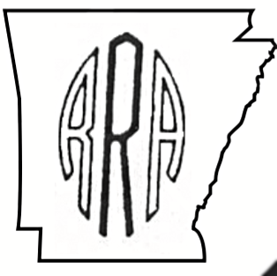

**RODEO**

**ARA Board of Directors**

**President**

**Chad Higginbotham**

**1st Vice President**

**Jimmy Driggers**

**2nd Vice President**

**Brandon Harris**

**Bareback Riding**

**Montana Duvall**

**Saddle Bronc Riding**

**Lane Jason**

**Breakaway Roping**

**Kyla Jones**

**Calf Roping**

**Andy Wise**

**Steer Wrestling**

**Myles Neighbors**

**Barrel Racing**

**Brittney Steed**

**Team Roping**

**Adam Newcomb**

**Bull Riding**

**Brandon Janes**

**Contract Acts**

**Kevin Steed**

**Producer**

**Tom Green**

Judy Canant* ARA Secretary *

1015 Hickory St *Perryville, AR 72126

501-607-4100*ararodeo@gmail.com

**2020**

**Est. 1968**

**Partnership & Advertising Programs**

**Deadline for Sponsorships: August 15th, 2020**

**Corporate Sponsor $5,000**

* Full Page ad in Finals Souvenir Program , Business card size ad displayed on ARA website homepage with link to your company’s website
* Corporate logo on all Finals jackets, approximately 220 awarded yearly
* Feature your Company’s merchandise during the Finals
* Arena banner with logo
* 4 Complimentary Finals jackets

**Event Sponsor $2,500**

* ½ page ad in Finals Souvenir Program
* Business card size ad displayed on ARA website sponsor page with link to your company’s website
* Company name displayed on 15 event Finals jackets
* Arena banner with logo
* 2 Complimentary Finals jackets

**Saddle Sponsor $1,000**

* ¼ page ad in Finals Souvenir Program
* Company ad displayed on ARA website sponsor page with link to your company’s website
* 1 Complimentary Finals jacket

**Timed Event Banner $600** *(only 2 available)*

* Banner with your logo displayed on timed event chute
* 1/8 page ad in Finals Souvenir Program
* 1 Complimentary Finals jacket

**Finals Banner $300**

* Banner with company logo displayed in arena during Finals
* 1/8 page ad in Finals Souvenir Program

**Buckle Sponsor $500**

* 1/8 page ad in Finals Souvenir Program

**Jacket Sponsor $500**

* 1/8 page ad in Finals Souvenir Program
* Company name displayed on 15 event Finals jackets

**Advertising Only** (Souvenir Rodeo Program)

* Full Page $200
* 1/2 Page $150
* 1/4 Page $100
* 1/8 Page $50

**ARA Website Advertising**

* Company ad or logo displayed on ARA website with link to your company’s website $500
* Company name listed on ARA website sponsor page with link to your company’s website $250

\**The above list shows typical donation amounts. However, our Association will graciously accept any donation you are able to send.*

The Arkansas Rodeo Association (ARA) was established in 1968. For 52 years the ARA has brought the world of rodeo to cities and towns across Arkansas, Oklahoma, Louisiana and Texas. Our goal is to promote and preserve the sport of rodeo and its rodeo athletes.

On a yearly basis, our membership averages 400 cowboys and cowgirls who compete in Saddle Bronc Riding, Bareback Riding, Bull Riding, Tie Down Roping, Breakaway Roping, Team Roping, Steer Wrestling, and Barrel Racing.

This year we will again travel the state and surrounding areas promoting rodeo in order to preserve the roots of the western lifestyle.

Please join in our quest by promoting your company throughout the State with an organization founded on tradition, hard work and the **COWBOY** way of life.

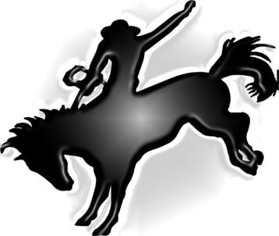

**Interested in becoming a sponsor? Contact the ARA Office or an ARA Director**