C:\Users\Owner\Pictures\Clip Art Work\matt18.tiff**** **The Spire**

September 2017!

The Pastor’s Moment…

Dear Park Place friends and family,

I’m writing this the day before I leave for our family vacation in Maine. I must admit I’m a little bit torn as I look forward to our annual reunion with cousins and my Aunt Julia who lives in Houlton, yet knowing I will miss you for the last two Sundays in August. Our joint services with Smithfield Ave. have been a joy this year, even bringing the two choirs together to sing. I pray we can plan more joint services during the year and we don’t have to wait until next summer.

We have an exciting September in front of us, as our family returns from vacations and comes together again to worship. Our Homecoming Sunday and Opening Day of Church School will be September 10th. On September 17th, we will celebrate the 135th anniversary of Park Place Church. Slow down and think about that for a minute. One-hundred, and thirty-five years ago, 120 people walked away from Pawtucket Congregational Church to plant a church on the west side of the river. They met in each other’s homes, without a pastor to lead them, and in only a few months that original 120 had grown to over 400. At that time they called Pastor J.J. Woolley to lead them. And the rest as they say, “is history.” We are still here worshipping together and serving the community through worship and feeding the hungry and meeting the needs of “the tides of society, which for any reason may flow past our doors.”

This is a challenging time for our nation, and we need to pull together and call on the Lord to guide us, strengthen us and heal our land. But God’s Word is clear, we are not just called to serve, to feed, to clothe, to comfort, or to visit, but first we are called to worship, and as a church we know worship is most effective when done in community. May each of us take time to recommit our lives to God, and to live out our faith together as the church united, so that we may see Jesus’ words fulfilled, “That they may all be one.”

See you in church.

In Christ’s love,

Pastor Bill

**stepup_6677cC:\Users\Linda\Desktop\Clip Art\assist_9632c.wmfAugust Worship Assisting**

**Greeters & Ushers:** *Amanda Ruh & Dawn Shaw, Ginny Platt & Lynn Usher, Shirley Harris & Ginny Platt*

**Lay Readers:** *Non needed during August union services.*

**Coffee Hour Hosts**: Cathy Shute, Lynn UsherDarlene McMillan, Leslie Brouwer, Cindy Boulay & Kristine Gervais, Sara Morrissette

***Coffee Hour hosts for the Month of******September are members from the Elizabeth Circle.******Members of this group are invited to host a Sunday! Thank you!***

**Worship Schedule for September**

*Please note that the time for worship is listed as 9:45 a.m. only to allow time for the Preparation for Worship. Come early to hear some wonderful spiritual music to get you into the quietness of meditation and worship! Worship begins at 10 a.m.*

**September 3: *- Holy Communion Sunday Worship 9:45 a.m.* -** ***Leading******worship****: Pastor Wayne /* ***Communion set up:*** *Ginny Platt/* ***Deacons:*** *Ginny Platt & Amanda Ruh /* ***Coffee Hour*** *@ 11 a.m.* / *Visiting the Holiday Retirement Home @ 2 p.m./* Sinai Church 1-3 p.m.

**September 10:** - ***Welcome Home Worship at 9:45 a.m.*** - ***Leading worship-*** *Pastor Bill /* ***Opening Day of******Sunday School*** *-* ***11 a.m.*** */* ***Coffee hour******11 a.m.*** */* Sinai Church 1-3 p.m.

**September 17: - *135th Anniversary of Park Place Church!! Worship at 9:45 a.m.* *– Leading worship:*** *Pastor Wayne/* ***Sunday School – 11a.m.*** */* Sinai Church 1-3 p.m. 135th Anniversary at 12 p.m. Davenport's Restaurant, 1925 Pawtucket Ave, East Providence, RI 02914. Cost is $20 pp. Reservations happily accepted until September 10th.

**September 24: -*Worship 9:45 a.m.* – Leading worship:** *Pastor Bill/* ***Sunday School 11 a.m./ Coffee Hour 11 a.m./*** Sinai Church 1-3 p.m. (Our Monthly Music & Praise Hour will resume in October)

****

**Baptisms**

**Eric & Meghan Mobley’s son, John Michael Mobley was baptized before our Park Place Family on April 30, 2017. Jaye Weldon & Kevin Mobley are John’s sponsors! May the Lord accept & bless John Michael Mobley into our Church family helping to guide him in his faith journey.**

**Daniel & Sara Cabral’s daughter, Haley Jaymes Cabral was baptized before our Park Place Family on August 12, 2017. Haley’s sponsors are Evan Cloutier & Amanda Cabral. May the Lord accept & bless Haley Jaymes Cabral into our church family helping to guide her in her faith journey.**

**Birth Announcement!**

**Stephanie & Christopher Frappier announce the birth of their 2nd little girl, Bridget Catherine Frappier on May 27, 2017. Norah is happy in her new role as Big Sister! Congratulations to this happy family! May the Lord bless your new little one and her family!**

Our Christian Education/ Sunday School!

We have changed the time of Sunday School. Students will now attend worship service beginning at 10am. Folders will be available for them to pick up as they enter the sanctuary. They will find worksheets inside that coincide with the service that should be completed by the end. After service, the students will meet downstairs, as a group, to discuss the lesson and plan other events. Please see Kristine if you have any questions.

****Park Place Congregational UCC Missions**

***Please remember* *All are welcome to join any activity or***

***just drop in to see what is going on!***

**C:\Users\Linda\Pictures\Clip Art\music_3516c.wmf*Let’s Sing!***

We will be going to The Holiday Retirement Home in Manville, RI, and sing to/with the residents for about an hour on September 3, October 1 November 5 and December 3. Our visits are the first Sunday of each month to make planning easier. We’d love to have you join us.

We will be visiting The Village at Waterman Lake in Greenville, RI on October 8, November 12 and December 10. We would love to have you come and join us to bring music to the residents. Our visits are usually on the second Sunday of each month to make planning easier. *Both places are great outreaches to some wonderful people! All are welcome!*

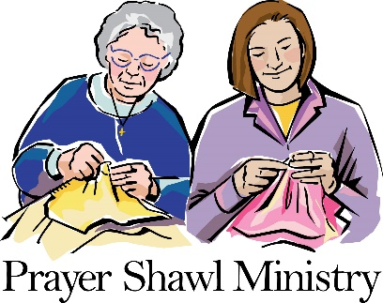Our Prayer Shawl Ministry continues to add to the lives of all who receive them; so much so that we are running very low on our wonderful prayer shawls! ***Prayer Shawls are greatly needed at this time!***

We will be meeting again on September 17, from 6:30-8 p.m.! Our future meetings will be the third Sunday of each month. If you can’t make our meeting, please continue making shawls. Prayer shawls should be 25-30 inches wide 70 inches in length. Baby Blankets are also needed, as we’ve had quite a few Baptisms over the past few months! All are welcome! Even if you don’t know how to knit/crochet, we’ll teach you!

***Stop by the Thrift Shop*** **Big Sale Going on!!!!**

Come stop by on Wednesdays & Saturdays from 8:30 a.m.-12:30 p.m. You never know what you’ll find! The Annex (Aka., The Gregory Room) will also remain open.  Look for new bargains there! Plus shop the clothing area for a big sale; $5.00 Bag Sale until September 16th! Fill a bag with all types of clothes for $5.!!!

**The Elizabeth Circle Needs YOU!!!!!!**

The Elizabeth Circle will be crafting on September 27, from 6-8 p.m. Come and join the fun! This group is looking for some crafty people or anyone who would love to become crafty! All are welcome! Men & Women! Come one, Come all!

**Symbols of Faith!!**



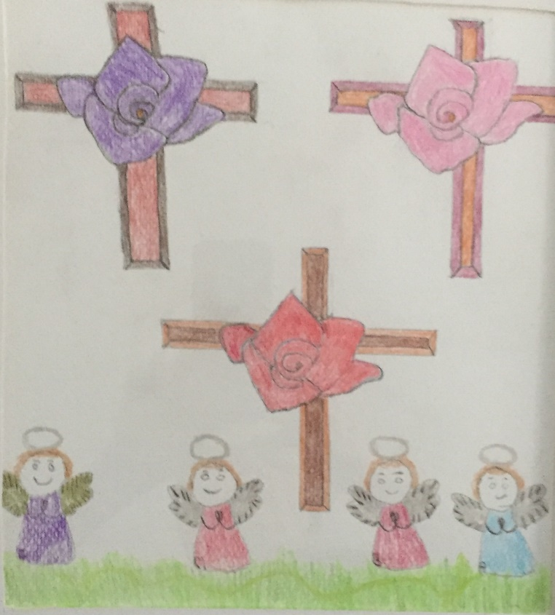When I started, the first symbol I chose was a rose. In Christianity the rose symbolizes heaven and harmony in the world...it symbolizes love. I wasn't sure what to do next. Then the cross came to me and when I was almost done the angel came. I believe it happened this way because of love. God's love for us is shown in many ways...by the sacrifice of his son on the cross to the feeling that comes when I see and smell the roses. And in knowing that there is an angel watching over me. It started out as something to honor my mother which it still does. But I believe it also honors God and the love we have for each other.

Ginny Platt



***Thank You!!***

Thank you to everyone who helped set up and dismantle our Flea Market on August 19; Leslie Brouwer, Kristine, Hunter and Hannah Gervais, Deborah and Taylor Poland, Matt Golding, Myra Green, Shirley Harris, Ana Soares, Lois and George Grenier, Iain Brouwer, Dylan Pavelka and Britney Duron. Couldn’t have done it without your help!

Thank you,

Cathy Shute

**September Memorial & Honorary Altar Flowers**

**September 3:** The Altar flowers are given in a loving September 11th birthday remembrance of Wendy Lincoln from Bill and Darlene.

**September 10:** The Altar flowers are given to the Glory of God by Barbara and Don Langford in loving memory of Charles and Selma Ross and daughter, Pamela.

**September 17:** The Altar flowers are given to the Glory of God by Catherine Shute in loving memory of Edmund Henry.

**September 24:** The Altar flowers are given to the Glory of God by Bill and Darlene McMillan in loving memory of their friends, Mary Beck & Lynn Dieterich.

*(Note: Thank you for your donations of the beautiful altar flowers each week, your continued support is greatly appreciated. Please remember that payment of $35.00 for the altar flowers is due during that month. Thank you for your attention.)*

**Prayers & Concerns for Our Family**

*****Please keep these people in your daily prayers:* Ralph & Ana who are awaiting a call from a hospital for a new liver for Ralph; Mary Anderson; Terry May Neves; Nancy Lepper; Lois Grenier; Geno Cantell; Peter-emotional turmoil; Kathy Morrissette; Anna; Brenda; Linda C.; Stacia; Colin Walker; Gloria Sasnett; Bobby Nicholson; Charlie; Betsy; Paul; Moe; Shelia Clough; Jackie Gardikis; Josh Barber; Patricia Bartosiak; Paul; Melanie; Gabriella; Karen; Libby; Beth Fournier; Kenny; John Peter; Michael; Virginia; Steve; Alice; Deb C; Emily; Debbie Coury; Ann-Marie; Terry; Irene Marteno- cancer; Phyllis; Joyce – (cancer); Lauren & Heather; Frank; Cory; Joanne; Katherine; Irene; Bev; Jim; Ethel; Grace; Tom; Gregg; Peter; Nancy; Eric Green; Debbie Ziegenhagen; Cathleen; Claudia Berube; Trevor Bynoe; Dianne; Bob; All people fighting cancer.

 …. our service men and women, and veterans both old and young who have served our country with honor and pride.

…. the victims of all the ‘terror attacks’ worldwide. May the Lord bring Peace to this world.

…. for the victims and families of domestic abuse.

*Continued prayers for our homebound family members and friends:* Madeline Shay; Rita Clough; Carolyn Chirnside; Barbara & friends at the Holiday Retirement Home and The Village at Waterman Lake.

|  |
| --- |
| **What’s your calling?** |
| https://download.newsletternewsletter.com/artlinelibrary/s/si/signs_16170c.gif  When you have a sense of calling — whether it’s to be a musician, soloist, artist, in one of the technical fields or a plumber — there is something deep and enriching when you realize it isn’t just a casual choice; it’s a divine calling. [That’s] not limited to vocational Christian service, by any means.   —Charles R. Swindoll |

**Heroes of the Faith – September, 2017**

**Heroes**

**of the**

**Faith**

**Jonathan Edwards (1703 -1758)**

It is unfortunate that many people imagine Jonathan Edwards as a ranting Puritan preacher, pounding the pulpit and trying to frighten sinners into heaven. Of course, most of these people have probably never read his famous sermon *“Sinners in the Hands of an Angry God”* or even examined the life of this godly man. For Jonathan Edwards was a quiet scholar, a loving father, a concerned pastor, a burdened missionary, and a man who loved God and longed more than anything else to glorify him.

He came from good Puritan stock, especially on his mother’s side of the family. Her father was Reverend Solomon Stoddard, revered pastor of the Congregational Church in Northampton, Massachusetts. Stoddard was the accepted spiritual leader of the churches in the Connecticut Valley; in fact, some people called him “Pope” Stoddard. He pastored there for fifty years, and under his ministry at least five special spiritual awakenings had been experienced.

In 1716, at the age of thirteen, Edwards entered Yale College, where he invested four years in undergraduate study and then two more years studying theology. It was while he was at Yale that he had two life-changing experiences. The first was his conversion when he was about seventeen years old. Since childhood he had revolted against the doctrine of the sovereignty of God. But as he read 1 Timothy 1:17, he had a remarkable experience of the sense of God’s greatness and glory, and all his theological objections disappeared.

Edwards was never content to have only book knowledge of God. He sought to experience God in his own life in a personal way. He was not an ivory tower theologian, spinning webs of words. He always centered on the experience of the heart; it was this conviction that brought him many spiritual blessings as well as many spiritual battles. Edwards came to the conclusion that “knowledge” was not something divorced from the rest of life, but that a man’s sense helped to teach him truth. In other words, sensory experience and thinking must go together. Again, Edwards saw the importance of uniting the mind and the heart.

This approach would govern his philosophy of preaching for the rest of his life. He would first aim for the heart and move the affections before trying to instruct the mind. In one of his most important books, *A Treatise Concerning Religious Affections*, Edwards wrote, “True religion, in great part, consists in holy affections.” However, he opposed emotion for emotion’s sake. He carefully explained the difference between shallow emotionalism and true affections that prepare the way for men and women to receive God’s truth.

On January 12, 1723, Jonathan Edwards solemnly dedicated himself to God. On February 15, 1727, Jonathan Edwards was ordained and became assistant to his grandfather Solomon Stoddard. Jonathan married Sarah Pierrepoint, and together they had eleven children. Jonathan used to spend at least one hour every night with his children before they went to bed. He often studied thirteen hours a day, yet he took time for his family.

In February 1729, Solomon Stoddard died, and Jonathan Edwards became the pastor of his church, perhaps the most important congregation outside of Boston. In 1734 he preached a series of sermons on justification by faith. The time was ripe, and the Spirit began to move. In the next year, Edwards saw more than three hundred people unite with the church. Some notable sinners in the town were converted, and some remarkable events took place. This was one of the early phases of the spiritual movement in America historians call the Great Awakening, which covered a period from about 1725 – 1760.

Whenever the Spirit works, the flesh and the devil start to work to counterfeit God’s blessing; and it was not long before excesses appeared in the revival movement. George Whitefield had joined the movement in 1740, and in some of his meetings people fainted, cried out with fear, and even experienced fits of shaking. Whitefield, like Edwards, did not encourage these activities, but had no control over them. Ministers who opposed religious enthusiasm openly criticized Edwards and accused him of leading the people astray, so Edwards wrote and published a book on how to discern a true working of God’s Spirit: *The Distinguishing Marks of a Work of the Spirit of God.*

That same year (1741), Edwards was invited to preach at Enfield, Connecticut, and on July 8, he preached “Sinners in the Hands of an Angry God,” perhaps the most famous sermon ever preached in America. There was no question that Edwards had one purpose in mind: to shake the people out of their religious complacency and into the saving arms of the Lord. Edwards was always quiet in his delivery; he read from a manuscript and rarely looked at the people. He did not pound the pulpit or shout. He simply opened up the Scriptures and warned lost sinners to flee from the wrath to come. The Spirit of God broke into the meeting and many people came under conviction.

Concerned with the salvation of the lost, in 1748, he informed the Northampton Church that he would not receive as new members person who had not given evidence of salvation, nor would he permit unconverted people to come to the Lord’s table. Even though ministers in that day had far more authority and respect than they do today, this step was daring and violently opposed by most of the other church leaders. There followed two years of discussion and debate and the result was the dismissal of the pastor. Edwards preached his farewell sermon on July 1, 1750, a pastoral message that showed no animosity or bitterness, although certainly the preacher was a man with a broken heart.

Jonathan Edwards moved his wife and large family to Stockbridge, Massachusetts, where he ministered as a missionary to the Indians. His income was reduced, of course, and yet God provided all their needs. In 1757, he was named president of Princeton College, an office that his son-in-law Aaron Burr later held. He took office in 1758 when a smallpox epidemic was invading the area; he caught the infection through an inoculation that backfired, and on March 22, he died.

Edwards used imagination in his preaching, like every good teacher and preacher, he turned the ear into an eye and helped people to *see* spiritual truth. He knew that the mind is not a debating chamber – it is a picture gallery.

He was a courageous man who held to his biblical convictions even though they cost him his church and the loss of many friends. He stood with George Whitefield when many were opposing him. Edwards encouraged spiritual awakening even though he knew there would be excesses and abuses. He would have enjoyed Billy Sunday’s reply to the critic who said that revivals did not last: “Neither does a bath,” said Sunday, “but it’s good to have one once in awhile!” Edwards preached for decisions in an era when ministers were not supposed to disturb the congregation.

(This account of Jonathan Edwards reflects excerpts taken from *“50 People Every Christian Should Know”* which was compiled by Warren Wiersbe.)