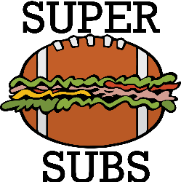
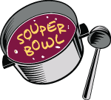
“SOUPERBOWL” SUNDAY SOUP & Sandwich FUNDRAISER!!!
WHEN: February 8th, 2026
TIME: Pick up orders after worship!
WHAT IS IT???
Park Place is holding a Soup & Sandwiches fundraiser! There will be chicken noodle soup, broccoli & cheese soup, Venus Di Milo soup, and a variety of sandwiches available for order!
Orders will be taken from January 11th through February 1st 2026. There will be some extra soup available for purchase that day but we strongly encourage pre-orders.

Souper Prices:
Bowl of soup: $6 Quart of soup: $9 Brownies: $1 Sandwiches: $9
Turkey, Ham, Italian (bologna, salami, mortadella), Chicken Salad
Add On’s: Lettuce, Tomato, Onion, Cheese: American, Provolone, Swiss
Please fill out an order form or call (401)726-2800 or email the church at office@ppucc.necoxmail.com to place your order! Thank you!
Superbowl Soup & Sandwich 2026
Enjoy a great meal while watching the game!
Name:________________________________
Soup order: Bowl (B - $6 ea.) – Quart (Q -$9 ea.) – Brownies ($1 ea.)
Chicken soup ________ Broccoli & Cheese soup ______________
Venus Di Milo soup __________ Brownies: _________
Total: $_____________
------------------------------------------------------------------------------
Name: _______________________________
Sandwich order: ($9)
Turkey: ______________ Ham: _____________ Italian: _________________
Chicken Salad: ________________ ^{(bologna, salami, mortadella):}
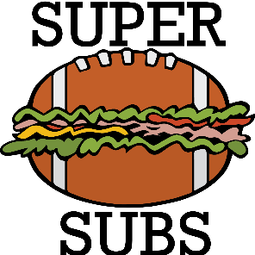
Condiments: __________________ ________________________
Lettuce, Tomato, Onion, Cheese- American, Provolone, Swiss
Mustard, Mayo, onions Total: $ _____________

