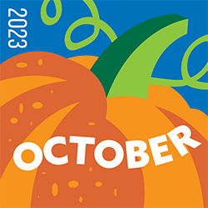 The Spire

Dear Park Place Family and Friends,

 It seems hard to believe that another summer has come and gone and we are now in the fall season of the year. I love this time of year as the New England area becomes an array of beautiful colors. Many of us will be venturing to the sights of Autumn around New England and we will glory in the splendor of God's beauty. God gives us so much always and, in the wrath, and the turmoil of our world, God gently reminds us that there are wonders and gifts to behold everywhere we turn if we only open our eyes and hearts to witness them.

I want to thank everyone who lifts their hearts and love to the ministries of Park Place. Thanks to all who made our Pasta supper such a success and great time of fellowship. Thanks to all who have been working on our Calendar Raffle and please watch for our exciting additions to our Christmas on the Hill/Vendor Faire coming up November 11th. I hope that you continue to watch online if you aren't able to be with us in person for all the gifts and blessings that God helps us to share. Also, remember to check the calendar for upcoming events including another great bible study series with Bill McMillan, our retired Pastor. Thanks to you to all of our online ministries as well.

As you see the beautiful array of colors that will be blessing us, may we all remember the gift of beauty in our own lives. May we look beneath the surface and find the hidden treasure in those whom we love and in the unexpected blessings from strangers in our midst. May we be the beautiful colors of God's vision in our everyday lives so that we can bring love, joy and hope. Have a blessed month, hope to see you all.

Yours In Christs Love & Service,

**Pastor Wayne**

**Worship Schedule**

Please join us for Worship Service Sundays @ 10 a.m.!! All are welcome! Can’t make it to worship? Tune into Facebook for a live feed and recorded for anytime. YouTube viewing Mondays for later viewing!

*If you would like to attend worship but need a ride, please call the church office no later than Friday 3p.m. and we will try to arrange transportation.*

October 1st, 2023 10 a.m. Holy Communion – Pastor Wayne, leading worship with our Chancel Choir & Jane Bedia on keyboard. Communion setup Kristine Gervais & serve: Kristine Gervais & Darlene McMillan; breakdown: Darlene McMillan.

October 8th, -10 a.m. Pastor Wayne, leading worship with our Chancel Choir & Jane Bedia on keyboard.

October 15th, -10 a.m. Pastor Wayne, leading worship with our Chancel Choir & Jane Bedia on keyboard.

October 22nd, - 10 a.m. Pastor Wayne, leading worship with our Chancel Choir & Jane Bedia on keyboard.

October 29th, - 10 a.m. Pastor Wayne, leading worship with our Chancel Choir with Jane Bedia on keyboard.

**************************************

**Sunday School Begins!!!!**

**All Children are Welcome!**

Please attend worship with your family and then following the Moment for All Ages we will join together and process to class! All children in K-12 are invited.

**October 15 – Sara Morrissette**

**October 22 & 29 – Megan Palumbo**

**************************

**Church News & Events!**

For those of you who cannot attend worship in-person, please join us live on Facebook at 10 a.m. or YouTube on Mondays. We continue offering weekly posts on Tuesdays: A Moment with Pastor Wayne, Thursdays: Words & Music with Pastor Wayne & Jane Bedia on keyboard; Saturdays: “Love Stories of Our Faith,” with D & Andy and Andrea & Sophia Padula on rotating weeks.

* Calendar Raffle – Tickets will be drawn daily. Winners will be contacted as their name is drawn via phone and email! Good Luck! A Winner Daily!!
* Christmas on the Hill & Vendor Faire – November 11th, 9 a.m.- 2 p.m. More info below!

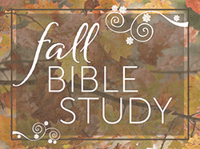

**Bible Study Begins on October 3rd!**

Our next Bible Study will begin on Tuesday, October 3, at 6:00 PM. This time we’ll walk through 1 John. It is a very small book near the end of the New Testament, only five chapters; but it is packed with so much richness, that you’ll probably be surprised at how many treasures we can find in these five chapters. The first week will be an introduction. If you’ve never been to a Bible Study and you’re considering attending, please, at least come to our first session, to try it out. Then if you find it interesting come back for the rest of the study.

Our sessions will be on the following Tuesdays at 6:00 PM; October 3, 10, 17, 24, and November 7 & 14. We won’t have a session on Halloween, October 31. All you need is a Bible and a pen or pencil. A workbook will be provided, which will give you background information and pages to take notes on.

I look forward to our journey together through this exciting and encouraging book of 1 John.

In Christ’s love and mine, Bill McMillan

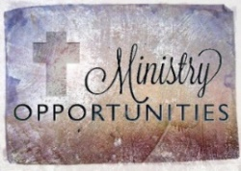**Park Place Congregational UCC Missions**

***Please remember All are welcome to join any activity or just drop in to see what is going on!***



***Stop by the Thrift Shop!*** Thrift Shop hours are Wednesdays & Saturdays 10 a.m. to 1 p.m. Please do not leave your donations in front of the store, please bring in while we are open. Thank you for your attention.

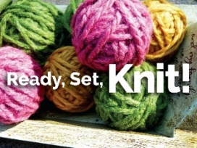Prayer Shawl Ministry

Our Prayer Shawl Ministry is ongoing, group Will Be Meeting October 15th, 2-3:30 if you cannot make this date, please continue to knit and crochet at home. Shawls can be either knitted or crocheted and should measure 25-30 inches wide and 70 inches in length. Thank you in advance for supporting our Prayer Shawl Ministry.

*********************

The Month of October will be our 1st Annual Calendar Raffle!

A Name of the Lucky Winner will be drawn Daily!!

Winners will be Notified via phone & email!

Good Luck!

**Christmas on the Hill & Vendor Faire**

November 11, 2023, 9 a.m. – 2 p.m.

Terry and Bob’s Kitchen Luncheon 11 a.m.-1 p.m.

**Menu:** Soups, Chicken Noddle & Broccoli and Cheese, Hot Dogs,

Grilled Cheese, American Chop Suey, Soda, Chips

Join us for Lunch, visit our Bake/Fudge Table, Gift Table, Basket Auction, Christmas Corner! Vendors: Apron Lady, Classy Flamingo, Holiday Hooking, Left-Handed Hooker, Timeless Treasures, Usborne Books, Homemade Bath-towels, Crafts by Hannah, Jewelry & Bows, Wreaths & Crafts.

Happy Birthday!!

****Wishing you all a Happy October Birthday! Please consider sending a card, making a phone call or reaching out in some way to one of our birthday people!

**NOTE:** If you are not listed in our birthday list please email or call the church office to let us know. Thank you.

3: Andrea Padula 4: David Walker 4: Laurie Phillips Olson

6: Sara Morrissette 17: Taylor Poland 21: Michael Padula

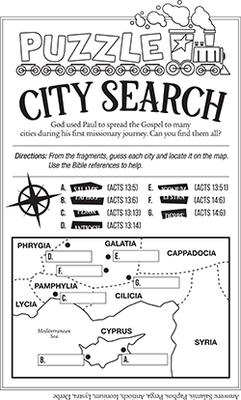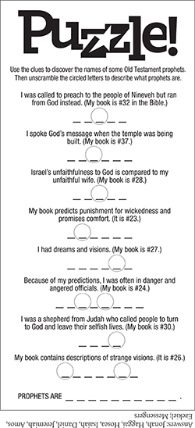

Kid’s Page

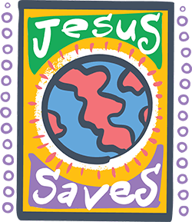Bible Quiz

Not long before Jesus’ arrest, he said: “I did not come to the world, but to ____ the world.” Fill in the blanks.

A. judge; save

B. hate; love

C. condemn; teach

D. disrupt; conform to

**Bible Quiz Answer:** A (See John 12:47, NIV.)

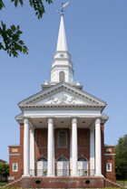Park Place Congregational United Church of Christ

71 Park Place

Pawtucket, RI 02860

Phone: 401-726-2800

Email: [office@ppucc.necoxmail.com](mailto:office@ppucc.necoxmail.com)

Website: parkplaceucc.com

**A Prayer That I May Do God’s Will**

The following is the Third-Step Prayer in Alcoholics Anonymous. It’s surely a prayer we all can make, that God’s will — not ours — may be done and guide our lives.

God, I offer myself to thee  
to build with me and to do with me as thou wilt.  
Relieve me of the bondage of self, that I may better do thy will.

Take away my difficulties,  
that victory over them may bear witness  
to those I would help of thy power,  
thy love and thy way of life.  
May I do thy will always!