C:\Users\Owner\Pictures\Clip Art Work\matt18.tiff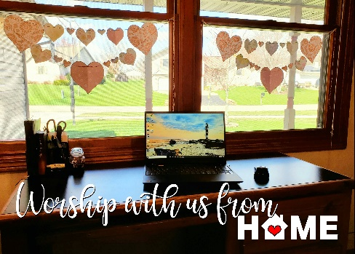

**The Spire**

September 2020



Dear Park Place Friends and Family,

Summer is a great time for renewal and family times and celebrations together, yet with all that’s going on in our world, so much has changed. BUT, that doesn’t mean that we can’t still reach out to one another and bring each a bit of joy. Sometimes a visit with a friend or family member, especially during times like these can make a person’s day. It can be driving by in your car, a phone call, or even a visit on FaceTime. We can even meet in person but with care.

This past Sunday, August 23, several members of our church family met together and did a drive-by parade visit to Sylvia, our retired organist who had been here for many, many years offering her talents, time and dedication. She was always a blessing. Our parade with horns beeping and balloons and signs saying Hi! We love you and miss you! And Greetings from Park Place was a beautiful way to let her know that we were thinking of her. Many of the people in the community where Sylvia lives also came outside to watch the “Parade” of love and care. All of us who participated felt that joy of remembering and sharing even it was just for a few moments. I think it helped to make our day brighter as well as Sylvia’s and the people who live in the community. Thank you to all who participated. Even our Church Administrator Linda joined the “parade via FaceTime all the way from Florida. Think about how you can make someone’s day today and I promise it will make your day brighter as well. Hope to see you all soon and that you continue to watch our online services on Sunday mornings and then Monday thru Friday times with Pastor Bill and Pastor Wayne on Facebook and YouTube. Hoping that we will get to see each other soon in person. May God’s Love and Light brighten your days!

In Christ’s Love and Service,

Pastor Wayne

**Worship Schedule**

Join us as we continue to use Social Media to worship and praise God! We will offer daily messages & prayer, as well as Sunday Worship on which can be viewed on either Facebook (Park Place Church) or on YouTube: search Park Place Congregational Church

**September 6:** *Holy Communion Worship Service – 10 a.m. Please join us for Communion worship by getting these things ready prior to your worship, you’ll need bread (crackers are fine as well) and juice (a beverage) and partake when blessings and instructions to do so are given. /Services will be posted to Facebook and YouTube. Also, please look for Pastor Bill’s Chats on Facebook on Monday, Wednesday and Fridays and Words and Music moments with Pastor Wayne on Tuesdays and Thursdays.*

**September 13:** *Worship Service- 10 a.m. Available on Facebook-ParkPlaceChurch or YouTube.*

**September 20:** *Worship Service – 10 a.m.- Prayer Shawl Ministry 2-3:30 p.m. Please join us by knitting/crocheting during this time away from one with one another.*

**September 27:** *Worship Service – 10 a.m./ Music & Praise will return when we are able - We will keep you posted as to when we can return to our regularly scheduled activities!*

**Southern New England Conference Annual Meeting: It's Official!**

Due to the extended State of Emergency in Massachusetts, the Sept. 26 online Conference gathering will be the first official Annual Meeting of the Southern New England Conference, which was formally incorporated on Jan. 1, 2020.

The Meeting will be woven through with vibrant worship, will include small group break-out sessions focused on shared ministry interests, and will include the election of the Conference's first Executive Conference Minister.

The Meeting will also include pre-recorded Speakouts, in which delegates have 60 seconds to address the meeting on the topic of their choice. Anyone wishing to submit a Speakout should sign up by Tuesday, Sept. 1 at 4 PM.

Visit the Annual Meeting page at sneucc.org/2020AM for details, delegate materials and online registration. <https://www.sneucc.org/eventdetail/annual-gathering-and-worship-14027304>

**✍✍✍✍✍✍**

Greetings Park Place Family and Friends,

I find I need to inform you that I have a Covid-related disease. Yup. It’s Corona Brain. I used to call it being a blonde. (No groaning please...or being offended. I was a natural born towhead). Whatever anyone wants to call it.....even aging (ugh!), everyone starts to experience it at some point in their lives. I also used to blame it on losing brain cells giving birth. Later I blamed it on stress – working, maintaining a home, raising my daughter. So, I’ve had Corona Brain for some time now but it seems to be accelerating...not drastically or to be medically concerned...but at a rate that is annoying. I forget a word, a name, a whole thought. Recently, I was driving down Broad Street in Cranston with friends and none of us could remember the name of the hospital that used to be there...although we remembered Adams Drug was across the street. Later I got a text...Cranston Hospital. How simple was that? Why am I confessing this you ask? I’ll tell you. Linda let me know earlier this week my blurb was due by Friday and I already knew what I wanted to talk about and planned to write and send it Wednesday. For the life of me, I cannot recall what that topic was. I know it will wake me up in the middle of the night and I will be smart enough to write it down and hopefully it will be appropriate for a future Spire. In the meantime, I pray you are all healthy, wealthy and wise. I hope no one else is inflicted with Corona Brain.

Blessings,

Shirley​

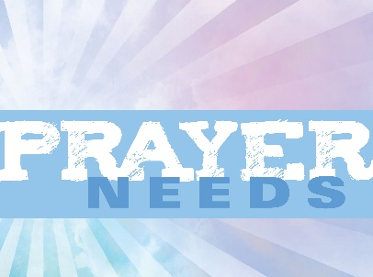**Prayers & Concerns for Our Family**

*Please keep these people in your daily prayers:* Marc who continues for have difficulty with his vision; Raymond who is recovering from hand surgery; Jim Hersey who is recovering from surgery and will be needing another surgery soon; Linda’s family; Tara who is going through health issues & her mother Paula who has heart problems; Shannon recovering from thyroid surgery; Gary Bowen who is in stage 4 bone cancer; Curtis P.; Dave Hartshorn; Michelle, Micah; Ken Depot; Beverly Fountaine; Janet Theberge; Shelagh Lees; Debbie Ziegenhagen; Jocelyn; Laurie; Eva; Lauryn Maples; Janet Estes; Steven; Claudia Dunn; Elaine; Bob, Carol; John; Carlene; Karen B; Richard Deblois, Judy O; Kathy Morrissette; Anna; Brenda; Linda C.; Stacia; Colin Walker; Charlie; Betsy; Paul; Moe; Jackie Gardikis; Josh Barber; Paul; Melanie; Gabriella; Karen; Libby; Beth Fournier; Kenny; John Peter; Michael; Virginia; Steve; Alice; Deb C; Emily; Debbie Coury; Ann-Marie; Terry; Irene Marteno- cancer; Phyllis; Joyce – (cancer); Lauren & Heather; Frank; Cory; Joanne; Katherine; Irene; Bev; Jim; Ethel; Grace; Tom; Gregg; Peter; Nancy; Eric Green; Cathleen; Claudia Berube; Trevor Bynoe; Dianne; Bob; Sherry; Terry; All people fighting cancer.

Please continue prayers for

… Those who are recovering from Corona-virus, those who are working in hospitals, First Responders and all who are working with the public.

…For our country as we navigate our world of change, understanding, forgiveness, friendship and love. All of those that are working together to bring awareness to the Black Lives Matter movement.

… the victims of the terrorist attacks across our great nation and across the world. May the Lord bring Peace to this world.

… all those impacted by all the natural disasters all around the world.

… for the victims and families of domestic abuse.

… our service men and women, and veterans both old and young who have served our country with honor and pride.

Continued prayers for our homebound family members and friends: Sylvia Kaufmann; Rita Clough; friends at the Holiday Retirement Home and The Village at Waterman Lake.

**Bible Quiz**

Which of these was not one of the 10 plagues God brought against Egypt to persuade Pharaoh to let the Hebrew people go?

A. an abundance of frogs B. the Nile River turned to blood

C. the collapse of the pyramids D. thick darkness

(Answer on last page)

****Park Place Congregational UCC Missions**

***Please remember* *All are welcome to join any activity or***

***just drop in to see what is going on!***

We plan to continue our nursing home ministry when it is safe to do so and all restrictions are lifted.

***Stop by the Thrift Shop!*** The Thrift Shop will reopen as soon as we are able. We pray that our customers are all well and safe during this time.

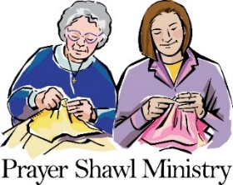Our Prayer Shawl Ministry continues to add to the lives of all who receive them; so much so that we are running very low on our beautiful prayer shawls! Although we cannot meet together at this time, please continue to knit and crochet at home. If you are seeing us on Facebook or YouTube, please consider making a shawl or two and donating it to our Prayer Shawls Ministry. Shawls can be either knitted or crocheted and should measure 25-30 inches wide and 70 inches in length. If you are an experienced knitter you may visit some on-line sites to find fancy patterns, although a simple garter stich is all that is needed. Thank you in advance for supporting our Prayer Shawl Ministry. If you are helping us, please let us know via phone or email: 401-726-2800 or office@ppucc.necoxmail.com

********************************

Happy Birthday!!

Wishing you all a Happy September Birthday! Please consider sending a card, making a phone call or reaching out in some way to one of our happy people!

**September:**

4: Timothy Shaw 6: Dawn Shaw 14: Jocelyn Neves

20: Ron Barber 29: Hannah Gervais 29: Tina Champeau

***************************

**September Memorial & Honorary Altar Flowers**

**Altar flowers will not be ordered until we are able to once again return to our beautiful church for worship and fellowship. This is how the donations would read if we were ordering flowers:**

**September 6:** The Altar flowers are given in a loving September 11th birthday remembrance of Wendy Lincoln from Bill and Darlene.

**September 13:** The Altar flowers are given to the Glory of God by Barbara and Don Langford in loving memory of Charles and Selma Ross and daughter, Pamela.

**September 20:** The Altar flowers are given to the Glory of God by Catherine Shute in loving memory of Edmund Henry.

**September 27:** The Altar flowers are given to the Glory of God by Bill and Darlene McMillan in loving memory of their friends, Mary Beck & Lynn Dieterich.

**Kids Page**



Bible Quiz Answer: C (See Exodus 7:14–12:32.)

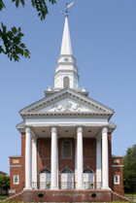Park Place Congregational United Church of Christ

71 Park Place

Pawtucket, RI 02860

Phone: 401-726-2800

Email: [office@ppucc.necoxmail.com](mailto:office@ppucc.necoxmail.com)

Website: parkplaceucc.com

“When God Crosses Our Paths”

Pastor and martyr Dietrich Bonhoeffer wrote, “God will be constantly crossing our paths and canceling our plans by sending us people with claims and petitions.” Last spring, the whole world had plans canceled, first by Covid-19 and then by God “sending us people with claims and petitions.” Some needed prayers for healing or for coping with grief. Medical staff, teachers, pastors and others serving long hours needed support: meals, check-in calls, “thinking of you” cards. Parents working remotely while helping kids with distance-learning needed encouragement. Crucial nonprofit work still required donations.

Pre-pandemic, you may not have realized that staying home or wearing a face mask could be a ministry. Or that sending a card expresses love in Jesus’ name. Or that buying takeout from a local restaurant can be a gift to the owners. When our calendars empty, God “crosses our paths” in new ways — both to be with us and to nudge us toward others (even if virtually, or 6 feet apart!)