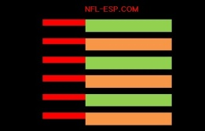
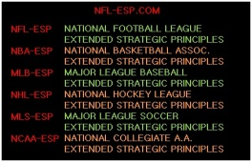
NFL-ESP
NFL-EXTENDED STRATEGIC PRINCIPLES

● NFL-ESP results in a data-proven 10-15% increase in a football team’s [and all major sports] overall productivity and POINT PRODUCTION; or +1.6 to +2.4 wins per 16-game NFL season!

● It is a program and system, over 40-years in development, whereby data suggests the current NFL head coaches most associated with its use have won 11-of-the-last-14 Super Bowls.

● It is a strategic system, 6-time NFL Executive-of-the-Year, Mr. Bill Polian; began partially implanting with the Super Bowl XLI Champion Indianapolis Colts and consulted with us at length at the 2013 MIT Sports Analytics Conference.

● It is a program, Chicago Bears Head Coach, Marc Trestman helped develop and with whom we consulted extensively won a pair of CFL championships; while only having the opportunity to implement 50% of the system.

● It is a strategic system supplying exclusive statistical data, “Reports” to serve in making more PRODUCTIVE key pre-game and in-game STRATEGY and GAME MANAGEMENT decisions.

● It is the development and formation of a third, primary COORDINATOR, who implements the data found in the Reports, called the “GAME MANAGEMENT COORDINATOR [GMC].”

● It uses a complex formula to assign a comprehensive POWER-RATING to all NFL [and all major sports] teams; and a single qualitative number, and probability percentage, to determine the statistical difference between the teams called the POWER-SPREAD.

● It’s system uses an in-game calculation called the POWER-SPREAD INDEX or PSI; and a numerical percentage to gauge which STRATEGY DECISION is most probable and PRODUCTIVE.

● It possesses a component which includes information and insights on “X’s and O’s” or play design; in addition to a component which includes stadium design and franchise development.

● It is a MOTIVATIONAL program which consults implementing perspectives and tools drawn from a wide variety of MOTIVATIONAL minds, leaders, coaches and players.

● It is a SPIRITUAL program which counsels using virtually all faiths, philosophies, religions, and perspectives including its “Ten Commandments of Championships.”

©Copyright 2013 All Rights Reserved
VCG, Inc. www.vcgusa.com. Mark Anthony DiBello www.NFL-ESP.com

