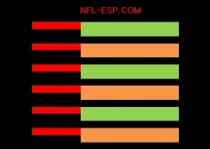
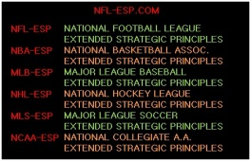
NBA-ESP
NBA-Extended Strategic Principles

● NBA-ESP results in a data-proven, minimum, 10-15% increase in a basketball team’s overall productivity and POINT PRODUCTION; or +8.2 to +12.3 wins per NBA season!

● It is a system, over 40-years in development, whereby data suggests the head coaches most associated with its use have won 11-of-the-last-14 Championships.

● NBA-ESP is a system whose development continued while working with Sacramento Kings Head Coach, and former coach of the Albany Patroons, Mr. George Karl; the 3rd leading coach in wins in the history of the NBA.

● It is a system, who’s creator introduced to Detroit Pistons Head Coach Stan Van Gundy at the 2012 MIT Sports Analytics Conference.

● It is a broadcast, “NBA-Moneyball” which covers the games from the unique perspective of NBA-ESP and has interest to those in Las Vegas and those who play Fantasy Sports. It was recently introduced to the team at TNT Sports and Commissioner Silver at CES 2016.

● It uses a complex formula to assign a comprehensive POWER RATING to all NBA [and all major sports] teams; and a single qualitative number to determine the statistical difference between the teams called the POWER SPREAD.

● It is a strategic system supplying exclusive statistical data “Reports” to serve in making more PRODUCTIVE key pre-game and in-game STRATEGY decisions.

● It is a component of a program which includes information and insights on “X’s and O’s” or play design, in addition to sports and strategic theory.

● It is a MOTIVATIONAL program which consults implementing perspectives and tools drawn from a wide variety of MOTIVATIONAL minds, leaders, coaches and players.

● It is a component of a program which includes stadium design and franchise development.

● It is a SPIRITUAL program which counsels using virtually all faiths, philosophies, religions, and perspectives including its “Ten Commandments of Championships.”

©Copyright 2016 All Rights Reserved
Mark Anthony DiBello www.NFL-ESP.com

