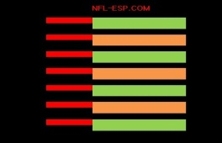
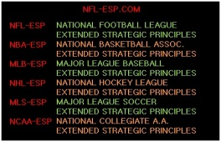
Description of NCAA-ESP [Extended Strategic Principles]
“Extended Strategic Principles” is an analytical and STRATEGIC program and system for use in the NFL, NBA, MLB, NHL, MLS, CFL [Canadian Football League], PGA and in NCAA football and basketball. It serves a team in making the most PROBABLE and PRODUCTIVE game management and STRATEGY DECISIONS; thus increasing PRODUCTION, scoring, and wins.

The program incorporates STRATEGIC, MOTIVATIONAL, SPIRITUAL knowledge and X’s and O’s design proven to increase a team’s win production by at least 10-15% per season!

The key to the STRATEGIC statistical system are exclusive, complex, and highly-accurate team POWER-RATINGS and the numerical difference between teams called the “POWER-SPREAD.”

The POWER-SPREAD is the single-most accurate [and misunderstood] statistical number which incorporates all relative team and game data. It is a single qualitative statistic which determines the strength of one team vs. another. This number is NOT an opinion; it is based on extensive data! However, a similar, biased, subjective, often inaccurate “number” is published for every major sporting event. Additionally, the terms “UNDERDOG” and “FAVORITE” are NOT opinions; they affect a team STRATEGICALLY, emotionally and MOTIVATIONALLY!

In addition, recognizing how to use the POWER-SPREAD when game planning and making strategy decisions is highly advantageous especially for the “UNDERDOG.” A Head Coach must ask himself: “Do I just analyze tape and match-ups or do I analyze certain statistical data?” Again, this statistic, the POWER-SPREAD, not only incorporates all the most meaningful stats, rankings, and records; but any numerical information regarding plays, players and the game!

In comprehending its use, picture it like this: Two armies are in hand-to-hand battle in an open field...a wall is in the middle of the field. The first coach doesn't know the wall’s height; the second coach knows the wall is 10-feet tall. It stands to reason; the coach who knows the wall’s height will know what decisions his team must make to better scale the wall and win the war. The question is: Does a Head Coach make key strategy decisions by analyzing the POWER-SPREAD as a barometer; or in the illustration, in the context of knowing the height of that wall?

For example: When a basketball coach makes a decision on playing half-court tempo or a fast-break style...Does he refer to the score and/or go by “feel” or “gut instinct”...OR...is there a statistic which helps him make the most PROBABLE and PRODUCTIVE decisions to outscore the opponent and win? In fact, these decisions should be communicated to him pre-game by a consultant or coordinator; and in-game, by a Game Management Coordinator or GMC.

In closing, in the NCAA-ESP strategy system; a coach is taking a statistical number and using it to PRODUCE and win games just as the most ingenious minds in sports analysis do in their highly-profitable worldwide financial markets. If a coach does not use NCAA-ESP, he places his team at a proven 10-15% disadvantage!

