BRIEF DESCRIPTION OF ESP [EXTENDED STRATEGIC PRINCIPLES]
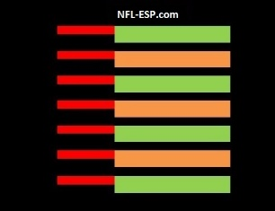
To begin, established in 1968, NFL Extended Strategic Principles [www.NFL-ESP.com] is one of a dozen sports data products, systems, consultation and broadcast services we have developed in professional and collegiate sports.
Our data product, system, and service is mathematically proven to increase a team’s WIN PRODUCTION by at least 10-15% in pro sports and is of greater VALUE in collegiate sports!
ESP generates exclusive data and information from a SPIRITUAL, MOTIVATIONAL, “X’s and O’s” [play design] and STRATEGIC perspective; featuring our highly complex, but simplified, statistical number or index called the POWER-SPREAD and its PROBABILITY PERCENTAGE.
The greatest value to the POWER-SPREAD is its systematic use in servicing coaches [pre-game, in-game, and post-game] in making the most PROBABLE and PRODUCTIVE BASIC STRATEGY DECISIONS.
This POWERFUL statistical data and system is offered in our customized 1-page, Short Version; or multiple pages, Long Version ESP Reports; followed-up by our consultation on how to best apply the data.
The most POWERFUL and PRODUCTIVE service we offer; since scoring, stats and strategy decisions change; is the use of our exclusive and variable POWER-SPREAD INDEX [PSI] and PROBABILITY PERCENTAGE; relayed from a Game Management Coordinator [GMC] live at a game, match, or race.
In addition, with experience in broadcasting and as a credentialed media member, we appreciate the media and the POWER of mass communication; thus, we have developed a broadcast called “ESP Moneyball” with the innovation of airing a fan-friendly version with some simplistic information to the viewing public, but also recording a more in-depth version as a video teaching tool or tutorial for the coaching staff as the primary or optional consultation service.
Lastly, we wholeheartedly believe in the integrity of professional and collegiate sports; yet, Nevada and almost 50% of the United States now use an altered and inaccurate version of our original POWER-SPREAD to profit from the wagering public. Thankfully, our system contains built-in and competitive infrastructures to insure fair and balanced play and outcomes.

