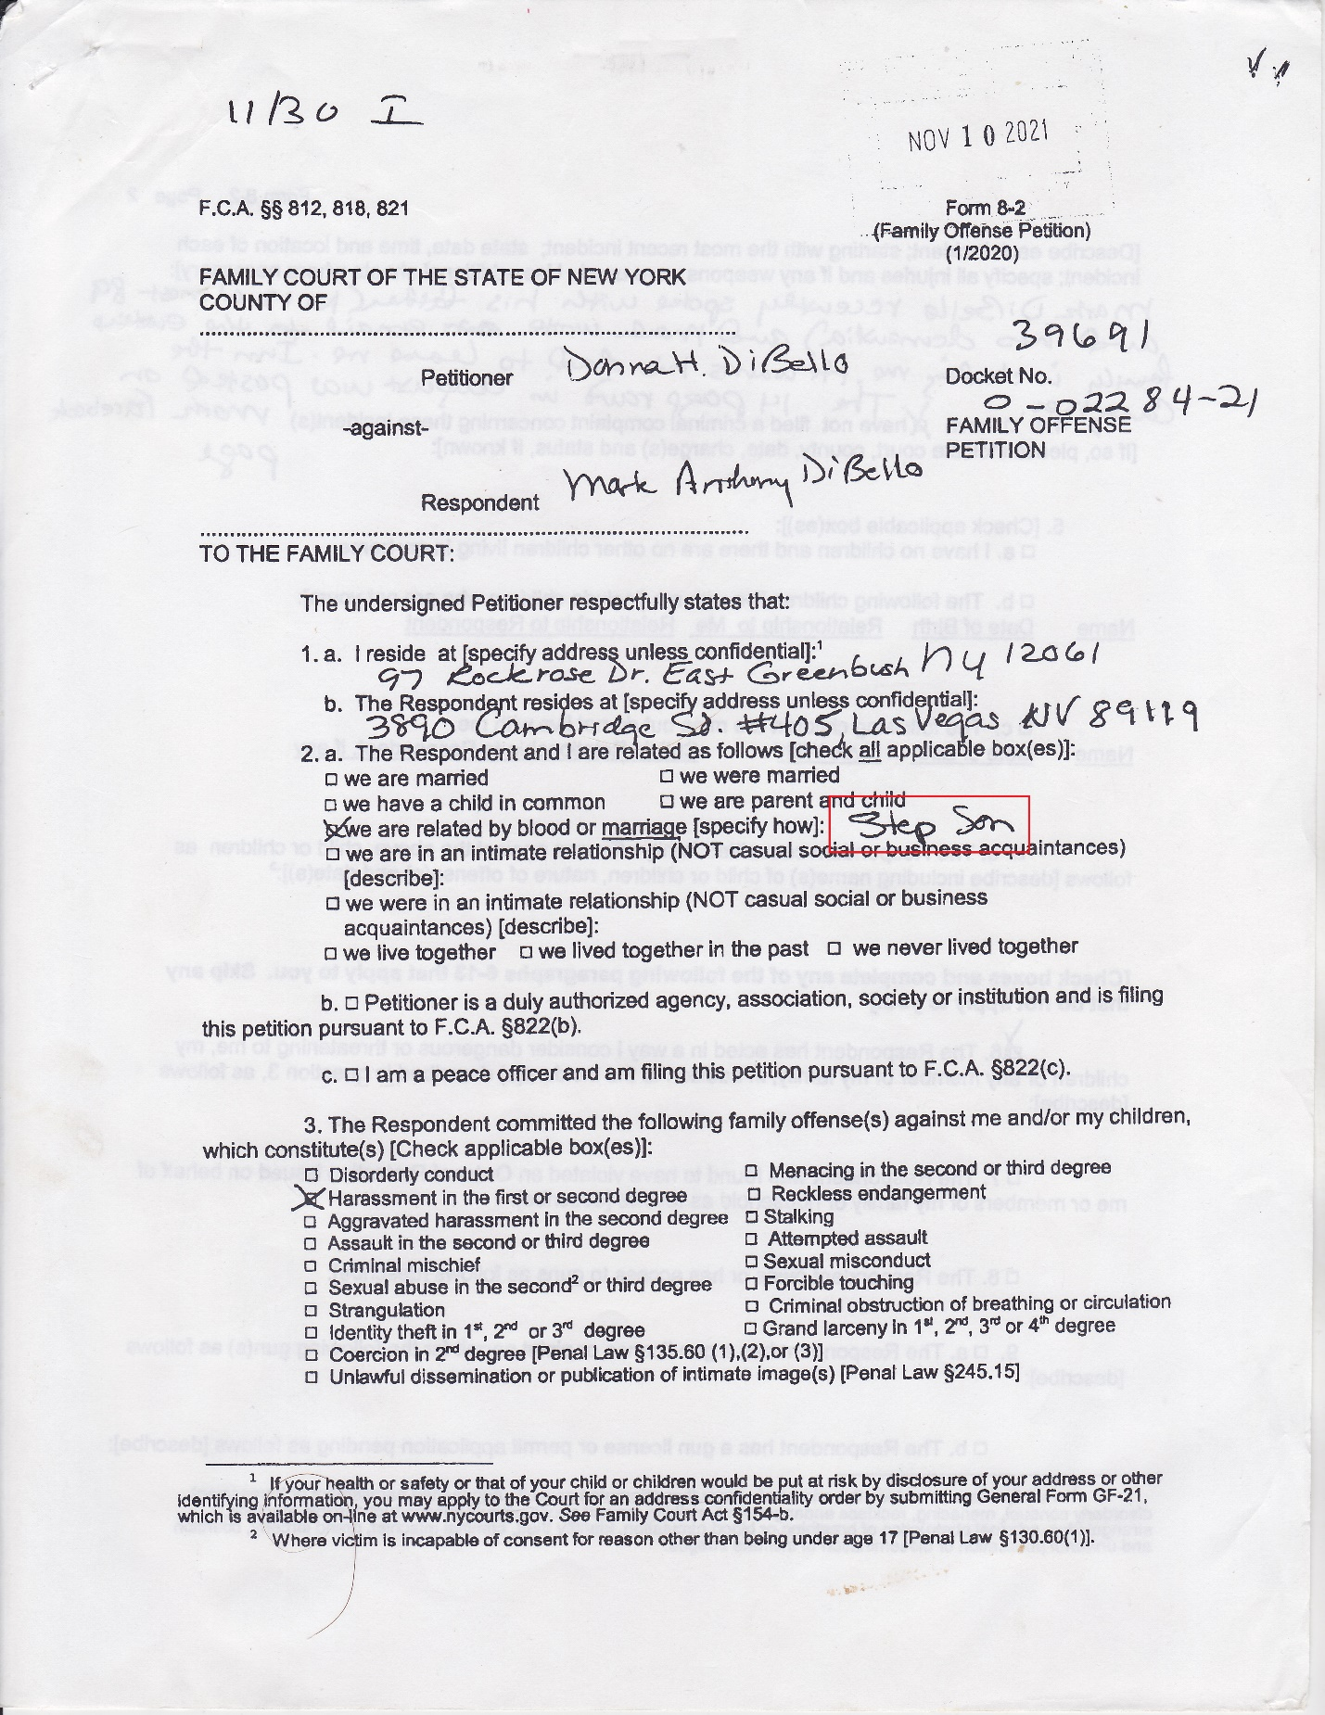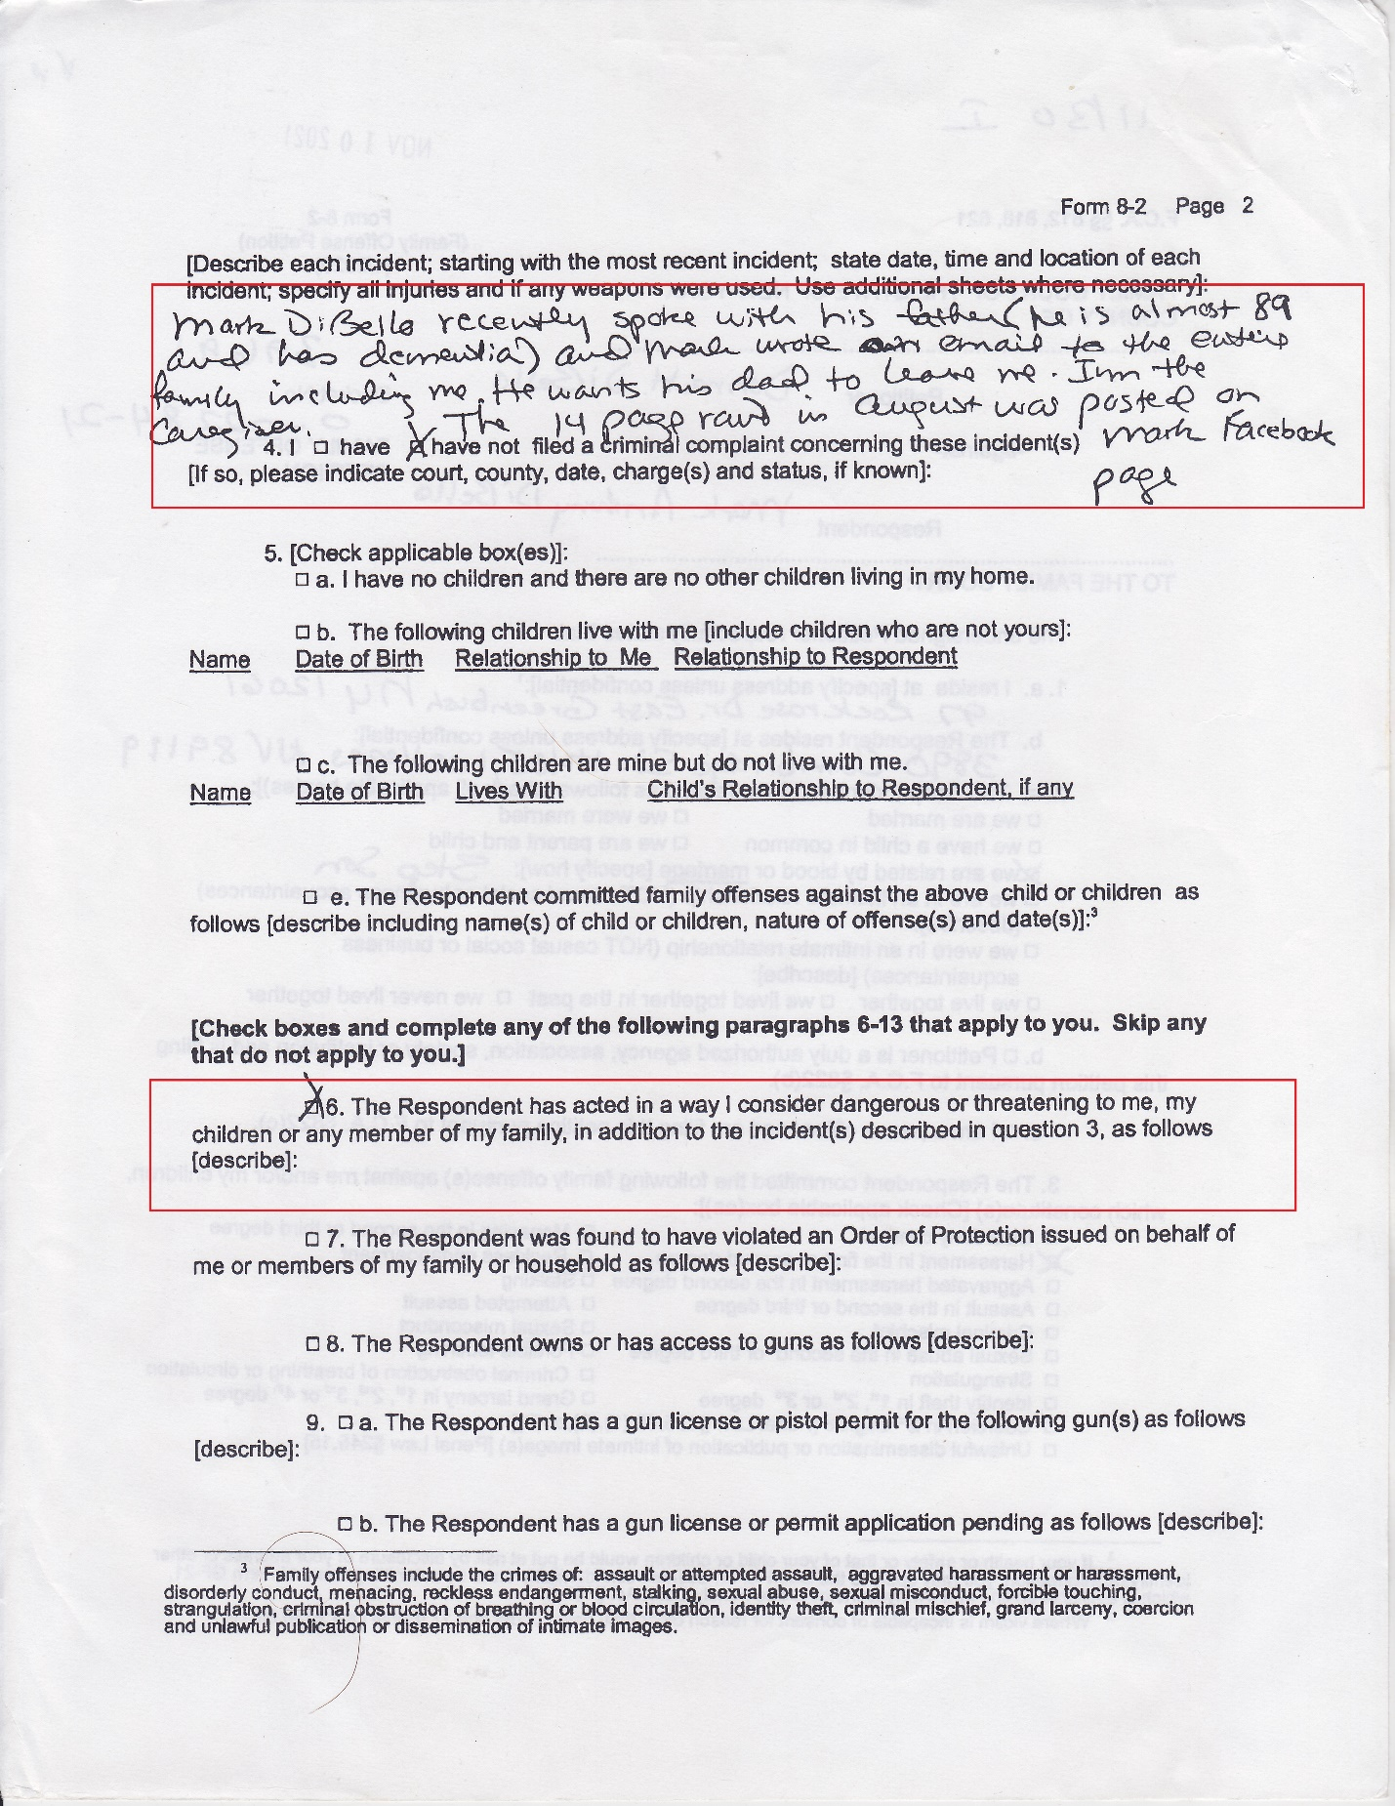

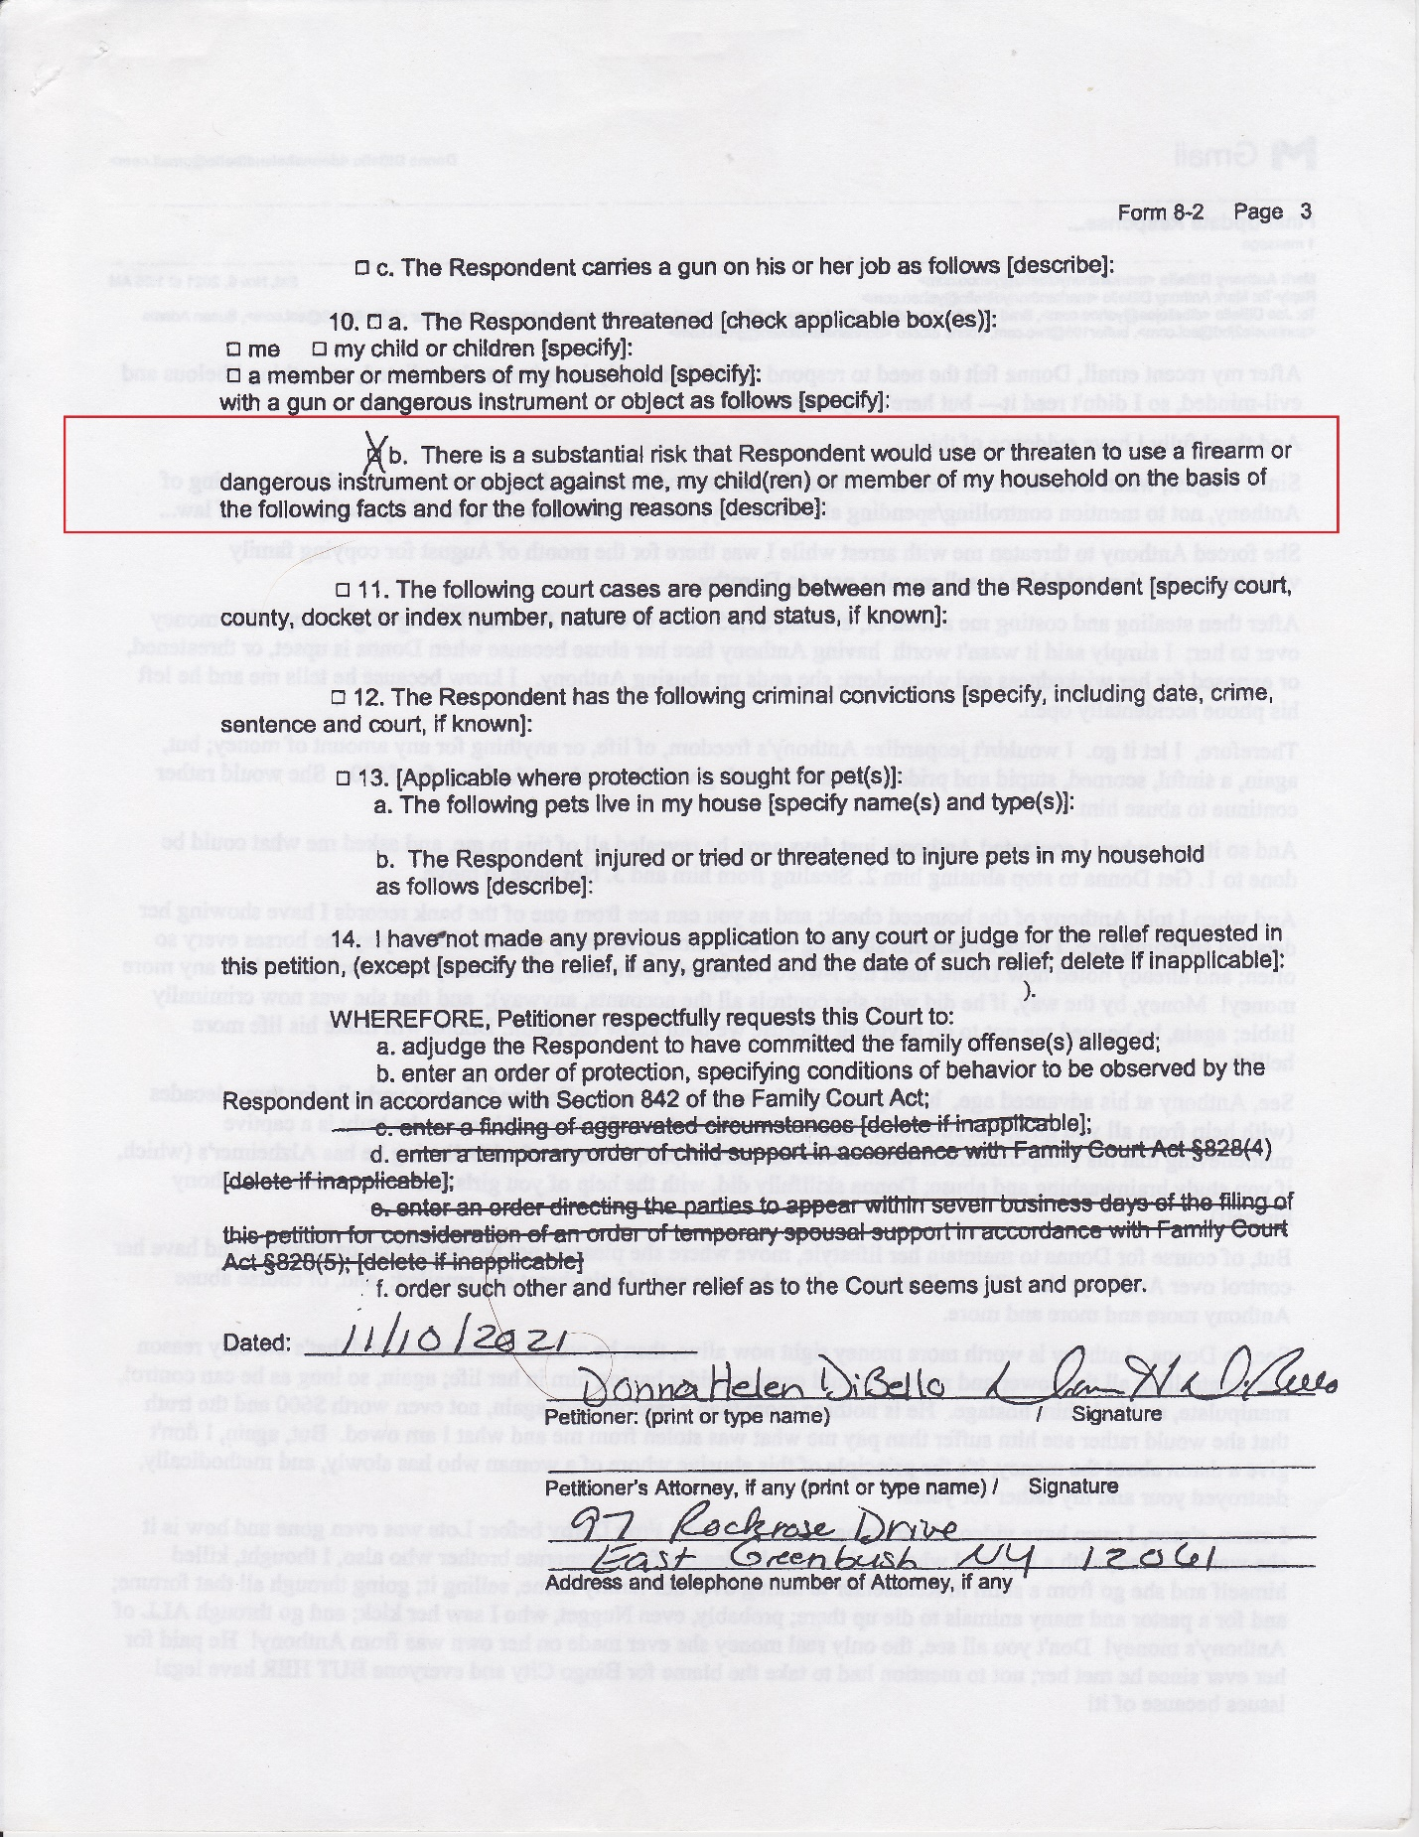

As noted, after returning to my apartment, in the most criminal part of Las Vegas, from a ministerial retreat, on Thanksgiving, November 25, 2021. There was a yellow envelope in my door or in my mailbox [which usually has other former tenants mail], I don't recall. I opened it and read the first three pages of lies, fraud, and libel on the opening pages. It read like a protection order keeping me from my father's wife [not my dad!]. After that, I had the choice to "TURN THE OTHER CHEEK," or IGNORE the remaining pages. I did not choose to SUBJECT MYSELF TO FRAUD, LIES and FALSE ACCUSATIONS.

2. I NEVER identified, EVER, as this person's "step son."

4. "Mark wrote an email to his entire family, including me, that he wants his dad to leave me." My father begged for my to leave this person and asked me to write and granted me permission, and I read transcripts to him, on any email I sent to his children or her, and after he told me of the spousal abuse against him!

4. I IGNORE those who tell me [or my father], I "rant." "...The 14-page rant..."

6. I NEVER threatened or appeared dangerous to this person.

10b. I have NEVER owned a handgun and NEVER used a gun or knife against anyone, EVER!

Therefore, since it seemed I was already served an order to stay away from this person, I did that! As I noted, previously, I also had Covid, at that time, and was incapacitated for many weeks; my computer was stolen so I couldn't open the links; and I get 100's of spam and hacking links a day [and even phone messages from "Judge Walsh," stating, "You may think this is a spam call, but it is not"]; I also get PRANKED by television shows so I thought it may be a joke; lastly, the transmissions came on Tuesday's at 6:00AM PST. I NEVER read most of them [and still have not] till after I was arrested, when I was bullied into reviewing some of them, as Tuesday is my one day off, a week, and a religious day of obligation, for me, so I discard them!

