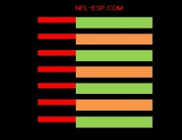
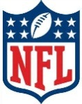
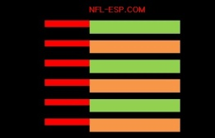
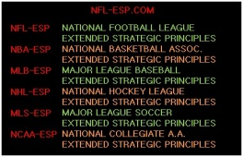
NFL-ESP
NFL-EXTENDED STRATEGIC PRINCIPLES

● NFL-ESP results in a data-proven 10-15%+ increase in a football team’s [and all major sports] overall productivity and POINT PRODUCTION; or +1.6 to +2.4 wins per 16-game NFL season!

● It is a program and system, over 45-years in development, whereby data suggests the current NFL head coaches most associated with its use have won 12-of-the-last-15 Super Bowls.

● It is a strategic system, 6-time NFL Executive-of-the-Year, and Hall-of-Famer, Mr. Bill Polian; began partially implanting with the Super Bowl XLI Champion Indianapolis Colts and consulted with us at length at the 2013 MIT Sports Analytics Conference.

● It is a program former Chicago Bears Head Coach Marc Trestman helped develop and with whom we consulted extensively; and while only having the opportunity to implement 33% of the system, won a pair of CFL championships.

● It is a STRATEGIC system supplying exclusive statistical data, “Reports” to serve in making more PRODUCTIVE key pre-game and in-game STRATEGY and game management decisions.

● It is the development and formation of a third, primary COORDINATOR, who implements the data found in the Reports, called the “Game Management Coordinator [GMC].”

● It uses a complex formula to assign a comprehensive POWER-RATING to all NFL [and all major sports] teams; and a single qualitative number, and PROBABILITY PERCENTAGE, to determine the statistical difference between the teams called the POWER-SPREAD.

● Its system uses an in-game calculation called the POWER-SPREAD INDEX or PSI; and a numerical percentage to gauge which STRATEGY DECISION is most probable and PRODUCTIVE.

● It possesses a component which includes information and insights on “X’s and O’s” or play design; in addition to a component which includes stadium design and franchise development.

● It is a MOTIVATIONAL program which consults implementing perspectives and tools drawn from a wide variety of MOTIVATIONAL minds, leaders, coaches and players.

● It is a SPIRITUAL program which counsels using virtually all faiths, philosophies, religions, and perspectives including its “Ten Commandments of Championships.”

©Copyright 2015 All Rights Reserved
Mark Anthony DiBello www.NFL-ESP.com

