Exploring NASA Sources for Climate Change
-Global Climate Change Vital Signs of the Planet
NASA (website)
Engage
Go to
http://climate.nasa.gov/vital-signs/global-temperature/
We have talked about global temperature changes, CO2 emissions, etc… Today we are going to explore these data sets in depth.
Watch the time series graph at the website. What do you observe? Describe the change in color and what that indicates.
______________________________________________________________________________

Extremas
Relative maximums, relative minimums
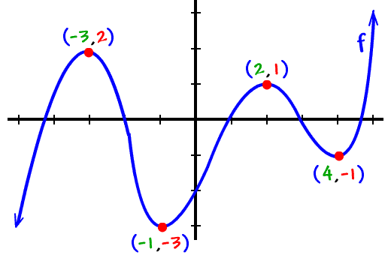
The tops of the mountains are relative maximums because they are the highest points in their little neighborhoods (relative to the pointsright around them):
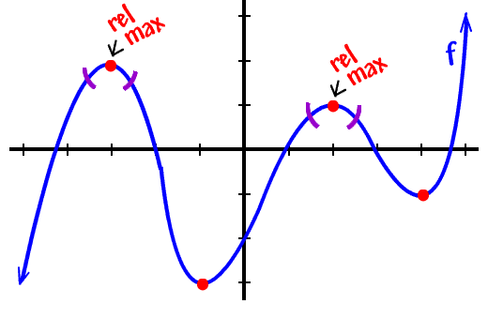

Suppose you're in a roomful of people (like your classroom.) Find the tallest person there. (It's usually a guy.) He is the relative max of that room. Specifically, he's the tallest, relative to the people around him. But, what if you took that guy to an NBA convention? There'd be lots of guys who beat him.

For more go to
http://www.coolmath.com/precalculus-review-calculus-intro/precalculus-algebra/12-relative-extrema-minimums-maximums-02

Your Turn:
Identify the relative maximas and minimas on the graph that follows. Labeel the ordered pairs.
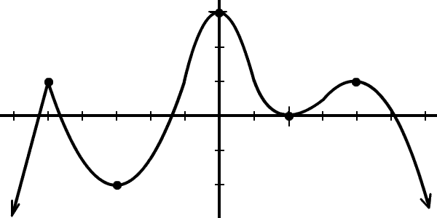

Absolute maximum, absolute minimums- highest or lowest value when compared to the entire domain.
There is one point on the graph above where the function value is the greatest as compared to the others… can you identify it? Put a star there.

I'll make this really quick and simple:
The absolute max is the highest point.
The absolute min is the lowest point.
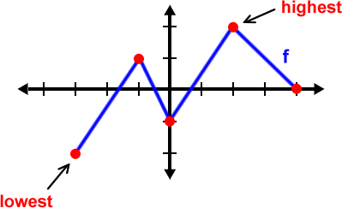

f has an absolute max of 2 at x = 2.
(This is also a relative max!)
f has an absolute min of -2 at x = -3.
(This cannot be a relative min, since it doesn't
have points on BOTH sides to compare it to.)

For more on the nature of graphs go to http://www.coolmath.com/algebra/22-graphing-polynomials/11-absolute-extrema-maximums-minimums-01

BACK TO NASA – Global Temps
Highs and Lows- compare to the 5 year mean
There are many relative maximums and minimums throughout the data set. Temperature anomaly rises and falls, yet over time it is ____________________.
Prior to 1977, in what year was the temperature anomaly an absolute maximum? _________
In what year was there a relative minimum in temperature anomaly? _______________

Where We Live
Now compare our location to that of the world by clicking on or going to the following link http://paldhous.github.io/climate-change/
Select North Salem , NY and report your observations _________________________________________

Select 5 additional locations from other places around the world and make a comparison… is temperature rising there too? Choose from the Northern Hemisphere, Southern Hemisphere, near the equator, etc… Choose extreme places. Give the latitude and longitude of each location. Research a source to help with this. Take a snapshot by using the snipping tool and save a copy of the graph to this document.

Location1 :__________________________
Observations__________________________________________________________________________

Location2:__________________________
Observations__________________________________________________________________________

Location3:__________________________
Observations__________________________________________________________________________

Location4:__________________________
Observations__________________________________________________________________________

Location5:__________________________
Observations__________________________________________________________________________

Write a summary of your observations:
__________________________________________________________________________________________________________________________________________________________________________________________________________________________________________________________________________________________________________________________________________________________________________________________________________________

