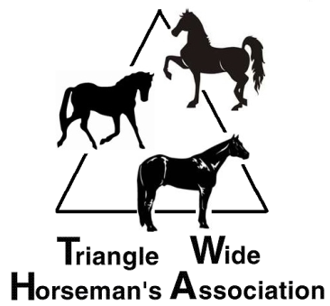
2020 TWHA Sponsorship
And Advertising Rates for TWHA

July 18 & 19 – May Days - Hunt Horse Complex, Raleigh, NC
August 1 & 2 – TWHA Youth Fundraiser, Hunt Horse Complex, Raleigh, NC
September 5 & 6 – TWHA Open Show, Hunt Horse Complex, Raleigh NC
2nd Annual Championship Challenge & Jackpot shootout – Final held Sept 21

OR - Do you have something you would like to sell or just advertise on the web, but don't know where to go to do so? TWHA offers advertising on our website. Your item doesn't have to be horse related, but it will need to be approved before it can be submitted for viewing.
Sponsoring/Advertising with TWHA is a great way for you to get your information out to people in the horse industry as well as support a great Open Breed Horse Association. We offer different levels of Sponsor/Advertising to fit your needs.
We can be found here on our web at www.trianglewidehorsemansassociation.com, on Facebook, and we have a newsletter that goes out to all members monthly.
Please review the options below and choose which one you feel best fits your needs.
- $ 60.00 - One (1) Class Sponsorship at all of the above TWHA Shows.
- $100.00 – Two (2) Class Sponsorships at all of the above TWHA Shows. It also includes one (1) month Business Card size space advertising on our website and on our Facebook page with a link to your website.
- $200.00 – Four (4) Class Sponsorships at all of the above TWHA Shows. It also includes three (3) months Business Card size space advertising on our website and on our Facebook page with a link to your website.
- $300.00 – Ten (10) Class Sponsorships at all of the above TWHA Shows. It also includes five (5) months 3 x 5 inch advertising space on our website and on our Facebook page with a link to your website.
- $500.00 – this includes a Major sponsor at all of the above TWHA Shows. 1 year, 3 x 5 inch, advertising space on our website and on our Facebook page with a link to your website. This will also include a banner (you provide) at all of the above TWHA Shows.
- $1000.00 – this includes a Platinum sponsor at all of the above TWHA Shows. 1 year, 3 x 5 inch, advertising space on our website and on our Facebook page with a link to your website. This will also include a 2 banners (you provide) at all of the above TWHA Shows, 2 tickets to our year end Awards Banquet with Dinner, and include a Business Card (you provide) attached to each ribbon for the above listed TWHA Shows.

Company/Individual Name: __________________________________________________________________
E-mail address & Phone Number: ____________________________________________________________
Item you want to advertise: __________________________________________________________________
Description of item (use additional pages if necessary):
________________________________________________________________________________________
________________________________________________________________________________________
Website address (if applicable): ______________________________________________________________
It is the responsibility of requesting party to provide all information needed to insure proper advertising: including photos, etc.
Complete this form and return it along with payment to:

Triangle Wide Horseman’s Association c/o Kim Moser
155 Grayson Jenkins Road, Apex, NC 27523 - 919-219-0256

