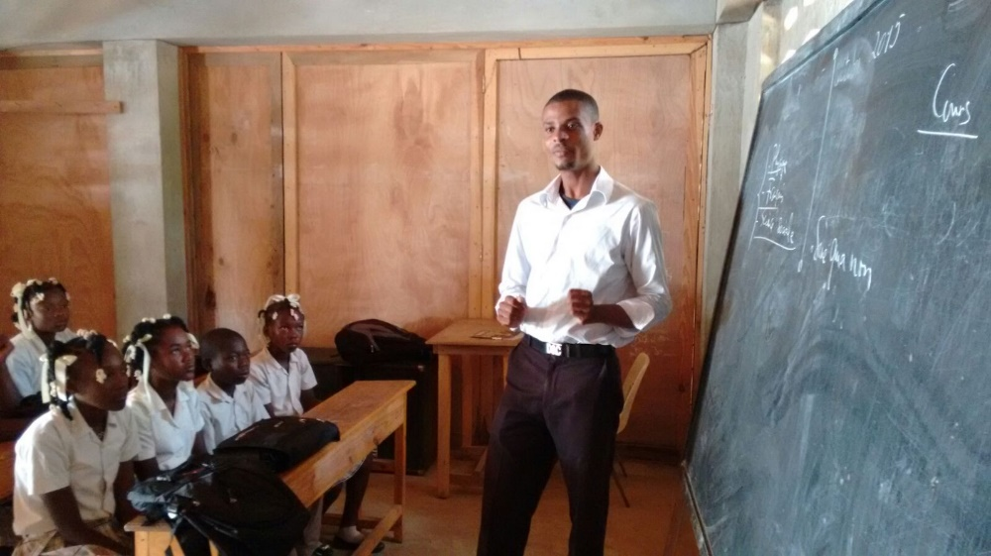**Student Sponsorship Program**

Only 52% of children in Haiti finish primary school and only 18% finish secondary school (USAID 2024). This number is closer to 30% in rural areas. The literacy rate is a shocking 61%. The public school system is almost non-existent in rural Haiti, and where it is available it is not free. Many families simply cannot afford to send their children to school. Fr. Voltaire, pastor of our sister parish, is asking us to sponsor some of the costs to educate students at the parish school. Please prayerfully consider giving one of these children a chance at a better future.

Donations can be made by check to *St. Anthony Church - Haiti Ministry* and sent to PO Box 3, Morris, IN or placed in the collection basket in an envelope marked Haiti.

Name_______________________________________

The estimated cost to educate and feed a child for a year is $175.

______ I would like to donate $175 to sponsor a child’s education.

______ I am unable to fully sponsor a student, but would like to partially sponsor a student with $_____

______ I would like to make an additional donation of $_____ toward education

Only 41% of children in Haiti finish primary school (Unicef 2019), this number is closer to 30% in rural areas. The literacy rate is a shocking 61%. The public school system is almost non-existent in rural Haiti, and where it is available it is not free. Many families simply cannot afford to send their children to school. Fr. Reginald, pastor of our sister parish, is asking us to sponsor some of the students at the parish school who could not afford to attend without our help. Please prayerfully consider giving one of these children a chance at a better future.