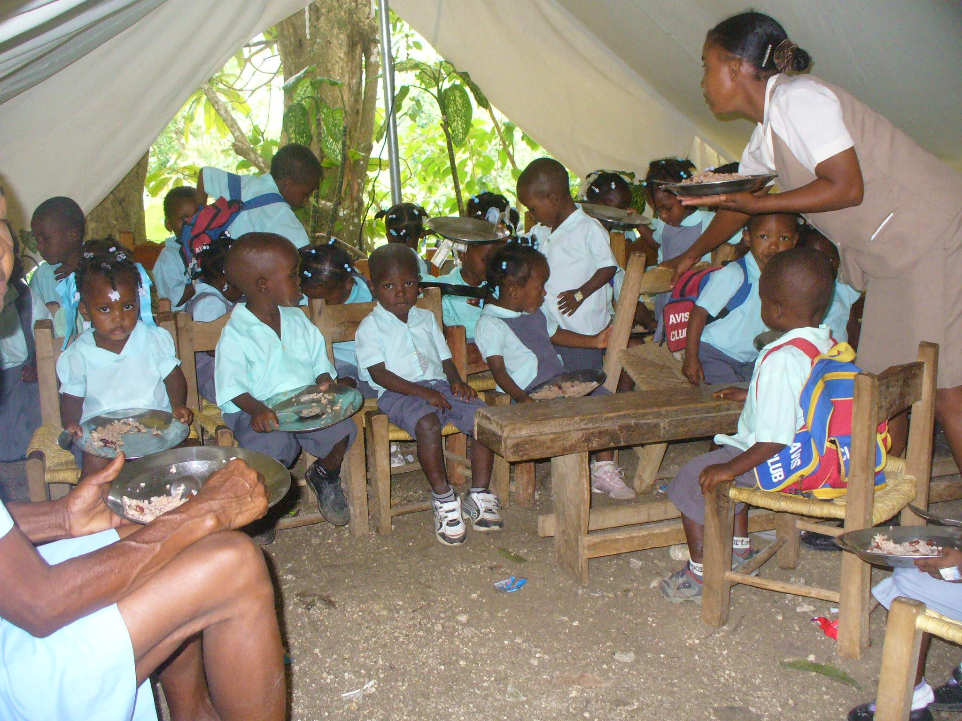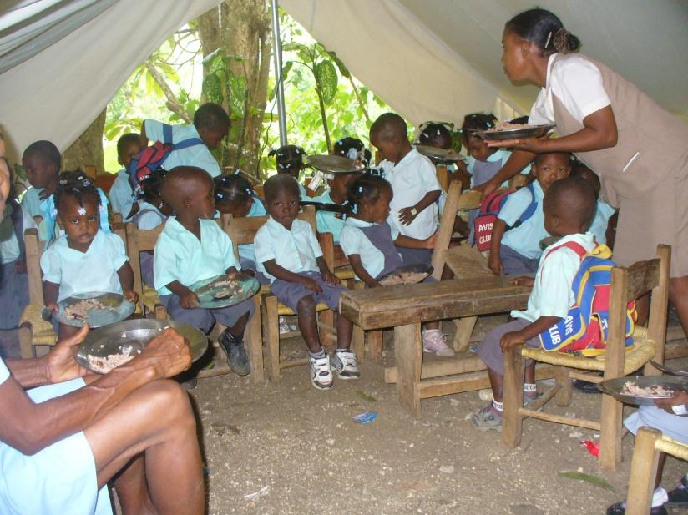

Only 41% of children in Haiti finish primary school (UNICEF 2019), this number is closer to 30% in rural areas. The literacy rate is a shocking 61%. The public school system is almost non-existent in rural Haiti, and where it is available it is not free. Many families simply cannot afford to send their children to school. Fr. Reginald, pastor of our sister parish, is asking us to sponsor some of the students at the parish school who could not afford to attend without our help. Please prayerfully consider giving one of these children a chance at a better future.

Sponsor a student at our sister parish school, St. Francis Xavier in Gandou, Haiti!

____$90 for tuition for a year and help with uniforms

____$150 for tuition and help with uniforms and lunch every day*

____$40 a month ($480) for a year to sponsor a teacher’s salary

____I cannot sponsor a student at this time, but would like to donate $___

Name ____________________________________

Donations came be made by check to *St. Anthony Haiti Charity* and sent to the parish office.

PO Box 3, Morris, IN 47033

*All students receive a free lunch through the food program St. Anthony’s is sponsoring. The $60 (cost to feed one student for a year) will be used to defray the total cost of the program.

Sponsor a student at our sister parish school, St. Francis Xavier in Gandou, Haiti!

____$90 for tuition for a year and help with uniforms

____$150 for tuition and help with uniforms and lunch every day*

____$40 a month ($480) for a year to sponsor a teacher’s salary

____I cannot sponsor a student at this time, but would like to donate $___

Name ____________________________________

Donations came be made by check to *St. Anthony Haiti Charity* and sent to the parish office.

*PO Box 3, Morris, IN 47033*

*All students receive a free lunch through the food program St. Anthony’s is sponsoring. The $60 (cost to feed one student for a year) will be used to defray the total cost of the program.

Only 41% of children in Haiti finish primary school (UNICEF 2019), this number is closer to 30% in rural areas. The literacy rate is a shocking 61%. The public school system is almost non-existent in rural Haiti, and where it is available it is not free. Many families simply cannot afford to send their children to school. Fr. Reginald, pastor of our sister parish, is asking us to sponsor some of the students at the parish school who could not afford to attend without our help. Please prayerfully consider giving one of these children a chance at a better future.

**Food program at St. Francis Xavier**

**school in Gandou, Haiti**