Haiti Ministry
St. Anthony, Morris
St. Louis, Batesville
St. Francois Xavier, Gandou
June 2021

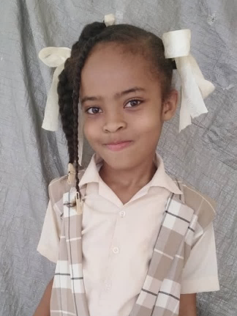
Student Sponsor Pictures
Student sponsor pictures are being mailed out this week for the 2020-2021 school year. We apologize for the delay. These pictures are usually sent out in late winter following our January trip. Due to Covid-19, our January trip was delayed until March this year to allow more of the volunteers from here to be vaccinated. Because of the volatile political situation in Haiti at the time, only a small team made the trip. With the lower number of participants, everyone was needed in the medical and dental clinics and no one was available to take the student pictures. We have been working with Fr. Voltaire since then to obtain the pictures. This has been a slow process due to limited internet in Gandou and several school closings due to the political instability over the last few months. The current school year in Gandou will end in July. Renewals for student sponsors will be mailed out in the fall as usual. Thank you to all our sponsors!

March Medical Clinic
Medical Clinic
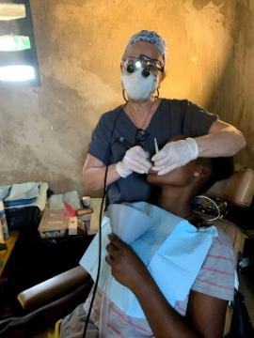
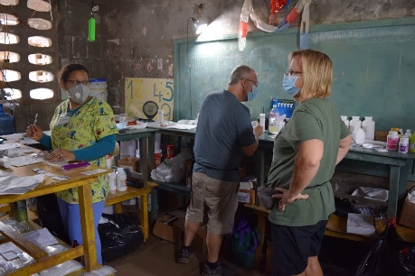
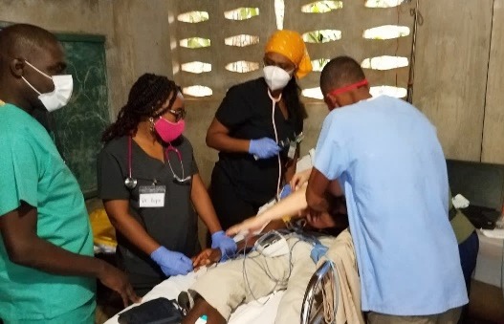
A dedicated team traveled to Gandou during March to hold a delayed medical trip. The team worked with our Haitian physicians, dentists, nurses, health workers, and translators to hold a successful medical and dental clinic. During the week, the team saw 937 patients in the medical clinic and 268 patients in the dental clinic. The physicians also saw most of the chidren in our malnourished program and several patients in our referral program. They also met with the local midwives and provided them with much needed supplies.
Dental Clinic
Pharmacy

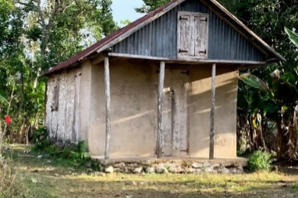
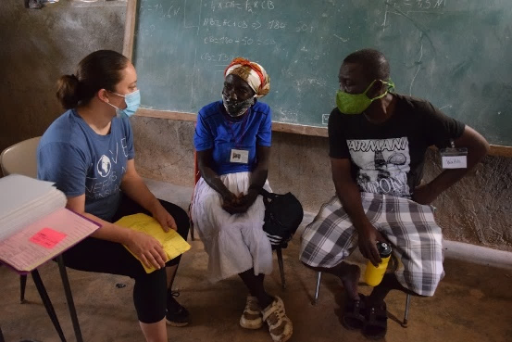
In addition to medical care, our team worked on several of our other programs as well. Team members met with families in our Family Empowerment program to assess their needs and see how we can empower them to improve their situations. We also met with individuals in the microloan and goat programs. We had the opportunity to visit some of the recently rebuilt or repaired homes in the community as well.
Family Empowerment Program

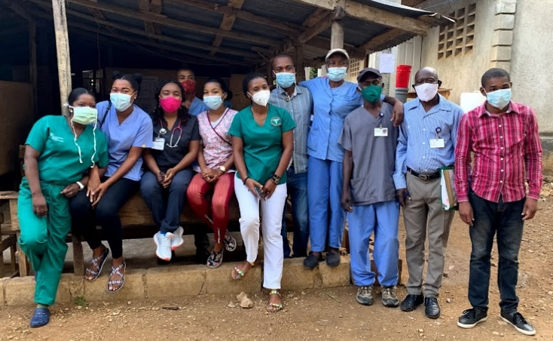
In addition to supporting the medical and dental clinics, our maintenance team worked on the water supply to the Gandou area. There is a capped spring that feeds a small concrete reservoir near the parish center. The line from the spring to the reservoir was damaged and the reservoir was unusable. Our team worked with local men to dig up and repair the line. Fr. Voltaire recently sent photos of the reservoir that is now full. The team also assessed the school roof to see what needs done to install gutters and downspouts that would allow the school to collect rain water. Currently the students are carrying water to the school each day.
Although we have four nurses and six health workers employed year round to provide a basic medical clinic and run our malnutrition, hypertension, and referral programs, there is still no physician serving our community. We are currently talking to Haitian physicians about the possibility of working full-time in our clinic.
Year round Haitian staff

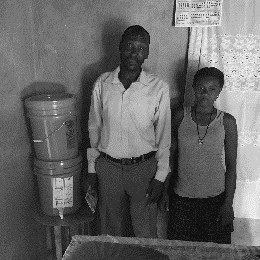
Gift of Water
Through the Gift of Water program, four hundred families have received two-bucket filtration systems in their homes. Two local men have been trained as water technicians to visit the families monthly and monitor their systems. In April, a third water technician was trained to allow expansion of our project. An additional two hundred families will receive filtration systems this summer. We hope to expand again to an additional two hundred families later this fall.
Family Fun Night and Silent Auction
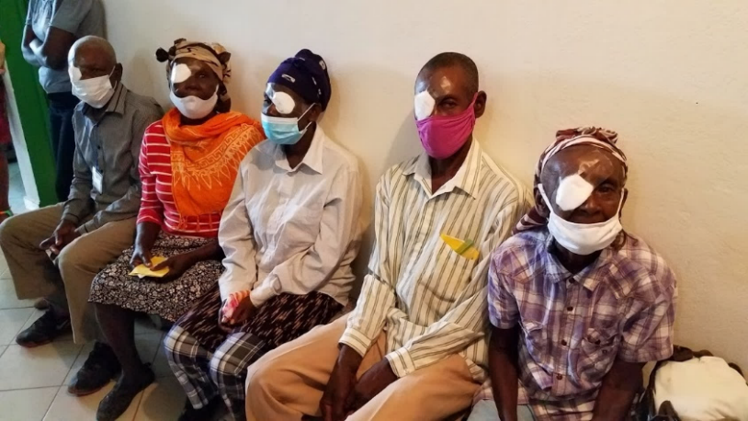
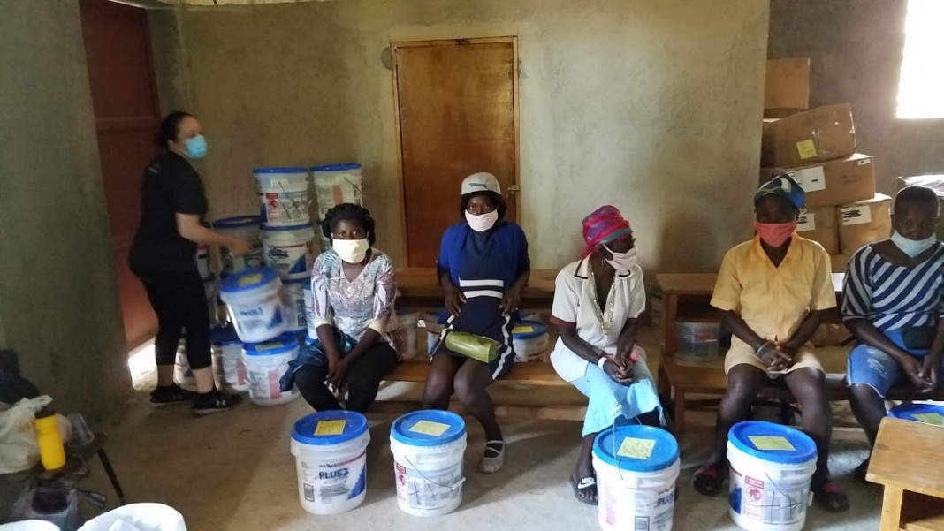
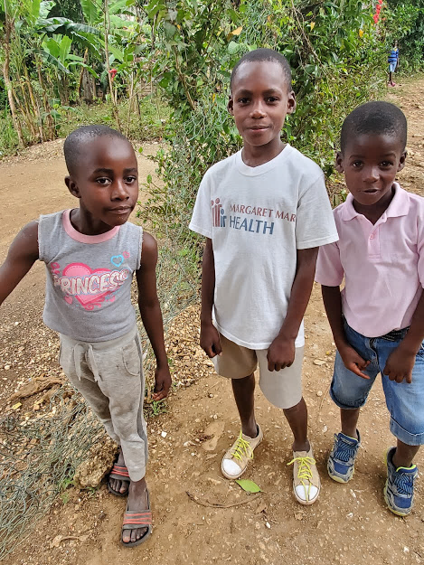
Save the date! We are planning to bring back our silent auction this year on October 16th. It may look a little different this year, but will still be a great evening of fun and fellowship while raising funds to support the projects of our ministry.
Referral patients who received cataract surgery in LaVallee
Midwives receiving supplies
Tax deductible donations can be made by check to St. Anthony Haiti Ministry and sent to the parish office P.O. Box 3, Morris, IN 47033
Tax deductible donations can be made by check to St. Anthony Haiti Ministry and sent to the parish office P.O. Box 3, Morris, IN 47033

