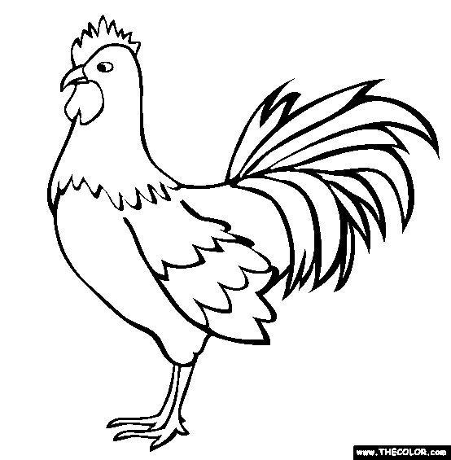 St. James Festival Sunday Chicken Dinner Presale Ticket Order Form
Fried Chicken Dinners from Richie’s Colerain will be served in the parish hall Sunday from 4:00–6:30 pm. 7/23/23. Pre-sale tickets are available via the order form below. Payment may be made by check payable to Saint James Festival. Mail to Saint James Church, 3565 Hubble Road, Cinti, OH 45247 or place in an envelope marked chicken dinner and drop into the collection basket during weekend Masses until 7/16/23. Mail order of dinner tickets need to be postmarked by 7/14/23. After that dinner purchases made in person will be on a first-come basis, due to the limited quantity of chicken allocated by presale and an estimated additional amount. Confirmation orders will be sent by email only. Names will be on a list at the check-in table. Please provide the first name of the person(s) for whom you are ordering to facilitate individual meal distribution at the dinner. Thanks to Team Hoelzer for sponsoring and running the dinner!
Name: ________________________________________________________(Person placing orders)
Phone: ___________________________ Email: _______________________________________________ ADULT MEALS $13.00 each: 1 meat, 2 sides, a Butter Bitt (North College Hill Bakery)
& a homemade dessert donated by St. James Parishioners
MEAT OPTIONS- choose one of the following: (additional strips ,legs or thighs can be purchased for $3 each)
WH= 2 piece white (breast & wing) DK- 2 piece dark (leg & thigh) or CST=3 chicken strips

SIDE OPTIONS: choose two of the following (additional sides can be purchased for $2.00 each) GB-green beans MP-mashed potatoes w/gravy MC-mac-n-cheese CS-cole slaw AS- applesauce

FIRST NAME OF DINER CIRCLE 1 MEAT CHOICE CIRCLE 2 SIDE CHOICES
Extra piece ($3)* Mark any additional sides with a + ($2.00)
1) _____________ _ (circle 1): WH DK CST (+___ ) (circle 2): GB (_) MP (_) MC (_) CS (_) AS(_)
2) _____________ _ (circle 1): WH DK CST (+___ ) (circle 2): GB (_) MP (_) MC (_) CS (_) AS(_)
3) _____________ _ (circle 1): WH DK CST (+___ ) (circle 2): GB (_) MP (_) MC (_) CS (_) AS(_)
4) _____________ _ (circle 1): WH DK CST (+___ ) (circle 2): GB (_) MP (_) MC (_) CS (_) AS(_)
5) _____________ _ (circle 1): WH DK CST (+___ ) (circle 2): GB (_) MP (_) MC (_) CS (_) AS(_)
KID’S MEALS (12 & under) $6.00 each: 2 chicken strips, applesauce, cookies & a Little Hug fruit drink
PROUD SPONSOR
Additional requests: CHICKEN STRIPS @ $3.00 Each SIDE OPTIONS @ $2.00 Each GB-green beans MP-mashed potatoes w/gravy MC-mac-n-cheese CS-cole slaw AS- applesauce

1) ______________ Add CST (__ ) Add sides: GB (_) MP (_) MC (_) CS (_) AS(_)
2) ______________ Add CST (__ ) Add sides: GB (_) MP (_) MC (_) CS (_) AS(_)
3) ______________ Add CST (__ ) Add sides: GB (_) MP (_) MC (_) CS (_) AS(_)
TOTALS ______Adult Meals X $13.00 = $_____________
______Kids Meals X $6.00 = $_____________
______ Additional Chicken* X $3.00 = $_____________
______ Extra Sides X $2.00 = $_____________
*additional breast or wing are not available Total due: $_____________
4) ______________ Add CST (___ ) Add sides: GB (_) MP (_) MC (_) CS (_) AS(_)
Payment may be made by check payable to Saint James Festival. Mail to the church office or drop into the collection basket prior to 7/17. Additional items may be purchased with cashier.

