RECOVERY SUPPORTS

In the Rooms – multiple pathways available https://www.intherooms.com/livemeetings/list

Alcoholics Anonymous
AA Phone Meetingshttp://aaphonemeetings.org/
AA Western MA Intergroup Virtual Meetings https://westernmassaa.org/aa-meeting-schedules
AA en Espanol https://aa-intergroup.org/languages/index_es.html
AA Boston https://aaboston.org/
AA Search by State: https://www.aa.org/pages/en_US/find-aa-resources
AA Intergroup http://aa-intergroup.org/
AA Online Grouphttps://www.onlinegroupaa.org/

Pause a while Free conference calls for AA meetings at 2pm every day
- Dial in number: 425-436-6360
- Access Code: 422932

A Virtual AwakeningClosed online AA meetings for women, trans, and non-binary people
Sun, Mon, Wed, Fri at 8:30pm EST, Thurs 1:00pm EST
- https://zoom.us/j/4822208285

Narcotics Anonymous
New England Region of Narcotic Anonymous Virtual Meeting list:https://nerna.org/nerna-virtual-meetings/
Phone meetings: www.nabyphone.com
Global Online meetings: https://virtual-na.org/
Free NA Speaker Streaming 24-7 www.naspeaker.com
Never Alone Club Online Meetings https://www.neveraloneclub.org/
NA in Multiple Languages: https://virtual-na.org/meetings/

Cocaine Anonymous
https://www.ca-online.org

Marijuana Anonymous
http://marijuana-anonymous.org/find-a-meeting/
Gamblers Anonymous
Massachusetts Hotline Number: 855-2CALLGA (855-222-5542), GA virtual Meeting on In the Rooms and http://newenglandga.com/ hosting phone meeting every night of the week from 9:00-11:00 PM Eastern time. Phone Number 712-770-4160 – Access Code 611704#.

Nicotine Anonymous
www.nicotine-anonymous.org

Recovery Speakers: Listen to recovery speakers from many different 12 step groups
www.recoveryspeakers.com

Sober Recovery provides an online forum for those in recovery and their friends and family https://www.soberrecovery.com/forum

Embark Recovery: Daily 12pm & 6 pm in English and 12:30 and 5:30 in Spanish
https://www.embarkreco.com/events

Herren Project: Variety of meetings, including Women’s Meeting Tuesdays at 7:30PM
https://herrenproject.org/recovery-meeting/
In the Rooms: online meeting at 9am, 12pm, 3pm, 6pm, 9pm. These are “all recovery” meetings and any pathway or programs are welcome.
https://www.intherooms.com/home/category/community-and-meetings/

LifeRing Secular Recoveryis an organization of people who share practical experiences and sobriety support, and embraces what works for individual.
https://www.lifering.org/online-meetings

Lion Rock Recovery: Variety of support groups every day of the week
https://www.lionrockrecovery.com/online-aa-meetings-and-support-groups

Recovery Dharma
https://recoverydharma.online/has meetings using Buddhist practice
Reddit Recovery offers a virtual hang out and support during recovery
https://www.reddit.com/r/REDDITORSI NRECOVERY/

Refuge Recovery provides online and virtual support
http://bit.ly/refugerecovery1

SMART Recovery
https://www.smartrecovery.org/community/ has a wide variety of online resources
http://www.smartne.org/meetings.html: has a listing of meetings but also a link for online meetings

SoberCity offers an online support and recovery community
https://www.soberocity.com/

Sobergrid offersanonlineplatformto help anyone get sober and stay sober
https://www.sobergrid.com/

Soberistas provides a women-only international online recovery community
https://soberistas.com/

Sober Mommies: online support group for moms in recovery
https://sobermommies.com/groups/online-support/

WEconnect and Unity Recovery - 4 times daily 7 days a week (9am,12pm,3pm,9pm EST)
unityrecovery.zoom.us/my/allrecovery

Women for Sobriety –https://womenforsobriety.org/ (website) https://wfsonline.org/ (online meetings)
Helps women gain hope and encouragement with other women in similar circumstances.

SUPPORT FOR FAMILIES WITH A LOVED ONE WITH SUD

Smart Recovery Family
Smartrecovery.org/family
Learn to Cope
https://www.learn2cope.org/
Al-anon
https://al-anon.org/al-anon-meetings/electronic-meetings/

FREE YOGA AND FITNESS

Phoenix Gym offers a range of FREE virtual exercise classes (meditation, yoga, CrossFit, etc. for people in recovery. Every 2 hours from 7 am - 9pm https://thephoenix.org/virtual/
Down Dog Yoga: https://www.downdogapp.com/
Trauma-informed Yoga/The Trauma Institute in Boston: https://www.traumasensitiveyoga.com/online-tctsy.html
Peloton App (offering free trial for 90 days, no bike)
Alo Yoga: https://www.youtube.com/channel/UCJEi1foUiGObzzQM3QA2H5A

Recovery Apps (download to your smartphone via app store/google play/website)
- Sober Grid - App Store
- Celebrate Recovery - App Store
- Smart Recovery - www.smartrecovery.org
  - Connections smartphone app to support recovery
https://www.addictionpolicy.org/connections-app
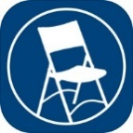
MEETING GUIDE is a free mobile app focused on helping people find A.A. meetings and resources near them. Also included are DAILY REFLECTIONS – a selection of reflections by and for A.A. members.
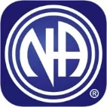NA MEETING SEARCH is a free mobile app developed to help find an NA meeting. It can use your current location to display the meetings nearest you. Daily JUST FOR TODAY meditations are also bundled in this app. http://www.nabyphone.com/

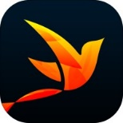RECOVERY PATH is a free mobile app is designed to allow people to navigate their own path to sustained recovery, share progress with others, and receive support.

Online Resources to Support Your Recovery
Scan the QR code below to go directly to the type of support you are looking for.
- Online AA Meetings  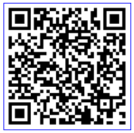 | - Recovery Dharma Online Meetings  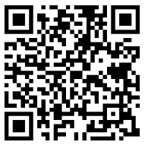 | - In the Rooms Online Support  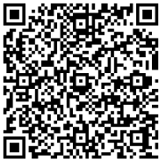
- Al-Anon Electronic Meeting List  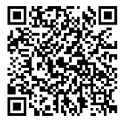 | - Online Group AA Meetings  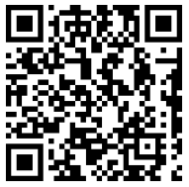 | - Substance Abuse and Mental Health Services Website  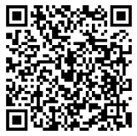
- Virtual Narcotics Anonymous Meetings  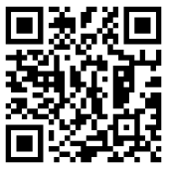 | - Smart Recovery Online  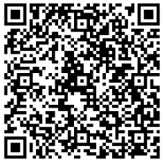 | - Never Alone Club – 24 Hour Chat and Support  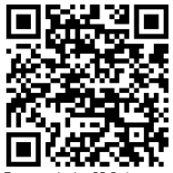
- Narcotics Anonymous by Phone  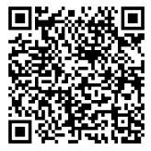 | - Marijuana Anonymous Online Meetings  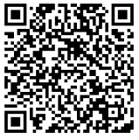 | - Connections App – tools to support early recovery  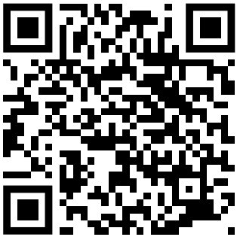
- The Herren Project – Recovery Meetings  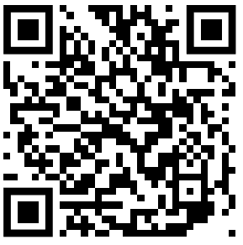 | - AA speaker tape and 12 steps – iPhone App  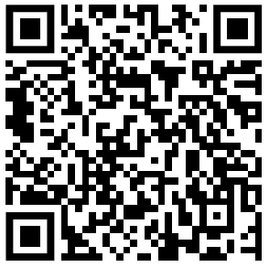 | - Smokefree – Tools and Support to Quit Smoking  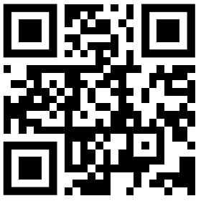

Facebook Recovery Groups (logon to Facebook, search group, ask to join):
- CLEAN AND SOBER - Addiction Recovery Support Group
- Daily Reflections AA
- Massachusetts Organization of Addiction Recovery
- Methadone & Buprenorphine Discussion and support
- MIPSA-Methadone Information & Patient Support Network
- Mommy Group
- Recovery Soldiers
- Send it! (Recovery Network)
- Sober Mommies
- Virtual Recovery – Meetings At Home
- Voices To End Addiction & Inspire Recovery
- Women in AA

RECOVERY CENTER FACEBOOK PAGES
Peer 2 Peer Recovery Support Center, Fall River
https://www.facebook.com/P2PRSC/

Everyday Miracles Peer Recovery Center, Worcester
https://www.facebook.com/EDMPeers

No One Walks Alone (NOWA) PRSC, Whitinsville
https://www.facebook.com/NOWARSC/SC

PIER Recovery Center of Cape Cod, Hyannis
https://www.facebook.com/Pier-Recovery-Center-of-Cape-Cod-1214021491947603/

Turning Point Recovery Center, Walpole
https://www.facebook.com/Turning-Point-Recovery-Center-100326408019268/

STEPRox Recovery Support Center, Roxbury https://www.facebook.com/StepRoxRecoverySupportCenter

Alyssa's Place Peer Recovery Center, Gardner
https://www.facebook.com/Alyssas-Place-Peer-Recovery-and-Resource-Center-1036671136361774/

The Recovery Connection, Marlborough
https://www.facebook.com/therecoveryconnection.org

Plymouth Recovery Center, Plymouth
https://www.facebook.com/PlymouthRecoveryCenter/

Devine Recovery Center, South Boston
https://www.facebook.com/DevineRecoveryCenter

A New Way Recovery Center, Quincy
https://www.facebook.com/A-New-Way-Recovery-Center-447672198690167/

Hope for Holyoke Recovery Center, Holyoke
https://www.facebook.com/HFHRC/

The RECOVER Project, Greenfield
https://www.facebook.com/TheRECOVERProject

New Beginning Recovery Center, Lawrence
https://www.facebook.com/New-Beginnings-1400295300266527/

Northampton Recovery Center, Northampton
https://www.northamptonrecoverycenter.org/calendar

Living in Recovery, Pittsfield
https://www.facebook.com/Living-In-Recovery-102917867894826/

Stairway to Recovery, Brockton
https://www.facebook.com/Stairway2Recovery

Parenting&Families
Sober Mommies: online support group for moms in recovery
- https://sobermommies.com/groups/online-support/

Hello It’s Me is a Facebook group for families that are pregnant and close to delivery or home with a newborn during COVID-19
https://www.facebook.com/groups/204741563956171/

Parenting Journey is creating an emergency fund and families can request a stipendfor those impacted financially by the COVID-19 crisis. https://parentingjourney.org/it-takes-a-village-emergency-fund/

Parents Helping ParentsParental Stress Line (available 24/7): 1-800-632-8188
Online Support Groups https://www.parentshelpingparents.org/
- Click this link to join the meeting by computer or smartphone: https://zoom.us/j/6607380697
- No Computer, Dial in by phone: 1-646-558-8656 then input the meeting id 6607380697#

National Parent Helpline1-855-4APARENT (1-855-427-2736)

Other Resources
7cups offers free emotional support. No matter what you are going through you will be heard and cared for. 24/7 chat. https://www.7cups.com/online-therapy/

Local Crisis Hotlines
- Northampton CSO 413-586-5555
- Greenfield CSO 413-774-5411
- Holyoke BHN 413-532-8016
- Springfield BHN 413-733-6661
National Domestic Violence Hotline offers help to people experiencing violence in their home during COVID-19 restrictions. There is a hotline, texting service, and webchat service. https://www.thehotline.org/2020/03/13/staying-safe-during-covid-19/
National Suicide Prevention Lifeline
- 800-273-8255

Project Bread’s FoodSource Hotline provides up-to-date information– in multiple languages – about what is happening in school districts and what resources are available, such as SNAP application assistance, and referrals to open community resources. 1-800-645-8333 or by chat at Gettingsnap.org

Samaritans:Helpline remains open 24/7 for calls and texts at 877-870-4673

SAMHSA National Helpline
- 800-662-4357
https://www.samhsa.gov/find-help/national-helpline

COVID-19 Resources

COVID-19 FAQs from mass.gov
https://www.mass.gov/info-details/frequently-asked-questions-about-covid-19

CDC Information about preparing your family
https://www.cdc.gov/coronavirus/2019-ncov/prepare/index.html

Talking to children about Covid-19 (available in multiple languages)
Talking to Children About COVID-19 (Coronavirus): A Parent Resource
Supporting Kids During the COVID-19 Crisis

Just for Kids: A Comic Exploring the New Coronavirus
http://www.capradio.org/articles/2020/03/07/just-for-kids-a-comic-exploring-the-new-coronavirus/

Coping/Managing Stress:
Mental Health and Coping During COVID-19

How to Avoid Passing Anxiety on to Your Kids
https://childmind.org/article/how-to-avoid-passing-anxiety-on-to-your-kids/?utm_source=newsletter&utm_medium=email&utm_content=%20Parents%20Guide%20to%20Problem%20Behavior&utm_campaign=Weekly-03-16-20

National Child Traumatic Stress Network resource on helping parents talk to children about COVID-19
https://www.nctsn.org/sites/default/files/resources/fact-sheet/outbreak_factsheet_1.pdf

National Child Traumatic Stress Network in multiple languages:
https://www.nctsn.org/resources/parent-caregiver-guide-to-helping-families-cope-with-the-coronavirus-disease-2019

Link for small children from ZERO TO THREE
https://www.zerotothree.org/resources/3210-tips-for-families-talking-about-the-coronavirus

Link Boston + MA COVID19 Resources
https://docs.google.com/document/d/1-x6vOZKVsla5H363mtdgcyivvLmcx7-f2s6l-O_ba8A/mobilebasic

