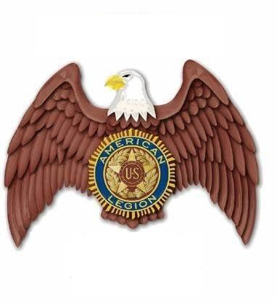
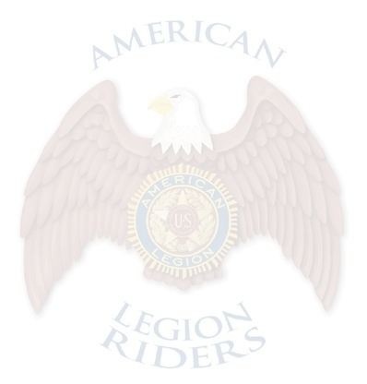

Jim J. Gilleo American Legion Riders Chapter 283 Membership Meeting
April 5th, 2025

The meeting was called to order at 09:00 by Director Jim Nowak. Prayer was offered by the Chaplain Yvette Moore.
POW/MIA flag placed on chair by Sgt at Arms Vicki Skipper-Compton. Pledge of Allegiance led by the Sgt at Arms.
Rider’s creed was recited by all in attendance.

Roll called

Present:

Director- Jim Nowak, Asst. Director- Edward Johnson, Adjutant- Ashley Rall, Sgt at Arms- Vicki Skipper-Compton, Membership- Karen Hunter-Nowak, Webmaster- Jim Nowak, Historian- Kaytlyn
Satterwhite, Safety Officer- John Lambert, Road Captain- Kyle Satterwhite, Chaplain- Yvette Moore, Lady Veterans- Yvette Moore, Finance Officer- Ella Rae Jansen, Quarter Master- Ella Rae Jansen, Event Coordinator- Ella Rae Jansen

Not Present:

2nd Vice- (none appointed at this time) (Quorum is met)
Committee Reports:

There was one new member present, David Evans.

Adjutant: In lieu of reading the minutes, they are posted on our website. A motion was made by Kyle Satterwhite to accept minutes as posted. Motion was seconded by Vicki Skipper-Compton and without any discussion motion passed.

Finance Officer: The checking account forward was $10,648.22. We had deposits of $1534 and debits of
$1495.14. Our checking account balance is $10,687.08. The Rider Down Fund balance forward was $2946.19, there were no deposits. Rider Down Fund is $2946.19. Money market account forward $4116.89, we had 8 cents in interest. Money market account is $4116.97. Charity account balance forward $6941.22, we had $1500 deposits. Charity account balance $8441.22. Poker Run balance forward was $3460.15, we had deposits of
$64.35. Poker Run balance is $3524.50. Total funds are $29715.96

Vicki Skinner-Compton made a motion to accept the Finance Officers’ report as stated. Kaytlyn Satterwhite seconded the motion. No discussion was had. Motion passed.
Ast. Director: March totals: 11737.8 miles, 1447.9 hours, $0 donations. YTD: 157,092 miles, 16,476.93 hours,
$28,987.69 donations. Please make sure you enter your miles and hours as they all go toward the Chapter of the Year award.
Chaplin: I would like us all to keep the sick and shut in in our prayers. Also keep in your prayers everyone that is getting ready to go on the Unity Ride. We will be having the Blessing of the Bikes after the meeting.
Sgt at Arms: We have 31 members present today, one guest, and $14 dollars in the Rider Down Fund.

Road Captain: We have Round Robin this month, the Unity Ride this month so let's do a lot of riding this month. We will not have a ride after the meeting today. If you feel you need to be more visible, wear a safety vest on the outside of your vest. Be careful and watch for others on the road. Let's all ride safely.
We would like to see if we can put together a ride on the 26th of this month to go down to Titusville with two other posts and maybe visit some posts down there. This will give us a lot of points for our chapter.
The other half of the 5th district unity ride will be on the 27th.

Safety Captain: No report.

Membership: We currently have 133 members, 47 lifetime members, 15 new members, and 71 members that have renewed. I still need to see a lot of people’s endorsements and insurance after the meeting.
2nd Vice: (Given by Director Jim Nowak) I would like our meals to be planned for the rest of the year so that we are not scrambling when the time comes. Thanks again to the kitchen crew for volunteering.
Webmaster: I have everything up to date so far for the year so keep the pictures coming and I will keep everything updated.
Historian: 88 had their fun run 29th. 129 came and retrieved our plaque. Vicki and Ella visited New Orleans this month. We rode to Daytona after the meeting last month. We retrieved our plaque that same day. On the second we visited 270,120, 129. On the 8th the plaques from 54, 9, 137 were taken, and we also had Margie's party. We had our bike night on the 11th at Choppers. On the 15th 250, 57, 9 all had their plaques taken, we had our Mardi Gras party that night. We had Taco Tuesday on the 25th. Please remember to take pictures.
Event Coordinator: I have plaques from the poker run if anyone would like to deliver them.

Quartermaster: I got some more patches in; they are $50 apiece. I am going to contact the guy from Summit about making our shirts and will report about it next meeting about what the approximate cost will be. We voted a while back on blue so that is what color the shirts will be.
Lady Veterans: I have flyers for the Northeast Women Veterans, a nonprofit organization that helps female veterans have recently changed their name to Women Veterans United. They have a support group that meets two times a month. I have a list of events that they have as well. There is a paint and twist event on April 26th in the San Marco area that is open to everyone.
Director: I'd like to recognize Ed, Brenda, Kyle, and Kaytlyn for their support in helping the post 88 fun run, for providing the food and getting all that set up. I think there were 112 people all together that participated in the fun run. Thank you, guys, for stepping up and taking care of that, you guys are rock stars. On the same note I'd like to recognize all those who step up for our dinner nights and show up for that. We could be successful without all your help. A lot of the time it is the same people, so I just want to thank you guys. Lastly, I want to thank everyone that is here, the core membership. We have done more in the last six months than we did last year. Last year I had a slogan “Do more 2024” and we couldn't do it without everyone's participation and support. I appreciate all of you.
Next up, this is the last month for everyone to enter the nominations for Rider of the Year. I haven't been looking at the nominations, it takes five minutes to nominate someone who goes above and beyond and who you think recognizes the recognition. It can be anyone, not just an officer. You can nominate multiple people as well. Next month we will be having elections, and then we will present Rider of the Year as the officers installation. I need at least three volunteers who would be willing to look through the nominations and determine who will be Rider of the Year. The volunteers cannot be running for office.
Wes, Rodney, and Trish volunteer.

Convention is on June 14th, the rooms are already sold out, but it is on June 14th at 1500 hours. All other events are posted on the rider’s board. Today is 316s oyster roast at 1200.
A motion was made by Kyle Satterwhite to donate $300 to post 316. Creeper makes a motion to increase the donation to $500. Kyle Satterwhite amends his original motion to $500. Vicki Skinner-Compton seconds the motion. Motion passed without further discussion.
Please log your hours and miles in the riders app. If you need to be shown, how come see someone after the meeting and we will show you how to do it.
The Harley Davidson raffle tickets were mailed out last week.

If you're unsure what our website is, it's in my emails, it is alrspost283.com. You can find all our information there as well.
The instate unity ride is the 6th through the 12th. We have been asked to provide food for them when they stop here. We will be having a hot dog bar for the riders. If you aren't riding in the unity ride, please consider joining as a virtual rider.
The following are the nominations for Officers at this meeting:

Sgt at Arms: John Eddie Reffit (nomination accepted), John Lambert (nomination rescinded) Assistant Adjutant: Yvette Moore (nomination accepted)
Assistant Sgt at Arms: Rodney (nomination accepted) Road Captain: Sam Ballenger (nomination accepted) Historian: Glenda (accepted)
Upcoming events to be mailed out to the membership, please also check the 5th District calendar.

Old business: In regard to the 50/50 raffle, it is up to each “family” of the legion to decide how they want to handle their 50/50 raffle. Our original plan was that we would have five bottles of liquor and two buckets of beer and a drawing for 50/50. The money we got back would go towards replenishing the alcohol for the raffle. One of the families did not agree to this so we cannot go forward with this idea so as to not create conflict within the legion. We can do the raffle on our night, but not on the nights of the other families. I have three people coming in to help set up the hot dogs for the unity ride, so if you can come in and help, please do so. Next weekend on Sunday I'm planning on having a ride down to Ellie-Rays to check out the campground and have lunch.
TW volunteers to be the third person to oversee the Rider of the Year nominations.

New business: No report.

A motion was made by Karen Hunter-Nowak to adjourn the meeting. The motion was seconded by Ashley Rall. Motion was carried without discussion.
Our next meeting will be May 3rd, 2025 @ 9am. POW/MIA flag retrieved by temp Sgt at Arms Rick Knight. Closing prayer offered by the chaplain.
Director adjourned meeting at 09:53:00 For God and Country.
Respectfully submitted by: Chapter 283 Adjutant Ashley Rall
Ashley Rall


