What’s New in ArcGIS Business Analyst Web 9.4
The December 2021 release includes Census 2020 Redistricting (PL94-171) data, a new Threshold Areas workflow, updated ArcGIS StoryMaps, and the ability to share more sites to ArcGIS Dashboards.
Read more in this Esri Community blog with highlights for the upcoming Business Analyst Web App 9.4 release... What's coming to ArcGIS Business Analyst Web App (December 2021 Online release)

- Census 2020 Redistricting (PL94-171) for USA and Puerto Rico

U.S. Census 2020 Redistricting data (PL-94)
The first set of a phased delivery of the U.S Census Bureau 2020 data, also known as redistricting data. This includes population and characteristics on race and Hispanic or Latino Origin, group quarters, and housing status.

Public Law 94-171 (PL-94-171) requires the U.S. Census Bureau to provide states tabulations of population, which were released on August 12th, 2021. This block-level data is now available in Business Analyst Web App for the entire country, and for individual states, District of Columbia, and Puerto Rico. The data is used by states in the redrawing of their congressional and state legislative district boundaries. This is the first phase of the Census 2020 data in Business Analyst Web and that the remaining variables will be integrated as the Census releases the data.
Learn more in the blog article Census 2020 redistricting data coming to ArcGIS Business Analyst

You can use the U.S. and Puerto Rico Census 2020 data in Business Analyst Web through mapping analysis, reports, and infographics.

Access the new Census data from the Country Switcher by clicking on USA.
  - Click on the gear icon to view details about the data, such as the number of variables, available data categories and geography levels.
  - Click the Apply button to add the dataset and use the data in workflows, infographics, and reports.
Access the data for Puerto Rico in the Country Switcher as well.
  - With the addition of the Census PL94-171, there are now four data sources for Puerto Rico.
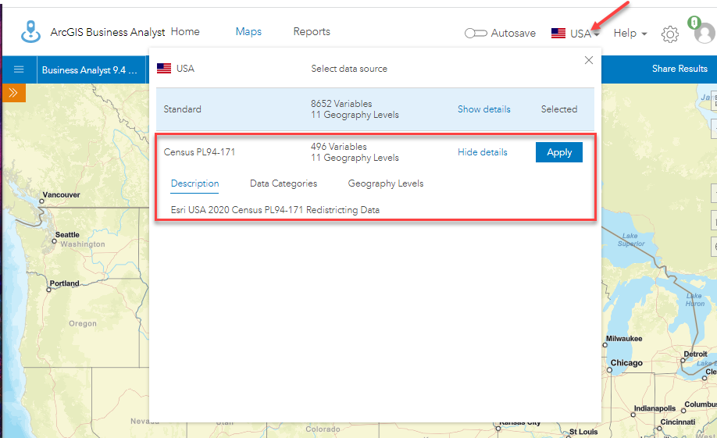

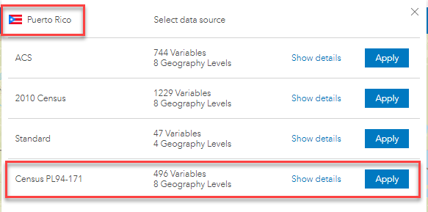

  - New 2020 Census Redistricting Data Infographic and Report
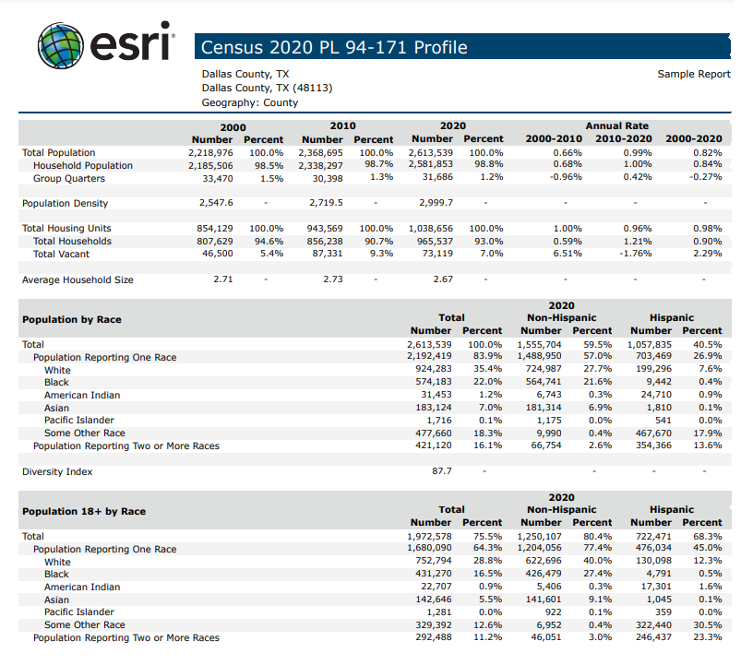

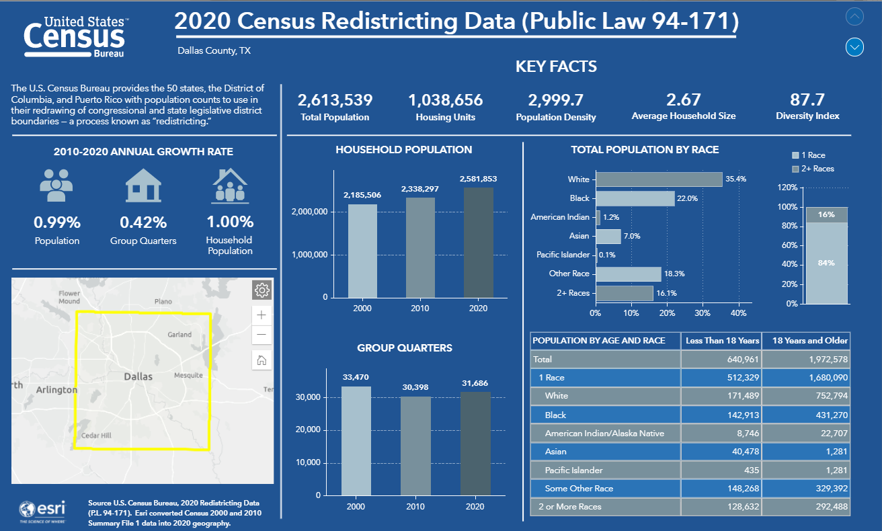

- Threshold Areas

Threshold Areas enables you to create drive time or ring areas that captures a defined data criterion, such as a specified population value or number of households. The threshold area will expand until the defined value is met. For example, how far would you need to drive to meet a criterion of 100,000 households.

You will find Threshold Areas in the Run Analysis tab. The workflow makes it easy to create thresholds in only a few steps. Select your location(s), set the desired thresholds, and view the results.
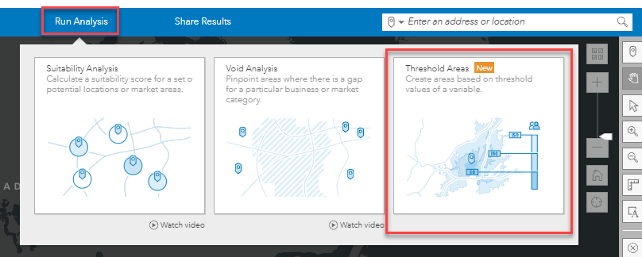

- Click on Threshold Areas in the Run Analysis tab to open the workflow and click the Get Started button.

- There are three methods for selecting locations. You can start with a single point location by entering an address or placing a pin on the map, choose multiple points from a layer, or use the center point of existing location sites currently on the map or from projects. A maximum of 10 location sites can be used.

  - For this example, the Single Location method is selected in Step 1 and then click Next.
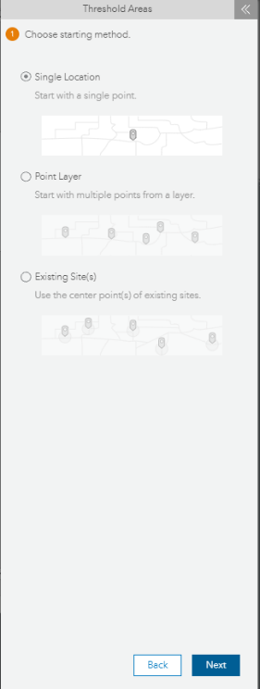

- Step 2 of the Single Location workflow, enter an address in the search bar or click on the pin icon to place a point on the map. Click Next to continue.
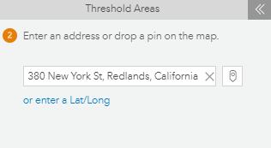

- In Step 3, you will define the threshold areas by selecting a variable, setup the threshold area values and choose the area type and units. Begin by selecting the data variable used to calculate the areas. If desired, you can use the defalut “Total Population” variable, or click on the edit pencil to view other options and change the variable.

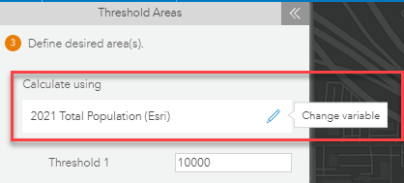

- Clicking on Change variable reveals two of the most often used variables for threshold area analysis, Total Population and Total Households. Simple click on the variable name to use it in your analysis, or click Browse for a variable to select varibles from the Data Browser.

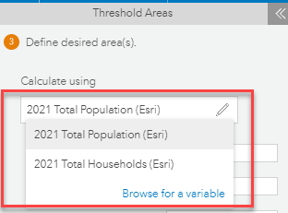

- For this example, we will click on Total Population to calucate threshold areas.

- Our next step is to set the threshold values. You can create up to three threshold areas for each location.
  - Accept the default population value of 10000 for Threshold 1.
  - Enter 20000 for Threshold 2.
  - Enter 30000 for Threshold 3.

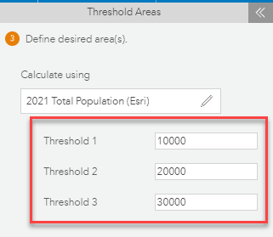

- The final step to define threshold areas is to choose the area type and units. You can create threshold areas using rings or drive times and select the desired units.

- Click on Drive time and click More options
  - Because Toward facility is often used when creating threhold areas, it is selected as the default option. If perferred, you can select the Away from facitity option, and/or Use traffic in calculating the threshold areas.

- In this example, the default Toward facility is used as the area type and minutes as the units.
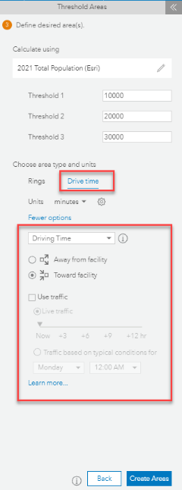

- Click on the Threshold settings gear icon to view performance options.

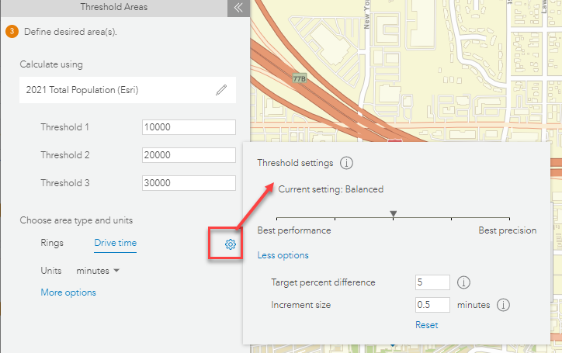

Move the slider handle to adjust the calculation for better performance or better percision. Moving the slider to the right will provide the best percision in the calculation of the threshold areas, while moving the slider to the left, will provide faster results with some diminishment of precision. The default setting in the middle provides a balanced setting between best performance and best precision.

In the Threshold settings pane, you can click More options to specify the target percent difference and increment size used when calculating the area. There are default values in these fields for each point on the slider. You can specify your own values or click Reset to return to the defaults.

Please Note: You can easily set up your own default threshold variables, area values, map styling, type, and threshold settings in Preferences > Maps > Run Analysis > Threshold Areas.

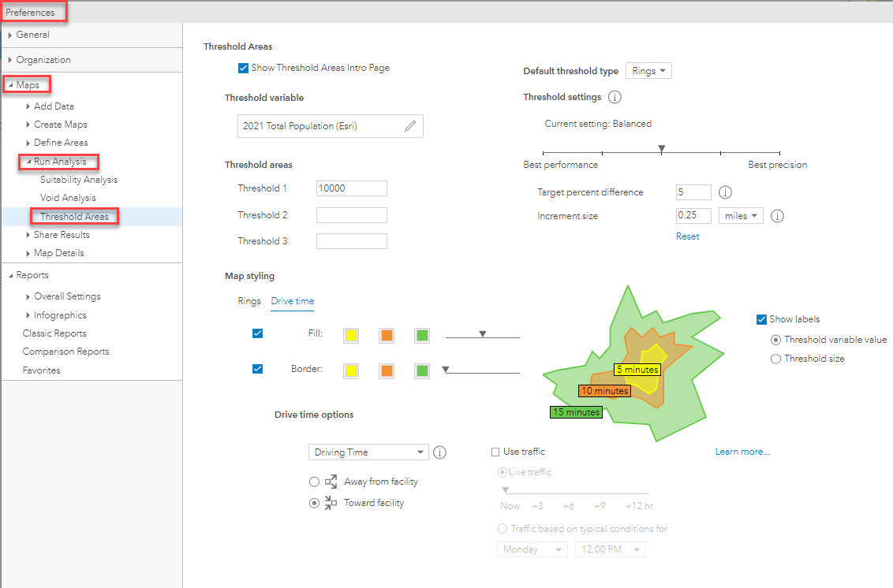

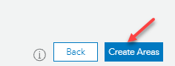
- Now that the areas have been defined, click Create Areas.

  - A “Please wait…” dialog will display while the thresholds are being created and saved. This can take awhile depending on the type of area, number of areas requested and performance settings. For example, drive times for 10 sites with three threshold areas each, and a best precision setting will take longer than rings with only one or two areas and a best performance setting. The blue progress bar at the bottom of the dialog indicates the percent of completion.

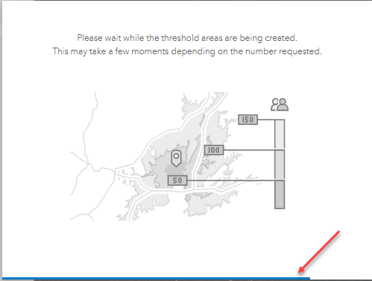

- The next step (4) in the Threshold Areas workflow is View Results.

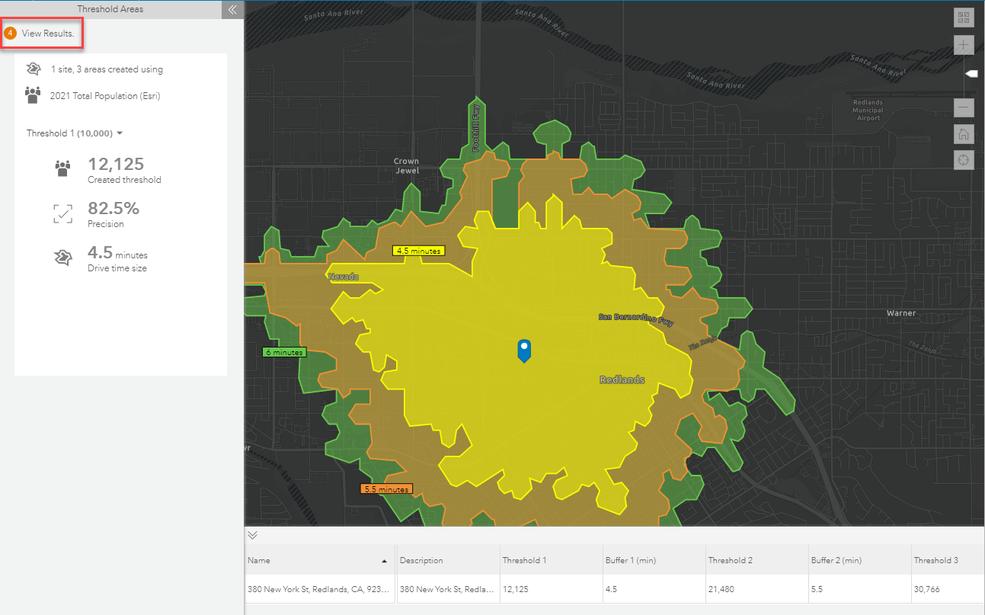

- Click on the dropdown arrow to toggle between threshold areas and view results for each area.

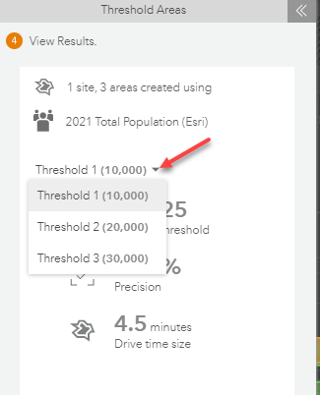

  - For example, in the image below the results are shown for Threshold 3.

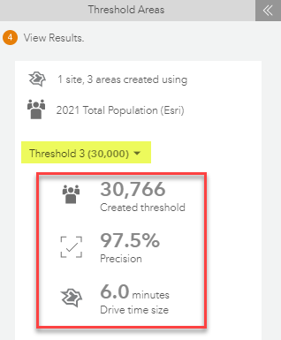

  - Let’s examine each result.
    - The first result shows the Created thershold value for Threshold 3, where the total population value of “30,766” of the requested 30,000 is included in the threshold area. The area expanded to as close to the requested 30,000 population is reached based on the selected balanced threshold setting.

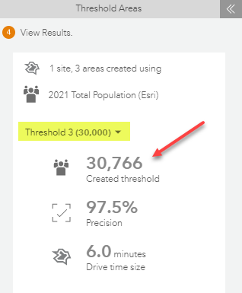

    - The second result shows the Precision.
      - You can mouseover the precision result to reveal a popup that explains the precision and how it is calculated. The precision is calucalted by dividing the requested threshold value by the created threshold value.

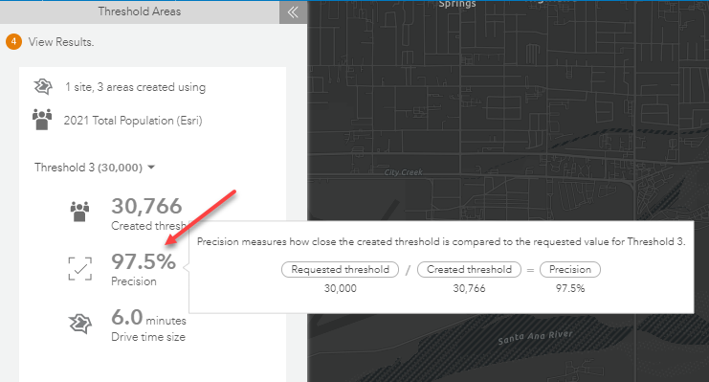

    - The third result in our example shows the Drive time size.
      - This is the size of the threshold area created to meet the requested value. For example, the drive time size expanded 6.0 minutes to reach the 30,766 threshold value.

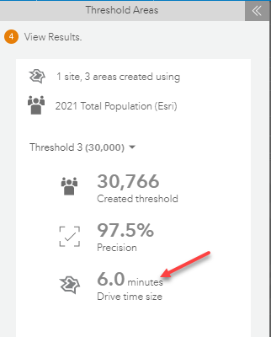

- The detailed threshold area results are shown in a table at the bottom of the screen.
  - You can export the threshold area summary and details to Excel.

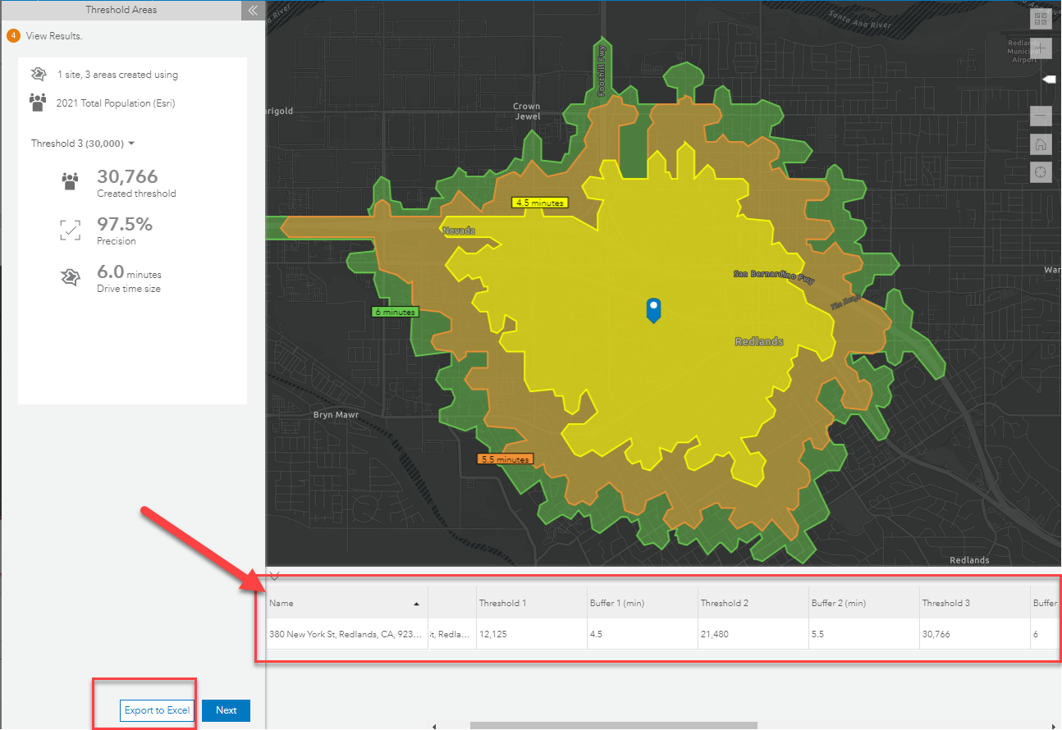

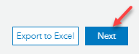
- Click Next to complete the workflow.

- The final step in Threshold Areas asks what you would like to do next. You can run infographics and reports for your threshold areas, create new threshold areas, or if you are finished, click I’m Done.

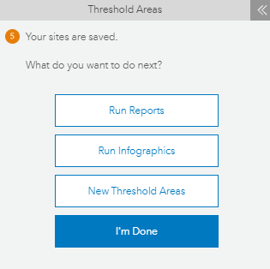

- Threshold area sites are saved in the project table and can be found in the Threshold Areas (Sites) > My Point Locations folder.
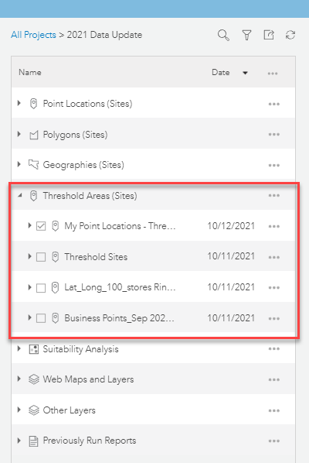
- Updated ArcGIS StoryMaps

Share content to the new ArcGIS StoryMaps.
  - The new generation platform of ArcGIS StoryMaps for telling stories with maps is available in Business Analyst Web App. Classic Story Maps are still available for now; however, these older templates are in extended support, so you will need to transition to the new ArcGIS StoryMaps.

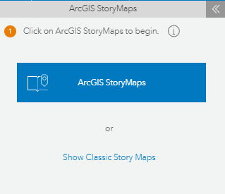

ArcGIS StoryMaps offers many useful capabilities that were never available in the classic templates, such as express maps, timelines, custom themes, reader analytics, collections, autosave, draft mode, and much more!

- Share more sites in ArcGIS Dashboards

Create ArcGIS Dashboards for up to 500 sites.
  - You can now create dashboards for up to 500 sites. Previously a maximum of 100 sites were allowed at the same time.

- Improved error messages

More context has been added in error messages for roles and privileges requirements and the maximum number of allowed projects. These improved messages will provide users with a better understanding of the cause of error.
  - Business Analyst Web App license requires a Creator or GIS Professional user type in your ArcGIS organization. A role defines the privileges that a member has within the organization and are configured by the organization administrator. The error messages have been improved when users do not have the sufficient privileges needed for specific Business Analyst Web workflows and features.
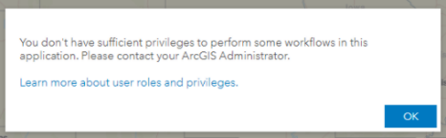
    - Example:

  - The maximum number of projects (groups) you can belong to is 512.
    - Error message example: “You can't create a new project because you have already reached the maximum of 512 groups (projects), counting groups you own and are a member of. Learn more about managing groups.” (URL link provided in the message)

- Data Updates Include:

  - 2021 Data updates for Canada demographics, reports, ten new infographics and updated business locations (Data Axle).
  - U.S. business locations (Data Axle and SafeGraph (Q4 2021)) and traffic points (Kalibrate (Q4 2021)).

