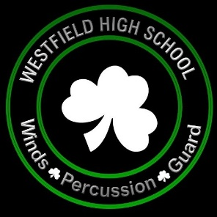
Westfield Band Boosters Association, Inc.
Monday, September 12, 2022 – 6:30pm
Attendees

- Greg Andelin, President
- Joy Rust, VP of Fundraising & Engagement
- Maura Clark, Secretary
- Angie Davis, VP of Finance
- Kelly Alford, Social Media Coordinator
- Rae Andelin, VP of Events
- Emily Kidwell, VP of Operations
- Lisa Gibson
- Stacy Hall
- Tracy Hughes
- Emily Jefferies
- Angela Ku
- Becky Morgan
- Amie Pratt
- Andrew Muth, Director of Bands
- Peter Lintzenich, Director of Operations
- Dave Shinault, Preforming Arts IA

Agenda

- Welcome
- August Meeting Minutes
- Treasurer’s Report
- Director’s Report

Committee Reports

- Fundraising & Sponsorship
- Events
- Operations
- Social Media

Old Business

New Business

Closing

Next Meeting: Monday, October 10, 2022 – 6:30pm

