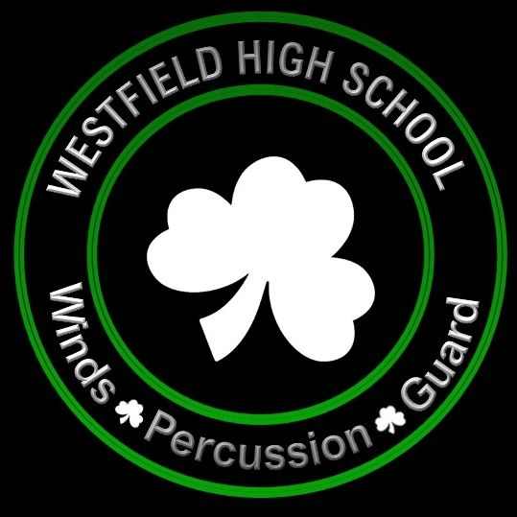
Westfield Band Boosters Association, Inc.
Monday, May 9, 2022 – 6:30pm
Attendees

- Greg Andelin, Interim President
- Joy Rust, Vice President
- Maura Clark, Secretary
- Angie Davis, Treasurer
- Kelly Alford
- Rae Andelin
- Stacy Hall
- Tracy Hughes
- Emily Kidwell
- Angela Ku
- Julie Lakomek
- Becky Morgan
- Andrew Muth, Director of Bands
- Peter Lintzenich, Director of Operations
- Dave Shinault, Preforming Arts Instructional Assistant

Agenda

- Welcome
- March Meeting Minutes
- Treasurer’s Report
- Director’s Report

Committee Reports

- Concessions
- Fundraising & Sponsorship
- Social Media
- Committee and Coordinator Needs

Old Business

- Open nominations for Board of Directors

New Business

- Approve Slate of Board Members
- Open Nominations for Officers
- Approve Slate of Officers
- Trailer Wrap - $10,000 provided by the school, $6,500 approval requested
- Uniform Steamer - $80 requested
- Banner “Thank You for Supporting” - $150 Requested
- Banner for Winds State Championship
- Attention Devices 8ft Stake Flags - $130 Requested
- Signatures required for Board Member Code of Ethics

Closing

Next Meeting: Monday, June 13, 2022 – 6:30pm

