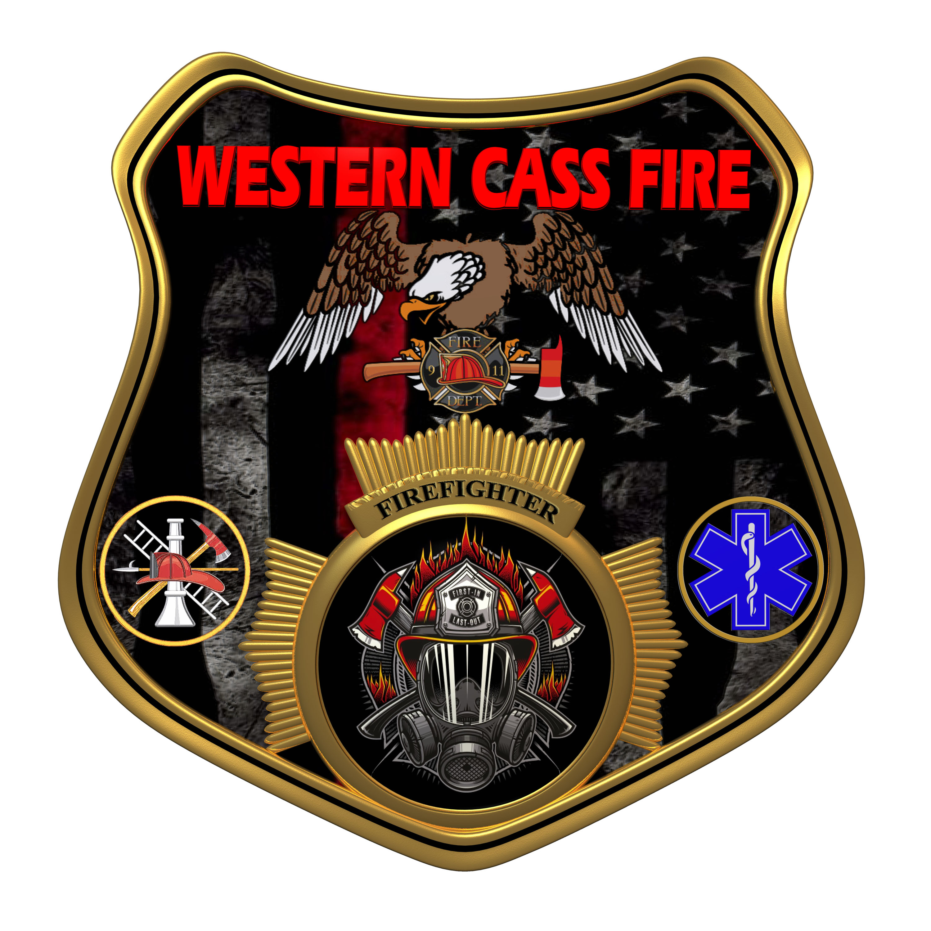 | Tentative Agenda  Western Cass Fire Protection District  Special Session  Monday, October 03, 2022, at 7:00 pm  Fire Headquarters  5 S. Rogers Rd., Cleveland, MO 64734  Discussion Protocols and Organization Rules for Meetings:  Questions from the public must be in writing with the following information: Name, Phone #, Physical Address, Email Address.  Board Members will be limited to 3 minutes for discussion of agenda items, twice per item, and discussion of items will last no more than 10 minutes per item.  Notice: The August 05, 2022 meeting is cancelled
- Call to Order by the Secretary
- Pledge of Allegiance
- Roll Call (Quorum)
a) President and Chair John Webb (2022- 2027)
b) Vice Chair Marty Hardman (2022- 2023)
c) Director Sue Hosterman (2019-2025)
d) Director Kerri VanMeveren (2020-2026)
e) Director Darvin Schildknecht (2021-2027)
- Adopt and Approve Wednesday, September 21, 2022 Tentative Agenda
- Personal Appearances / Public Comments
- Reports - No Reports
7) Unfinished Business
a) Approve the September 21, 2022 Regular Session Minutes
b) Banking
c) Discuss Dolan West Dolan Proposals
d) District Emergency Personnel
e) District Attorney
f) Station 2 Repairs
8) New Business
9) Closed Session: Personnel Issues
Personnel matters are confidential until such time as they may be made public by the Board of Directors, and the nondisclosure of such records outweighs the public interest in disclosure of the records as according to RSMo 610.021(1)(3)(13)(19).

10) Adjourn

