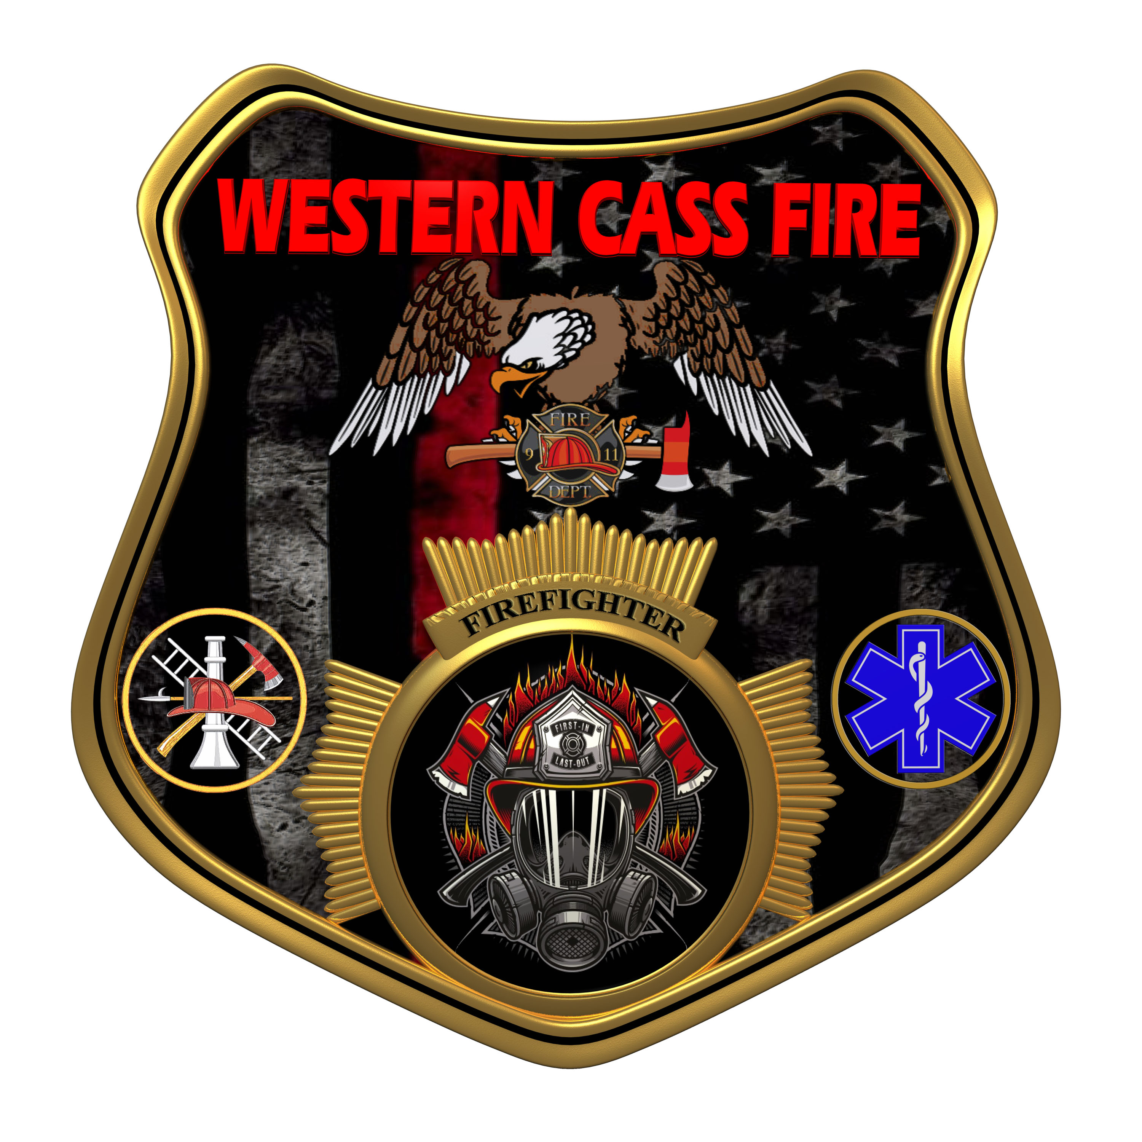 | Western Cass Fire Protection District  Regular Session Minutes  Friday, December 30, 2022, at 5:00 pm  Fire Headquarters  5 S. Rogers Rd., Cleveland, MO 64734  Lieutenant Claiborne of the Cass County Sherrif Department was present.
- Call to Order by the Secretary
- Pledge of Allegiance
- Roll Call (Quorum)
a) President and Chair John Webb (2022- 2027) Present
b) Vice Chair Marty Hardman (2022- 2023) Present
c) Director Sue Hosterman (2019-2025) Present
d) Director Kerri VanMeveren (2020-2026) Present
e) Director Darvin Schildknecht (2021-2027) Present
- President Webb made a motion to adopt and approve the Friday, December 30, 2022 Tentative Agenda with Ordinance 22.30.01 added to the agenda and it passed.
President and Chair John Webb - Aye
Vice Chair Marty Hardman - Aye
Director Sue Hosterman - Aye
Director Kerri VanMeveren - Nay
Director Darvin Schildknecht - Nay

- Personal Appearances / Public Comments
6) Unfinished Business
7) New Business
a) President Webb made a motion toto approve the expenditure for the additional component to ESO that the department needs to use the software and it passed.
President and Chair John Webb - Aye
Vice Chair Marty Hardman - Aye
Director Sue Hosterman - Aye
Director Kerri VanMeveren - Nay
Director Darvin Schildknecht - Nay

b) President Webb made a motion to adopt the residency program with amendments requiring background checks, and drug and alcohol tests added and it passed.
President and Chair John Webb - Aye
Vice Chair Marty Hardman - Aye
Director Sue Hosterman - Aye
Director Kerri VanMeveren - Aye
Director Darvin Schildknecht - Aye

c) President Webb made a motion to approve up to $1500.00 to purchase fire proof safes to house department documents and sensitive equipment and it passed.
President and Chair John Webb - Aye
Vice Chair Marty Hardman - Aye
Director Sue Hosterman - Aye
Director Kerri VanMeveren - Nay
Director Darvin Schildknecht - Nay

d) President Webb made a motion to schedule monthly meetings for the third Wednesday of each month for the year 2023 and it passed.
President and Chair John Webb - Aye
Vice Chair Marty Hardman - Aye
Director Sue Hosterman - Aye
Director Kerri VanMeveren - Aye
Director Darvin Schildknecht - Aye
e) Ordinance 22.30.01 - No Action Taken
f) President Webb made a motion to adjourn the meeting and it passed by consent agenda with no dissention.
8) Adjourn 7:08 P.M.

