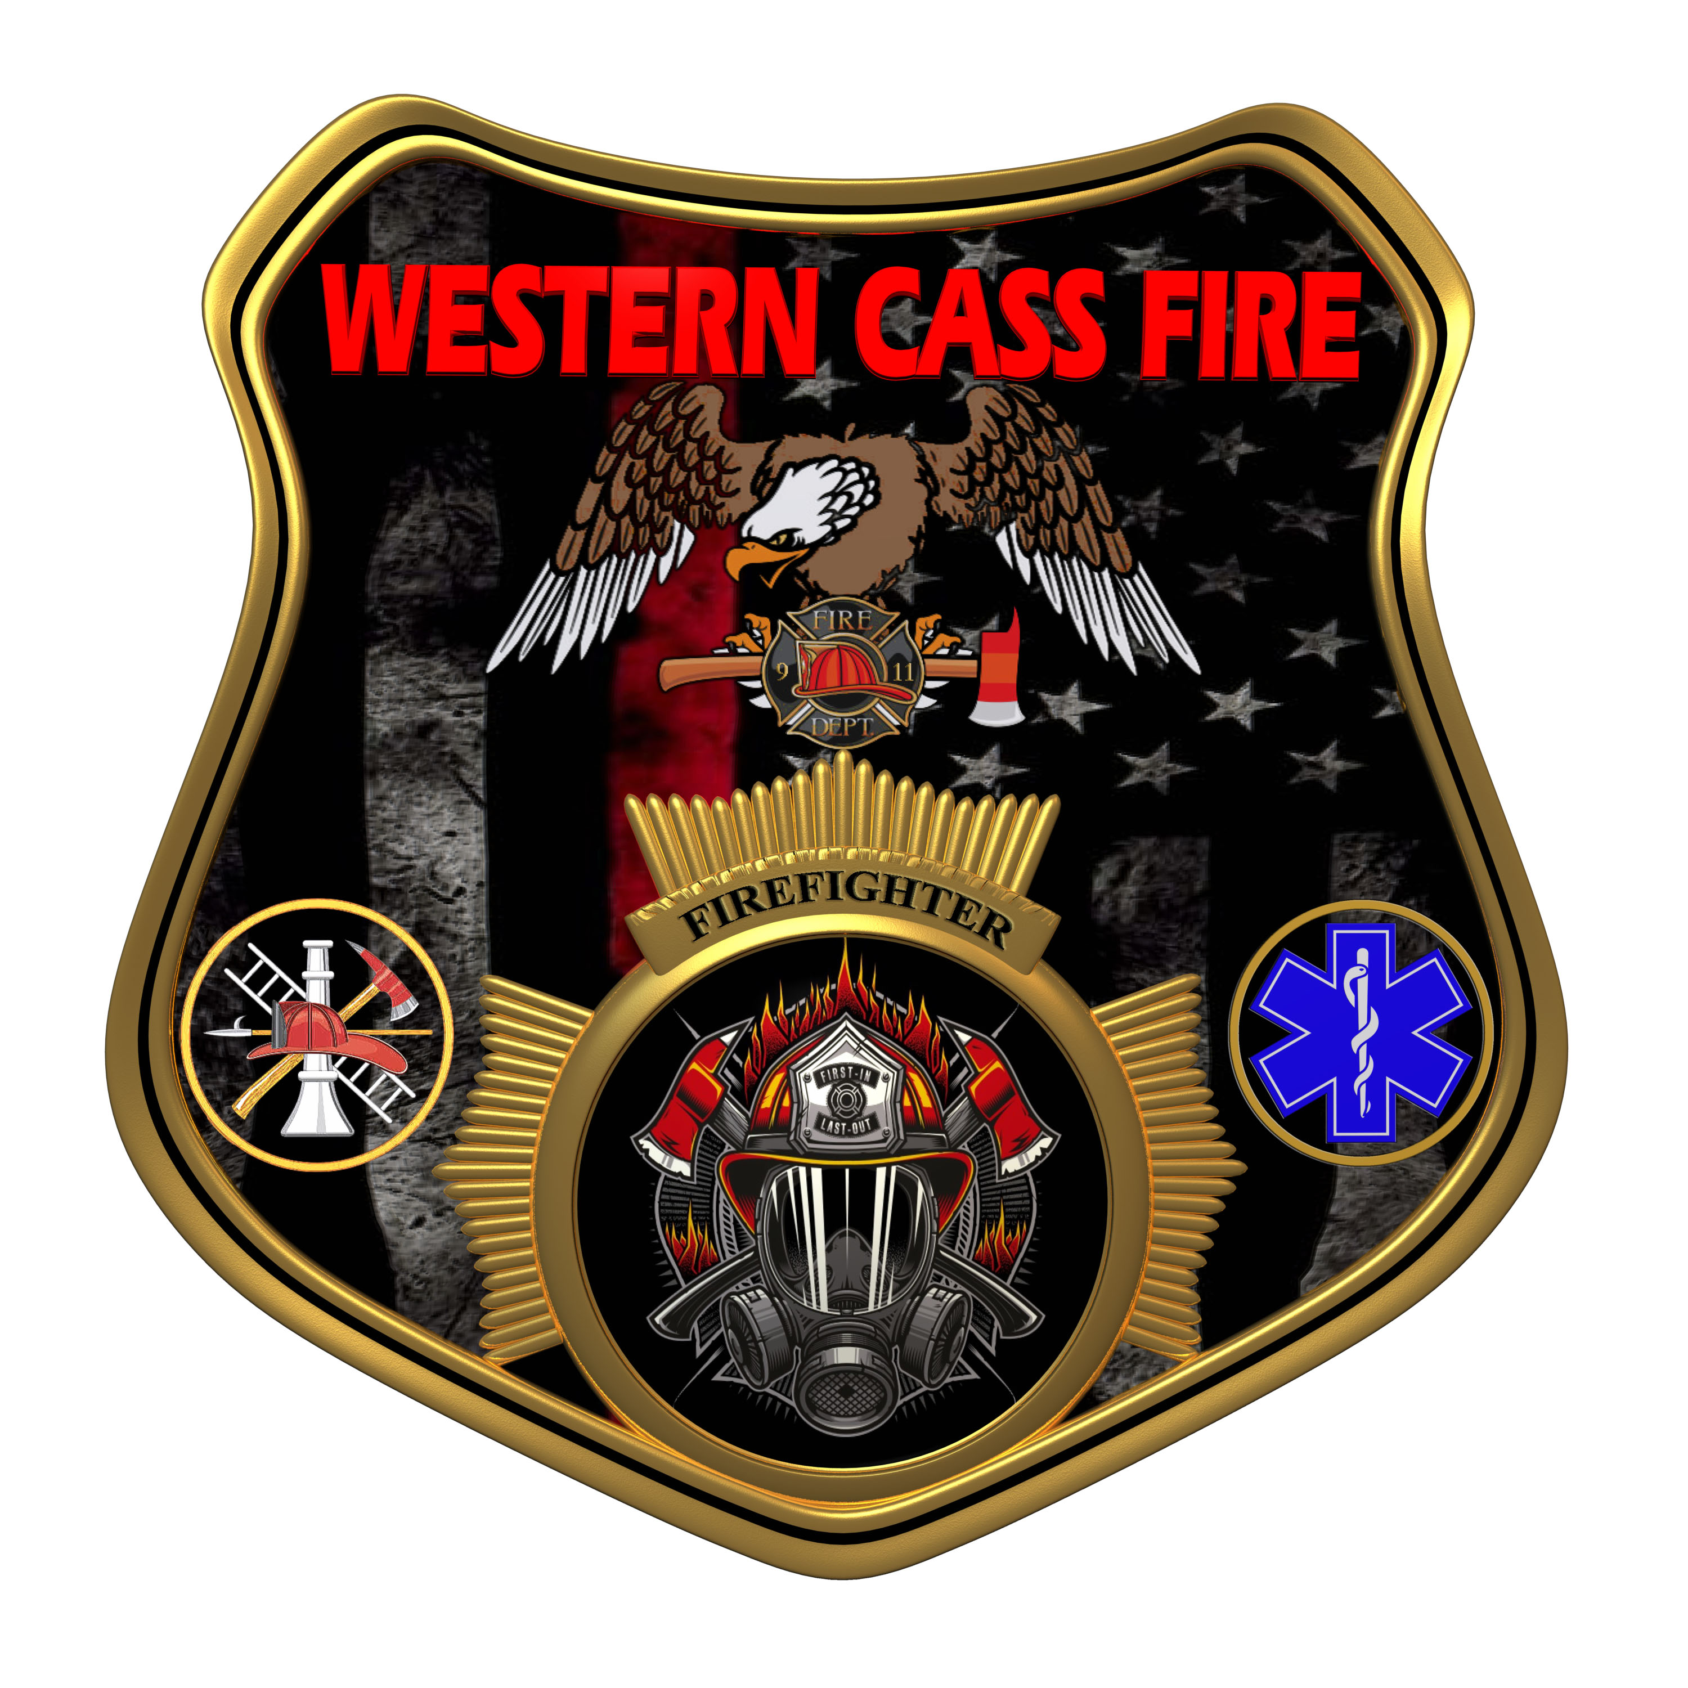 | Minutes  Western Cass Fire Protection District  Regular Session  Wednesday, November 16, 2022, at 7:00 pm  Fire Headquarters  5 S. Rogers Rd., Cleveland, MO 64734  https://tinyurl.com/5e34569x
- Call to Order by the Secretary 7:15 P.M.
- Pledge of Allegiance
- Roll Call (Quorum)
a) President and Chair John Webb (2022- 2027) Present
b) Vice Chair Marty Hardman (2022- 2023) Present
c) Director Sue Hosterman (2019-2025) Present
d) Director Kerri VanMeveren (2020-2026) Present Remotely
e) Director Darvin Schildknecht (2021-2027) Present
- President Webb made a motion to approve the Wednesday, November 16, 2022 Tentative Agenda with amendments added and it passed by consent agenda with no dissention.
- Personal Appearances / Public Comments
- Approve Minutes
a) President Webb made a motion to approve the Special Session minutes of October 03, 2022 and it passed.
President and Chair John Webb - Aye
Vice Chair Marty Hardman - Aye
Director Sue Hosterman - Aye
Director Kerri VanMeveren - Nay
Director Darvin Schildknecht - Nay
b) President Webb made a motion to approve the Regular Session minutes of October 19, 2022 and it passed. President and Chair John Webb - Aye
Vice Chair Marty Hardman - Aye
Director Sue Hosterman - Aye
Director Kerri VanMeveren - Nay
Director Darvin Schildknecht - Nay

- Reports
a) Directors Submit Written Reports
Note: Director Hardman will be cancelling her debit card with Community Bank of Raymore. The card was only used to pay for personnel background checks which are now done through the Sheriff's office, so the card is no longer needed. Director Hardman will cancel then destroy the card.
b) Treasurer Report Written Report
C) Chief Report Written Report
President Webb made a motion to check the battery for the emergency backup at Station 2, and permit the chief to have the battery tested and replaced if needed at a cost of no more then $200.00 and it passed.
President and Chair John Webb - Aye
Vice Chair Marty Hardman - Aye
Director Sue Hosterman - Aye
Director Kerri VanMeveren - Aye
Director Darvin Schildknecht - Aye

8) Unfinished Business
A) Bay Lights
President Webb made a motion to approve up to $3500.00 to replace the bay lights in Station 2 and remove the old fixtures, to be done by a new electrician that will be chosen from a new bid pool and with a signed contract, and it passed.
President and Chair John Webb - Aye
Vice Chair Marty Hardman - Aye
Director Sue Hosterman - Aye
Director Kerri VanMeveren - Aye
Director Darvin Schildknecht - Aye
B) Doctor Cusser Medical Director
President Webb made a motion to approve the contract with Doctor Cusser as the new medical director.
President and Chair John Webb - Aye
Vice Chair Marty Hardman - Aye
Director Sue Hosterman - Aye
Director Kerri VanMeveren - Aye
Director Darvin Schildknecht - Aye
C) Insurance Rider
Director Harman made a motion to sign the insurance rider for Station 2 and it passed.
President and Chair John Webb - Aye
Vice Chair Marty Hardman - Aye
Director Sue Hosterman - Aye
Director Kerri VanMeveren - Abstain (no vote recorded)
Director Darvin Schildknecht - Aye

9) New Business
A) Auditor Payment
President Webb made a motion to pay the bill from Trout Beeman and Co. for the work they did on the 12-21-21 audit and it passed.
President and Chair John Webb - Aye
Vice Chair Marty Hardman - Aye
Director Sue Hosterman - Aye
Director Kerri VanMeveren - Aye
Director Darvin Schildknecht - Aye

B) Chief Reimbursement Gasoline
1) President Webb made a motion to reimburse Chief for expenses he incurred on behalf of the district for a total of $380.74 and it passed.
President and Chair John Webb - Aye
Vice Chair Marty Hardman - Aye
Director Sue Hosterman - Aye
Director Kerri VanMeveren - Aye
Director Darvin Schildknecht - Aye
2) President Webb made a motion to pay no more than $400.00 for personnel HAZMAT training and it passed.
President and Chair John Webb - Aye
Vice Chair Marty Hardman - Aye
Director Sue Hosterman - Aye
Director Kerri VanMeveren - Nay
Director Darvin Schildknecht - Aye

C) Sheriff 22 Addendum - No Action Taken
D) Elections
1)President Webb made a motion to submit advertising for the coming election as required by statute for a cost of no more than $400.00 and it passed.
President and Chair John Webb - Aye
Vice Chair Marty Hardman - Aye
Director Sue Hosterman - Aye
Director Kerri VanMeveren - Abstain (no vote recorded)
Director Darvin Schildknecht - Nay
E) Station 2 Residency - No Action Taken
Director Hardman made a motion ordering director Schildknecht to cease the harassment of our fire personnel and it passed.
President and Chair John Webb - Aye
Vice Chair Marty Hardman - Aye
Director Sue Hosterman - Aye
Director Kerri VanMeveren - Nay
Director Darvin Schildknecht - Nay
F) Newsletter
President Webb made a motion to the citizens of the district at a cost of no more than $1500.00 and it passed.
President and Chair John Webb - Aye
Vice Chair Marty Hardman - Aye
Director Sue Hosterman - Aye
Director Kerri VanMeveren - Nay
Director Darvin Schildknecht - Nay
G) Christmas Party
President Webb made a motion to have a Christmas Party for district personnel on December 20, 2022 and spend up to $500.00 and it passed.
President and Chair John Webb - Aye
Vice Chair Marty Hardman - Aye
Director Sue Hosterman - Aye
Director Kerri VanMeveren - Nay
Director Darvin Schildknecht - Nay

10) President Webb made a motion to adjourn and it passed by consent agenda with no dissention.
11) Adjourn 8:34 P.M.

