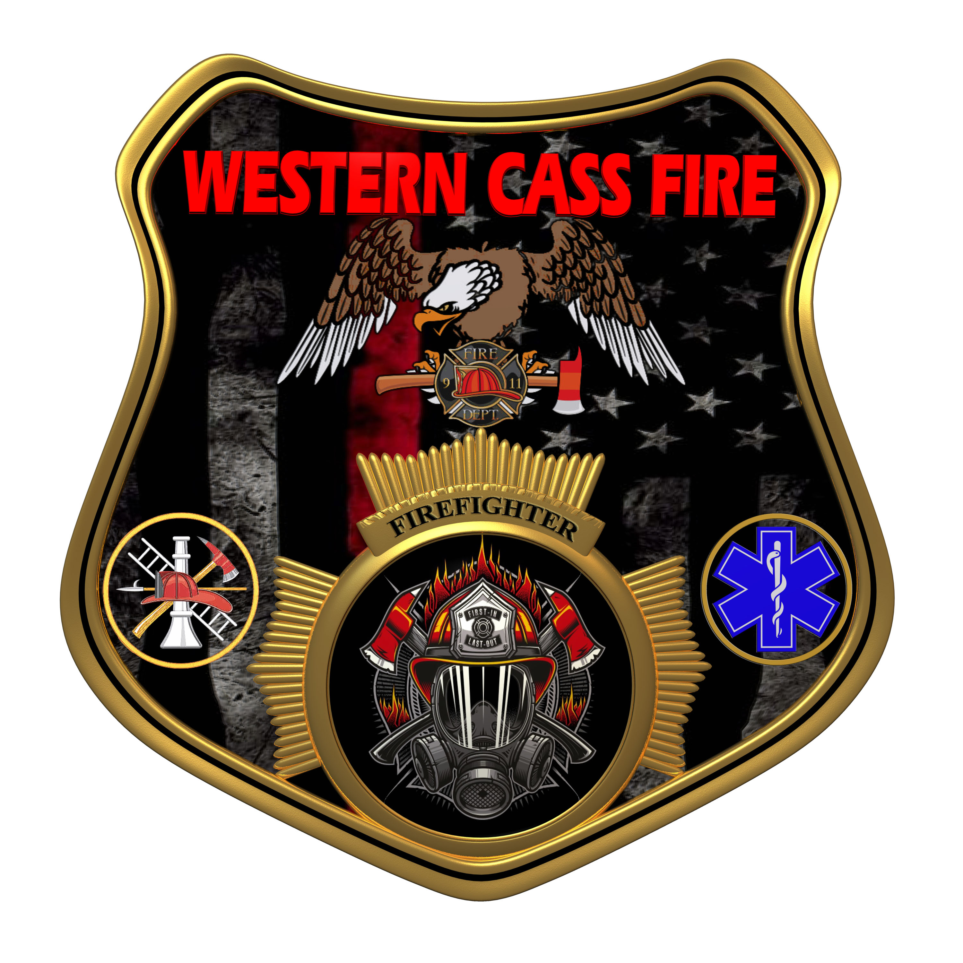 | Western Cass Fire Protection District  Closes Session Minutes  Wednesday, October 19, 2022, at 7:00 pm  Fire Headquarters  5 S. Rogers Rd., Cleveland, MO 64734  Discussion Protocols and Organization Rules for Meetings:  Questions from the public must be in writing with the following information: Name, Phone #, Physical Address, Email Address.  Board Members will be limited to 3 minutes for discussion of agenda items, twice per item, and discussion of items will last no more than 10 minutes per item.
- Call to Order by the Secretary 7:03 P.M.
- Pledge of Allegiance
- Roll Call (Quorum)
a) President and Chair John Webb (2022- 2027) Present
b) Vice Chair Marty Hardman (2022- 2023) Present Remotely
c) Director Sue Hosterman (2019-2025) Present
d) Director Kerri VanMeveren (2020-2026) Present Remotely
e) Director Darvin Schildknecht (2021-2027) Present
- President Webb made a motion to adopt the Wednesday, October 19, 2022 Tentative Agenda and it passed by consent agenda with no dissention.
- Personal Appearances / Public Comments
6) Reports - No Reports
7) Unfinished Business
a) Dispatch Contract
President Webb made a motion to sign the dispatch contract with the Cass County Sherrif's Office for $1500.00 per year plus $12.00 per event and it passed.
President and Chair John Webb - Aye
Vice Chair Marty Hardman - Aye
Director Sue Hosterman - Aye
Director Kerri VanMeveren - Abstain (no vote recorded)
Director Darvin Schildknecht - Nay
b) Carpet Contract
President Webb made a motion to sign the flooring contract with Harmon Floor Company and pay the 50% charge in advance for materials cost and it passed.
President and Chair John Webb - Aye
Vice Chair Marty Hardman - Aye
Director Sue Hosterman - Aye
Director Kerri VanMeveren - Nay
Director Darvin Schildknecht - Aye

8) New Business
a) Solicit Insurance Bids
Director Schildknecht made a motion to have Director Hosterman publish a public bid notice for insurance quotes and it passed.
President and Chair John Webb - Aye
Vice Chair Marty Hardman - Aye
Director Sue Hosterman - Aye
Director Kerri VanMeveren - Aye
Director Darvin Schildknecht - Aye
b) Operational Necessities
1) A.T.T. Account - P.T.T. Blankenship
President Webb made a motion to approve an AT&T Firstnet account for firefighter Jack Blankenship and it passed.
President and Chair John Webb - Aye
Vice Chair Marty Hardman - Aye
Director Sue Hosterman - Aye
Director Kerri VanMeveren - Aye
Director Darvin Schildknecht - Aye

2) Generator Repair 1923 Pumper
President Webb made a motion to pay for repair of the generator on the 1923 Pumper truck for up to $500.00 in cost and it passed.
President and Chair John Webb - Aye
Vice Chair Marty Hardman - Aye
Director Sue Hosterman - Aye
Director Kerri VanMeveren - Aye
Director Darvin Schildknecht - Aye

3) Extinguisher Annual
President Webb made a motion to pay to have the district Fire extinguishers inspected and repaired for costs not to exceed $750.00 and it passed.
President and Chair John Webb - Aye
Vice Chair Marty Hardman - Aye
Director Sue Hosterman - Aye
Director Kerri VanMeveren - Aye
Director Darvin Schildknecht - Aye

4) Emergency Lights - Pinion
President Webb made a motion to approve of the purchase of emergency lights for Deputy Chief Chris Pinion for up to $1200.00, and Chris Pinion will pay the district back at a rate of $100.00 per month, and should he leave the department prior to repaying the district back then the district will retain the lights and it passed.
President and Chair John Webb - Aye
Vice Chair Marty Hardman - Aye
Director Sue Hosterman - Aye
Director Kerri VanMeveren - Aye
Director Darvin Schildknecht - Aye

5) Atmospheric Testers
President Webb made a motion to purchase two atmospheric testers at a cost of no more than $1300.00 in total and it passed.
President and Chair John Webb - Aye
Vice Chair Marty Hardman - Aye
Director Sue Hosterman - Aye
Director Kerri VanMeveren - Aye
Director Darvin Schildknecht - Aye

6) Station 2 Generator Maintenance
President Webb made a motion to have Rockhill Electric service the generator at Station 2 at no charge to the district for labor but the district will pay for parts in case of repair and it passed.
President and Chair John Webb - Aye
Vice Chair Marty Hardman - Aye
Director Sue Hosterman - Aye
Director Kerri VanMeveren - Aye
Director Darvin Schildknecht - Aye

7) Station 2 Bay Lights
Director Hardman made a motion to hire Crosco Services to install new bay lighting and emergency lighting as cited in their bid and pay them one third of the cost in advance for materials after both parties sign a contract prepared by the attorney for the district and it passed.
President and Chair John Webb - Aye
Vice Chair Marty Hardman - Aye
Director Sue Hosterman - Aye
Director Kerri VanMeveren - Aye
Director Darvin Schildknecht - Aye
8) President Webb made a motion to go into closed session to discuss personnel matters and it passed.
President and Chair John Webb - Aye
Vice Chair Marty Hardman - Aye
Director Sue Hosterman - Aye Director Darvin Schildknecht - Aye
Director Kerri VanMeveren - Aye

9) Closed Session: Personnel Issues
Personnel matters are confidential until such time as they may be made public by the Board of Directors, and the nondisclosure of such records outweighs the public interest in disclosure of the records as according to RSMo 610.021(1)(3)(13)(19).
A) New Personnel
1) President Webb made a motion to hire Chris Martin as a volunteer upon the recommendation of the Chief and it passed.
President and Chair John Webb - Aye
Vice Chair Marty Hardman - Aye
Director Sue Hosterman - Aye Director Darvin Schildknecht - Aye

2) President Webb made a motion to hire McCann Busch as a volunteer upon the recommendation of the Chief and it passed.
President and Chair John Webb - Aye
Vice Chair Marty Hardman - Aye
Director Sue Hosterman - Aye Director Darvin Schildknecht - Aye

B) Return to Open Session
President Webb made a motion to return to open session and adjourn and it passed by consent agenda with no dissention.

10) Adjourn 8:05 P.M.

