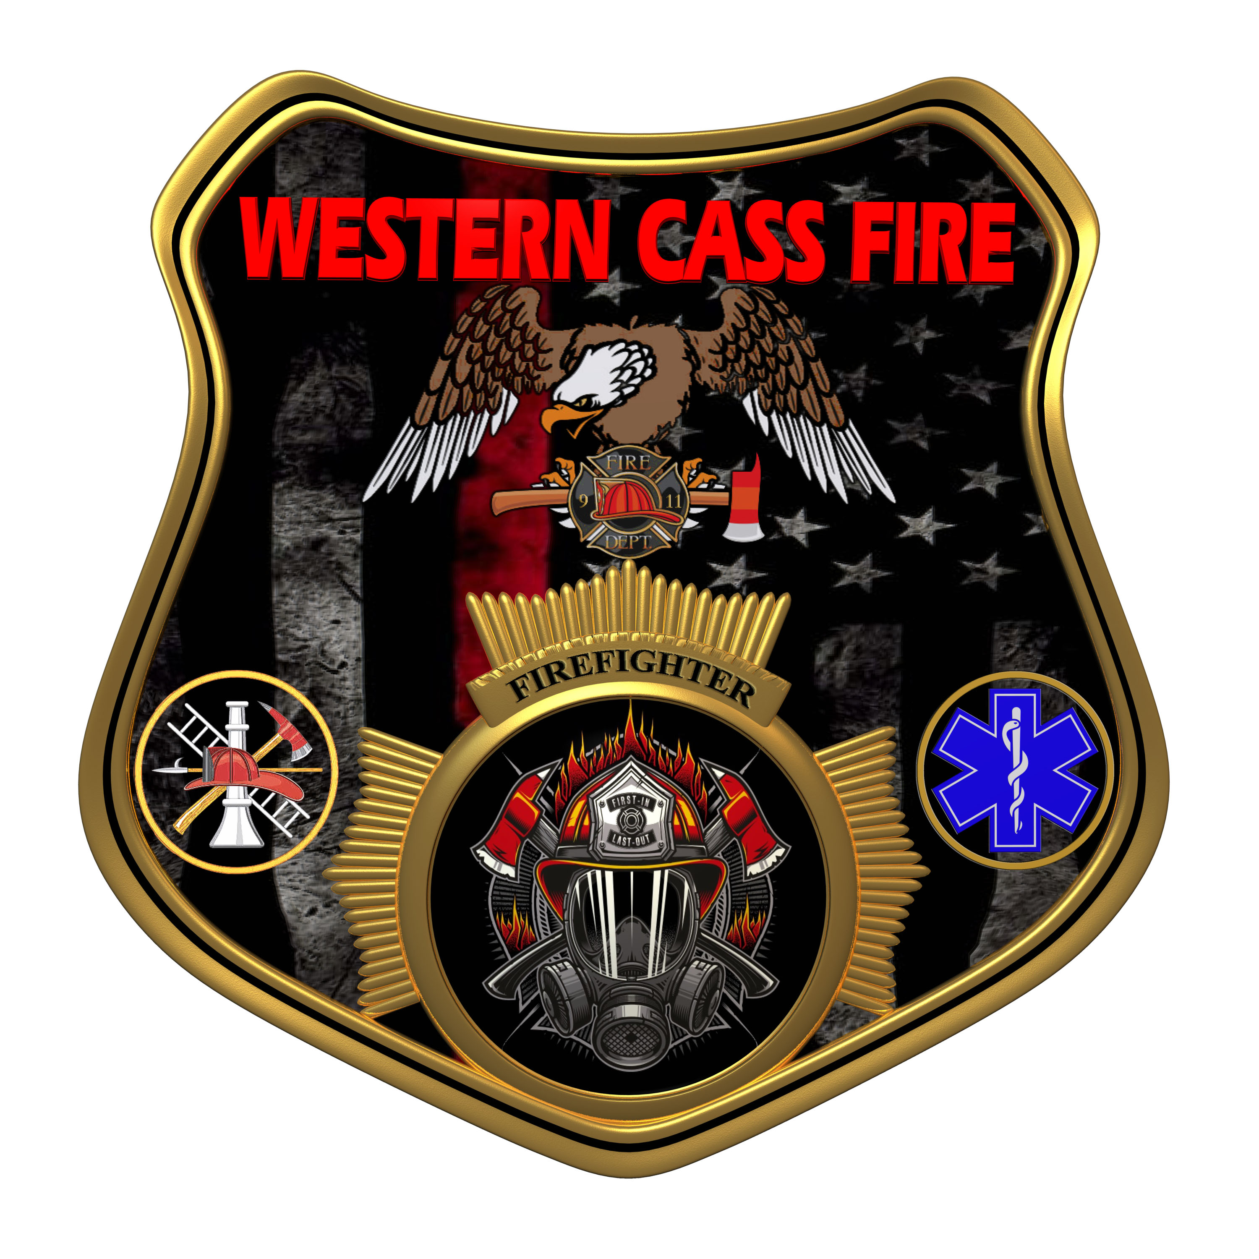 | Minutes  Western Cass Fire Protection District  Special Session  Monday, October 03, 2022, at 7:00 pm  Fire Headquarters  5 S. Rogers Rd., Cleveland, MO 64734
- Call to Order by the Secretary - 7:01 P.M.
- Pledge of Allegiance
- Roll Call (Quorum)
a) President and Chair John Webb (2022- 2027) Present
b) Vice Chair Marty Hardman (2022- 2023) Present
c) Director Sue Hosterman (2019-2025) Present
d) Director Kerri VanMeveren (2020-2026) Present Remotely
e) Director Darvin Schildknecht (2021-2027) Present
- President Webb made a motion to adopt and approve Wednesday, October 03, 2022 Tentative Agenda with corrected dates and amendments to New Business and it passed.
President and Chair John Webb - Aye
Vice Chair Marty Hardman - Aye
Director Sue Hosterman - Aye
Director Kerri VanMeveren - Aye
Director Darvin Schildknecht - Abstain
- Personal Appearances / Public Comments
- Reports - No Reports
7) Unfinished Business
a) President Webb made motion to approve the September 21, 2022 Regular Session Minutes and it passed.
President and Chair John Webb - Aye
Vice Chair Marty Hardman - Aye
Director Sue Hosterman - Aye
Director Kerri VanMeveren - Nay
Director Darvin Schildknecht - Abstain
Director Schildknecht made a motion to record all board meetings and allow remote attendance at all meetings and it failed.
President and Chair John Webb - Nay
Vice Chair Marty Hardman - Nay
Director Sue Hosterman - Nay
Director Kerri VanMeveren - Aye
Director Darvin Schildknecht - Aye

b) Banking
1) President Webb made a motion to have the board reconsider the resolution to fund a MOSIP account and use Commerce Bank as our only bank and it passed.
President and Chair John Webb - Aye
Vice Chair Marty Hardman - Aye
Director Sue Hosterman - Aye
Director Kerri VanMeveren - Aye
Director Darvin Schildknecht - Aye
2) Note: During the discussion on moving funds to a new bank and creating a new account to hold the bond fund overpay money, Director Schildknecht said that would make it easier for money laundering.
3) Director Hardman made a motion that when the Citizen's Bank CDs mature then the district will withdraw the funds in the form of a cashier's check made out to WCFPD that will then be deposited with Commerce Bank and it passed.
President and Chair John Webb - Aye
Vice Chair Marty Hardman - Aye
Director Sue Hosterman - Aye
Director Kerri VanMeveren - Aye
Director Darvin Schildknecht - Aye
c) District Emergency Personnel
1) President Webb made a motion to approve the various ranks of fire personnel as recommended by the chief with no respect to pay rate and it passed.
President and Chair John Webb - Aye
Vice Chair Marty Hardman - Aye
Director Sue Hosterman - Aye
Director Kerri VanMeveren - Nay
Director Darvin Schildknecht - Nay
2) Director Schildknecht made a motion to table the motion to accept the ranks as recommended by the chief until another meeting and it failed.
President and Chair John Webb - Nay
Vice Chair Marty Hardman - Nay
Director Sue Hosterman - Nay
Director Kerri VanMeveren - Aye
Director Darvin Schildknecht - Aye
d) Station 2 Repairs
1) President Webb made a motion to sign the service contract with Harmon Floor Company and it passed.
President and Chair John Webb - Aye
Vice Chair Marty Hardman - Aye
Director Sue Hosterman - Aye
Director Kerri VanMeveren - Aye
Director Darvin Schildknecht - Aye
2) Director Hardman made a motion to pay all contractors for Station 2 upon completion of their work and after passing a final inspection, and it passed.
President and Chair John Webb - Aye
Vice Chair Marty Hardman - Aye
Director Sue Hosterman - Aye
Director Kerri VanMeveren - Nay
Director Darvin Schildknecht - Aye
8) New Business
a) President Webb made a motion to spend $400.00 + shipping and handling on a rebuilt charger for the tanker truck and it passed.
President and Chair John Webb - Aye
Vice Chair Marty Hardman - Aye
Director Sue Hosterman - Aye
Director Kerri VanMeveren - Aye
Director Darvin Schildknecht - Aye
b) President Webb made a motion to adopt the new district insignia that the Chief requested to be created and it passed.
President and Chair John Webb - Aye
Vice Chair Marty Hardman - Aye
Director Sue Hosterman - Aye
Director Kerri VanMeveren - Aye
Director Darvin Schildknecht - Aye
c) President Webb made a motion to recess to closed session and it passed.
President and Chair John Webb - Aye
Vice Chair Marty Hardman - Aye
Director Sue Hosterman - Aye
Director Kerri VanMeveren - Nay
Director Darvin Schildknecht - Aye
9) Closed Session: Personnel Issues
Personnel matters are confidential until such time as they may be made public by the Board of Directors, and the nondisclosure of such records outweighs the public interest in disclosure of the records as according to RSMo 610.021(1)(3)(13)(19).

10) Return to Open Session
a) Director Hardman made a motion to pay Cody Porter an additional $100.00 to cover the cost of the new appliques and it passed.
President and Chair John Webb - Aye
Vice Chair Marty Hardman - Aye
Director Sue Hosterman - Aye
Director Darvin Schildknecht - Aye
b) President Webb made a motion to adjourn and it was passed by consent agenda with no dissention.
11) Adjourn - 9:40 P.M.

