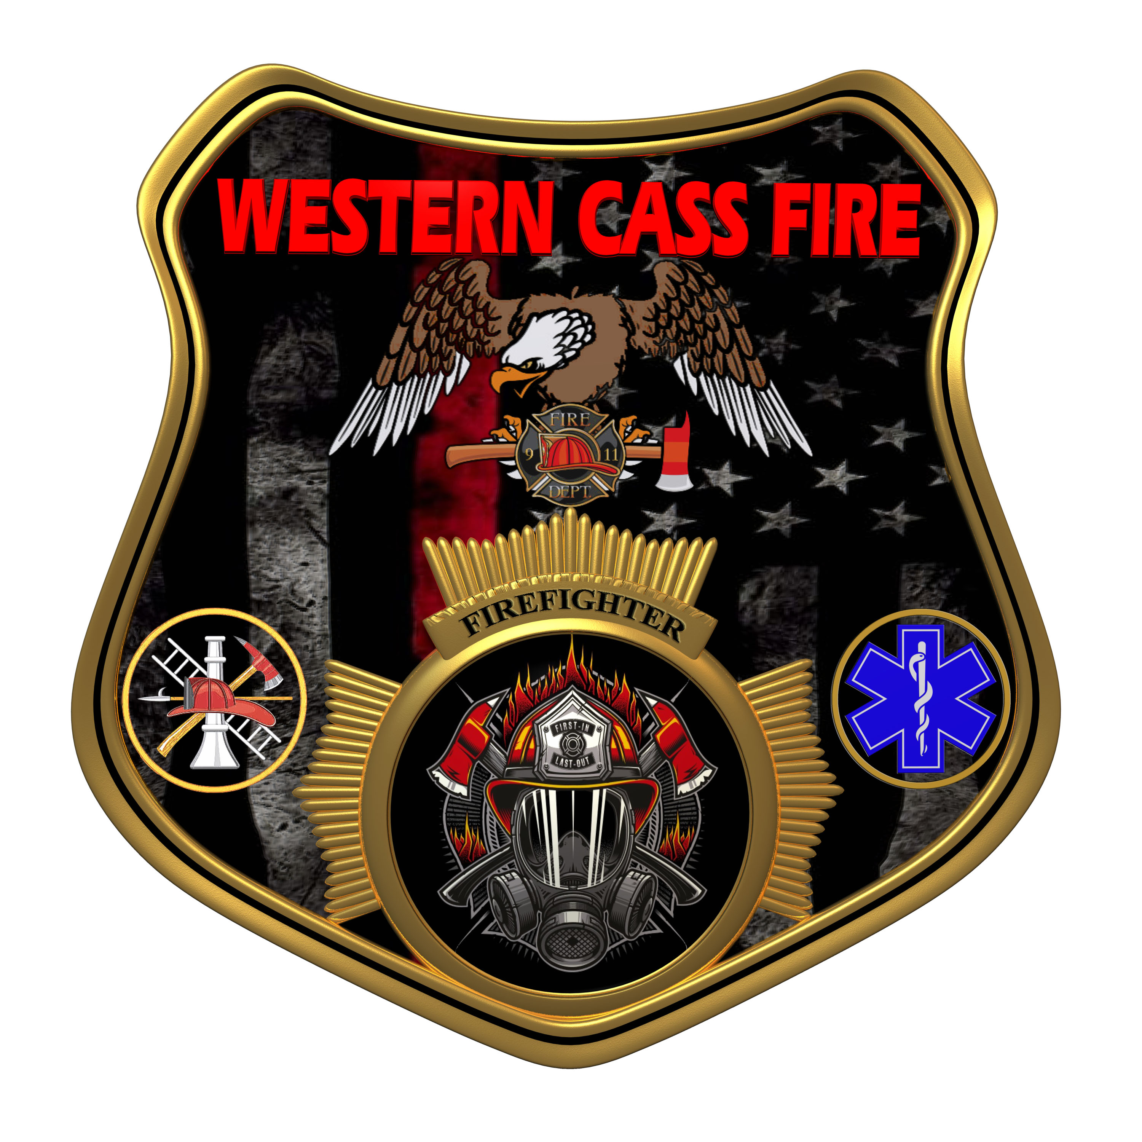 | Tentative Agenda  Western Cass Fire Protection District  Regular Session  Friday, December 30, 2022, at 5:00 pm  Fire Headquarters  5 S. Rogers Rd., Cleveland, MO 64734  In Person Only  Discussion Protocols and Organization Rules for Meetings:  Questions from the public must be in writing with the following information: Name, Phone #, Physical Address, Email Address.  Board Members will be limited to 3 minutes for discussion of agenda items, twice per item, and discussion of items will last no more than 10 minutes per item.
- Call to Order by the Secretary
- Pledge of Allegiance
- Roll Call (Quorum)
a) President and Chair John Webb (2022- 2027)
b) Vice Chair Marty Hardman (2022- 2023)
c) Director Sue Hosterman (2019-2025)
d) Director Kerri VanMeveren (2020-2026)
e) Director Darvin Schildknecht (2021-2027)
- Adopt and Approve Friday, December 30, 2022 Tentative Agenda
- Personal Appearances / Public Comments
6) Unfinished Business
7) New Business
a) ESO
b) Resident Policy
c) Fire Proof Safe
d) Meeting Schedule 2023
8) Adjourn

