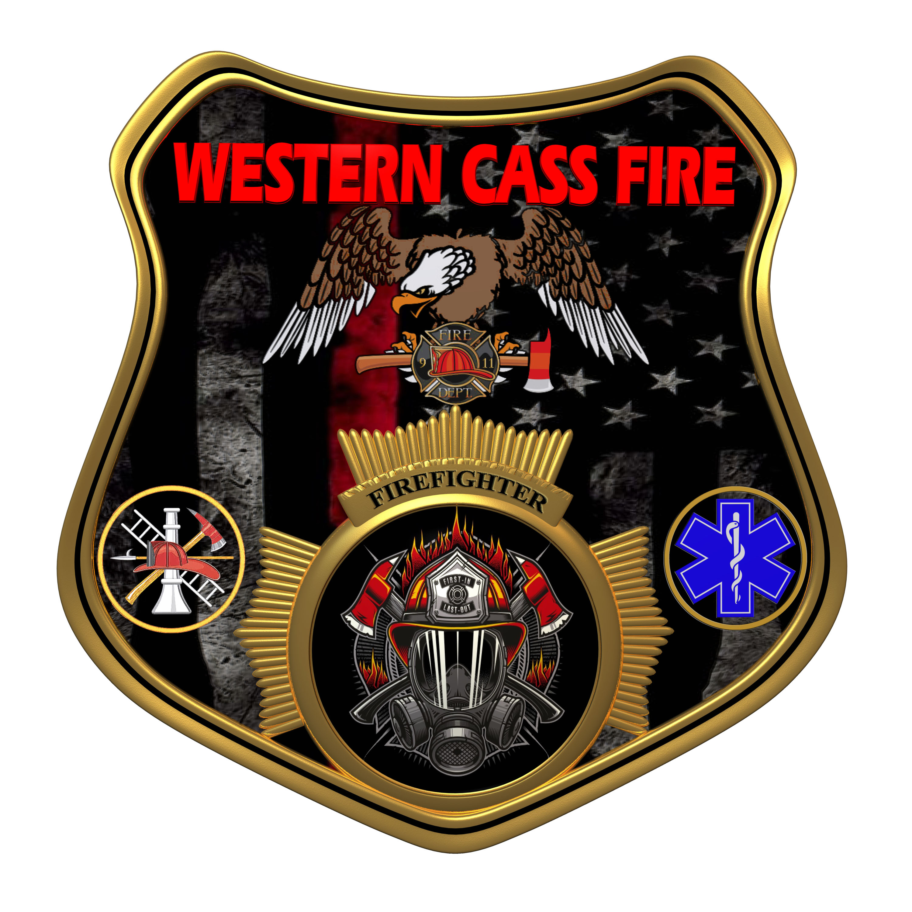 | Tentative Agenda  Western Cass Fire Protection District  Regular Session  Wednesday, November 16, 2022, at 7:00 pm  Fire Headquarters  5 S. Rogers Rd., Cleveland, MO 64734  https://tinyurl.com/5e34569x  Discussion Protocols and Organization Rules for Meetings:  Questions from the public must be in writing with the following information: Name, Phone #, Physical Address, Email Address.  Board Members will be limited to 3 minutes for discussion of agenda items, twice per item, and discussion of items will last no more than 10 minutes per item.
- Call to Order by the Secretary
- Pledge of Allegiance
- Roll Call (Quorum)
a) President and Chair John Webb (2022- 2027)
b) Vice Chair Marty Hardman (2022- 2023)
c) Director Sue Hosterman (2019-2025)
d) Director Kerri VanMeveren (2020-2026)
e) Director Darvin Schildknecht (2021-2027)
- Adopt and Approve Wednesday, November 16, 2022 Tentative Agenda
- Personal Appearances / Public Comments
- Approve Minutes
a) Approve the Special Session minutes of October 03, 2022
b) Approve the Regular Session minutes of October 19, 2022
- Reports
a) Directors Submit Written Reports
b) Treasurer Report Written Report
C) Chief Report Written Report
8) Unfinished Business
9) New Business
a) Auditor Payment
b) Chief Reimbursement Gasoline
c) Sheriff 22 Addendum
d) Elections
10) Adjourn

