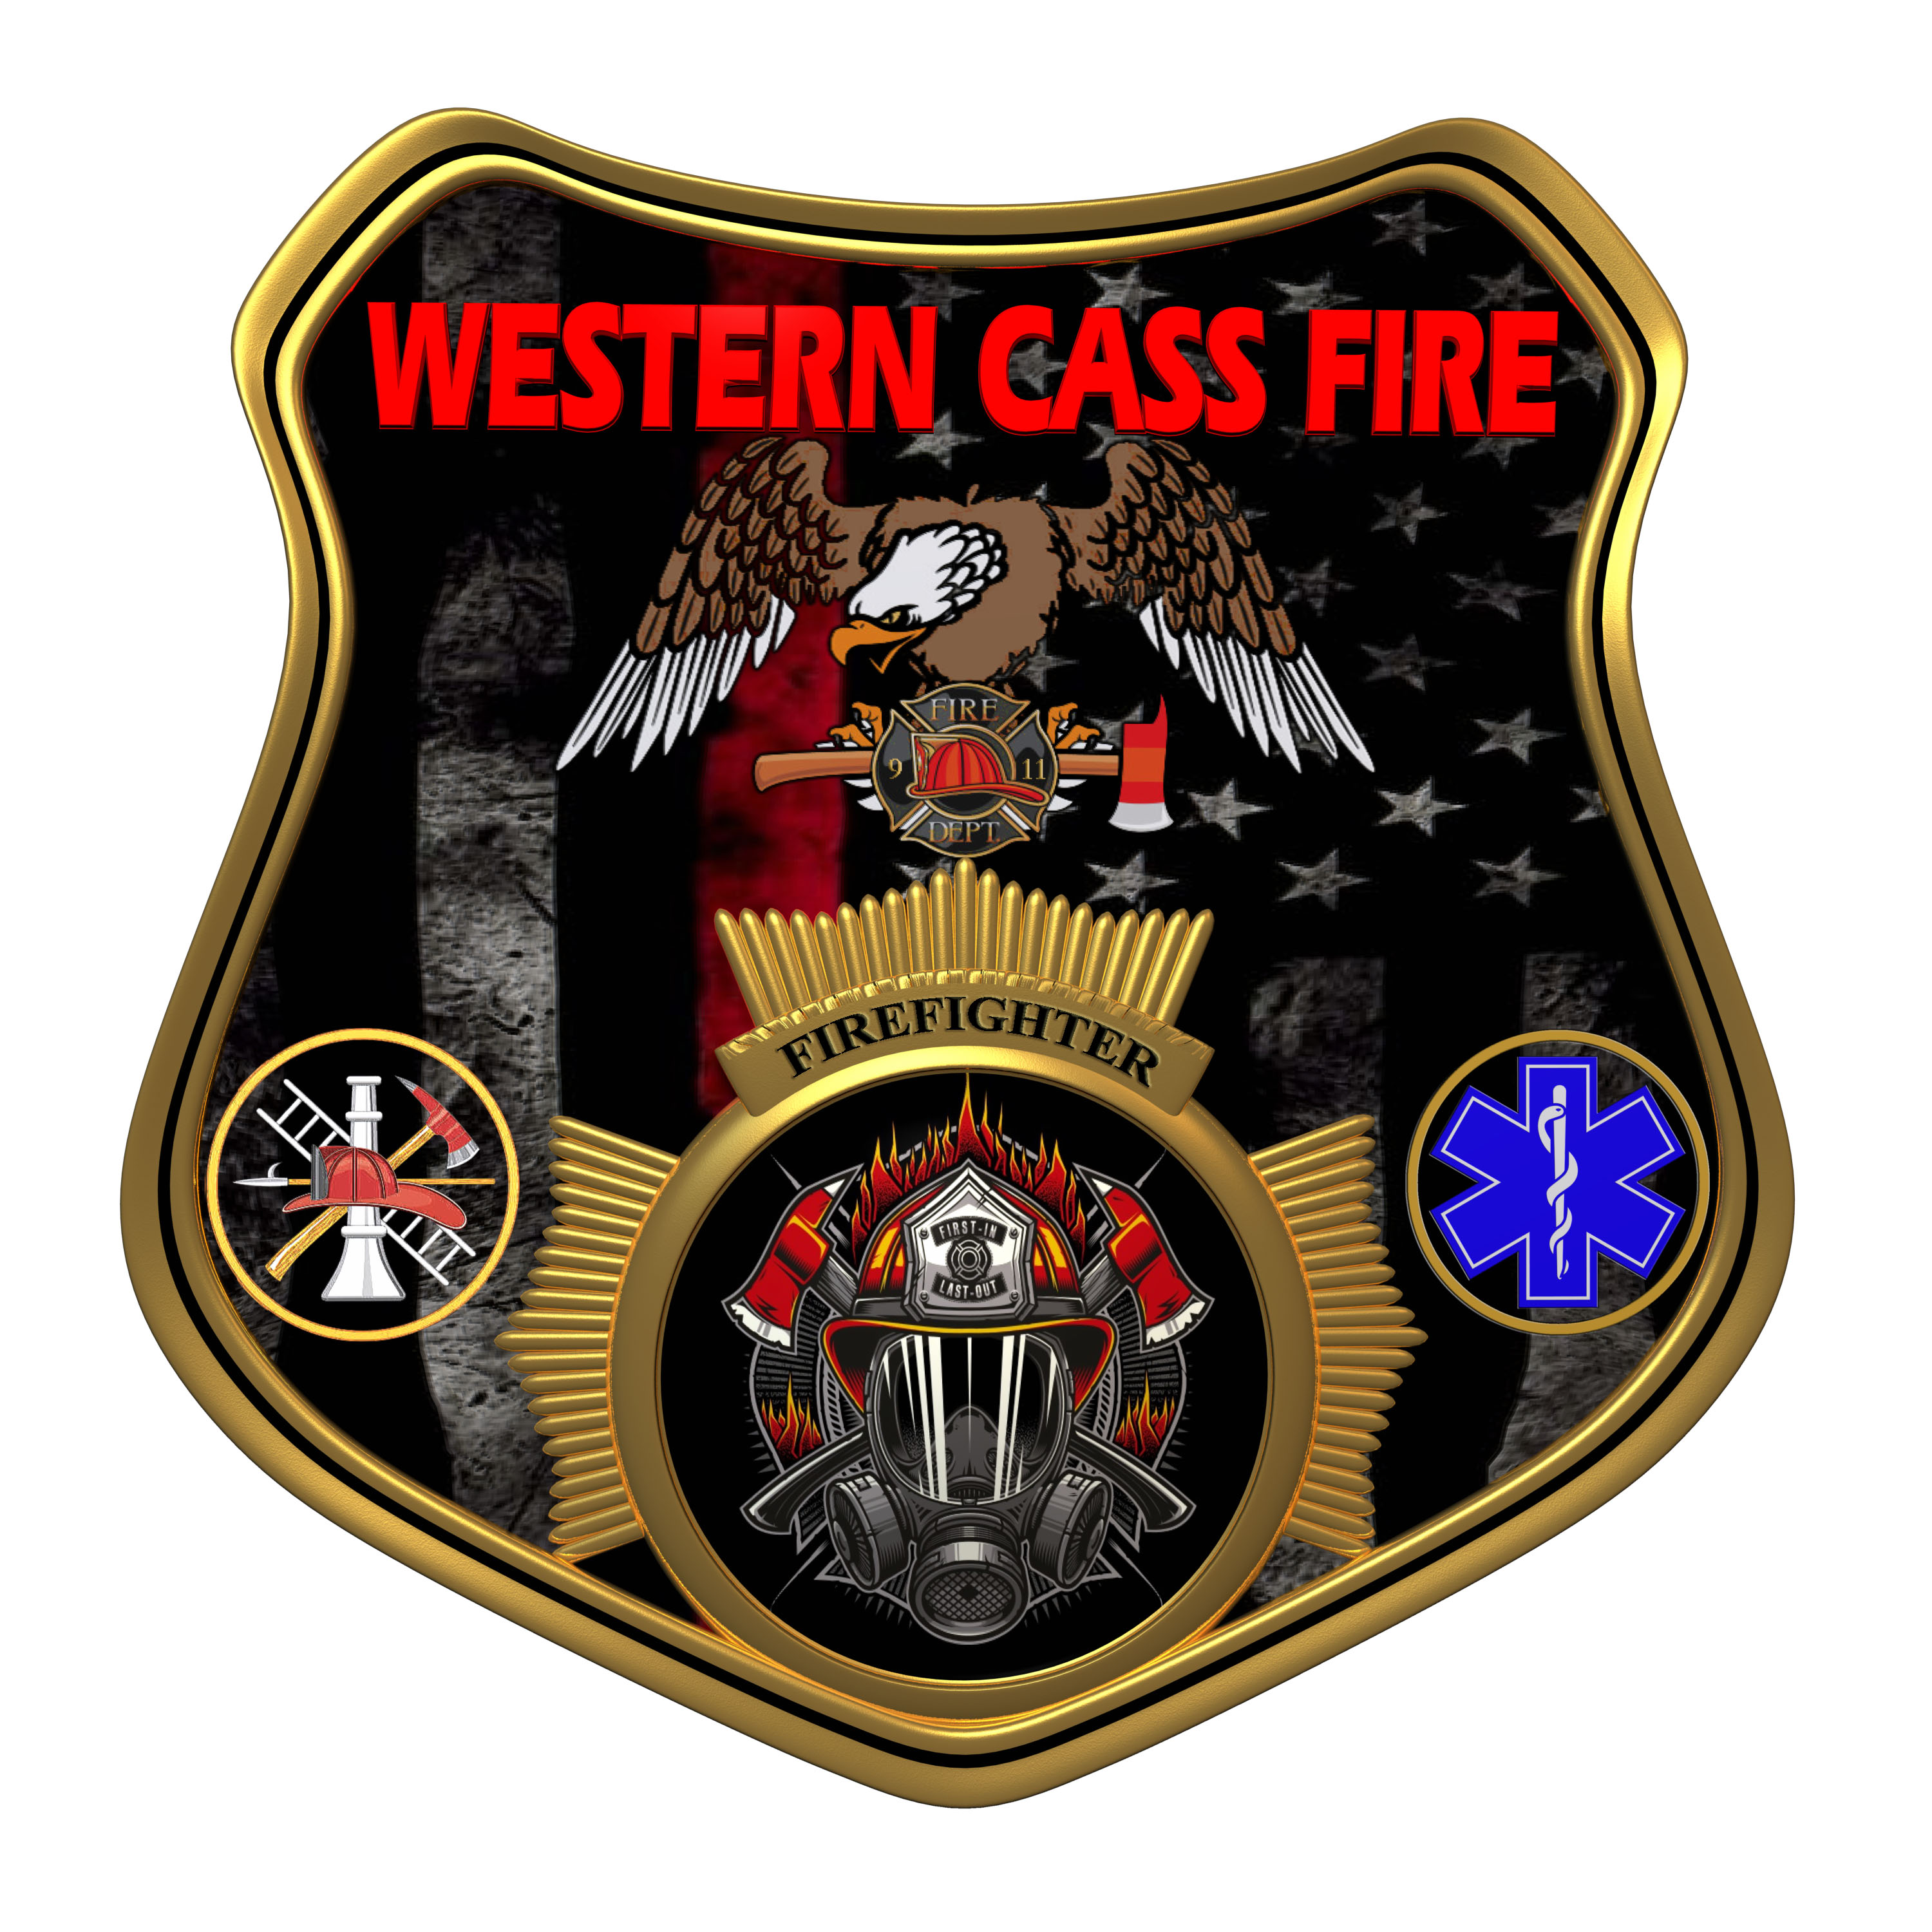 | Tentative Agenda  Western Cass Fire Protection District  Regular Session  Wednesday, October 19, 2022, at 7:00 pm  Fire Headquarters  5 S. Rogers Rd., Cleveland, MO 64734  https://tinyurl.com/34dpvt5p  Discussion Protocols and Organization Rules for Meetings:  Questions from the public must be in writing with the following information: Name, Phone #, Physical Address, Email Address.  Board Members will be limited to 3 minutes for discussion of agenda items, twice per item, and discussion of items will last no more than 10 minutes per item.
- Call to Order by the Secretary
- Pledge of Allegiance
- Roll Call (Quorum)
a) President and Chair John Webb (2022- 2027)
b) Vice Chair Marty Hardman (2022- 2023)
c) Director Sue Hosterman (2019-2025)
d) Director Kerri VanMeveren (2020-2026)
e) Director Darvin Schildknecht (2021-2027)
- Adopt and Approve Wednesday, October 19, 2022 Tentative Agenda
- Personal Appearances / Public Comments
6) Reports - No Reports
7) Unfinished Business
a) Dispatch Contract
b) Carpet Contract
8) New Business
a) Solicit Insurance Bids
b) Operational Necessities
1) A.T.T. Account - P.T.T. Blankenship
2) Generator Repair 1923 Pumper
3) Extinguisher Annual
4) Emergency Lights - Pinion
5) Atmospheric Testers
6) Station 2 Generator Maintenance
7) Station 2 Bay Lights
9) Closed Session: Personnel Issues
Personnel matters are confidential until such time as they may be made public by the Board of Directors, and the nondisclosure of such records outweighs the public interest in disclosure of the records as according to RSMo 610.021(1)(3)(13)(19).
10) Adjourn

