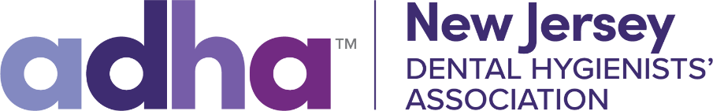

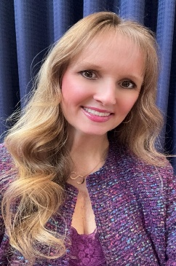
An Update From NJDHA President, Dr. Stacy L Onofrietti –
Nevada bill SB495, sections 77-79, dies in the assembly at the very start of our day at midnight! Thank you to all who have helped and continue to help. Those who wrote an opposition letter, who are writing and speaking to your legislation, who are speaking to your family and friends, and who are educating patients and the public on keeping the high standards of care and education for the dental hygiene profession. Thank you for helping to protect public health and voicing your concern for anything like SB495 (77-79) in Nevada to never pass. Congrats Nevada Dental Hygienists’ Association, ADHA and the dental hygiene profession.
ADHA leadership has been working tirelessly for our profession, all dental hygienists and dental hygiene students to build partnerships with organizations to gain support for us today and in the future. Thank you to the ADHA leadership volunteers and staff dedicating all of their efforts for the betterment of our dental hygiene profession. This work is shining through at this time where numerous prestigious national organizations across the US stepped forward to support us and stand with us like IFDH, AGD, IAMO, and AAOM. The collaboration of professional organizations and various professionals is a key to overall patient care and health. We need your experience, knowledge and skills as dental hygienists to enhance the journey for all of us.

Thank you to all of you who have been a member of ADHA over the years, thank you to those of you reaching out to become members as recent graduates, thank you to those coming forward to join at this time. If we chose not to continue as members and you chose not to do join, we would not exist and this great accomplishment with Nevada and the future we are building for the dental hygiene profession would not continue to grow and expand in the way it has and will. We need all of you as dental hygienists and dental hygiene students to join and become another voice during this time of change for our profession and its future. We need you, as dental hygienists, to unite and empower, as we are stronger together.

As I have mentioned, it is integral that dental hygienists, dental hygiene students, our families, friends and the public unite to defend our profession. The collaboration of NJDHA, NJDA, and NJDAA has become the way in our state of NJ in this past year as a sign of our strength together in NJ. We have also begun posting billboard/posters on Optimal oral health, asking your dental hygienist -What’s in your mouth? created and realized by the NJDHA Central Component Board from 5/27- 10/12/2025 to promote and advocate for our profession to the public in a unique way. The first is up until 10/12/2025 at route 17 and Freeman St. in Lyndhurst and others will follow in Ocean, Redbank, and Toms River. Thank you all for writing to us with questions and concerns, please continue to do so as we are here to help.
Protect. Respect. Retain- ADHA.

