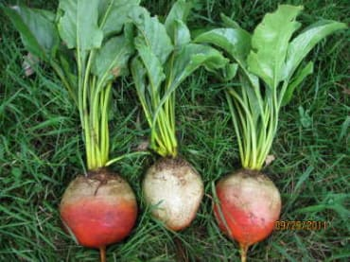

Touchstone Gold Beet

Beta vulgaris  
(55 days) Open-pollinated. A refined and reliable golden beet with long attractive green tops, Touchstone takes the guesswork out of growing golden beets. Market growers love its dependable germination and uniformly round roots that resist zoning. Like other golden beets, retains its color when cooked and has the sweet flavor prized by aficionados. Performed well even when overcrowded in our trial.

**Culture:** Spring or fall, beets are hardy and easy to grow. Can be sown almost as soon as ground can be worked in spring. **Minimum germination temperature 40°, optimal range 60–85°.** For full-sized beets, you must thin to at least 3" apart. Early thinnings make good salad greens; baby-beet thinnings cooked with tops are a Yankee delight!

**Disease:**  
PM: Powdery Mildew  
DM: Downy Mildew  
CLS: Cercospora Leaf Spot looks like someone shot a series of small target-like circles in the foliage. Prolonged periods of rainfall and high humidity exacerbate this disease. In serious cases the spots darken and extend. Rotating crops, removing plant debris, and wider spacing to ensure adequate air circulation are preventive measures.

Scab, the same disease that afflicts potatoes, causes rough brown spots on the skin. Adequate irrigation is a preventive.

Master Gardeners of Santa Clara County rate this as one of the recommended varieties of beet for this area. We chose a golden beet because the flavor is less earthy and a bit sweeter than red beets and the beet greens are especially nice. Greens are most tender when small, so start harvesting when they are 2" tall. You can take as much as one third of a beet plant's outer leaves without harming the root crop.

**When to Sow Outside:** RECOMMENDED. 2 to 4 weeks before your average last frost date, when soil temperature is at least 45°F, ideally 60°–85°F, for early summer crop. 6 to 8 weeks before your average first fall frost date for late summer/fall crop. Mild Climates: Sow fall through winter.

**When to Start Inside:** Not recommended. Root disturbance delays maturity.

**Days to Emerge:** 5–21 Days

**Seed Depth:** ½"

**Seed Spacing:** 1 seed every 4"

**Row Spacing:** 12"

**Thinning:** When 2" tall, thin to 1 every 4"

**Height at Maturity**: 8 – 12”