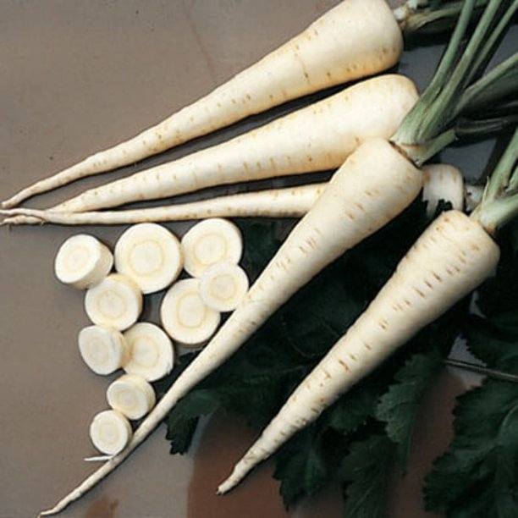**Harris Model Parsnip**

* **Botanical Name:***Pastinaca sativa*
* **Days to Maturity:** 110–120 days
* **Family:** Apiaceae
* **Native:** Eurasia
* **Days to Emerge:** 10–25 days
* **Seed Depth:** ½"
* **Seed Spacing:** A group of 3 seeds

every 3"

* **Row Spacing:** 18"
  + - **Thinning:** When 4" tall, thin to 1 every

3”

* **Hardiness:** Biennial grown as annual. Roots can be harvested in fall after a few frosts or left in ground through winter for harvest before tops begin growth in spring.

**Variety Information:** Creamy white, tapered roots; foliage is a much broader leaf than carrot foliage

**Culture:** Seed is short-lived; Sow about 1" apart in mid-spring. Thin to 2–3". Parsnips require a full growing season. Suitable for harvest after frost for late fall delights. Parsnips left to overwinter in the ground will nearly triple their fall sugar content. For the best early spring treats, harvest as soon as possible before the plants resume growth. Roots become more woody as the plants re-grow.

**Seed Saving:** Save some plants for seed in year 2. Plants will shoot up 6' before July-Aug. Homegrown parsnip seed often is better and more viable than any you can buy on the market.

**When to plant:** Direct seed January–March (possibly April), September

**Harvest window**

* Harvest when the roots reach 1" diameter at the top.
* Expect 90–120 days to maturity.
* Flavor is best when the mature plants are exposed to cool weather for 2–4 weeks which encourages the starches in the roots to convert to sugars.
* Loosen soil with a digging fork before pulling roots.

**Care overview**

* Soil temperature should be >50º F for germination. Seeds are very slow to sprout at that temperature (3–4 weeks). In general, expect at least two weeks for germination.
* Plant seeds 1/2 to 3/4 inches deep.
* Thin to 2–4 inch spacing. When thinning, it's recommended to snip off unwanted seedlings rather than pulling to avoid disturbing the roots of remaining plants.
* Mound soil at base of plant to prevent greening of the root shoulders.
* Cultural requirements are very similar to those of [carrots.](https://mgsantaclara.ucanr.edu/garden-help/vegetables/carrots)

Parsnips have a long culinary history, are versatile and nutritious and are being added to the menus of many upscale and specialty restaurants. Their tender, white, carrot-like roots have a sweet and distinctive flavor that's delicious in soups and stews, mashed, stir-fried or roasted. The trick to growing the sweetest parsnips? Wait to harvest until after the first frost. Cold temperatures change the starch into sugar making them sweeter.

**Hardiness:** Biennial grown as annual. Roots can be harvested in fall after a few frosts or left in ground through winter for harvest before tops begin growth in spring.

**Plant Dimensions:** Sweet-flavored smooth tapered roots average 10”

**When to Sow Outside:** RECOMMENDED. Late spring or early summer, about 4 months before your average first fall frost date. *Mild Climates*: Sow in fall for harvest the following spring. Ideal soil temperature for germination is 50°–70°F.

**When to Start Inside:** Not recommended. **Harvesting:** To harvest parsnips, dig them up with a shovel or garden fork being careful not to cut or damage roots. If you wish to harvest before winter, leave parsnips in the ground for at least 2 weeks after a hard fall frost. You can improve the sweetness by storing at 32°-34°F for 2 weeks before using. If you leave parsnips in the soil over winter, throw a few inches of soil over the crowns and mulch heavily with straw or compost after the first fall frosts. During extended cold periods, stored starches are changed to sugar as the first-year plants prepare for new growth, thus roots harvested in early spring are especially tender and sweet. The roots lose flavor and become fibrous if you do not harvest them before new tops and seed stalks begin to grow.