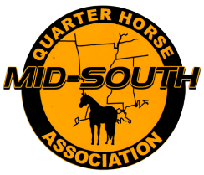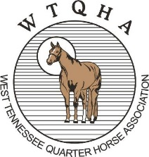
Mid-South Quarter Horse Association and west tennessee quarter horse association
Sponsorship Levels

Platinum – Corporate Sponsor - $2,500.00
Company Logo/Name and Information on all Show Bills as well as any other advertising throughout the year. Business name announced throughout all shows and displayed on the Arena Marquee. Banner with company name displayed. Link to your company website on the MSQHA and WTQHA websites. Free Vendor space or choice of location of stall at show.

Gold – Show Sponsor - $1,000.00
Business name announced throughout all shows and displayed on the Arena Marquee. Banner with company name displayed at the show. Company Logo/Name and information on all show bills. Link to company website from the MSQHA and WTQHA websites. Half price for Vendor space or choice of location of Stall at the show.

Silver Division Sponsor - $500.00
Business Name announced before and during the sponsored division and displayed on the Arena Marquee. Banner with company name displayed at the Show. Company Logo/Name and information on all show bills. Link to company website from the MSQHA and WTQHA websites.

Bronze Class Sponsor - $350.00
Official Class Sponsor – Name announced before and during your sponsored Class and displayed on the Arena Marquee. Banner with name displayed at the Show. Name on MSQHA and WTQHA websites.
Pewter Class Sponsor - $100.00
Your name announced during the class you choose to sponsor. First come first served on the Choice of class.

Thank you for your consideration. We depend on our sponsors for our continued success!

