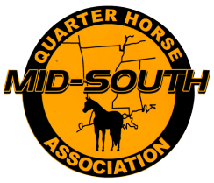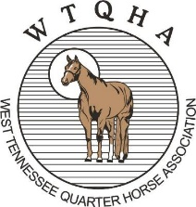
2024 SPONSORSHIP APPLICATION
MID-SOUTH AND WEST TENNESSEE QUARTER HORSE ASSOCIATIONS

NAME: ____________________________________________________
COMPANY NAME: ___________________________________________
ADDRESS: __________________________________________________
CITY, ST, ZIP: ________________________________________________
PHONE: ____________________________________________________
EMAIL: ____________________________________________________
WEBSITE: __________________________________________________

SPONSORSHIP LEVEL
_____ PLATINUM CORPORATE SPONSOR $2,500.00
_____ GOLD SHOW SPONSOR $1,000.00
_____ SILVER DIVISION SPONSOR $500.00
_____ BRONZE CLASS SPONSOR $350.00
_____ PEWTER CLASS SPONSOR $100.00

Send payments to: MSQHA 2060 Tall Trees Drive Horn Lake, MS 38637

