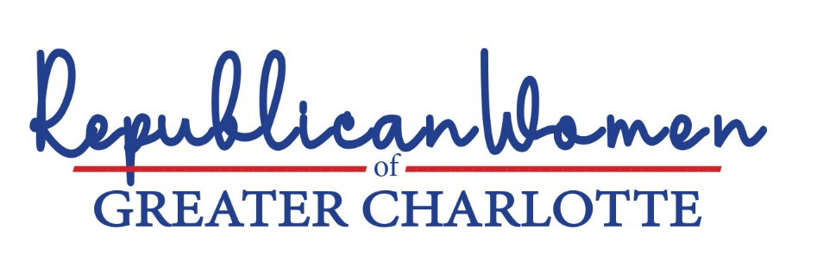

A school’s role in instructing, counselling, promoting or advising students on issues related to their gender identification or sexual preferences should be limited. Parents should have primary responsibility for addressing such issues, in accordance with their values.

We recognize that homosexuality has existed for thousands of years. While their chosen lifestyles may not be consistent with our Judeo-Christian values, we have loved and accepted our sons and daughters, nephews and nieces and other family and friends who are gay. In modern society, Americans have understood that what takes place between consenting adults in the privacy of their bedrooms should not be the subject of government regulation.
Through technology, however, and deliberate lobbying and indoctrination by well-organized LBGTQ+ advocacy groups, children today are being exposed to sexual content beyond their age of comprehension. Naturally, it’s confusing. Research adds to the well-established wisdom that children are better off if they are not allowed to make major life decisions without their parents’ involvement and permission. Parents generally are better positioned than anyone else, including the children themselves, to understand the needs of their children when making important decisions.
We believe questions about gender identification and sexual preferences are best addressed within the family, and roles of schools, counsellors and teachers in this area should be limited. Specifically,
    - For grades K-4, schools and teachers should not be instructing, advising or otherwise discussing anything about sexual preferences or gender orientation with children.
    - For all grades, parents should have full transparency as to what is being taught in modern sex education classes; and should be required to “opt-in” to such training prior to it being given.
    - For all grades, schools and teachers should not be promoting or instructing students in alternative, minority lifestyles through books or any other materials made publicly available to students.
    - Parents should be kept informed by schools of all matters related to their children’s physical or mental well-being, and school personnel should encourage a child to discuss issues related to their well-being with their parents or facilitate discussion of the issue with the parents.
At this writing, the North Carolina General Assembly is debating a bill called The Parents’ Bill of Rights (SB 49) that would empower parents: with full transparency regarding what their children are being taught and ensure age appropriateness for those subjects; to make health care decisions for, and be informed of any physical, emotional or mental changes in, their children; and rights to know about their children’s educational progress and tools to help their children succeed in school. The bill also would: subject to disciplinary action State employees who unethically attempt to coerce or instruct a child to withhold information from their parents; prohibit instruction on gender identity, sexual activity, or sexuality in the curriculum provided in grades kindergarten through fourth grade; and requires parental opt-in to so-called protected information surveys.
    - We fully support The Parents’ Bill of Rights and urge the General Assembly and Governor Cooper to put it into law.

“Puberty Blockers, Cross-Sex Hormones and Youth Suicide” Jay Greene, PhD, Heritage Foundation, June 13, 2022. The study concludes, “State policies that undermine this relationship between parents and children are dangerous and should be repealed. Similarly, those who work with children in professional capacities, including health, education, and counseling, should be careful about substituting their own judgment for that of the parents. State policies that undermine this relationship between parents and children are dangerous and should be repealed. Similarly, those who work with children in professional capacities, including health, education, and counseling, should be careful about substituting their own judgment for that of the parents.”
There being no recrimination against children whose parents opt out.
The book “George,” by Alex Gino, for example, Is a children’s book found to be used in North Carolina classrooms that illustrates a biological boy in the fourth grade who wants to be a girl. The book talks about cutting off male genitalia and hormone therapy. Recommended for third- to seventh-grade students, the submitter who shared this information said the book was included in their child's elementary school. An excerpt from the book provides, “So, like, do you want to”–he made a gesture with two fingers like a pair of scissors–“go all the way?” George squeezed her legs together. “Maybe someday,” she said. See, Robinson Study.
Protected information surveys include information regarding a child’s political or religious affiliations, sexual preferences, mental or emotional well-being and incriminating behaviors, among other things.

