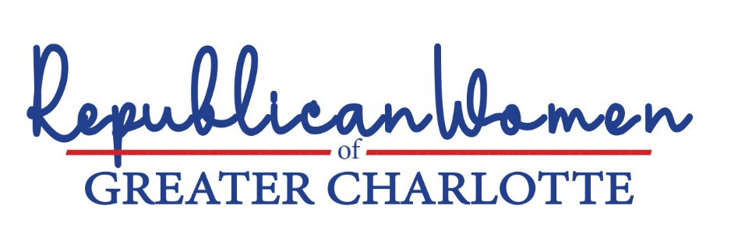

Critical Race Theory (CRT) has no place in public schools (K-12) or in public universities in North Carolina and Mecklenburg County

Despite protestations to the contrary from a biased liberal media and complicit corporate America, CRT has crept into public school systems and public universities throughout the country. In October 2022, a City Journal survey asked eighteen-to-twenty-year-olds whether they had been taught six concepts related to critical race theory. These included: “America is a systemically racist country,” “White people have white privilege,” “White people have unconscious biases that negatively affect non-white people,” “America is built on stolen land,” “America is a patriarchal society,” and “Gender is an identity choice.” Each of these was answered in the affirmative by a majority of participants, of whom more than 80 percent attended public schools.
North Carolina’s largest school system in Wake County launched a website in 2020 that provided BLM lessons for teachers to use in classrooms and for parents to use at home. The website, created by the school system’s Office of Equity Affairs, encouraged teachers to “address the injustices that exist beyond education by the conversations we have with others, by speaking up when we see hate, by supporting efforts that oppose racism and oppression, and by directly engaging in advocacy work.”
The New York Times-originated 1619 Project believes that America was “founded … on an ideal and a lie” as a “slavocracy,” and that “anti-blackness” is “at the core of so many of our institutions and really our society itself.” A new documentary about the series was just released on Hulu. Prominent conservative black advocate, Bob Woodson, who has worked for decades to help lift black communities out of poverty and a reliance on social welfare, bemoans the divisiveness and victimhood of the 1619 series, noting:
… the program, which began airing right before the start of Black History Month, isn’t telling the whole story. Viewers won’t hear about Americans’ remarkable resistance to and triumph over slavery, which led to flourishing black communities and unprecedented achievements …
We are called to witness to history in its fullness, not weaponize it against fellow citizens. Black Americans have never been solely defined by victimhood. They have resisted oppression from the start, and their resistance has helped make America more free.
These stories transcend academic or political utility, and they contain within them the seeds of a better future.
People are motivated to change when you show them that victories are possible. These stories tell us that everyday men and women can rally together and win great victories on behalf of themselves and their communities. They remind us what black Americans and all Americans are capable of.
These are the stories we should be teaching. This is the future we ought to build. This month, remember and retell all of black history.
While the history of the United States is exceptional, it is not without its blemishes, from which we learn. As Southerners, we know better than most the legacy of our original sins. Our public schools must not hide our historical mistakes.
- We firmly oppose rewriting our history and civics courses through a woke lens that inordinately focuses on racial inequalities. We simply don’t agree that US institutions are inherently racist, and we don’t want that taught to our children.
- We agree with Bob Woodson that American history should emphasize success stories like the triumph of Americans over slavery and the thriving black communities that resulted therefrom, as well as the significant achievements of black Americans in education, participation in the workforce and leadership since passage of the Civil Rights Act.
- We find it disgraceful that the History and Civics standards published by the North Carolina Department of Public Instruction in 2021 received failing grades from a non-partisan think tank that studied such programs for all 50 states. A new process should be instituted, to revise these standards, subject to public review and comment.
- Moreover, research-based, standardized curriculum on History and Civics – free of CRT ideology – should be developed and used in all such classes statewide
Finally, we note that state universities contribute to the problem. First, education departments are producing future teachers who lack appropriate skills and training. Teacher quality has an outsized influence on student achievement. But North Carolina’s teacher preparation programs too often attract mediocre or low-quality students. Graduates of the state’s education schools frequently lack mastery of relevant content along with the skills to teach. Without proper training or a standardized curriculum, we shouldn’t be surprised that North Carolina teachers turn to the internet to develop their teaching tools.
Second, universities are bastions of this woke CRT ideology and do not tolerate dissenting opinions.
- State universities should improve the quality of education school graduates by raising program admissions standards, increasing subject-area course requirements, and providing rigorous instruction in research-based teaching methods.
- We encourage the North Carolina General Assembly and Governor Cooper to follow the example of Florida Governor Ron DeSantis, who recently announced a proposal to eliminate all funding for so-called “diversity, equity and inclusion” and critical race theory “bureaucracies” at public universities.
- The Governor should give university presidents and boards of trustees more power in the hiring and firing of professors — power that has been taken away by faculty entitlements like tenure and bloated bureaucracy like the DEI committees.
- State education reforms should also include implementing core course requirements that will be grounded in actual philosophy that has shaped Western civilization and will propel students to think for themselves.

“Debunking the grievance industry in our schools,” Casey Chalk, City Journal, November 2022. (School systems in the United States have introduced Black Lives Matter (BLM)-themed lesson plans. Other history and social studies curricula have become beholden to racial ideologies pushed by the 1619 Project and the Southern Poverty Law Center (SPLC). Many schools, including those in neighboring Virginia, have embraced the SPLC’s “Teaching Hard History” curriculum, while school districts across the country are using the 1619 social studies curriculum.)
Id.
Rachmuth, Sloan and Jensen, Katie, “Black Lives Matter in Public Schools is Turning Children Into Little Marxists,” The Federalist, July 8, 2020 (“By partnering with these organizations, school systems across the country—including North Carolina – are indoctrinating our children to achieve Marxist objectives.”) The material apparently has since been taken down.
See, “US Schools Have Openly Taught the 1619 Project for Months,” Chantal da Silva, Newsweek, September 2020.
“Remember to Tell All of Black History,” William Schambra and Bob Woodson, WSJ, February 8, 2023.
Public school students today, for example, learn to think critically about prior cruelty to indigenous peoples, as they study our country’s founding. And they study slavery and the Civil War, as well as the Civil Rights movement.
See, State of the State Standards for Civics and U.S. History in 2021, Thomas B. Fordham Institute, which gave the North Carolina Department of Public Institution’s 2021 civics and history standards a D- and F, respectively.
“Teaching Profession,” Dr. Bob Luebke, John Locke Foundation.
Id.
“We don’t want students to go through, at taxpayer expense, and graduate with a degree in zombie studies,” DeSantis said in making the announcement of higher education reforms. ‘Zombie studies’ isn’t the only bizarre curriculum offered by unhinged academic departments in Florida; full college degrees exist in puppet arts, cannabis cultivation, feminist theory, and gender studies, for example.

