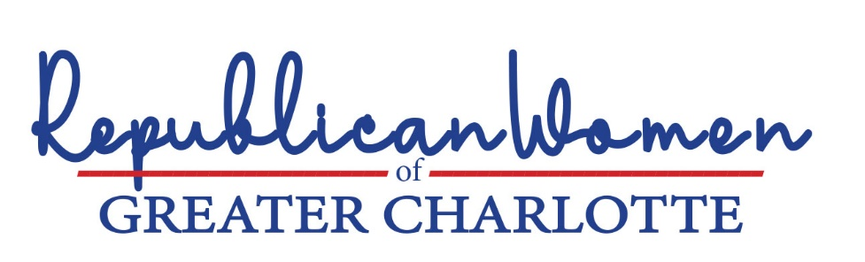

New leadership and ideas are needed to correct the performance of public schools
in North Carolina and Mecklenburg County.

Results of standardized tests for school year 2021/2022, show that North Carolina students collectively rank in the bottom half of the nation in core learning. Half of students in the Charlotte Mecklenburg Schools (CMS), are not proficient in math and reading. Approximately 82% of CMS juniors graduate from high school. But the vast majority of high school juniors are unprepared for college.
The numbers are particularly grim for black and Hispanic students. Scores for fourth and eighth graders in 2022, as measured by the National Assessment of Educational Progress (NAEP) showed significant declines from 2019, the last year those tests were administered. The achievement gap between white and Asian, and black and Hispanic students widened during the period.
While student learning in CMS languished, education administrators spent time and resources on DEI initiatives, like renaming schools and producing public television advertisements touting these so-called successes. Parents’ frustration is understandable.
2022 NAEP Results
Percent Earning Proficient Scores:
Grade 4 | Math | Reading
Nation | 35% | 32%
NC | 35% | 32%
CMS | 35% | 33%
Grade 8 | Math | Reading
Nation | 26% | 29%
NC | 25% | 26%
CMS | 30% | 29%

Clearly, our public schools in North Carolina and CMS are not meeting the educational needs of minorities. In the meanwhile, the percentage of Hispanic students in the North Carolina school system is growing exponentially. In ten years, Hispanic students have increased from 7.4% to 17.4% of North Carolina students. Frequent absenteeism and expulsions are high for black and Hispanic students relative to their white and Asian peers.
At a time when North Carolina’s economic prospects are exploding – North Carolina was ranked “top state for business” by CNBC in 2022 – our students are graduating without the appropriate skills to take advantage of these opportunities.
The goal should be to lift both the bottom and the top.

The left’s explanation for decades of poor performance and for the achievement gap between white and Asian students and students of color is ‘institutional racism,’ and they seek to diversify the school’s racial mix of students, and more recently, the racial mix of teachers. School boards, administrators and their DEI bureaucracies are focused on ensuring the racial composition of the faculty “represents the racial composition of the community,” rather than ensuring the faculty is composed of the most competent teachers available – or that sufficient numbers of them speak Spanish.
Equally problematic is the left’s determination to achieve racial parity by watering down or eliminating educational enrichment programs, like STEM magnet schools, gifted programs and AP courses and objective acceptance criteria, such as test scores. The University of California (UC) Board of Regents, for example, has eliminated SAT and ACT scores in applications for admissions by California high school students for entrance to UC schools. Closer to home, Charlotte Mecklenburg Schools uses a lottery system for admission to magnet schools, including those focused on Science, Technology, Engineering and Math (“STEM”). Low-income students are given priority in the selection process, with the remaining applicants subject to a lottery. In school year 2022/2023, STEM magnet schools were over-subscribed, which raises the question whether the most qualified students are being accepted in these programs.
The weight of the evidence from decades of research shows such methods will not raise the performance of minority students. Jason Riley of the Wall Street Journal put it succinctly in a recent editorial:
You don’t help underperforming groups by pandering to them or by holding them to lower standards. And you don’t help black children by insisting that they must be seated next to white children in order to learn. It’s not only insulting and condescending but contradicted by decades of evidence. Low-income black students need quality schools … and the focus on racial balance at any cost will only ensure that another generation of black youth receives an inferior education.
Reducing, modifying or eliminating standardized testing in favor of “equity” is wrong-headed and will have dire consequences for the U.S. Jason Riley spelled-out the implications of these policies in his editorial:
This war on standards is part of a larger war on meritocracy, with economic and geopolitical consequences that should concern all of us, regardless of race. China and India are not eroding standards in the name of equity and social justice. They are not abandoning enrichment programs for their brightest students. They are selecting people based on talent and promoting them based on performance. What we’re doing to ourselves in moving away from merit-based systems will only make it more difficult for our children to compete with their children.
- North Carolina and CMS educational institutions should stop blaming the poor performance of minority students on institutional racism or lack of diversity. And programs and resources dedicated to such false ideologies, such as bloated DEI bureaucracies, should be reallocated to improving underperforming schools.
- Educational achievement should be celebrated and encouraged. Enrichment programs, like STEM magnet schools, gifted programs and AP courses, should be expanded, not watered-down or eliminated to achieve ‘equity’; and objective acceptance criteria, such as test scores, should be used for determining admission, without regard to race.

North Carolina School Report Cards. Statewide results are comparable.
College Preparedness: Only 45% of students taking the ACT scored at or above UNC system admissions minimum requirement of a composite score of 19 (blacks-24%; and Hispanics-27% fared particularly badly).
Based on a representative sampling of fourth- and eigth-graders who took reading and math tests given by NAEP in the first three months of 2022. National staff select the schools and students to be tested so no one can cherry-pick the best test-takers.
Much of these results are attributed to COVID protocols, which impacted economically-disadvantaged communities most severely.
The NAEP allows comparisons of student test scores across states, but it does not account for the fact that states can serve very different student populations, and those differences can impact test scores. The Urban Institute publishes a dataset that adjusts the NAEP data for such democratic data, such as race and English spoken in the home. Notably, when the NAEP data is adjusted for race and other socioeconomic factors, North Carolina ranks among the top 10 states.
Of the 171 public schools in CMS, nearly one-third (50) are ranked “low performing” under state standards. State Superintendent Truitt and other state education leaders are reportedly exploring new methods of measuring school performance, other than test scores, to avoid “socioeconomic bias.” WRAL, February 5, 2023.
“Black Students Need Better Schools, Not Lower Standards (The fixation on racial parity at any cost will doom yet another generation to educational failure),” Jason Riley, WSJ, February 7, 2023.
Id.

