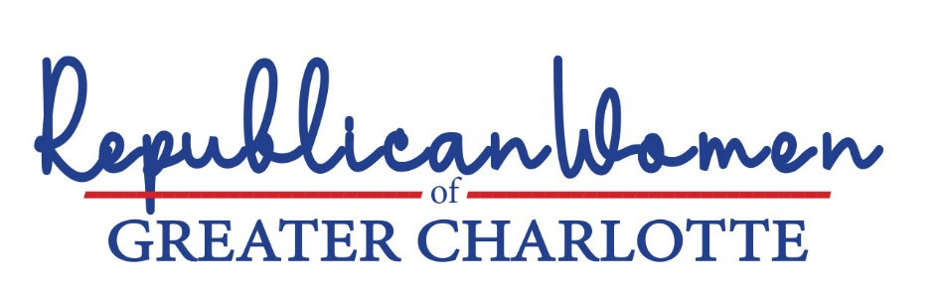

PARENTS’ RIGHTS AND CHILDREN’S WELLNESS
Conservatives today are justifiably dismayed by the changes taking place in public schools. These changes are most profound in the toxic content and un-American ideologies to which children are being exposed in the classroom, through social media and other forums designed to displace the traditional values of their parents.
In 2021, Lieutenant Governor Mark Robinson formed a blue-ribbon commission of education professionals to study these changes across the State of North Carolina. The findings confirmed conservative parents’ worst fears:
The Sexualization of Kids: There have been numerous reports of the sexualization of kids across the state. This may involve coercing students into affirming ideas about sex and gender that their parents do not wish for them to be taught … In some instances, school administration instructed educators to lie to parents … and to keep issues regarding their child's sexual identity and preference hidden from the parent.
Critical Race Theory (CRT): [Websites such as] Learning for Justice Club, [as well as other sources provide North Carolina teachers with] … resources which find their way into the school system but are not state-supported or state-approved resources.
White Shaming: Students who are members of racial minorities or other “identity groups” across the state have been given authority by teachers to shame white students for being ‘racist oppressors.’ This ‘white shaming’ instills in children the notion that all white people are racist, and that all racial minorities are oppressed.
Shaming of Certain Political Beliefs: Teachers, parents, and students across the state have reported how the political agenda in many schools is one-sided.
Fear of retaliation. Teachers, parents, and students across the state are afraid to report indoctrination, or speak up in their communities, out of fear they will lose their jobs or face mistreatment when pushing back against indoctrination, bias, or a lack of freedom of inquiry and freedom of speech in the classroom.
Parents became more aware of this insidious creep of ‘woke’ indoctrination and pernicious ‘cancel culture’ during the pandemic, when children were studying at home. Other effects of the pandemic and at-home learning were unfinished learning. Children also exhibited increased levels of mental health problems. Impacts were particularly severe among black and Hispanic students. Unless addressed, this unfinished learning will follow these children throughout their working lives, resulting in lifetime income losses of between $49,000 to $61,000.
In large numbers, throughout the country, conservative parents are demanding change. Specifically, these parents want to see:
- discontinuation of sexual and gender ideology training and indoctrination that robs children of their innocence and is more appropriately addressed by parents according to their values;

- a return to traditional history and social studies that recognize our patriotic dates (e.g., the country was founded in 1776, not 1619), explain our democratic institutions, with their systems of checks and balances, and celebrate United States achievement within the context of world history, while acknowledging and critically assessing historical atrocities;

- a reallocation of resources toward lifting student academic achievement and away from Diversity, Equity and Inclusion (DEI) bureaucracies, which distract teachers and staff from the primary goal of preparing students for success in life; and

- improvement in the performance of the public school systems in North Carolina and Mecklenburg County, without watering-down traditional performance metrics or curriculum, with particular focus on increased educational engagement and academic improvement by black and Hispanic students.
RWGC addresses each of these issues in greater detail in this section on Education and makes recommendations for legislative and administrative changes to effect positive change.

“Indoctrination in North Carolina Public Education” The Office of Lieutenant Governor Mark Robinson, August 24, 2021. (Robinson Study)
“Simply put, critical race theory states that U.S. social institutions (e.g., the criminal justice system, education system, labor market, housing market, and healthcare system) are laced with racism embedded in laws, regulations, rules, and procedures that lead to differential outcomes by race.” Rashawn Ray et al., Brookings Institute.
A comment from an educator using these materials notes, “[Learning for Justice] provides me with the means to promote social justice, challenge bias, and engage students in discussions about diversity that would perhaps not happen otherwise.” Robinson Study
History and social studies curricula across the country have become beholden to racial ideologies pushed by the 1619 Project and the Southern Poverty Law Center (SPLC).
One school employee in the Charlotte area reported, “I am writing to report that CMS has all high school students participating in "social justice" lessons on Thursdays in the advisory period homeroom. The lessons are prepared by CMS staff and have included lessons on white privilege, racism, BLM, LGBTQ+, and many more that fit the liberal agenda.” Robinson Study
These concerns of retaliation are real. In Charlotte, one family’s children were permanently expelled from Charlotte Latin, a premiere private school, when the children’s parents – together with 60 other parents -- expressed concerns regarding the “woke” curricula being taught at the school.
A recent study by McKinsey & Company concluded that remote learning put students 5 months behind in math and 4 months behind in reading proficiency by the end of the 2020/2021 school year “Covid 19 and education: The lingering effects of unfinished learning,” McKinsey & Company, July 2021. The national survey of children’s health shows that the percentage of children, ages 3 to 17, who had anxiety or depression rose from 9.4% in 2016 to 11.8% in 2020 — a 25% increase. North Carolina went from 7.6% to 11.3% — a 48% increase. See, Kids Count Data Book. In the Kids Count report, North Carolina ranks 34th in overall child well-being — 31st in the economic category measuring poverty and employment, 36th in health, 34th in family and community, and 21st in education. Id.
. In the McKinsey Report, 35 percent of the parents surveyed expressed concern regarding their children’s mental health. A national survey of children’s health shows that the percentage of children, ages 3 to 17, who had anxiety or depression rose from 9.4% in 2016 to 11.8% in 2020 — a 25% increase. North Carolina went from 7.6% to 11.3% — a 48% increase. See, Kids Count Data Book. In the Kids Count report, North Carolina ranks 34th in overall child well-being — 31st in the economic category measuring poverty and employment, 36th in health, 34th in family and community, and 21st in education. Id.
Id.

